**Function: caesar_cipher**

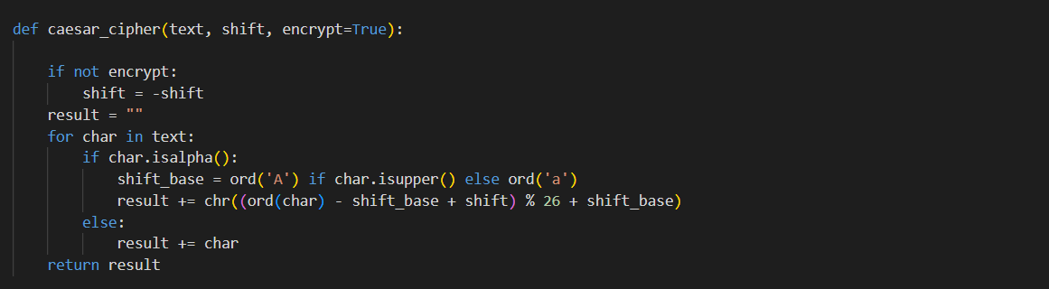

1) Parameters:

text: The input string to be processed.

shift: The number of positions each letter in the text is shifted.

encrypt: A boolean flag indicating whether to encrypt (True) or decrypt (False). Default is True.

2) Shift Adjustment:

If encrypt is False, the shift value is negated to reverse the direction of the shift. This allows the same function to handle both encryption and decryption.

3) Processing Each Character:

Initialize an empty string result to store the final processed text.

Loop through each character in the input text.

If the character is a letter (checked using isalpha()):

Determine the base ASCII value: ord('A') for uppercase letters and ord('a') for lowercase letters.

Calculate the new character using the Caesar cipher formula: (ord(char) - shift_base + shift) % 26 + shift_base.

Append the new character to result.

If the character is not a letter, append it unchanged to result.

4) Return Result:

Return the final processed text stored in result.

**Function: main**

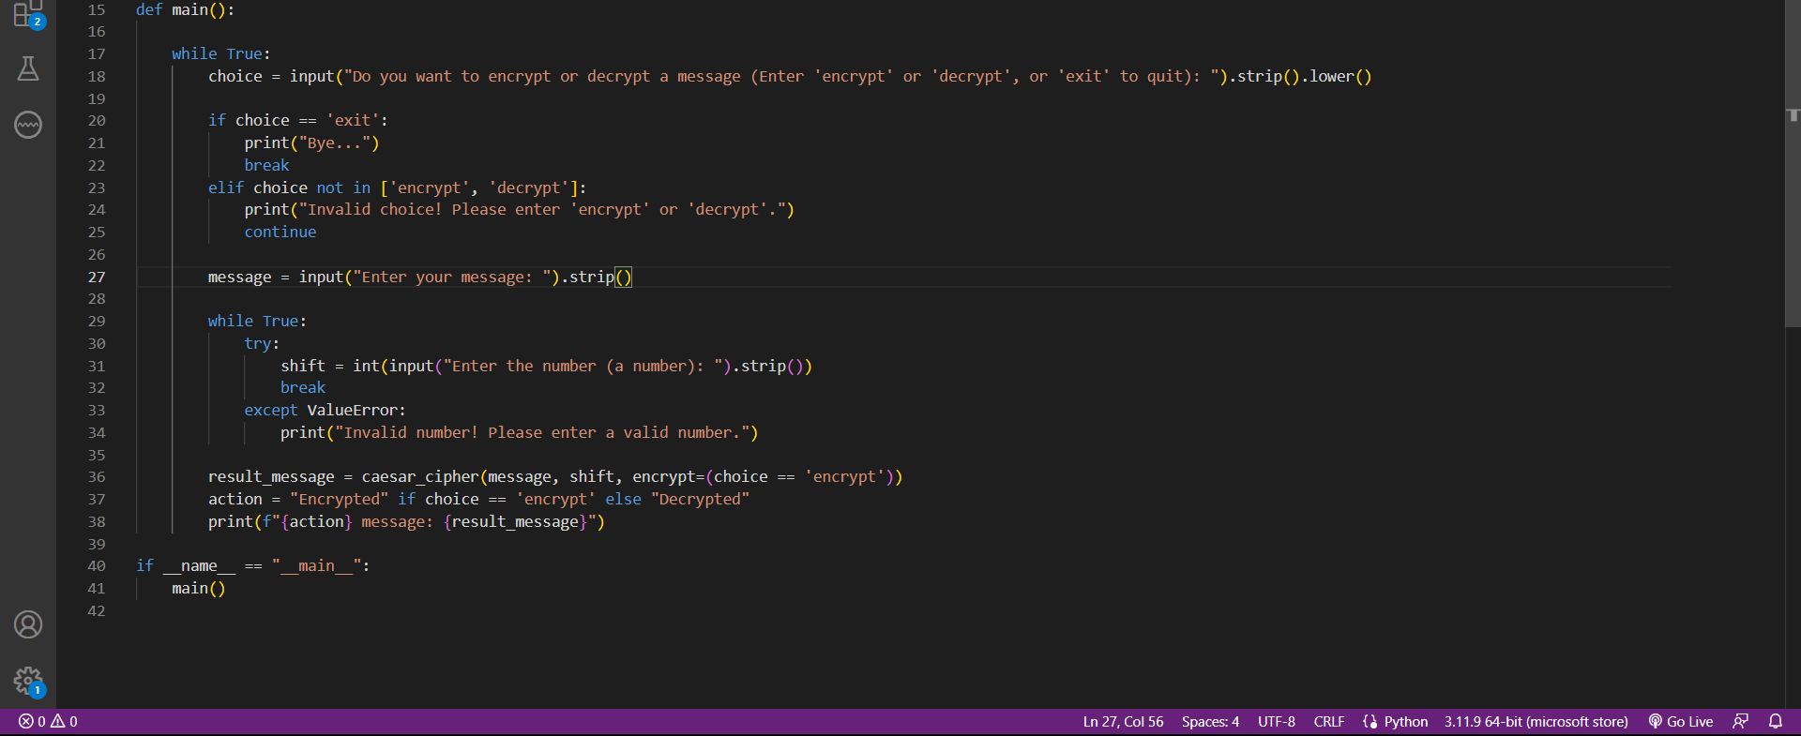

1) Infinite Loop for Continuous Interaction:

The while True: loop ensures the program keeps running until the user decides to exit.

2) User Choice:

Prompt the user to choose between 'encrypt', 'decrypt', or 'exit'.

If the user chooses 'exit', print a farewell message and break the loop to terminate the program.

If the user enters an invalid choice, print an error message and prompt again.

3) Message Input:

Prompt the user to enter the message they want to encrypt or decrypt.

4) Shift Value Input and Validation:

Use a nested loop to prompt for a valid shift value until the user provides a valid integer.

If the input is not a valid integer, catch the ValueError and print an error message, then prompt again.

5) Encrypt or Decrypt:

Determine the operation based on the user's choice (encrypt = (choice == 'encrypt')).

Call caesar_cipher with the appropriate parameters (message, shift, and encrypt flag).

Print the resulting message, indicating whether it was encrypted or decrypted.

This block ensures that the main() function is called only when the script is executed directly, not when it is imported as a module in another script.