1. **Where are items stored and if they were rearranged, could a warehouse be eliminated?**

To find the answer of this question, I identified the which items are store in each warehouse and calculate the total inventory for each warehouse, form which It can be easly identify that which warehouse (south) has constently low inventory

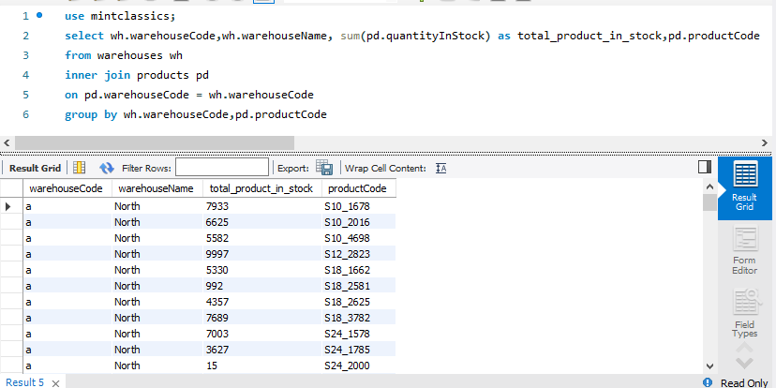

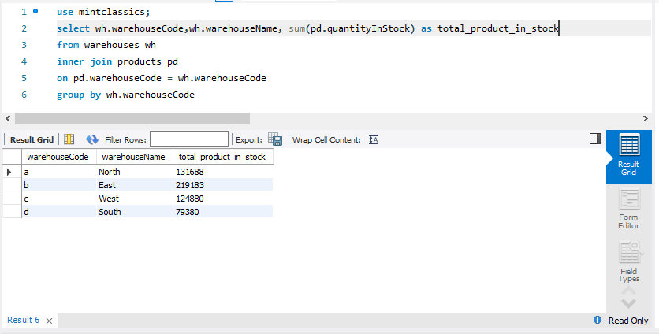

2. Determine important factors that may influence inventory reorganization/reduction.

through this question we can determine the relationship between sales and inventory,

through sql it is analyze that number of sales for each item and its inventory,

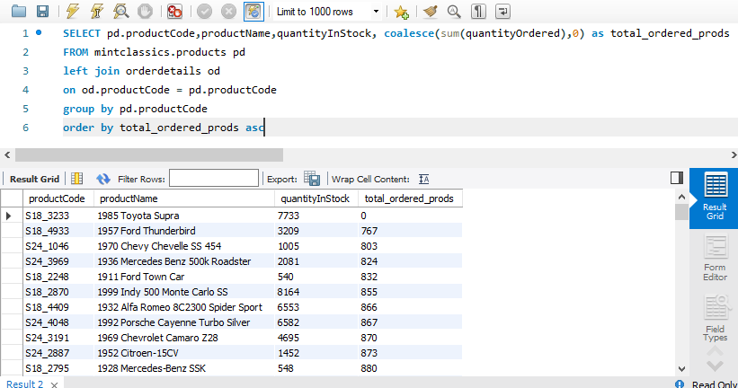

It can be easily identify from the result set that the top listed products are the products with minimum sales and their alternative stock is high

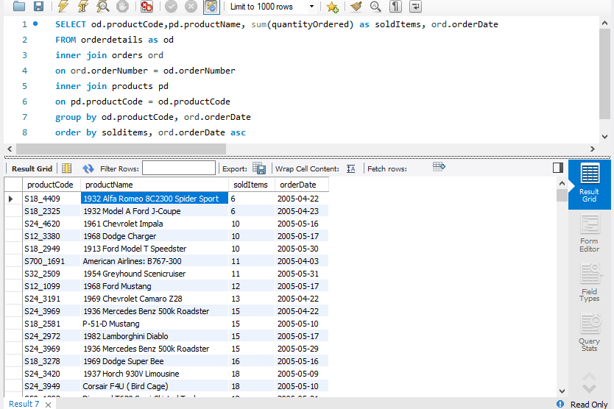

Here the number of sold items on each date, and order the in ascending represents the least sold items each day.

# **Results and Conclusion**

Also from the insights it can be concluded that the south warehouse would be the first priority to close because the less number of stock as compare to other warehouses,

And there are few items in inventory which need to be remove from the inventory because of less number of sales of that item.