**Question 7**

* 1783 boxes passed the threshold and 22 (1805-1783) boxes were filtered out because they were below the threshold.
* Maximum number of boxes = 1805 because all the boxes have scores greater than or equal to the threshold.
* Minimum number of boxes = 0 because all the boxes have scores below the threshold.

**Question 8**

* Anchor boxes help to detect objects of **different scales, overlapping objects, and multiple objects per grid.**
* **K-means clustering algorithm** is used for the generation of anchor boxes.

**Question 10**

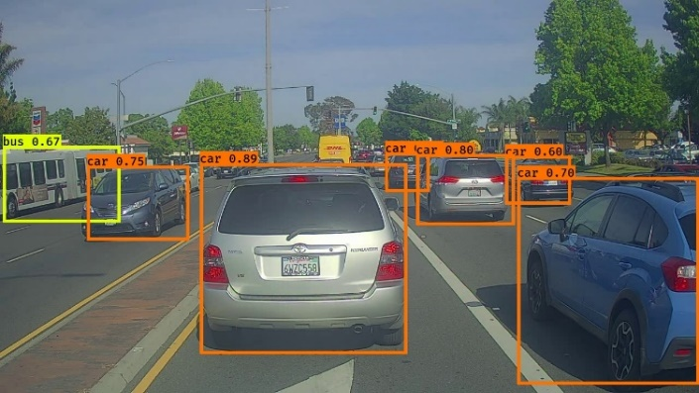

* All the objects are detected correctly

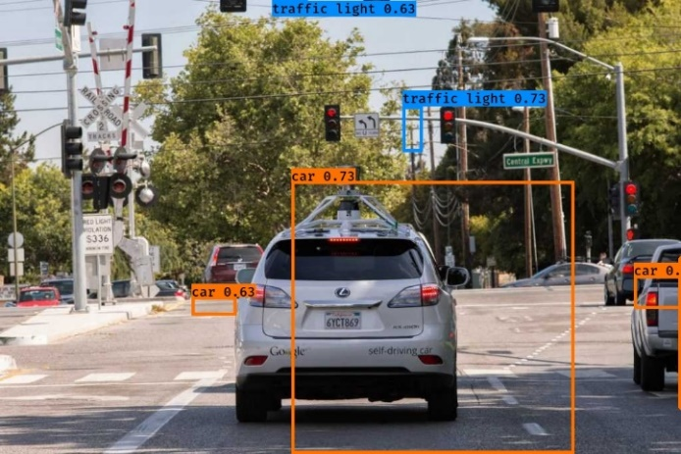

* Most of the images are detected but the boundary values are not displaying properly.
* But some traffic lights and cars are not detected

**Question 11**

* boxes [100] to a different value – no change
* **A car on the road

  Description automatically generated**the score_threshold [0.7] to a different value – objects with a score which is less than 0.7 are not displayed with boundary boxes

* the iou_threshold [0.4 & 0.6] to a different value – no change