Reviving the Lost Wilderness: Measuring the Educational Value of Immersive Technologies in Prehistoric Wildlife Exploration

Project ID: 25-26J-417

Project Proposal Report

Dissanayake D.M.D.T

B.Sc. Special (Hons.) Degree in Information Technology Specializing in Interactive Media

Department Of Information Technology

Faculty of Computing

Sri Lanka Institute of Information Technology
August 2025
Reviving the Lost Wilderness: Measuring the Educational Value of Immersive Technologies in Prehistoric Wildlife Exploration

Project ID: 25-26J-417

Project Proposal Report

Dissanayake D.M.D.T

B.Sc. Special (Hons.) Degree in Information Technology Specializing in Interactive Media

Department Of Information Technology

Faculty of Computing

Sri Lanka Institute of Information Technology
August 2025
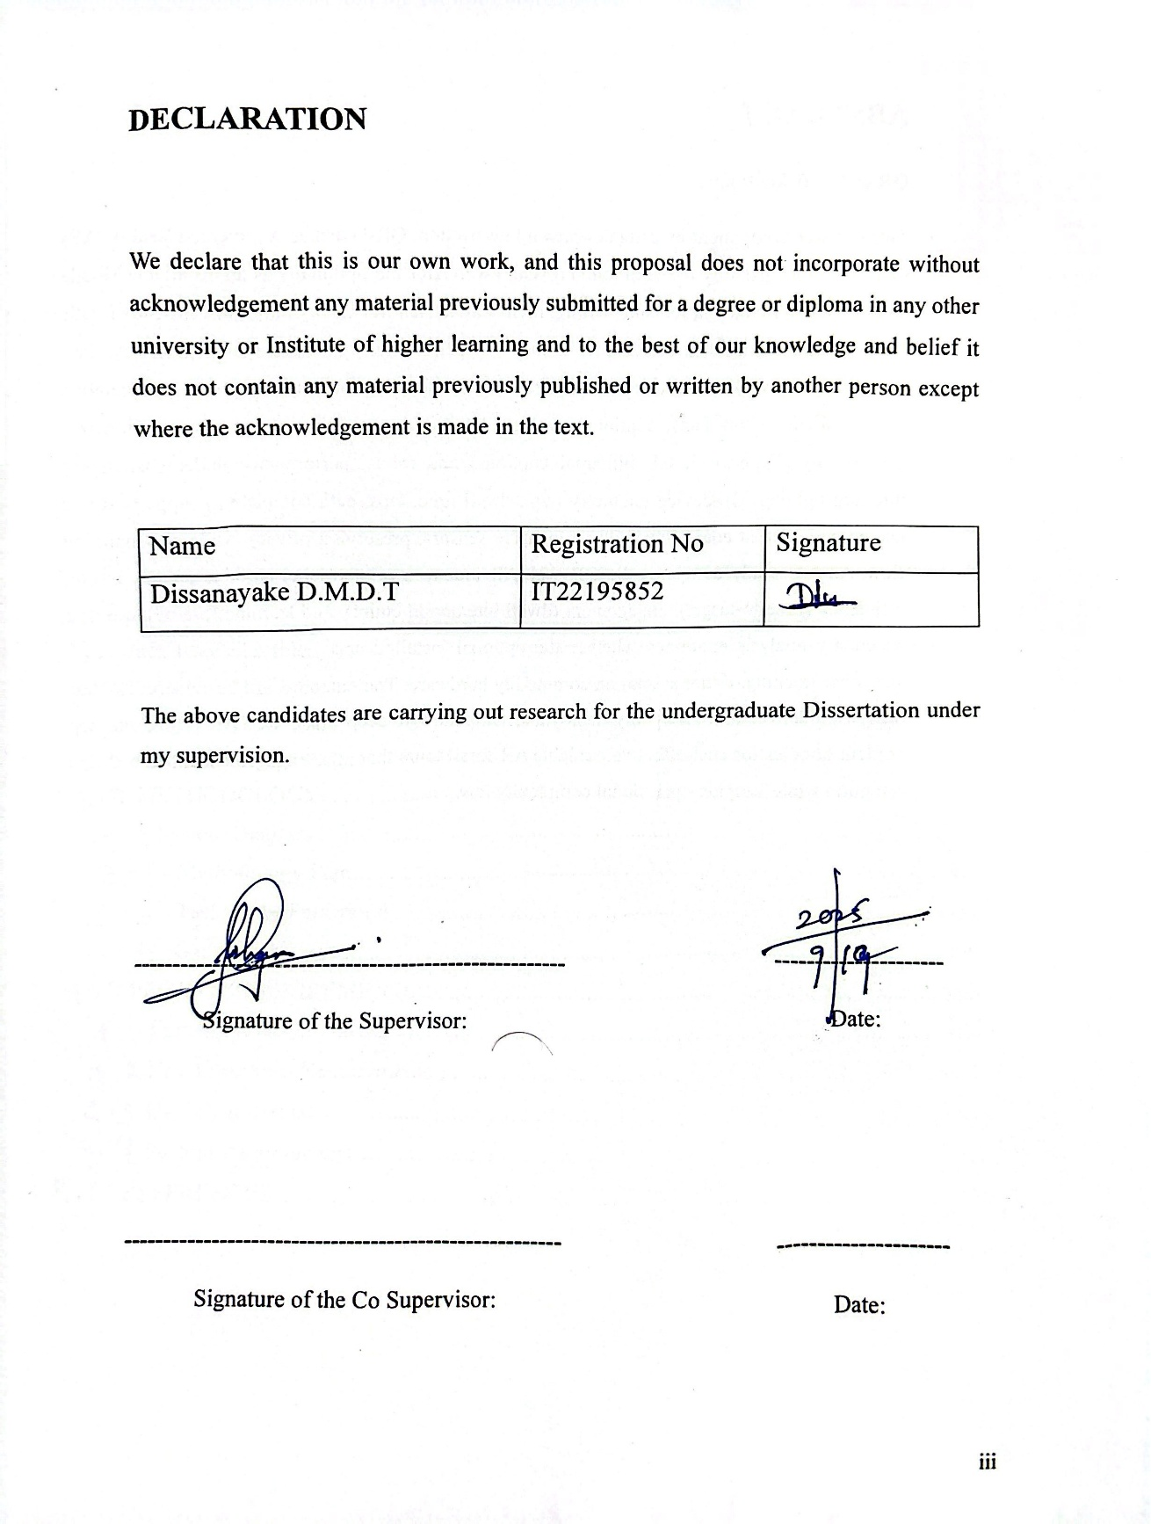

ABSTRACT
QR code AR fossil tour
This research component investigates how a low-friction, QR-launched Augmented Reality (AR) tour accessible instantly in the mobile browser (Web AR) and optionally as an installable Mobile app and transform navigation and learning in Sri Lankan natural history museums. Instead of static labels, visitors scan a QR beside each exhibit to open lightweight, offline-capable AR overlays that both guide wayfinding (directional arrows, “next fossil” prompts) and enrich interpretation (tap highlights, short facts, captions). Designed for mid-range phones, the system prioritizes accessibility (large-touch UI, bilingual captions) and robust performance under challenging museum lighting. On-device telemetry (e.g., dwell time, taps, path completion) supports subtle pacing and content adaptation without invasive sensors, preserving privacy while personalizing flow. An A/B study compares the QR-Web AR tour to a printed label baseline on wayfinding efficiency (time-to-target), engagement (dwell/interaction count), and learning (pre/post quiz); a secondary analysis examines whether the optional installed app yields additional gains (e.g., smoother tracking, richer assets) on commodity hardware. The outcome will be evidence backed design guidelines and an openly deployable template QR deep links, Web AR pages, and app content bundles for cost-effective, scalable AR fossil tours that raise engagement and knowledge retention while keeping operational complexity low.

Table of Contents

LIST OF FIGURES vi
LIST OF ABBREVATIONS vii
1.0 INTRODUCTION viii
1.1. Background viii
1.2. Literature Review x
1.3. Research Problem xi
1.3.1. Main Research Question xi
1.3.2. Sub Research Questions xi
1.4. Research Gap xii
2.0 OBJECTIVES xiii
2.1. Main Objective xiii
2.2. Specific Objectives xiii
3.0 METHODOLOGY xiv
3.1. System Diagram xiv
3.2. Methodology Plan xv
3.3. Work Breakdown xix
3.4. Gantt Chart xxi
4.0 PROJECT REQUIREMENTS xxii
4.1. Functional Requirements xxii
4.2. Non-Functional Requirements xxiii
4.3. User Requirements xxv
4.4. System Requirements xxvi
5.0 REFERENCES xxvii

LIST OF FIGURES

Figure 1:System Overview Diagram xiv
Figure 2:AR Elephant Scene Museum gallery placement with plane reticle, soft shad xvi
Figure 3:Project Gantt Chart xxi

LIST OF ABBREVATIONS

Abbreviation | Description
AR | Augmented Reality
Web AR | Web-based Augmented Reality
QR | Quick Response
UI | User Interface
UX | User Experience
PNG | Portable Network Graphics
APK | Android Application Package
WAV | Waveform Audio File Format
CSV | Comma-Separated Values

INTRODUCTION

Background
The research component “QR-Code AR Fossil Tour” is a core pillar of the project’s mobile track, designed to turn static fossil displays into place aware learning sequences that most visitors can access on their own phones. Where print labels struggle to hold attention, this component overlays brief, bilingual interpretive cues and micro-interactions on top of the physical exhibit, aiming to lift both engagement and learning while keeping costs and operational complexity low for Sri Lankan museums. To minimize friction, each exhibit’s QR code launches a browser-based Web AR experience immediately on scan; visitors who prefer a richer first option can also install the companion mobile app [6] [10].
Based on current studies in museum learning and cultural-heritage AR, augmenting exhibits with lightweight AR consistently improves motivation, academic achievement, and visit experience compared with traditional labels alone [9],[10]. International exemplars (e.g., the Etches Collection’s “PalaeoGo”; an Augmented Fossil Tour in Greece) show that mobile AR can revive paleontological content in situ, while scoping reviews map education and storytelling as major growth areas for AR in museums [8], [10]. However, most prior work emphasizes visualization or bespoke hardware rather than low-friction, phone-based tours that also support wayfinding and inclusive, bilingual interpretation in Global South contexts leaving a practical gap this component addresses via QR-launched Web AR with an optional app path [7], [8], [10].
Technically, the build leverages Unity 6 with AR Foundation (ARCore/ARKit) to support broad device coverage. Exhibits are linked via printed QR markers or image targets that trigger on-device overlays and short audio/visual facts. The QR flow defaults to WebAR for instant access and offers a one-tap handoff to install/open the native app for enhanced tracking, pre-cached assets, and smoother performance on commodity devices. Content is packaged for offline use; the UI provides large touch controls and captions (Sinhala/Tamil, with optional English) for accessibility; and performance targets mid-range phones and tablets used by the museum. On device telemetry principally dwell time at an exhibit, interaction counts, and path completion offers a privacy-preserving window into engagement that can iteratively inform design [1], [2], [5].
Considering the state of the art, CH-AR surveys and case studies argue that mobile AR is mature enough for field deployment, yet still lacks clear, context-specific guidelines for inclusive content authoring, lightweight analytics, and reliable gallery performance especially under variable lighting and without network connectivity [10]. Psychology-oriented Museum studies also indicate that immersion, imagination, and emotional cues are key to learning and retention in AR experiences, but comparative evidence against label-only tours in similar time windows remains limited [4], [9]. This component therefore pairs phone-first delivery (QR → Web AR) and bilingual design with an optional installed app and rigorous, in-gallery evaluation, helping translate global best practices into actionable guidance for Sri Lankan museums [4], [10].
The development approach builds on published museum AR pipelines but adapts them for QR-code launch + image tracking, modular content packs, and A/B evaluation. First, exhibit selection and scriptwriting establish concise, accurate micro-interpretations. Next, Unity/AR Foundation scenes map each QR/image target to its overlay; audio narration and subtitles are synchronized to short reveal beats; and assets are optimized for stable tracking and smooth FPS on mid-range devices. Finally, an on-site study at the Natural History Museum of Sri Lanka compares the QR-AR tour (Web AR default with optional app) to a printed-label baseline using pre/post quizzes, engagement measures (dwell, interactions), and navigation efficiency. A secondary analysis examines whether the installed app yields additional gains (e.g., faster load, steadier tracking, richer assets) relative to Web AR. The outcome is empirical evidence and museum-ready guidelines for scalable, cost-effective AR tours that maximize reach while keeping operational complexity low [2], [6], [8], [10].

Literature Review
Museum based mobile AR consistently reports gains in learning and engagement over printed labels, establishing AR as a credible interpretive medium for natural-history contexts [7], [10]. Reviews and meta-analyses converge on education and storytelling as core value drivers, while exemplars such as the Etches Collection’s PalaeoGo and the Augmented Fossil Tour demonstrate phone-based feasibility with 3D reconstructions and contextual overlays delivered in situ [7], [8], [10]. Together, these strands suggest a pragmatic, phone-first workflow: launch via QR in the gallery, present concise, high-quality overlays, and keep interaction loops brief to respect realistic dwell times [2], [5], [8].
Beyond visualization, literature highlights narrative framing and psychological factors information quality, perceived richness, immersion, imagination, and motivation as key determinants of achievement and memory in museum AR. First-person or situated storytelling, paired with well-timed micro interactions (tap to reveal, hold to compare, before/after morphs), supports both cognitive (recall, transfer) and affective (curiosity, empathy) outcomes under time-constrained visits [5], [7], [10].
Technically, Unity 6 + AR Foundation (ARCore/ARKit) offers broad device coverage for QR-launched scenes and/or image-target tracking, with a hybrid access model QR → Web AR by default and a one-tap handoff to an installable mobile app balancing low friction with richer, offline-ready performance [1], [3]. The app path enables pre-cached asset bundles, steadier tracking (e.g., ARCore/ARKit depth/occlusion), background downloads, and resilient offline playback; it also gates features by device capability and defers analytics sync until online [1], [3]. The literature flags operational constraints (variable lighting, network unreliability, thermal/battery limits, mixed device vintages) and recommends asset optimization, short audio captions, robust fallbacks (2D cards when tracking drops), and inclusive UI (large-touch targets, high contrast, bilingual subtitles) [4], [10]. Recent deployments and proposals emphasize in situ A/B evaluations against label only baselines using privacy preserving on device telemetry (dwell time, taps, path completion) and aligned pre/post quizzes to quantify wayfinding efficiency, engagement, and learning under realistic visit times; the app variant is analyzed as a secondary condition for load speed, tracking stability, and content richness [4], [6], [7].

Research Problem

Main Research Question

“How can immersive technologies be designed and evaluated to transform passive prehistoric-wildlife displays in natural history museums into interactive experiences that measurably increase engagement, knowledge, and empathy?”

Sub Research Questions

- “Does VR behavior AI for extinct animals create dynamic, non-repetitive interactions and increase visitor engagement and empathy versus scripted behavior on museum-grade hardware?”
- “Does a real-time visual ecosystem demo with on-the-spot habitat switching raise curiosity and systems understanding versus a non-interactive video, while staying smooth and source-traceable?”
- “Do QR-code AR tours on visitors’ phones improve wayfinding, engagement, and learning versus a printed-label tour?”
Covering point by the researcher
- “Does phone-based AR quizzes turn fossil exhibits into interactive journeys and outperform labels for youth engagement and learning”

Research Gap
An identifiable gap emerges when comparing this component’s QR-code AR tour with existing museum interpretations. First, most prior AR deployments act as static overlays tied to individual labels, not as tour systems that also handle wayfinding and visit flow across galleries. There is little work on a QR first, phone-agnostic pipeline (Web AR with an optional installable app) that launches instantly on visitors’ own devices and couples’ navigation prompts with concise, bilingual interpretation at each stop an approach crucial for Sri Lankan museums serving school groups and mixed device audiences [4], [5], [10].
Second, while many studies report positive attitudes toward AR, few conduct in gallery A/B comparisons against printed-label tours within the same time budget; thus, evidence remains limited on whether a QR-AR tour yields equal or faster wayfinding, higher engagement (e.g., dwell, interaction counts), and measurably better learning (pre/post quiz) under real constraints [1], [9], [10].
Third, existing systems seldom integrate lightweight, privacy preserving analytics (on-device dwell/interaction logging, no accounts) or bilingual, large touch UI tuned for mid-range phones nor do they exploit an app path for pre cached assets and robust offline recovery leaving a practical gap in inclusive authoring and gallery reliability (variable lighting, recovery after target loss) [2], [4], [5], [6] [7]. This component addresses those gaps by delivering a scalable, commodity-phone QR-code AR tour (Web AR + optional app) and producing evidence-backed guidelines from an on-site A/B evaluation tailored to Sri Lankan natural history contexts [3].

OBJECTIVES

Main Objective
Design, implement, and evaluate a QR-code–launched mobile AR tour accessible via instant Web AR with a one tap handoff to an optional installable app that runs on most phones, combines wayfinding with concise, bilingual exhibit interpretation, provides an accessible large-touch UI, supports offline/pre-cached assets and robust tracking on the app path, and measurably improves outcomes navigation efficiency (time to target), engagement (dwell, interaction count), and learning (pre/post quiz) versus a printed-label baseline under the same visit time, producing deployable guidelines for Sri Lankan museum contexts.

Specific Objectives
- Deploy a QR-first, phone agnostic AR tour (Web AR + app) with reliable exhibit recognition (QR + image targets) and an accessible large-touch UI.
- Design & optimize concise bilingual (Sinhala/English) micro-interactions and wayfinding overlays that enrich interpretation and sustain visit flow on mid-range devices.
- Evaluate in gallery via an A/B study (AR vs printed labels), measuring navigation efficiency (time-to-target), engagement (dwell, interactions), and learning (pre/post quiz, short, delayed recall), and derive deployable guidelines.

METHODOLOGY

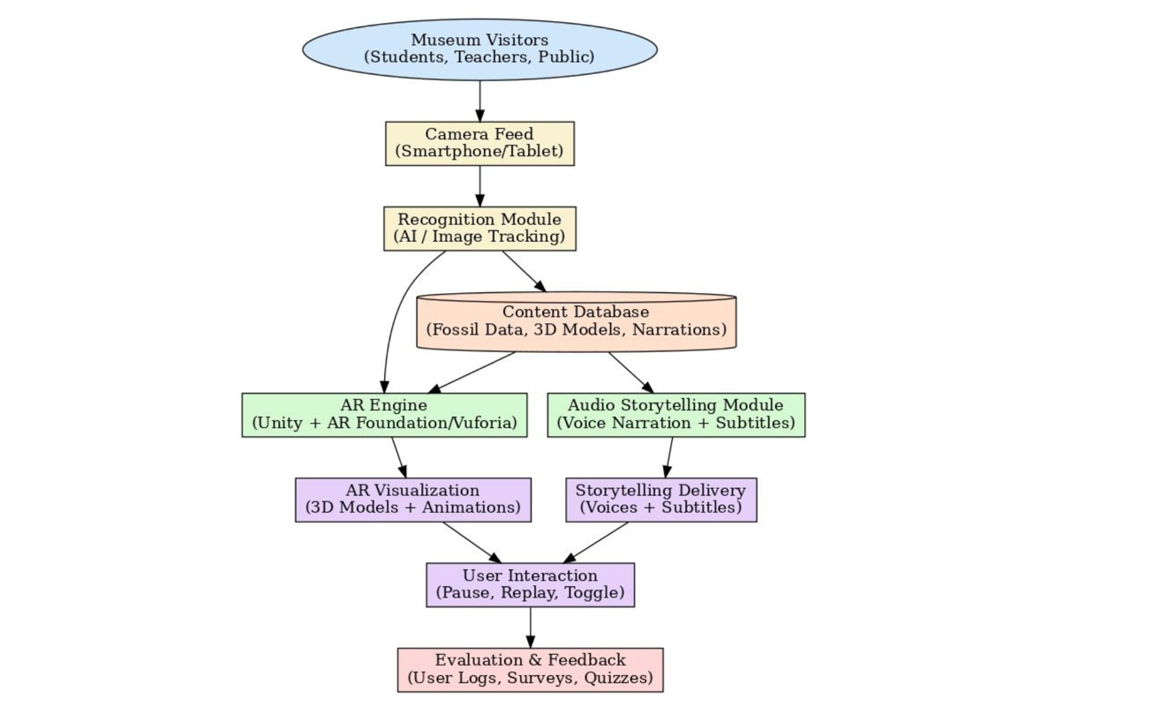
System Diagram
Figure 1:System Overview Diagram

Methodology Plan
We use a gallery first, dual delivery approach: a QR-code AR tour (Unity + AR Foundation) and a companion experience that opens in the mobile app or, if not installed, as a lightweight web page from the same QR. We co-design concise, bilingual interpretation with curators, pilot on the museum floor, then run an in-gallery A/B evaluation (AR/app vs printed labels; exploratory web only) to measure navigation efficiency, engagement, and learning. Privacy preserving logs and quizzes drive evidence-backed guidelines for Sri Lankan Museum deployment.

Phase 1 - Exhibit & Content Preparation
Working with curators, we select 6–10 fossil stops and compile the source set (label text, approved images/art, signage constraints). For each stop we author concise Sinhala/English copy (≈80–120 words) and define one or two micro-interactions e.g., tap-to-highlight a bone and a 20–30s audio fact with captions. A simple tour graph is drafted (start points for school groups, next-stop rules, short routes). Each stop gets a content pack QR artwork, image target, JSON mapping, media (PNG/SVG, MP3/WAV, VTT/SRT) plus a small style guide to ensure readable captions and ≥44px touch targets.

Phase 2 - Build (AR in Unity + Native App + Web)
We implement a QR-first deep link that opens the native app if installed or a responsive web page if not, both drawing from the same content packs. The Unity AR build (AR Foundation) provides image-target tracking, stable overlay registration near labels, and quick recovery flows (re-scan/fallback card). The native app adds a non-AR exhibit view (image, copy, audio captions), a simple gallery map/next-stop prompts, language toggle, and feedback. The web experience mirrors the non-AR view and, where supported, offers lightweight Web AR; otherwise, it remains a fast, accessible page. Performance is tuned for mid-range Android/iOS and common mobile browsers.
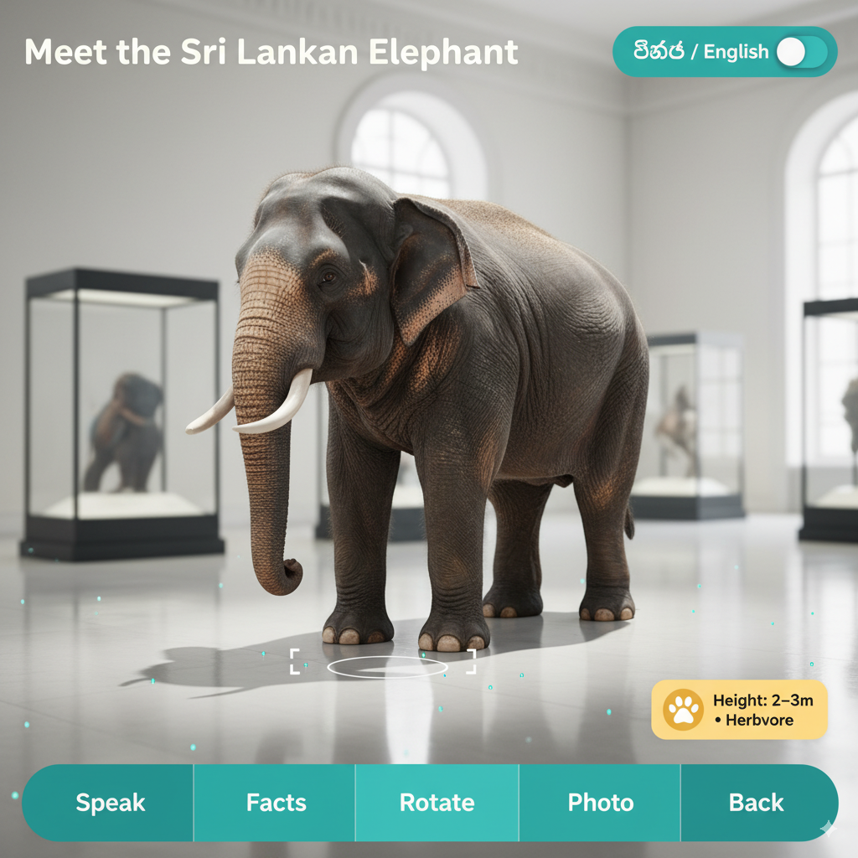
Figure 2:AR Elephant Scene Museum gallery placement with plane reticle, soft shad
Phase 3 - Pilot & Tuning
Small floor pilots with staff/students validate recognition robustness, overlay readability, caption legibility, arrow placement, and map clarity across typical lighting conditions. We adjust copy length to realistic dwell windows, retime audio, refine button sizing/contrast, and improve tracking targets or QR placement as needed. Evaluation instruments (pre/post quizzes aligned to copy, logging schema for dwell/interaction counts, timing rules) are frozen, and a deployment kit is prepared with print specs, stands, signage, and an operator checklist.
Phase 4 – In Gallery Evaluation
Under equal time budgets, visitors complete either the QR-AR tour or the printed-label tour; where feasible we counterbalance order and include a small web-only cohort to gauge the browser path. We measure navigation efficiency (time-to-target, wrong turns), engagement (per-stop dwell, interaction counts, voluntary revisits), learning (pre/post exhibit quiz; short same-day recall subset), usability (brief scale + comments), and operations (device compatibility, tracking/lighting incidents). All logs are privacy preserving (anonymous session IDs, no accounts) and exported daily for analysis.

Phase 5 - Analysis, Guidelines & Handover
We analyze dwell and quiz deltas with appropriate tests (e.g., t-test/Mann-Whitney), report effect sizes and confidence intervals, and examine error rates and compatibility by device class/age band. Findings are distilled into deployable guidelines QR/print placement, device checklist, lighting/tracking tips, authoring workflow, bilingual copy rules, and recommended micro-interaction patterns. The final deliverables include the AR build, native app package, web bundle, demo video, and a curator-friendly content-pack template so new stops can be added in ≤10 minutes without developer support.

Risks & Mitigations (key)
- Variable lighting/tracking → high-quality targets, matte lamination, recovery UI, staff placement guide.
- Device fragmentation → test top museum devices; adaptive layouts; provide loaner phones.
- Time pressure/throughput → ≤30 s AV bites, skip controls, short-route options.
- Network variability (web) → lean pages, media compression, caching, always-available non-AR view.

Success Criteria
- Access: At least 95% of scans lead to a usable page or app screen within 2–3 seconds.
- Navigation: AR achieves equal or faster time-to-target with fewer path errors than printed labels.
- Engagement: Median dwell time or interaction count increases by at least 20% compared with labels under the same time budget.
- Learning: Statistically significant pre-to-post gains for AR versus labels, with a small to medium effect size.
- Operations: Device compatibility at least 90%; fewer than 5% of sessions require staff assistance; a curator can add a new stop in 10 minutes or less.

Together, these phases deliver a dual delivery tour (native app + web from the same QR) that is co designed with curators, engineered for broad phone coverage, and verified on the museum floor through a controlled A/B evaluation against printed labels. Pilots de-risk tracking, readability, and wayfinding; the main study quantifies navigation efficiency, engagement, and learning with privacy preserving logs and short quizzes. The analysis culminates in deployable guidelines QR/print specs, device checklists, authoring workflow, and bilingual copy rules plus a reusable content-pack template so staff can add, or update stops in minutes. By coupling rigorous measurement with practical handover, the plan ensures the solution is not only effective for visitors but also scalable, maintainable, and ready for real world adoption in Sri Lankan natural-history contexts.

Work Breakdown
- Literature Review & Research
Review museum AR, wayfinding, mobile UX, and bilingual accessibility to ground design choices and metrics.

- Proposal Report and Presentation
Prepare the written proposal and an initial presentation outlining objectives, scope (app + web), methodology, and evaluation.

- Exhibit & Asset Gathering
With curators, select 6–10 fossil stops; collect label text, approved images/artwork, and signage constraints.

- Bilingual Scriptwriting & Micro-Interactions
Write concise Sinhala/English copy (≈80–120 words per stop) and define 1–2 interactions (tap highlight; 20–30s AV fact with captions).

- Tour Graph & QR/Target Planning
Design start points, next-stop rules, and short routes; assign QR codes and image targets; finalize print/placement specs.

- Progress Evaluation 1 (Concept Sign-off)
Review stop list, sample copy, tour graph, and QR/target plan with supervisors/curators; freeze scope for first build.

- Content Pack Pipeline
Create per-stop JSON mapping (copy, media, captions) and organize media (PNG/SVG, MP3/WAV, VTT/SRT) with a consistent folder structure.

- AR App Foundation (Unity 6 + AR Foundation)
Implement QR deep-link → AR scene, image-target tracking and stable registration, plus quick recovery (re-scan/fallback card).

- Native App & Web Experience (Non-AR Views)
Build the mobile app (scan, exhibit detail, map, feedback) and a responsive web page from the same content packs; enable optional Web AR where supported.

- Wayfinding, Accessibility & UI
Add arrows/next stop prompts from the tour graph; provide large-touch controls, Sinhala/English toggle, and captions ON by default.

- Privacy-Preserving Analytics
Log per-stop dwell time, interaction counts, revisits, and device/compatibility notes; store locally as JSON/CSV with anonymous IDs.

- Progress Evaluation 2 (Alpha: 2–3 Stops E2E)
Demonstrate QR → app/web → AR overlays end-to-end; gather feedback on stability, readability, pacing; prioritize fixes.

- Pilot Testing & Tuning
Run small floor pilots; refine tracking targets, copy length, caption sizes, arrow placement, and recovery flows; freeze quizzes/logging/timing.

- Performance Optimization & Compatibility Sweep
Improve load times, tracking in mixed lighting, and UI responsiveness on mid-range Android/iOS; verify behavior on the museum’s common devices.

- In-Gallery A/B Evaluation
Conduct a controlled study: AR/app vs printed labels (equal time); optional web-only cohort; capture navigation efficiency, engagement, learning, usability, and operational incidents.

- Research Paper Writing & Analysis
Analyze dwell/quiz deltas, path errors, and effect sizes, document methods, results, and implications for museum practice.

- Progress Evaluation 3 (Finalization & Handover)
Present results and a stable demo; deliver deployable guidelines (QR/print specs, device checklist, authoring workflow, micro-interaction patterns), final report, app/web builds, and viva presentation.

Gantt Chart

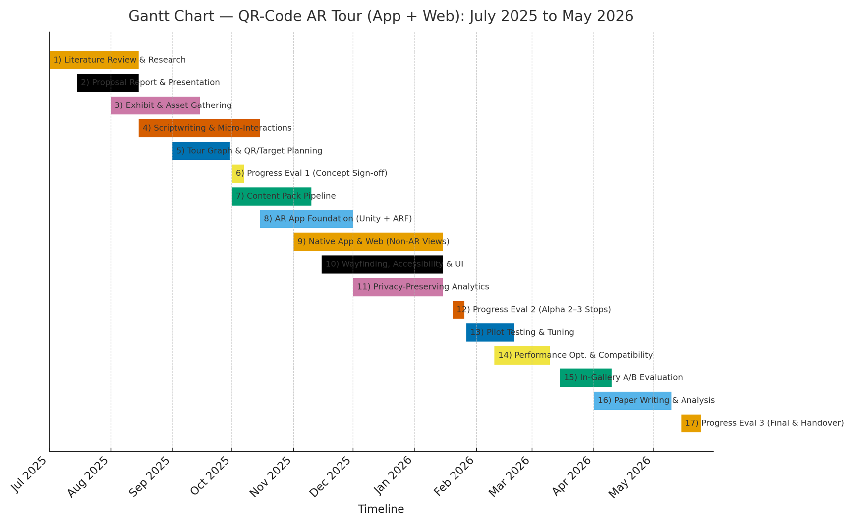
Figure 3:Project Gantt Chart

PROJECT REQUIREMENTS

Functional Requirements
- QR-First Launch & Deep Link
- The system must open the correct exhibit/tour node when scanning a QR.
- If the native app is installed, deep link into it; otherwise load the web experience.

- Exhibit Recognition (AR Image Targets)
- The system must recognize approved image targets placed near labels and anchor overlays to them.
- Provide fast re-scan and fallback to a non-AR detail view if tracking is lost.

- Wayfinding Overlays & Tour Flow
- The system must present arrows/next stop prompts based on a tour graph.
- Support short routes (e.g., for school groups) and allow jump to previous/next stop.

- Interpretation Micro-Interactions
- The system must offer tap to highlight parts (e.g., bones) and play 20–30s AV facts.
- Each stop must display a concise description with synchronized captions.

- Bilingual Content & Switching
- The system must display Sinhala/English content and let users switch language at any time.
- Language preference must persist across stops.

- Accessible Large Touch UI
- The system must provide large, high-contrast controls (play/pause, replay, mute, language, captions).
- Captions must be available and enabled by default.

- Device-Agnostic Web Experience
- The system must render a usable non-AR exhibit page in the browser for devices without the app or AR support.
- Where supported, the web path may offer Web AR; otherwise remain as 2D/3D detail with callouts.

- Compatibility & Recovery
- The system must detect camera/permission/capability issues and present clear recovery flows (grant camera, re-scan, open non-AR page).
- If an exhibit asset fails to load, show a fallback card with essential text and the next-stop option.

Non-Functional Requirements
- Performance & Responsiveness
- From QR scan to first content paint within 3 seconds on mid-range phones (web) and within 2 seconds in the app.
- AR overlay interaction latency under 100 milliseconds; video start delay under 500 milliseconds.
- Frame rate at least 30 FPS in AR mode and at least 45 FPS on 2D/3D detail pages.

- Reliability & Fault Tolerance
- Tracking reacquires within 1.5 seconds under normal gallery lighting.
- Graceful fallback to a non-AR detail view with no data loss.
- Mean time to recover from a failed asset request within 5 seconds.
- Availability & Operability
- Web tour uptime no less than 99.5% during museum hours.
- Core app functions (offline packs, player, language switch) work without a network connection.
- Clear status/error messages for camera, permissions, and capability checks.
- Compatibility & Portability
- Supports Android 9 and newer (ARCore where available) and iOS/iPadOS 15 and newer.
- Web path supports the last two versions of Chrome, Safari, Edge, and Firefox.
- Runs acceptably on mid-range museum devices (around 4 GB RAM and contemporary mid-tier chipsets).
- Scalability
- Handles at least 150 concurrent visitors per floor without noticeable slowdown.
- Uses CDN or edge caching for static assets; prefetches next-stop content during idle moments.
- Battery & Thermal
- A typical 15-minute tour consumes no more than 10% battery on a mid-range phone.
- Detects thermal throttling and automatically reduces effects (lower LODs, simplified effects, 24–30 FPS cap).
- Storage & Footprint
- App package size no more than 200 MB; each downloadable content pack no more than 80 MB.
- Web initial bundle no more than 5 MB; 3D/AV assets are lazy-loaded per stop.
- Accessibility & Inclusive Design
- Large touch targets at least 48×48 dp; high-contrast UI meeting WCAG 2.1 AA.
- Captions/subtitles enabled by default; all controls have screen-reader labels.
- Sinhala and English supported at launch; architecture allows adding Tamil without a rebuild of the core app.
- Internationalization & Locale Persistence
- Language switching is instant (no restart) and persists across stops and future sessions.
- Numbers, dates/times, and text layout follow the active locale.
- Security & Privacy
- All traffic uses HTTPS; no third-party trackers.
- No accounts or personally identifiable information collected; telemetry stored on-device (dwell, taps, path completion).
- Data exports are aggregated and anonymized; an opt-out is presented at start.

User Requirements
- Instant access from QR – As a visitor, I want the tour to open immediately when I scan a QR so I can start at the correct exhibit without installing anything.
- Clear wayfinding – I want on-screen arrows or next-stop prompts so I can easily navigate the gallery and follow a short or full route.
- Concise learning bites – I want brief facts (20–30s audio with captions and 80–120-word text) so I can learn quickly within my limited visit time.
- Simple controls – I want large, readable buttons to play/pause, replay, mute audio, and move to the next stop without confusion.
- Bilingual experience – I want to switch between Sinhala and English at any time and have my choice remembered across stops.
- Device flexibility – I want the experience to work on my phone and browser; if AR isn’t available, I still want a useful non-AR view.
- Privacy & respect – I want the app to avoid collecting personal data and clearly tell me what, if anything, is being logged about my visit.

System Requirements
- Unity 6 (Specifically version 6000.0.49f1)
- ARCore XR Plugin 6.x (Android) and ARKit XR Plugin 6.x (iOS)
- Android Studio
- Visual Studio Code
- Git + GitLab
- SQLite for database
- Blender

REFERENCES
[1] J. Garzón and J. Acevedo, “Meta-analysis of the impact of Augmented Reality on students’ learning gains,” Educational Research Review, vol. 27, pp. 244–260, Jun. 2019, doi: 10.1016/j.edurev.2019.04.001.

[2] “Use Depth in your AR Foundation Android app | ARCore | Google for Developers.” Accessed: Sep. 19, 2025. [Online]. Available: https://developers.google.com/ar/develop/unity-arf/depth/developer-guide
[3] “(PDF) FROM STATIC DISPLAYS TO INTERACTIVE AR: EVALUATING THE EFFECTIVENESS OF AN AR APP FOR GEN Z AND ALPHA IN MUSEUM PUSAKA.” Accessed: Sep. 19, 2025. [Online]. Available: https://www.researchgate.net/publication/392515841_FROM_STATIC_DISPLAYS_TO_INTERACTIVE_AR_EVALUATING_THE_EFFECTIVENESS_OF_AN_AR_APP_FOR_GEN_Z_AND_ALPHA_IN_MUSEUM_PUSAKA
[4] “PBS, BBC and bully! Let’s Users Walk with Dinosaurs | 8th Wall.” Accessed: Sep. 19, 2025. [Online]. Available: https://www.8thwall.com/blog/post/194063977908/pbs-bbc-and-bully-lets-users-walk-with-dinosaurs
[5] “Occlusion | AR Foundation | 6.0.5.” Accessed: Sep. 19, 2025. [Online]. Available: https://docs.unity3d.com/Packages/com.unity.xr.arfoundation%406.0/manual/features/occlusion
[6] “Enhancing Museum experience through deep learning and multimedia technology - PubMed.” Accessed: Sep. 19, 2025. [Online]. Available: https://pubmed.ncbi.nlm.nih.gov/38975172/
[7] Rosen Ivanov and Victoria Velkova, “Analyzing Visitor Behavior to Enhance Personalized Experiences in Smart Museums: A Systematic Literature Review.” Accessed: Sep. 19, 2025. [Online]. Available: https://www.mdpi.com/2073-431X/14/5/191
[8] Dionysia Liakopoulou, Christina Giamali, Emmanuel Galanopoulos, and Panagiotis Kaddas, “Augmented fossil tour, an AR application for exploring and studying fossils Bulletin of the Geological Society of Greece.” Accessed: Sep. 19, 2025. [Online]. Available: https://www.researchgate.net/publication/385606097_Augmented_fossil_tour_an_AR_application_for_exploring_and_studying_fossils
[9] Anping Cheng, Weiru Zhang, Anran Feng, Yunmengru Wu, and Wanjun Li, “Exploring psychological dimensions of augmented reality in education: a study on learning motivation and achievement in museums.” Accessed: Sep. 19, 2025. [Online]. Available: https://www.researchgate.net/publication/388898961_Exploring_psychological_dimensions_of_augmented_reality_in_education_a_study_on_learning_motivation_and_achievement_in_museums
[10]R. G. Boboc, E. Băutu, F. Gîrbacia, N. Popovici, and D.-M. Popovici, “Augmented Reality in Cultural Heritage: An Overview of the Last Decade of Applications,” Applied Sciences, vol. 12, no. 19, p. 9859, Sep. 2022, doi: 10.3390/app12199859.

