MAZE SOLVING ROBOT
Complete Design Document
Robofest Sri Lanka

Platform: STM32F411CEU6 (WeAct Black Pill)
Sensors: VL53L0X x5 | BNO055 IMU
Drive: 2x N20 Motor | TB6612FNG Driver
Power: 2S LiPo 7.4V | 2x MP1584 Buck Converter

Version 1.0 — 2026

Contents
1 Introduction to Maze Solving Robots 3
1.1 What is a Maze Solving Robot? 3
1.2 Why Build a Maze Solving Robot? 3
1.3 How Does a Maze Solving Robot Work? 4
2 Maze Solving Algorithms 4
2.1 Algorithm Comparison 4
2.2 Chosen Algorithm: Flood Fill 4
2.3 State Machine Design 5
3 Component Selection 6
3.1 Microcontroller — STM32F411CEU6 (Black Pill) 6
3.2 Distance Sensors — VL53L0X (Time of Flight) 7
3.3 IMU — BNO055 7
3.4 Motor Driver — TB6612FNG 8
3.5 Motors — N20 DC Gear Motor with Encoder 8
3.6 Power Components 9
4 Programming Approach 10
4.1 Programming Language — C (Bare Metal with HAL) 10
4.2 Programming Style — State Machine 10
4.3 Libraries Used 11
4.4 Why Not FreeRTOS? 11
5 Learning Path — From Zero to Robot 11
6 Robot Build Steps 13
7 Power Distribution System 15
7.1 Battery Pack 15
7.2 Battery Management System (BMS) 15
7.3 Power Rails 15
7.4 Buck Converter Calculations 16
7.4.1 7.4.1 MP1584 Output Voltage Formula 16
7.4.2 Buck Converter #1 — 7.4V to 5V 16
7.4.3 Buck Converter #2 — 7.4V to 3.3V 16
7.5 7.5 Motor Speed Control — PWM Instead of Extra Buck 16
7.6 7.6 LED Indicator Calculation 17
7.7 7.7 Battery Voltage Monitor 17
7.8 7.8 System Power Budget and Runtime 18
8 8. STM32F411 Pin Assignment 19
9 9. References and Datasheets 19

Introduction to Maze Solving Robots

What is a Maze Solving Robot?
A maze solving robot is an autonomous mobile robot that can navigate through a maze from a starting point to a finishing point without any human control. The robot uses sensors to detect walls around it, a microcontroller to process that information, and motors to move through the maze on its own.
Think of it like this: the robot is placed at the entrance of a maze. It cannot see the whole maze from above like we can. It can only sense what is directly around it — left wall, right wall, front wall. Using this limited information, it must figure out the correct path to the exit by itself.

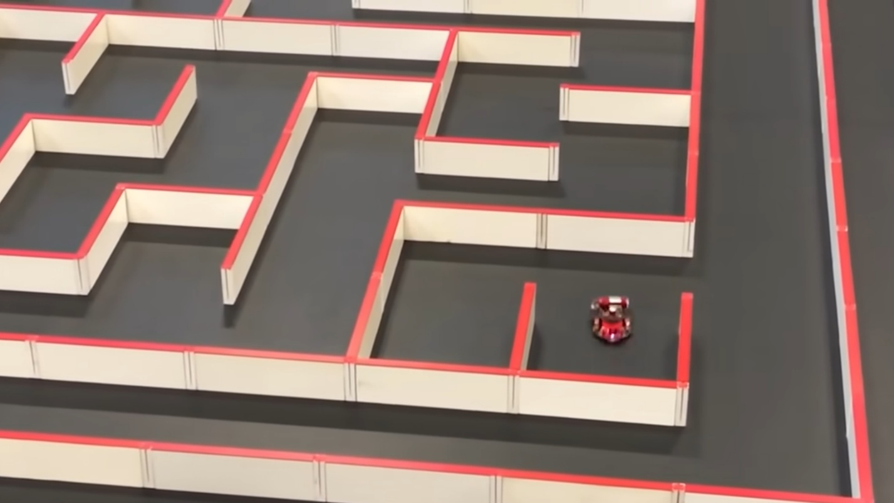

Why Build a Maze Solving Robot?
Building a maze solving robot teaches you some of the most important skills in robotics and embedded systems engineering:
- Sensor integration — reading real-world data from hardware sensors
- Decision making algorithms — making the robot think logically
- Motor control — translating software decisions into physical movement
- Power management — keeping all components running efficiently
- Embedded C programming — writing efficient low-level code for microcontrollers

💡 Note: This robot is built for Robofest Sri Lanka, a robotics competition that tests autonomous maze navigation skills.

How Does a Maze Solving Robot Work?
The robot follows a continuous loop of three steps:

The Sense → Think → Act Loop
1. SENSE — Sensors measure distances to walls on all sides
2. THINK — Microcontroller runs the algorithm to decide the next move
3. ACT — Motors execute the decision (move forward, turn left, turn right)

This loop runs hundreds of times per second, making the robot appear to move smoothly and intelligently.

Maze Solving Algorithms
An algorithm is a set of rules the robot follows to decide which way to go. Different algorithms have different strengths. We compared three common algorithms before choosing one for this robot.

Algorithm Comparison

Algorithm | Key Characteristics
Wall Follower (Left/Right Hand Rule) | Simple. Just follows one wall. Fast to implement but fails in complex mazes with disconnected walls.
Tremaux Algorithm | Marks paths already visited. More reliable than wall follower but slow and needs memory.
Flood Fill Algorithm | Treats the maze as a grid. Calculates the shortest path to the exit. Works for all maze types. Industry standard for competitions.

Chosen Algorithm: Flood Fill
We chose the Flood Fill algorithm because it finds the shortest path reliably in any maze, which is critical for a competition robot.

How Flood Fill Works
Imagine the maze as a grid of cells. The exit cell is given a value of 0. Every cell next to it gets a value of 1. Every cell next to those gets a value of 2, and so on. This creates a flood of numbers spreading out from the exit, like water flooding a room.

Flood Fill in Simple Steps
Step 1: Set the exit cell value = 0
Step 2: Every open neighbor cell gets value = current cell + 1
Step 3: Repeat until all reachable cells have values
Step 4: Robot always moves to the neighboring cell with the LOWEST value
Step 5: When robot discovers a new wall, recalculate the flood from scratch
Step 6: Robot reaches exit by always following the downhill numbers

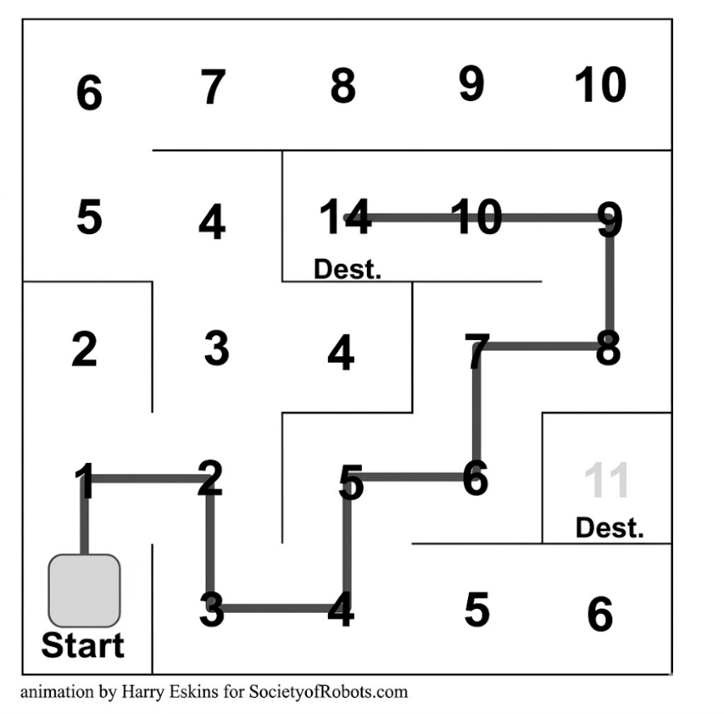
The robot does two runs:
Run 1 (Exploration/ Test Run): Robot explores the whole maze, building a wall map in its memory

Run 2 (Fast Run): Robot uses the flood fill result to race through the shortest path



State Machine Design
The robot uses a state machine to organise its behaviour. A state machine means the robot is always in one defined state, and specific events cause it to switch to another state.

Robot States
IDLE → Waiting to start, all sensors initialised
EXPLORING → Moving through maze, mapping walls, updating flood fill
TURNING_LEFT → Executing a left turn (uses gyroscope for accuracy)
TURNING_RIGHT→ Executing a right turn
MOVING_FWD → Moving straight forward one cell length
FAST_RUN → Second run using the shortest path found
FINISHED → Reached the exit, stop motors

Component Selection
Every component was chosen by comparing similar options across four criteria: robot size, power efficiency, resource usage, and ease of building. This chapter explains each decision.

Microcontroller — STM32F411CEU6 (Black Pill)
The microcontroller is the brain of the robot. It reads sensor data, runs the flood fill algorithm, and controls the motors.

Option | Comparison
Arduino Uno (ATmega328P) | Simple to learn. But only 32KB flash, 2KB RAM, no FPU. Too slow for flood fill + 5 sensors at once.
ESP32 | Has WiFi/Bluetooth and dual core. But complex for bare metal, higher power draw, and larger board size.
STM32F411CEU6 ✅ CHOSEN | 100 MHz Cortex-M4 with hardware FPU. 512KB flash, 128KB RAM. Compact Black Pill board. Perfect balance of power and size.

Why STM32F411CEU6 wins:
- Hardware FPU (Floating Point Unit) — does maths like sin/cos for gyroscope calculations in hardware, not slow software
- 128KB RAM — enough to store the full maze map in memory
- 96MHz — fast enough to run all sensors and flood fill without delay
- Small Black Pill board — fits in a compact robot chassis
- Multiple I2C buses — needed to talk to 5 VL53L0X sensors simultaneously

We use WeAct Studio STM32F411CEU6 :
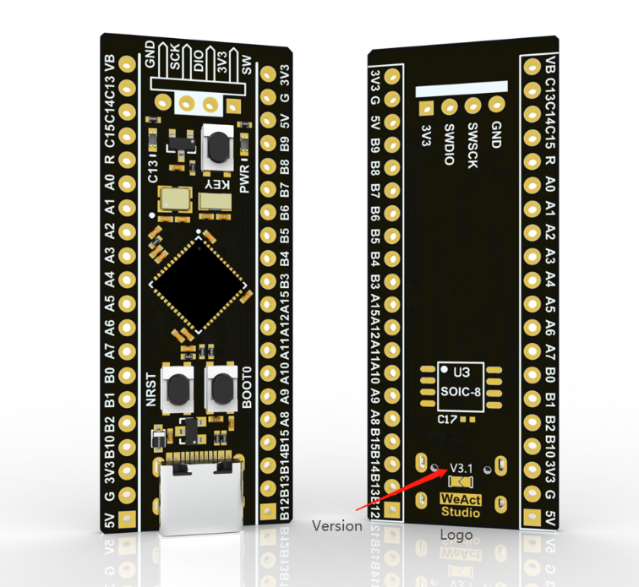

Distance Sensors — VL53L0X (Time of Flight)
The robot needs to detect walls on all sides. We use 5 VL53L0X Time-of-Flight sensors pointing in 5 directions: front, front-left, front-right, left, and right.

Option | Comparison
Ultrasonic (HC-SR04) | Cheap. But slow (needs 60ms per reading), wide beam angle causes false readings near corners.
Infrared (Sharp GP2Y) | Fast but only works at short range, affected by surface colour and sunlight.
VL53L0X ToF ✅ CHOSEN | Laser-based. Works up to 2m. Fast (up to 50Hz). Immune to surface colour. Small and accurate.
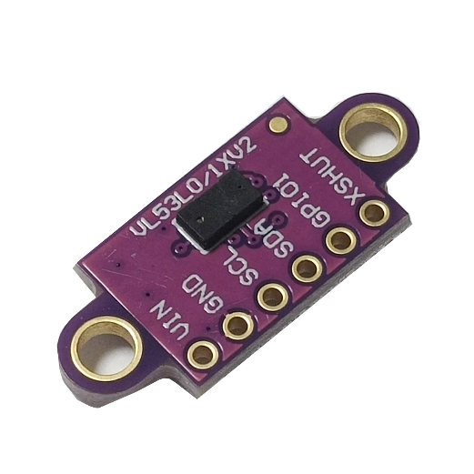
💡 Note: All 5 VL53L0X sensors share the same I2C bus. Since they all start with the same I2C address (0x29), we use 5 XSHUT pins (PB6 to PB10) to turn them on one at a time and assign each a unique address.

IMU — BNO055
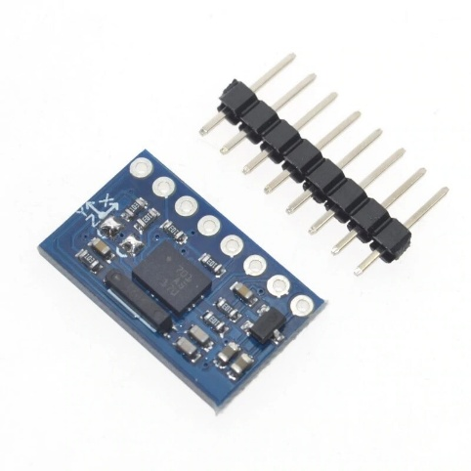
The IMU (Inertial Measurement Unit) gives the robot its sense of direction. It measures rotation so the robot knows exactly how much it has turned.

Option | Comparison
MPU-6050 | Raw gyroscope + accelerometer. Needs manual sensor fusion in software. More code, more CPU load.
BNO055 ✅ CHOSEN | Has built-in sensor fusion processor on the chip itself. Outputs ready-to-use heading angles directly. Less CPU work.

The BNO055 is used for accurate 90-degree turns. When the flood fill algorithm says 'turn left', the STM32 tells the motors to turn and watches the BNO055 until it reads exactly 90 degrees — then stops.

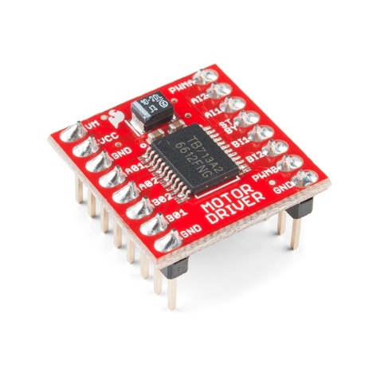
Motor Driver — TB6612FNG
Option | Comparison
L298N | Old design. High heat generation. Loses 2V due to internal drop. Inefficient for small robots.
L293D | Older than L298N. Even higher losses. Not suitable.
TB6612FNG ✅ CHOSEN | Modern MOSFET design. Very low voltage drop (0.6V). 1.2A per channel. Small board. Efficient.

Motors — N20 DC Gear Motor with Encoder
N20 motors are small, powerful, and widely used in competition maze robots. Their tiny size is ideal for keeping the robot compact enough to fit within maze cell dimensions.
- Rated voltage: 6V
- Speed: approximately 300 RPM at 6V (suitable for maze navigation)
- Current: 150mA rated, 400mA stall
- Armature resistance Ra = 8 ohm
💡 Note: Motor speed is controlled by PWM duty cycle from the STM32. Setting PWM to 81% gives the motors an effective 6V from the 7.4V battery rail.
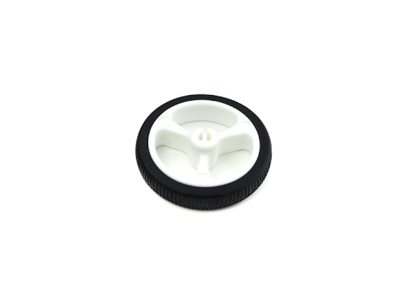

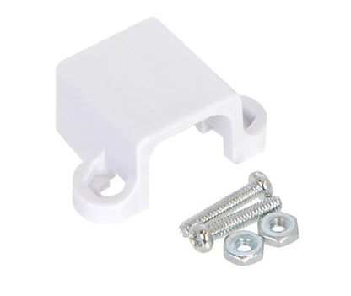
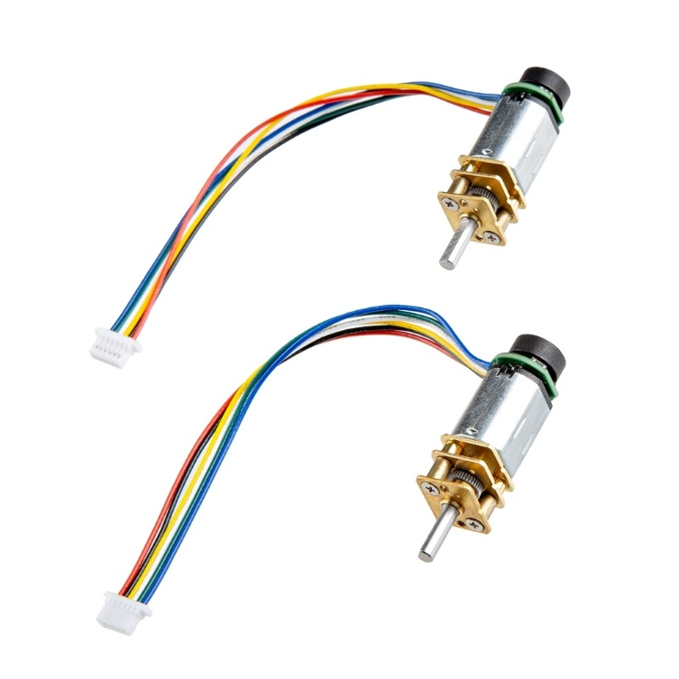

Power Components
Component | Choice and Reason
Battery | 2S LiPo (2 x 3.7V = 7.4V, 800mAh). Small, light, rechargeable, enough energy for competition.
BMS | 2S 20A HW-391. Protects battery from overcharge (4.2V/cell) and over-discharge (3.0V/cell).
Buck Converters | 2x MP1584. Efficient switching regulator (90% efficiency). Steps 7.4V down to 5V and 3.3V.
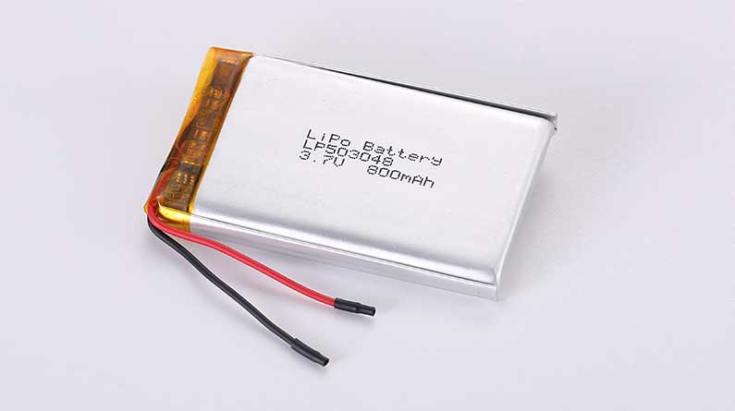
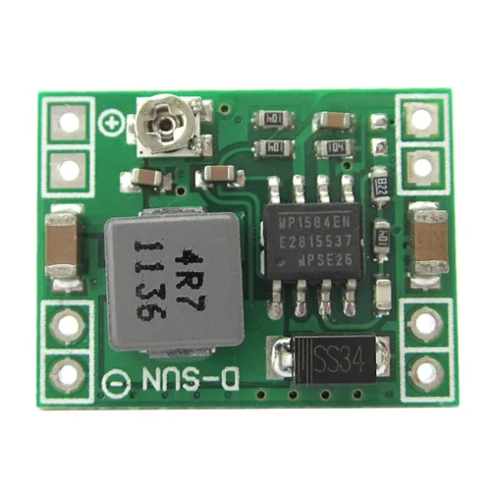
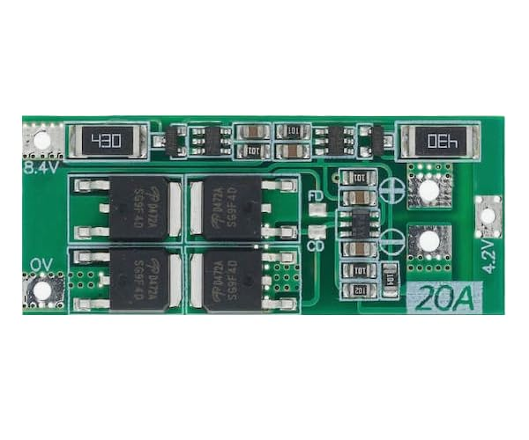

Programming Approach

Programming Language — C with HAL (Arduino-Style)
We compared three programming options for the STM32:

Option | Comparison
Arduino (C++) | Easy to start. But hides hardware details, slower execution, limited control over timing and peripherals.
MicroPython | Very beginner friendly. But Python is interpreted, much slower than compiled C. Cannot handle real-time sensor loops reliably.
C with HAL — Arduino-Style ✔️ CHOSEN | HAL library used for hardware control, but code is written in a simple, familiar Arduino-like style (setup() / loop() pattern). Easier to learn than bare metal, still fast and reliable. Compiled C with full HAL peripheral support.

Why C with HAL (Arduino-Style):

- Speed — compiled C runs directly on the CPU with no interpreter overhead
- Familiar structure — setup() initialize hardware once, loop() runs the sense–think–act cycle continuously
- HAL safety — STM32 HAL (Hardware Abstraction Layer) provides tested, reliable functions for I2C, UART, PWM, ADC, and GPIO
- Easier than bare metal — no need to manually configure every register; HAL handles the low-level details
- Real-time capable — precise timing for PWM, I2C, and interrupt handling is still possible through HAL

Development Environment — PlatformIO with VS Code
We use PlatformIO inside VS Code as our development environment instead of STM32CubeIDE.

Option | Comparison
STM32CubeIDE | Official ST tool. Complex setup, heavy IDE, difficult to configure HAL libraries from scratch. Harder for beginners.
PlatformIO + VS Code ✔️ CHOSEN | Lightweight, fast, and beginner-friendly. Automatically downloads STM32 HAL framework, manages dependencies, and integrates ST-Link flashing. Works inside familiar VS Code editor.

Why PlatformIO + VS Code:

- Simple setup — one extension install in VS Code; PlatformIO auto-downloads the STM32 HAL framework
- No complex project configuration — platformio.ini file defines the board, framework, and upload method in a few lines
- Integrated ST-Link flashing — upload code to the Black Pill directly from VS Code with one click
- Built-in serial monitor — view debug output from UART without any extra tools
- Library manager — easy to add and manage libraries like VL53L0X API and BNO055 driver

platformio.ini — Example Configuration
[env:blackpill_f411ce]
platform = ststm32
board = blackpill_f411ce
framework = arduino
upload_protocol = stlink
monitor_speed = 115200

Note: The ‘arduino’ framework in PlatformIO for STM32 uses the STM32duino core, which wraps STM32 HAL. This gives us the familiar setup()/loop() structure while still having full access to HAL functions like HAL_I2C_Master_Transmit(), __HAL_TIM_SET_COMPARE(), and HAL_ADC_GetValue().

Programming Style — State Machine
Instead of writing one big loop with many if-else conditions, we use a state machine. This makes the code organized, easy to debug, and reliable.

State Machine Benefits
Clean code — each state has its own small function
Easy debugging — you always know exactly which state the robot is in
No blocking code — robot never gets stuck waiting for one thing
Safe — unexpected sensor readings cannot cause the robot to enter an undefined state

Libraries Used

Library | Purpose
STM32duino HAL (via PlatformIO) | Controls all STM32 peripherals: I2C, PWM timers, ADC, UART, GPIO. Provided via PlatformIO arduino framework for STM32.
Arduino Core (STM32duino) | Provides setup()/loop() structure, Serial, Wire (I2C), and other familiar Arduino APIs on top of STM32 HAL.
VL53L0X API (ST) | Official ST library for the Time-of-Flight sensors. Handles all sensor initialization and range reading.
BNO055 Driver | Simple I2C driver to read euler angles (heading, pitch, roll) from the BNO055 IMU.

Why Not FreeRTOS?
FreeRTOS is a real-time operating system for microcontrollers. We evaluated it but decided against it for this robot for these reasons:

- Extra complexity — FreeRTOS adds task scheduling, semaphores, and queues which add code complexity without benefit here
- Small robot — the sensor-think-act loop is simple enough to manage without an OS
- Stack overhead — FreeRTOS uses RAM for each task stack, leaving less for the maze map

Learning Path — From Zero to Robot
This chapter outlines the recommended order to learn the skills needed to build and program this robot. Follow these steps in order to avoid confusion.

Phase 1: STM32 Basics (Week 1-2)
- Set up PlatformIO on your computer
- Learn GPIO — blink an LED on the Black Pill board
- Learn UART — send text from STM32 to your PC serial monitor
- Learn I2C — scan for connected devices and print their addresses
- Learn PWM timers — control LED brightness, then motor speed

Phase 2: Sensors and Actuators (Week 3-4)
- Read one VL53L0X sensor via I2C — print distance to serial monitor
- Control one N20 motor with TB6612FNG — forward, reverse, speed control
- Add all 5 VL53L0X sensors using XSHUT address assignment
- Read BNO055 heading angle — rotate robot and watch angle change
- Combine: read sensors and adjust motor speed based on wall distance

Phase 3: Navigation Logic (Week 5-6)
- Implement basic wall follower algorithm — robot follows right wall
- Implement cell-based movement — robot moves exactly one cell at a time using gyroscope for turns
- Implement flood fill algorithm on paper first — understand the numbers
- Code flood fill in C — test on a simulated maze array first
- Connect flood fill to actual robot movement

Phase 4: Integration and Testing (Week 7-8)
- Build full robot hardware — solder all components on PCB or breadboard
- Test power system — verify 3.3V and 5V rails with multimeter
- Run robot in a small 3x3 test maze
- Tune PID (if used) for straight line movement
- Full competition maze test and timing

Phase 5: Build Robot (Week 9+)
- Design and cut chassis (laser cut or 3D print)
- Final PCB or printed board wiring
- Competition preparation and optimization

Robot Build Steps
This chapter gives the physical build order. Always test each stage before moving to the next. Never skip a step.

Step 1: Power System First
Always build and verify the power system before connecting any other components. A wrong voltage will destroy your sensors instantly.
- Assemble 2S LiPo battery pack from 2 cells
- Connect BMS — verify B+, B1, B- and P+, P- connections
- Connect and adjust MP1584 #1 — verify output = 5.0V with multimeter
- Connect and adjust MP1584 #2 — verify output = 3.3V with multimeter

⚠️ Important: Do not connect the STM32 or any sensor until you have verified both 3.3V and 5V rails with a multimeter.

Step 2: STM32 Minimum Working Setup
- Connect STM32 VDD to 3.3V rail
- Connect all GND pins to common ground
- Connect ST-Link V2: SWDIO, SWCLK, GND, 3.3V
- Flash a simple LED blink program — confirm board works

Step 3: Motor Driver
- Connect TB6612FNG: VM to 7.4V (VMOT), VCC to 3.3V, GND to common ground
- Connect AIN1, AIN2, PWMA to STM32 GPIO and PWM pins
- Connect BIN1, BIN2, PWMB to STM32 GPIO and PWM pins
- Connect STBY pin to 3.3V (or a GPIO pin to enable/disable)
- Connect AO1, AO2 to Motor A. Connect BO1, BO2 to Motor B
- Test: run simple PWM code, confirm both motors spin

Step 4: VL53L0X Sensors
- Connect all 5 VL53L0X sensors: VDD to 3.3V, GND to ground, SDA to PB9, SCL to PB8
- Connect XSHUT pins: sensor 1 to PB6, sensor 2 to PB7, sensor 3 to PB8... etc
- Run I2C address assignment code — assign each sensor a unique address
- Verify all 5 sensors read distances correctly

Step 5: BNO055 IMU
- Connect BNO055: VDD to 3.3V, GND to ground, SDA and SCL to I2C bus
- Read euler angles — rotate board by hand and confirm heading changes

Step 6: Voltage Monitor
- Build voltage divider: R3=18kohm (top), R4=10kohm (bottom) between VBAT and GND
- Connect junction point to STM32 PA0 (ADC input)
- Add 100nF capacitor across R4 for noise filtering
- Read ADC value in firmware and convert back to battery voltage

Power Distribution System
This chapter documents the complete power system design including all calculations. Every formula is shown so the numbers can be verified or updated if components change.

Battery Pack

Battery Specifications
Cell type: Li-Po (Lithium Polymer)
Cell nominal voltage: 3.7V per cell
Cell full charge: 4.2V per cell
Cell cutoff voltage: 3.0V per cell
Configuration: 2S (2 cells in series)
Pack nominal voltage: 3.7V x 2 = 7.4V
Pack full charge: 4.2V x 2 = 8.4V
Pack cutoff voltage: 3.0V x 2 = 6.0V
Capacity: 800mAh
Pack energy: 7.4V x 0.8Ah = 5.92Wh
Formula used: V_pack = V_cell x n_s where n_s = number of cells in series

Battery Management System (BMS)
The BMS HW-391 protects both cells from damage by monitoring and controlling charge and discharge.
Protection Feature | Threshold
Over-charge protection | Cuts off at 4.2V per cell (8.4V total)
Over-discharge protection | Cuts off at 3.0V per cell (6.0V total)
Over-current protection | Trips at 20A continuous
Short circuit protection | Immediate cutoff
Cell balancing | Passive balance resistors equalise cell voltages during charging

Power Rails
Rail | Voltage | Source | Consumers
VMOT | 7.4V (nominal) | Direct from BMS | TB6612FNG VM pin, N20 motors (via PWM)
5V Rail | 5.0V | MP1584 Buck #1 | Power LED indicator
3.3V Rail | 3.3V | MP1584 Buck #2 | STM32F411, VL53L0X x5, BNO055, TB6612 VCC

Buck Converter Calculations

MP1584 Output Voltage Formula
The MP1584 uses a resistor divider on its feedback pin to set the output voltage. The internal feedback reference voltage is 0.8V.

MP1584 Voltage Setting Formula
Vout = Vref x (1 + R1/R2)

Where:
Vref = 0.8V (internal reference, fixed)
R2 = 10 kohm (lower resistor, standard value)
R1 = R2 x ((Vout / Vref) - 1) (upper resistor, calculated)

Buck Converter #1 — 7.4V to 5V
R1 = 10 x ((5.0 / 0.8) - 1) = 10 x (6.25 - 1) = 10 x 5.25 = 52.5 kohm
Use standard value: R1 = 51 kohm or 56 kohm (nearest E24 value)
Check: Vout = 0.8 x (1 + 51/10) = 0.8 x 6.1 = 4.88V (close enough, adjust trimmer if available)

Buck Converter #2 — 7.4V to 3.3V
R1 = 10 x ((3.3 / 0.8) - 1) = 10 x (4.125 - 1) = 10 x 3.125 = 31.25 kohm
Use standard value: R1 = 30 kohm
Check: Vout = 0.8 x (1 + 30/10) = 0.8 x 4.0 = 3.2V (within 3%, acceptable)

Motor Speed Control — PWM Instead of Extra Buck
The N20 motors are rated at 6V. Instead of adding a third MP1584 buck converter set to 6V, we use PWM (Pulse Width Modulation) from the STM32 to control the effective voltage seen by the motors through the TB6612FNG.

PWM Effective Voltage Formula
V_motor_effective = V_supply x (PWM_duty_cycle / 100)

V_supply = 7.4V (VMOT rail)
Target: 6V for N20 rated operation

PWM required = (6.0 / 7.4) x 100 = 81%

So: set base PWM to 81% for rated motor speed
Increase PWM above 81% for faster speed (short bursts only)
Decrease PWM below 81% for slower speed (turns, tight sections)

This approach gives us full variable speed control and the 6V equivalent for free, without adding any extra hardware.

LED Indicator Calculation
A green LED on the 5V rail shows the power system is working.

LED Resistor Calculation (Ohm's Law: V = I x R)
R_led = (V_supply - V_forward) / I_desired

V_supply = 5.0V (5V rail)
V_forward = 2.1V (green LED typical forward voltage)
I_desired = 10mA = 0.010A (safe operating current)

R_led = (5.0 - 2.1) / 0.010 = 2.9 / 0.010 = 290 ohm

Use standard value: 330 ohm

Power in resistor: P = I^2 x R = (0.010)^2 x 330 = 0.033W = 33mW
Safe for 1/8W (125mW) resistor.

Battery Voltage Monitor
The STM32 ADC input maximum voltage is 3.3V, but the battery can reach 8.4V. We use a voltage divider to scale the battery voltage down to a safe level for the ADC.

Voltage Divider Calculation
Vout = Vbat x R4 / (R3 + R4)

Target: Vout = 3.0V when Vbat = 8.4V (full charge, with safety margin)
R4 = 10 kohm (standard)

R3 = R4 x ((Vbat / Vout) - 1)
R3 = 10 x ((8.4 / 3.0) - 1) = 10 x (2.8 - 1) = 10 x 1.8 = 18 kohm

Verify at nominal (7.4V): Vout = 7.4 x 10/(18+10) = 7.4 x 0.357 = 2.64V OK
Verify at cutoff (6.0V): Vout = 6.0 x 0.357 = 2.14V (low battery threshold)

Firmware formula to recover Vbat:
Vbat = (ADC_raw / 4095) x 3.3 x (28/10) = ADC_raw x 0.000226V

Note: Add a 100nF ceramic capacitor across R4 (between ADC pin and GND) to filter electrical noise from the motors.

System Power Budget and Runtime

Component | Current Draw | Rail
STM32F411 (active at 96MHz) | 35mA | 3.3V
VL53L0X x5 (5 sensors) | 5 x 19mA = 95mA | 3.3V
BNO055 IMU | 3.6mA | 3.3V
TB6612FNG logic | ~5mA | 3.3V
LED indicator | 10mA | 5V
N20 motors x2 (rated load, 60% duty) | 2 x 150mA x 0.6 = 180mA | 7.4V (VMOT)
Buck converter losses (~10%) | ~30mA | 7.4V
TOTAL from battery (typical) | ~360mA | 7.4V

Runtime Calculation
t (hours) = Battery Capacity (mAh) / Total Current (mA)

t = 800mAh / 360mA = 2.22 hours (ideal)

With 15% safety margin for peaks and aging:
t = 800 / (360 x 1.15) = 800 / 414 = 1.93 hours

Practical runtime: approximately 1.5 to 2 hours
Competition runs are typically under 10 minutes, so runtime is not a concern.

STM32F411 Pin Assignment
This table shows how every component connects to the STM32F411 Black Pill board.

STM32 Pin | Connected To | Function
PB8 | VL53L0X x5, BNO055 — SCL | I2C1 Clock
PB9 | VL53L0X x5, BNO055 — SDA | I2C1 Data
PB6 | VL53L0X #1 — XSHUT | Sensor 1 enable
PB7 | VL53L0X #2 — XSHUT | Sensor 2 enable
PB10 | VL53L0X #3 — XSHUT | Sensor 3 enable
PA8 | VL53L0X #4 — XSHUT | Sensor 4 enable
PA9 | VL53L0X #5 — XSHUT | Sensor 5 enable
PA0 | ADC — Voltage divider junction | Battery voltage monitor
PA1 | TB6612 PWMA | Motor A speed (TIM2 CH2)
PA2 | TB6612 PWMB | Motor B speed (TIM2 CH3)
PB0 | TB6612 AIN1 | Motor A direction 1
PB1 | TB6612 AIN2 | Motor A direction 2
PB2 | TB6612 BIN1 | Motor B direction 1
PB3 | TB6612 BIN2 | Motor B direction 2
PB4 | TB6612 STBY | Motor enable (HIGH = enabled)
PA10 | UART1 RX | Debug serial (optional)
PA9 | UART1 TX | Debug serial (optional)

References and Datasheets

Component | Datasheet / Reference
STM32F411CEU6 | DS9716 Rev8 — stm32f411ce datasheet — st.com
VL53L0X | DS11494 Rev3 — vl53l0x datasheet — st.com
BNO055 | BST-BNO055-DS000 — bno055 datasheet — bosch-sensortec.com
TB6612FNG | TB6612FNG datasheet — toshiba.com
MP1584 | MP1584 datasheet Rev1.0 — monolithicpower.com
2S BMS HW-391 | Generic 2S Li-Po BMS 20A module specification
Flood Fill Algorithm | Micromouse Online — micromouseonline.com

