
Sri Lanka Institute of Information Technology

Enterprise Publishing Management System

Sprint 0
Information Systems Project Management 2026

Project ID: ISE_WE_0101_22

Submitted by:

- IT24101357 – Bandara N.H.M.W.W.D.S.
- IT24100863 – Ananda U.V.D.M.A
- IT24100696 – Dissanayake L.N
- IT24101035 – Sewwandi R.P.D.D.C

Submitted to:

(Supervisor’s signature)

…………………………..

Name of the supervisor

Date of submission

Criteria | Marks allocated | Marks given
Problem Specification | 5%
Business Idea | 5%
Solution Outline | 10%
Key Benefits | 10%
Main Objectives | 5%
Sub Objectives | 5%
Project Plan | 10%
Product Vision statement | 05%
Epics | 05%
User Stories | 10%
Initial product Backlog | 05%
Definition of Done | 05%
Hardware & Software requirements | 5%
Budget | 5%
References | 5%
Formatting | 5%
Total Marks (100) | 100%

Team Members:
Student ID | Student Name | Role (Product Owner / Scrum Master / Team Member)
IT24101357 | Bandara N.H.M.W.W.D.S | Scrum Master
IT24100863 | Ananda U.V.D.M.A | Team Member
IT24100696 | Dissanayake L.N | Team Member
IT24101035 | Sewwandi R.P.D.D.C | Team Member

Contents
1. Introduction 5
1.1 Problem Specification 5
1.2 Business idea 5
1.3 Solution Outline 5
1.4 Key Benefits 6
2. Objectives 7
2.1 Main Objective 7
2.2. Sub Objectives 7
3. Stakeholder Identification 8
4. Procedure 9
5. Product Vision Statement 10
6. Epics 10
7. User Stories 12
8. Initial Product Backlog 17
9. Definition of Done (DoD) 21
10. Sprint 1 Preview 22
11. Software and Hardware Requirements 24
12. Budget 25
13. References 27
Bibliography 27
14. Appendix 28

Introduction

Problem Specification
The Book Publishing House currently operates manually with several disparate software applications including email, telephonic communication, paper documents and Microsoft Excel spreadsheets. The tools are not integrated, so information is distributed along multiple departments, which results in a lack of efficiency in publishing process management and monitoring.
Consequently, the authors are unable to monitor the status of their manuscript submissions; editorial work is still done manually; inventory and printing are a painstaking task; customer order processing is fragmented; and author royalty calculation is done manually. Besides, there is a lack of real-time reporting for timely decision making, resulting in delays, gaps in communication, and decreased operational efficiency.

1.2 Business idea
The proposed business idea is to create an Enterprise Publishing Management System (EPMS) which is a system that integrates the main business processes of the publishing house in a digital way. The system will integrate manuscript submission, editing, book production, publishing processes, customer orders, stock management, finances, and royalties under a single roof.
By streamlining and automating manual processes with a digital workflow, EPMS adds value to the business by improving efficiency and transparency. It will enable staff to work together via a single system, make relevant information easier to access for authors and customers, and give management accurate and timely operational information for decision making. This provides a scalable digital platform that will help the publishing house become more efficient, provide a better service level and business performance.

1.3 Solution Outline
The suggested solution is the Enterprise Publishing Management System (EPMS) which is a centralized web-based system that combines the major business processes of the publishing house into one platform. The system will be able to manage author, manuscript, editorial workflow, book production, publishing operations, customer order, inventory and administration, finance and royalty management. This will eliminate the need to rely on disjointed manual mechanisms, and provide role-based access to the system to authorized users to access and manage relevant information digitally.
The architecture for EPMS will be client-server design, designed with the frontend as a web application that will be created with HTML5, CSS3, JavaScript and Bootstrap. The backend will be created with Java and Spring Boot, and offer RESTful APIs for business operations. For centralized data storage, it will be MySQL and for authentication and role based access control, it will be Spring Security. The system will be designed in a modular fashion, enabling the four key business areas to be served by a single and secure system.

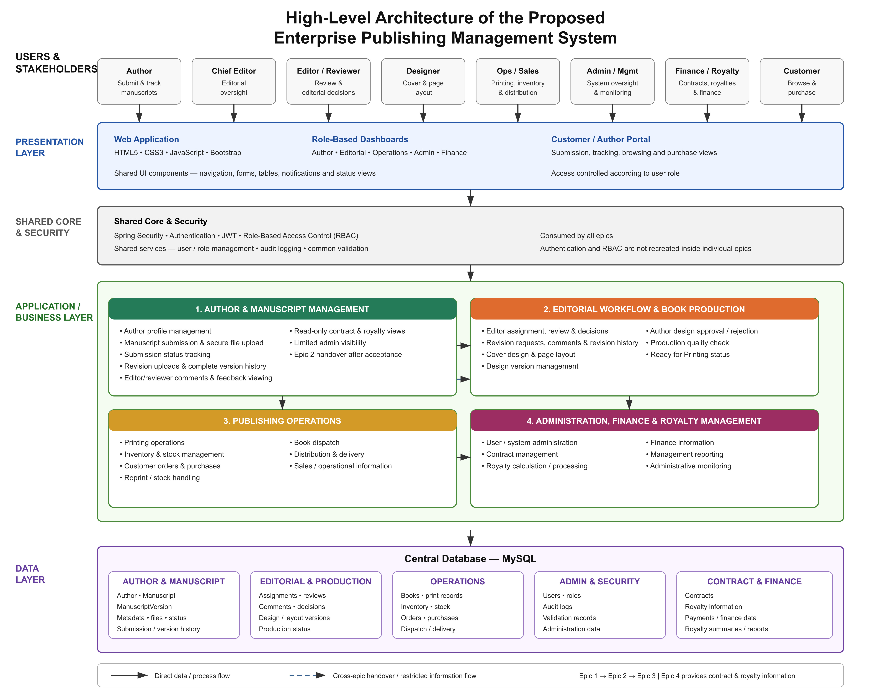

Figure 1.1 - High-Level Architecture of the Enterprise Publishing Management System

1.4 Key Benefits

- Reduced processing time: Digital processes and centralized information eliminate delays in manuscript review, production, order processing and approval.
- Reduced errors: Inventory updates, royalty calculations are automated, fewer errors due to manual data entry, and less errors due to spreadsheet calculations.
- Improved operational visibility: Manuscript, production, inventory and order statuses are tracked throughout the system by authors and staff.
- Better decision-making: All operational and financial data is centralized, allowing management to create reports and make quick and timely decisions based on data.
- Improved collaboration: Editors, proofreaders, designers, production, sales and finance team members can better work together on a shared platform.
- Improved customer and author experience: Authors can track their submissions and approvals, while customers can easily add orders and follow up related order information.
- Improved information security: Authentication and role-based access control limits access to valuable manuscripts, financial information and other business data.
- Scalability: The central system lays the foundation for expansion with more publishing, reporting and business functionality as the organization expands.

Objectives

2.1 Main Objective
To design and develop a secure, integrated Enterprise Publishing Management System (EPMS) that digitizes the publishing house’s core operations across the four identified business areas and delivers a functional Minimum Viable Product (MVP) within the planned project period.

2.2. Sub Objectives

- Author & Manuscript Management: To develop a centralized module that enables authors to register, submit manuscripts, respond to revision requests, and track the progress of their submissions digitally.
- Editorial Workflow & Book Production: To implement a structured workflow for manuscript review, proofreading, formatting, cover design, and author approval, enabling staff to manage publishing activities efficiently.
- Publishing Operations: To develop integrated functionality for printing, inventory management, customer orders, pre-orders, delivery, and bookstore distribution to improve the coordination of publishing operations.
- Administration, Finance & Royalty Management: To provide administrative dashboards, user management, reporting, financial record management, and automated royalty calculations to support secure and data-driven business decision-making.

Stakeholder Identification

Stakeholder | Type (Primary / Secondary / Tertiary) | Interest / Concern
Authors | Primary | Receiving revision feedback, reviewing final book designs, and approving or rejecting designs
Chief Editor | Primary | Editor assignment, review progress, editorial decisions, and overall workflow control.
Editors | Primary | Access to assigned manuscripts, conducting reviews, providing comments, and requesting revisions
Designers | Primary | Uploading and managing cover designs, layouts, and production versions.
Production Manager | Primary | Quality checking, production approval, and ensuring books are ready for printing.
Production Staff | Primary | Manage print jobs, schedule printing, update printing status, and record printed quantities.
Customers | Primary | Browse books, add books to cart, place orders, view order history, and track deliveries.
Sales Manager | Primary | Monitor customer/wholesale orders, approve wholesale orders, and monitor sales operations.

Procedure

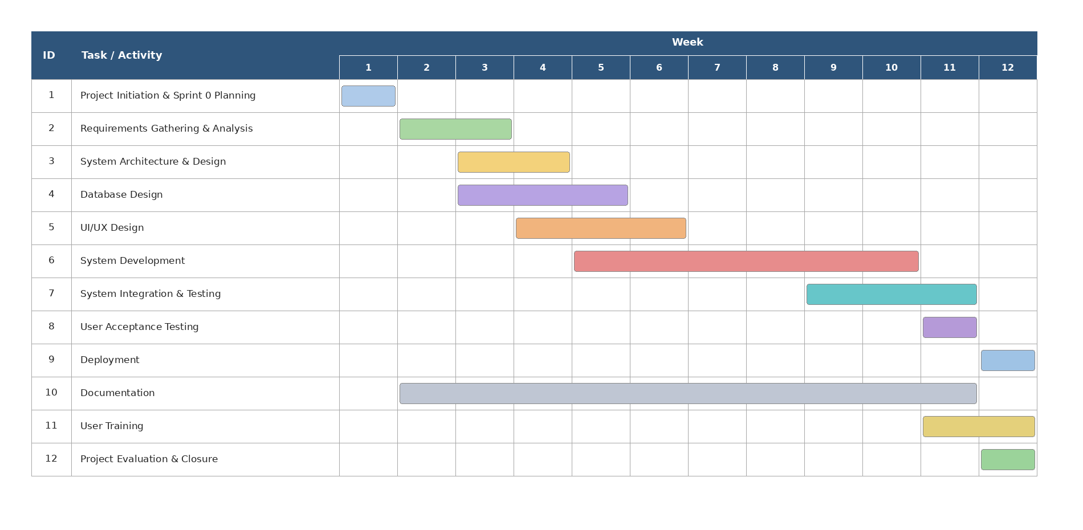Figure 4.1 - Gantt chart

Product Vision Statement

For book publishing houses that face fragmented and manual business processe,
Who need a more efficient and transparent way to manage their publishing operations,
The product Enterprise Publishing Management System (EPMS),
Provides an integrated digital environment that improves operational efficiency, collaboration, information visibility, and decision-making across the publishing lifecycle.

Epics

Epic ID | Epic Description
Epic 1 | Author & Manuscript Management — Enables authors to digitally manage their author profile and manuscripts, including manuscript submission, file upload, status tracking, revision handling, and viewing editorial outcomes, contract, and royalty information. Includes limited admin visibility into authors and submitted manuscripts.
Epic 2 | Editorial Workflow & Book Production – Manages the complete editorial and production lifecycle of accepted manuscripts, including editor assignment, manuscript review, revision management, cover and page-layout design, version management, author design approval, quality checking, and production approval before the book is transferred to printing.
Epic 3 | Publishing Operations  Manage the complete operational lifecycle of published books after they are approved for printing, including printing, inventory management, customer sales, order fulfillment, delivery, and wholesale distribution.
Epic 4 | Administration, Finance & Royalty Management  Provides Centralized administration of financial management, category management, genre management, system setting and announcements for the publishing house. Manages revenue monitoring, expense recording, invoicing and payment monitoring, and automates royalty agreement management, royalty calculation, statement generation and payment approval, based on completed sales data received from Epic 3, combined with author and contract data received from Epic 1, book and publication data received from Epic 2. Also includes executive level dashboards and business analytics on revenue, sales and author/book performance.

User Stories

Epic ID | User Story ID | User Story | Stakeholder
EPIC 1 | US1 | As an Author, I want to complete my author profile, so that the publishing house has my information before I submit manuscripts. | Author
EPIC 1 | US2 | As an Author, I want to submit my manuscript online, so that I do not have to submit it manually. | Author
EPIC 1 | US3 | As an Author, I want to upload my manuscript and supporting files securely, so that my submission is complete and safely stored. | Author
EPIC 1 | US4 | As an Author, I want to track my manuscript status, so that I know the current stage of my submission. | Author
EPIC 1 | US5 | As an Author, I want to view editor/reviewer comments on my manuscript, so that I understand what changes are required. | Author
EPIC 1 | US6 | As an Author, I want to upload a revised manuscript, so that I can respond to editorial feedback. | Author
EPIC 1 | US7 | As an Author, I want to view the version history of my manuscript, so that I can track how it has changed across submissions. | Author
EPIC 1 | US8 | As an Author, I want to view my contract and royalty information, so that I can monitor the outcome of my published manuscript. | Author
EPIC 1 | US9 | As an Admin, I want to view the list of registered authors and their profiles, so that I can monitor author records in the system. | Admin
EPIC 1 | US10 | As an Admin, I want to view submitted manuscripts and their submission details, so that I can monitor manuscript activity without accessing editorial functions. | Admin
EPIC 2 | US11 | As a Chief Editor, I want to assign accepted manuscripts to editors, so that each manuscript is reviewed by a responsible editor. | Chief Editor
EPIC 2 | US12 | As an Editor, I want to view my assigned manuscripts and their details, so that I can review the manuscripts assigned to me. | Editor
EPIC 2 | US13 | As an Editor, I want to review a manuscript and record my editorial decision, so that the manuscript can proceed through the appropriate workflow. | Editor
EPIC 2 | US14 | As an Editor, I want to request revisions and provide comments with a revision deadline, so that authors know what changes are required. | Editor
EPIC 2 | US15 | As a Chief Editor, I want to monitor review progress and revision history, so that I can ensure manuscripts are progressing through the editorial workflow. | Chief Editor
EPIC 2 | US16 | As a Designer, I want to upload and manage different versions of book cover designs, so that the design history is maintained without replacing previous versions. | Designer
EPIC 2 | US17 | As a Designer, I want to upload interior layouts and print-ready PDF files, so that the book can be prepared for production. | Designer
EPIC 2 | US18 | As an Author, I want to preview the final book design and approve or reject it with comments, so that I can provide formal approval before printing. | Author
EPIC 2 | US19 | As a Production Manager, I want to perform a production quality check, so that only books meeting production requirements proceed to printing. | Production Manager
EPIC 2 | US20 | As a Production Manager, I want to mark an approved book as Ready for Printing, so that the completed book can be formally handed over to for printing and distribution. | Production Manager
EPIC 3 | US21 | As a Production Staff member, I want to create a print job for an approved book so that the book can be sent for printing. | Production Staff
EPIC 3 | US22 | As a Production Staff member, I want to schedule and update the status of a print job so that I can track the printing progress. | Production Staff
EPIC 3 | US23 | As a Warehouse Staff member, I want to record printed books received into inventory so that available stock is accurate. | Warehouse Staff
EPIC 3 | US24 | As a Warehouse Staff member, I want to adjust and record damaged/returned stock so that inventory remains accurate. | Warehouse Staff
EPIC 3 | US25 | As a Customer, I want to browse, search, and filter published books so that I can find books I want to purchase. | Customer
EPIC 3 | US26 | As a Customer, I want to add books to my shopping cart and update quantities so that I can prepare my order. | Customer
EPIC 3 | US27 | As a Customer, I want to place an order and have stock reserved so that my selected books are secured for fulfillment. | Customer
EPIC 3 | US28 | As a Warehouse Staff member, I want to pack and dispatch confirmed customer orders so that orders can be delivered. | Warehouse Staff
EPIC 3 | US29 | As a Customer, I want to track my delivery so that I know the current status of my order. | Customer
EPIC 3 | US30 | As a Sales Manager, I want to approve or reject wholesale orders so that only authorized wholesale orders proceed to fulfillment. | Sales Manager
EPIC 4 | US31 | As an Administrator, I want to manage book categories (create, edit, archive), so that books can be organized consistently across the platform. | Administrator
EPIC 4 | US32 | As an Administrator, I want to manage genres, so that books can be classified accurately for readers and reporting. | Administrator
EPIC 4 | US33 | As an Administrator, I want to configure system settings, so that administrative parameters such as currency, tax rate, and invoice prefix reflect current business needs. | Administrator
EPIC 4 | US34 | As an Administrator, I want to create and manage announcements so that I can communicate important updates to system users. | Administrator
EPIC 4 | US35 | As a Finance Officer, I want to monitor revenue generated from completed sales, so that I can track the financial performance of the business. | Finance Officer
EPIC 4 | US36 | As a Finance Officer, I want to record and manage expenses so that the company's operating costs are accurately tracked. | Finance Officer
EPIC 4 | US37 | As a Finance Officer, I want to generate and manage invoices so that financial transactions are properly documented. | Finance Officer
EPIC 4 | US38 | As a Finance Officer, I want to record payments so that financial transactions are accurately tracked. | Finance Officer
EPIC 4 | US39 | As a Finance Officer, I want to generate financial reports (revenue, expense, profit), so that management can review the company's financial position. | Finance Officer
EPIC 4 | US40 | As a Finance Officer, I want to finalize financial reports, so that they become read-only and protected from further modification. | Finance Officer
EPIC 4 | US41 | As a Finance Officer, I want to access royalty agreements and terms for authors and books, so that I can apply the correct royalty rate during calculation. | Finance Officer
EPIC 4 | US42 | As a Finance Officer, I want to calculate royalties based on completed sales, so that authors are paid accurately for their book sales. | Finance Officer
EPIC 4 | US43 | As a Finance Officer, I want the system to prevent the same sales period from being calculated twice for the same agreement, so that duplicate royalty payments are avoided. | Finance Officer
EPIC 4 | US44 | As a Finance Officer, I want to generate royalty statements, so that authors can review how their royalty was calculated. | Finance Officer
EPIC 4 | US45 | As a Finance Officer, I want to approve royalty payments, so that only authorized payments are processed. | Finance Officer
EPIC 4 | US46 | As a Finance Officer, I want to record and process royalty payments with a unique payment reference, so that payment history remains accurate and traceable. | Finance Officer
EPIC 4 | US47 | As an Author, I want to view my own royalty statements and payment history, so that I can track my earnings from the publishing house. | Author
EPIC 4 | US48 | As an Executive, I want to view revenue and sales analytics, so that I can monitor overall business performance. | Executive
EPIC 4 | US49 | As an Executive, I want to view book and author performance analytics, so that I can identify best-selling books and top-performing authors. | Executive
EPIC 4 | US50 | As an Executive, I want to view royalty analytics, so that I can monitor royalty expenses and outstanding liabilities. | Executive

Initial Product Backlog

User Story ID | Remarks | Estimated story points | Estimated hours | Priority (High / Medium / Low)
US1 | A completed author profile is required before manuscripts can be submitted. | 3 | 6 | High
US2 | Core submission functionality forming the entry point into the publishing workflow. | 5 | 10 | High
US3 | Secure, validated file upload is essential for accepting manuscript files. | 5 | 10 | High
US4 | Lets authors monitor progress of their manuscript through the workflow. | 3 | 6 | High
US5 | Surfaces editorial feedback so authors know what to revise. | 3 | 6 | High
US6 | Supports the revision cycle by letting authors submit updated files. | 5 | 10 | High
US7 | Preserves and displays every manuscript version without overwriting. | 3 | 6 | Medium
US8 | Read-only display of contract/royalty data sourced from Epic 4. | 2 | 4 | Low
US9 | Read-only admin visibility into authors, needed for basic oversight without full editorial access. | 3 | 6 | Medium
US10 | Read-only admin visibility into manuscripts, supports monitoring without duplicating Epic 2's editorial view. | 3 | 6 | Medium
US11 | Assigning an accepted manuscript to an editor is required before the editorial review process can begin. | 3 | 6 | High
US12 | Editors need access to their assigned manuscripts before they can perform reviews. | 3 | 6 | High
US13 | Core editorial functionality allowing editors to evaluate manuscripts and record decisions. | 5 | 10 | High
US14 | Revision requests and comments are essential for handling manuscripts that require changes. | 5 | 10 | High
US15 | Enables the Chief Editor to monitor reviews, revisions, and overall editorial progress. | 3 | 6 | Medium
US16 | Allows designers to upload and maintain versioned cover designs for accepted books. | 5 | 10 | Medium
US17 | Supports interior layout and print-ready PDF preparation required before final approval. | 5 | 10 | High
US18 | Provides formal author approval or rejection of the completed book design before printing. | 5 | 10 | High
US19 | Performing a production quality check ensures that the completed book meets production requirements before it proceeds to printing. | 3 | 6 | Medium
US20 | Confirms production approval and marks the book as ready for printing. | 3 | 6 | High
US21 | Create Print Job | 5 | 8 | High
US22 | Schedule & Update Print Job | 5 | 8 | High
US23 | Receive Printed Stock | 5 | 8 | High
US24 | Inventory Adjustment, Damage & Returns | 8 | 12 | High
US25 | Book Catalog Browse, Search & Filter | 5 | 8 | High
US26 | Shopping Cart Management | 5 | 8 | High
US27 | Customer Order & Stock Reservation | 8 | 12 | High
US28 | Order Packing & Dispatch | 5 | 8 | High
US29 | Delivery Tracking | 5 | 8 | Medium
US30 | Wholesale Order Approval | 5 | 8 | Medium
US31 | Low Stock Alerts & Reprint Requests | 5 | 8 | Medium
US32 | Inventory Movement Tracking | 5 | 8 | Medium
US33 | Sales Dashboard & Operational Statistics | 8 | 12 | Medium
US34 | Master data required before books can be categorized elsewhere in the system. | 3 | 6 | High
US35 | Master data supporting book classification and reporting. | 3 | 6 | Medium
US36 | Configuration values affecting royalty/invoice calculations going forward. | 3 | 6 | Medium
US37 | Administrative content feature, independent of core financial logic. | 2 | 4 | Low
US38 | Core finance visibility built directly from Epic 3 completed sales. | 5 | 10 | High
US39 | Standard CRUD style expense recording with approval workflow. | 5 | 10 | Medium
US40 | Invoice generation tied to sales/royalty reference data | 5 | 10 | Medium
US41 | Payment record keeping supporting royalty and expense payments. | 3 | 6 | Medium
US42 | Aggregates sales, expenses, and royalty data into reports. | 5 | 10 | High
US43 | Enforces immutability of finalized financial records. | 3 | 6 | Medium
US44 | Required lookup step before any royalty calculation can run. | 5 | 10 | High
US45 | Core royalty engine; most complex logic in the epic (rate application, deductions, period validation). | 8 | 12 | High
US46 | Critical integrity control preventing duplicate royalty payments. | 5 | 8 | High
US47 | Statement generation from a finalized calculation. | 5 | 8 | High
US48 | Approval gate required before any payment can be processed. | 5 | 8 | High
US49 | Payment processing with uniqueness validation on reference number. | 5 | 8 | High
US50 | Read only author facing view, scoped to own data only. | 3 | 6 | Medium
US51 | Aggregate dashboard built on top of existing finance/royalty/sales data. | 5 | 10 | High
US52 | Analytics built from Epic 3 sales data and Epic 4 revenue records. | 5 | 8 | Medium
US53 | Performance analytics combining Epic 1/2 metadata with Epic 3 sales. | 5 | 8 | Medium
US54 | Analytics layered on top of existing royalty calculation data. | 5 | 8 | Medium

Definition of Done (DoD)

A user story or epic will be deemed Done if all the relevant acceptance criteria are met and the implemented functionality is complete, tested, reviewed and has been integrated into the EPMS.
Explain how a user story or epic will be considered Done.

- The agreed requirements and acceptance criteria have been fully implemented.
- Functionality has been successfully tested, including relevant validation, error handling etc.
- The code has been checked and added to the common project repository.
- The functionality operates properly with the appropriate system modules and database.
- Where applicable, security and role-based access has been applied.
- Defects from the user story identified have been resolved.
- Functionality has been proved and accepted by Product Owner.
- Where necessary, technical and user documentation has been updated to reflect the relevant.

A Done Epic is an Epic that has all associated user stories that are part of the agreed MVP scope met the Definition of Done and integrated functionality works correctly as a part of the overall EPMS.

Sprint 1 Preview
Epic 1 :
- US1 - As an Author, I want to complete my author profile, so that the publishing house has my information before I submit manuscripts.
- US2 - As an Author, I want to submit my manuscript online, so that I do not have to submit it manually.
- US3 - As an Author, I want to upload my manuscript and supporting files securely, so that my submission is complete and safely stored.
- US4 - As an Author, I want to track my manuscript status, so that I know the current stage of my submission.
- US5 - As an Author, I want to view editor/reviewer comments on my manuscript, so that I understand what changes are required.

Epic 2 :
- US11 - As a Chief Editor, I want to assign accepted manuscripts to editors, so that each manuscript is reviewed by a responsible editor.
- US12 - As an Editor, I want to view my assigned manuscripts and their details, so that I can review the manuscripts assigned to me.
- US13 - As an Editor, I want to review a manuscript and record my editorial decision, so that the manuscript can proceed through the appropriate workflow.
- US14 - As an Editor, I want to request revisions and provide comments with a revision deadline, so that authors know what changes are required.
- US15 - As a Chief Editor, I want to monitor review progress and revision history, so that I can ensure manuscripts are progressing through the editorial workflow.
Epic 3 :
- US21 - As a Production Staff member, I want to create a print job for an approved book so that the book can be sent for printing.
- US22 - As a Production Staff member, I want to schedule and update the status of a print job so that I can track the printing progress.
- US23 - As a Warehouse Staff member, I want to record printed books received into inventory so that available stock is accurate.
- US24 - As a Warehouse Staff member, I want to adjust and record damaged/returned stock so that inventory remains accurate.
- US25 - As a Customer, I want to browse, search, and filter published books so that I can find books I want to purchase.
Epic 4 :
1. US34 - As an Administrator, I want to manage book categories, so that books can be organized consistently.
2. US36 – As an Administrator, I want to configure system settings, so that administrative parameters reflect current business needs.
3. US38 – As a Finance Officer, I want to monitor revenue generated from completed sales, so that I can track financial performance.
4. US44 – As a Finance Officer, I want to access royalty agreements and terms, so that I can apply the correct rate during calculation.
5. US45 – As a Finance Officer, I want to calculate royalties based on completed sales, so that authors are paid accurately.

Software and Hardware Requirements
Table 11.1: Hardware Requirements
Component | Minimum Requirement
Processor | Intel Core i5/i7 or equivalent
Memory (RAM) | 16 GB
Storage | 256 GB SSD
Operating System | Windows 11 or Ubuntu 22.04 LTS
Internet Connection | Required for GitHub collaboration and package management

Table 11.2: Software Requirements
Category | Technology / Tool | Purpose
Frontend | HTML5, CSS3, JavaScript, Bootstrap | User interface development
Backend | Java, Spring Boot
  Business Logic, REST APIs and System Integration
Security | Spring Security | Authentication and authorization
Database | MySQL | Data storage and management
IDE | IntelliJ IDEA
  Application development
Database Tool | MySQL Workbench | Database administration
Version Control | Git & GitHub | Source code management and collaboration
Collaboration | GitHub Projects | Sprint planning and task management

The above hardware and software configuration provides a suitable development environment for implementing the Enterprise Publishing Management System. These technologies support efficient application development, database management, collaborative version control, system testing, and future maintenance.

Budget

The estimated project budget (Table 12.1: Estimated Project Budget) represents the approximate commercial value of developing the Enterprise Publishing Management System (EPMS). Since this is an academic project, the budget is provided for project planning purposes and does not represent the actual expenditure incurred by the development team. The development team will primarily use free, open-source, or academically available software and existing hardware resources. The estimate includes development effort, cloud hosting, domain registration, internet and communication, UI resources, testing, and contingency costs to provide a realistic project budget.

Table 12.1: Estimated Project Budget
Resource | Description | Estimated Cost (LKR)
Cloud Hosting (VPS) | 3 months staging server (AWS / Digital Ocean) | 12,000
Domain Registration | .com domain for 1 year | 4,500
Software Licenses | Development software and frameworks are free, open-source, or available through academic access | 0
Internet & Communication | Internet usage, online meetings, and project collaboration | 6,000
Development Labor | 4 Developers × 150 hours (Simulated at LKR 1,000/hour) | 600,000
UI Templates / Assets |  | 8,500
  UI design assets, icons and interface resources
Hardware |  | 0
  Existing team computers and devices used for development and testing
Third-Party APIs | No paid third-party APIs are required for the planned MVP | 0
Testing & Miscellaneous | Testing, printing, documentation, and other project-related expenses | 8,000
Subtotal |  | 639,000
Contingency Fund | Approximately 10% for unforeseen technical expenses | 63,900
Total Estimated Budget | Total Amount | 702,900

The development labor cost represents the simulated commercial value of the development effort and is not an actual payment made by the project team. The actual expenditure for the academic project is expected to be considerably lower because existing hardware and free or academically available software will be used. The contingency fund provides an allowance for unforeseen hosting, testing, or other project-related expenses.

References

Bibliography

[1] | C. Walls, Spring Boot in Action, Shelter Island, NY: Manning Publications, 2015.
[2] | K. Schwaber, The Scrum Guide: The Definitive Guide to Scrum: The Rules of the Game, Scrum.org, 2020.
[3] | Spring, "Spring Boot Reference Documentation," [Online]. Available: https://docs.spring.io/spring-boot/reference/. [Accessed 17 August 2026].
[4] | Spring, "Spring Security Reference Documentation," [Online]. Available: https://docs.spring.io/spring-security/reference/. [Accessed 17 August 2026].
[5] | International Publishers Association, "International Publishers Association," [Online]. [Accessed 2026].
[6] | Atlassian, "How to Write SMART Goals," [Online]. Available: https://www.atlassian.com/blog/teamwork/how-to-write-smart-goals. [Accessed 17 August 2026].

Appendix

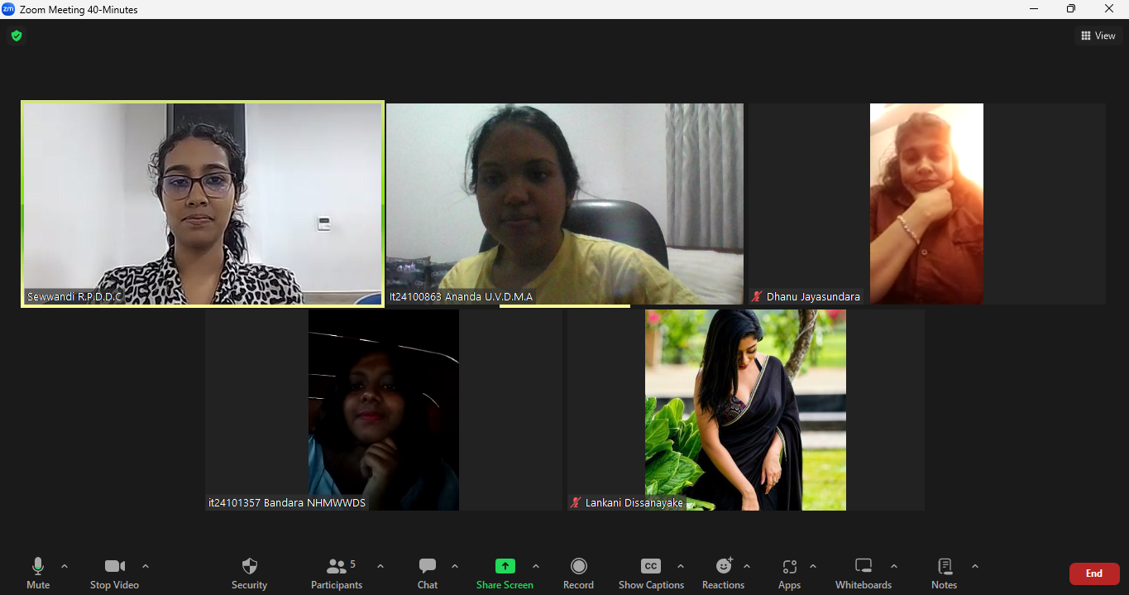Figure 14.1 - Screenshot of the Client Meeting Conducted via Zoom

