**TEAM MEMBERS NAMES**

* ALI OSMAN
* FRANK YAWSON
* DAVID ANDOH-ACQUAH

**PRODUCT NAME**

* VIRTUALBOX CONTROLLER



**TEAM PHOTOS**

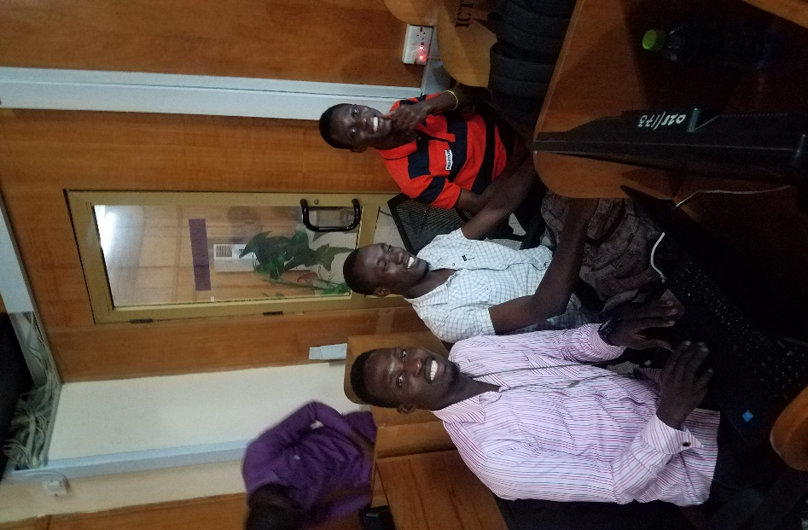 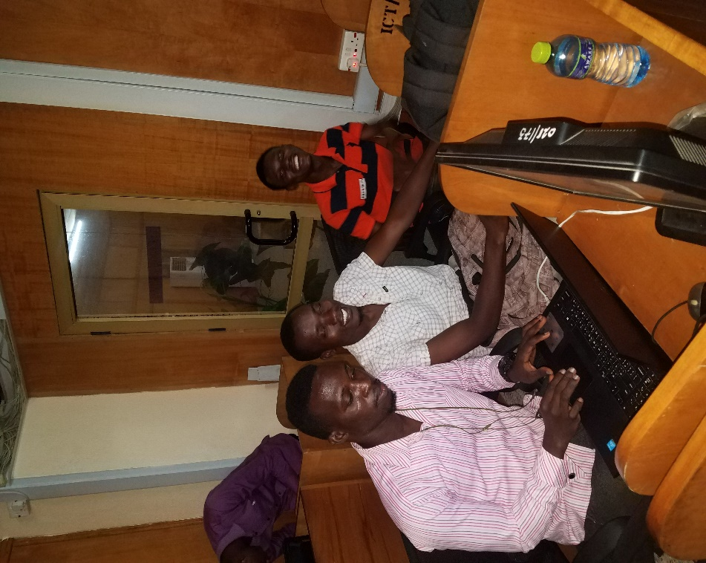

**PHOTOS OF TEAM WORKING ON PROJECT**

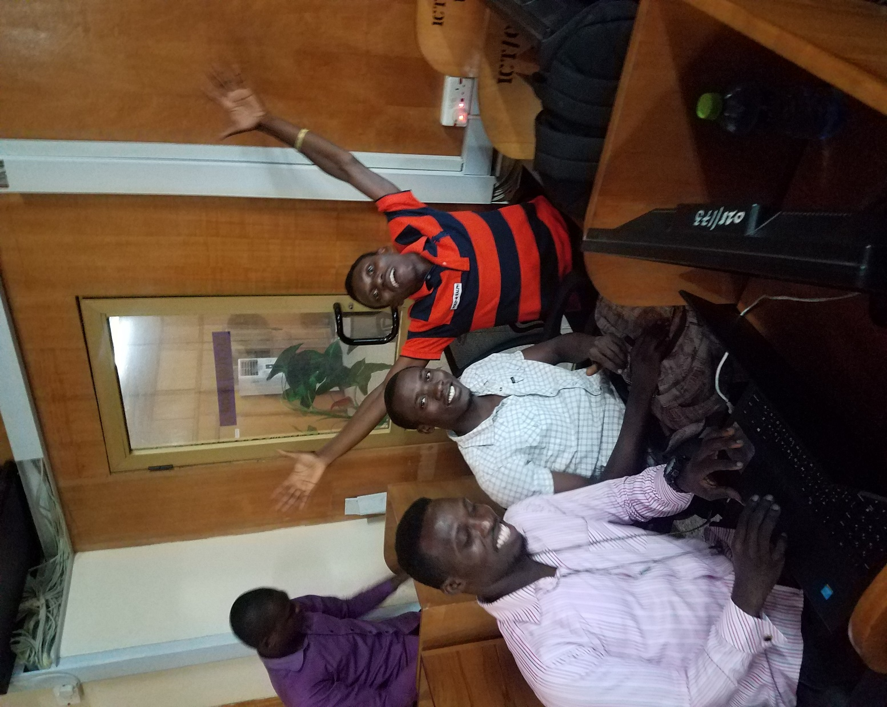

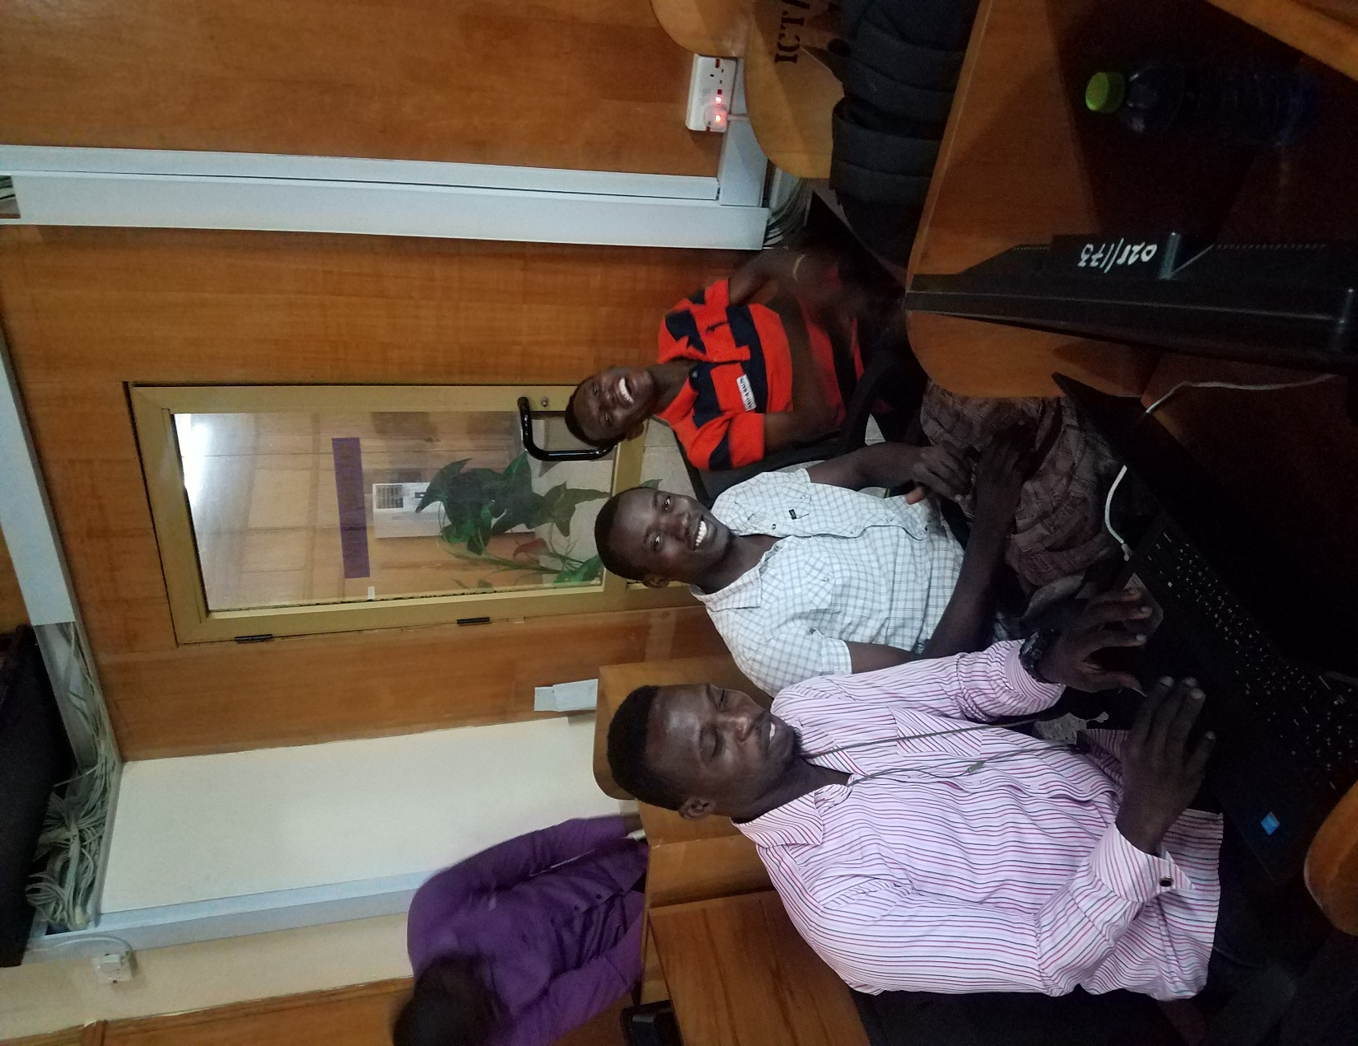

**CODE SAMPLES**

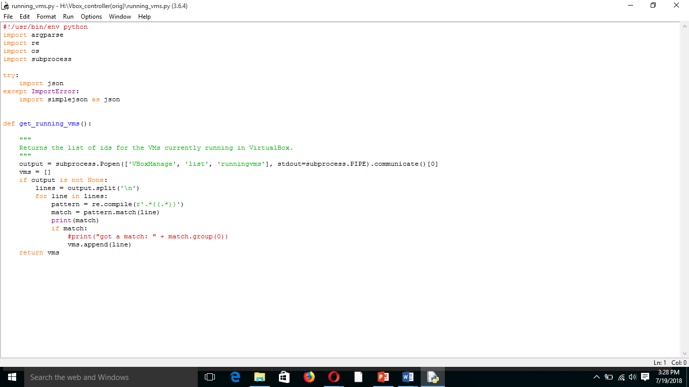

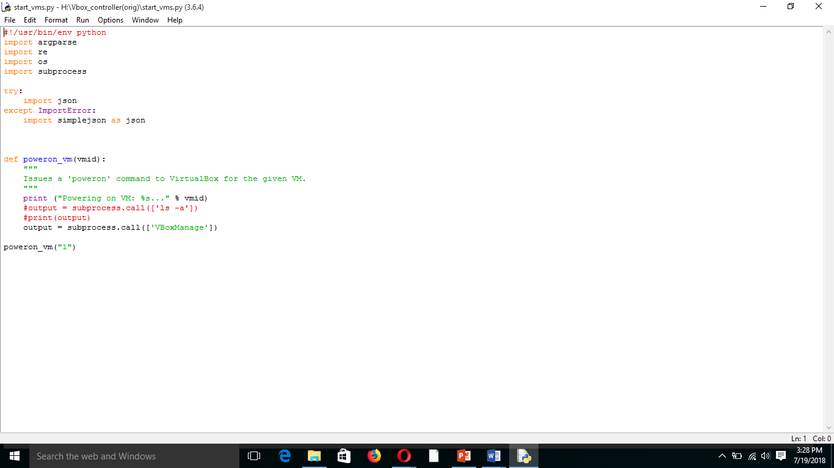

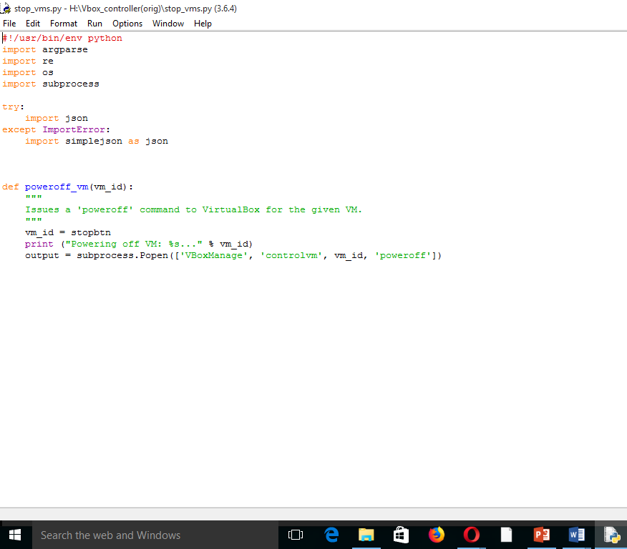

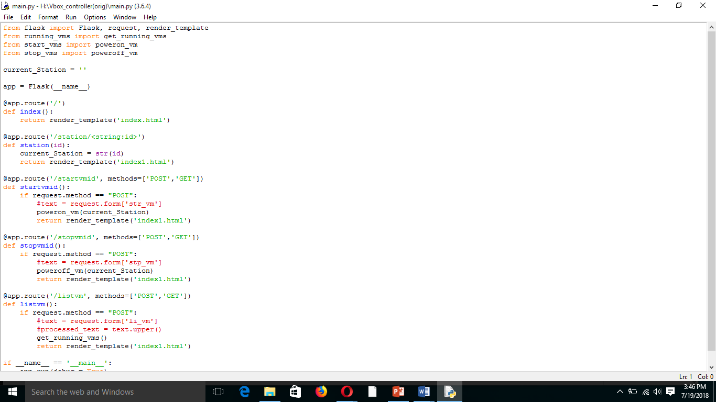

**DIAGRAMS OF HOW PRODUCT WORKS**

