Retract While Combing plugin for Cura

**License**

The RetractWhileCombing plugin is licensed under the Creative Commons - Attribution – Non Commercial - Share Alike (CC BY-NC-SA) terms

**Source**

See <http://github.com/Dim3nsioneer/Cura-Plugins/wiki/Retract-While-Combing-plugin>

**Author**

Stefan Heule (Dim3nsioneer), [dimensioneer@gmx.ch](mailto:dimensioneer@gmx.ch) V14.01+

|  |  |
| --- | --- |
| Note | **The RetractWhileCombing plugin works with these GCODE flavors:**   * RepRap GCODE (all versions),  *e.g. used by Ultimaker Original (UMO) and Original+ (UMO+)* * RepRap volumetric (V14.07+) * UltiGCode (all versions), *e.g. used by Ultimaker2 family (UM2)* |

Installation

(for Cura)

1. Close Cura if opened
2. Copy ‘RetractWhileCombing.py’ to the plugin folder of the Cura installation  
   *e.g on Windows: C:\Program Files (x86)\Cura_15.01\plugins*
3. Start Cura

Description

General purpose: Forces the printer to retract during combing moves.

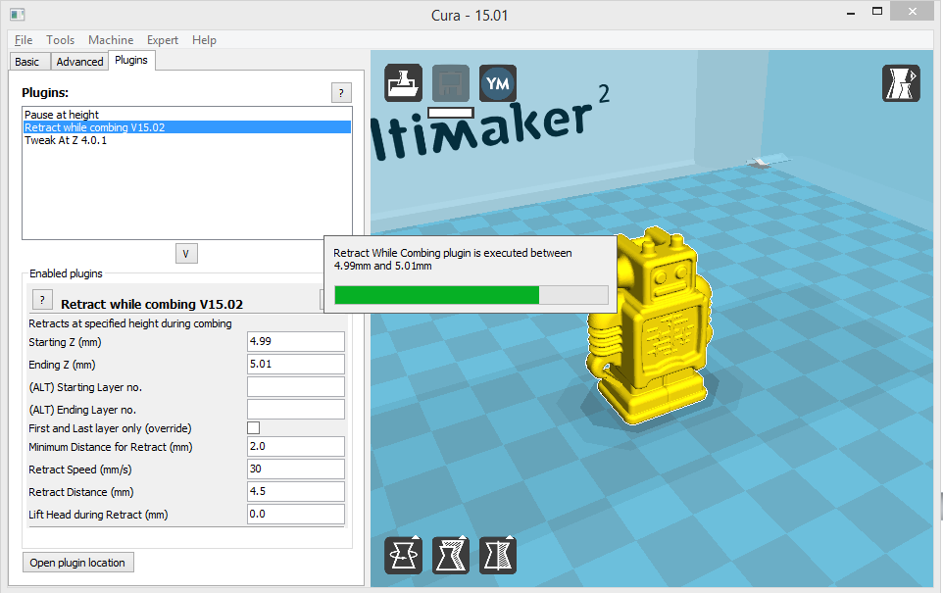

Screenshot of RetractWhileCombing 15.02

Version restrictions

The status bar feature only works on Cura versions from 14.12.

Input description (V15.02)

**Starting Z (mm)** Specifies in millimeters at which height retraction is enabled for combing moves

**Ending Z (mm)** Specifies in millimeters at which height retraction is disabled again for combing moves

**(ALT) Starting Layer no.** Alternatively, the starting layer can be specified by its number; if it is specified the starting Z from the previous input will be ignored

**(ALT) Ending Layer no.** Alternatively, the ending layer can be specified by its number; if it is specified the ending Z from the previous input will be ignored

**First and Last layer only (override)** If enabled, it overrides previous Z or layer no. settings and enables retraction on the first and on the last layer of the object but not for the layers in between them

**Minimum Distance for Retract (mm)** Distance below which no retraction will be performed for combing moves

**Retract Speed (mm/s)** Velocity of the retraction move; applies only to RepRap flavor; for flavor using G10/G11 commands for retraction no changes are made

**Retract Distance (mm)** Retraction length; applies only to RepRap flavor; for flavor using G10/G11 commands for retraction no changes are made

**Lift Head during Retract (mm)** Corresponds to the z-hop feature of Cura but applies only to combing moves altered by the plugin

Remarks / additional features

Z hops of about twice the layer height allow to get rid of remaining combing lines. Setting the travel speed as high as possible is recommended.

Feature List by version

|  |  |  |  |  |  |  |
| --- | --- | --- | --- | --- | --- | --- |
| Feature | Version | | | | | |
|  | 14.01 | 14.07 | 15.02 |  |  |  |
| Selection by Z | UMO  UM2 | UMO  UM2 | UMO  UM2 |  |  |  |
| Selection by layer no. | UMO  UM2 | UMO  UM2 | UMO  UM2 |  |  |  |
| Minimum distance for retract | UMO  UM2 | UMO  UM2 | UMO  UM2 |  |  |  |
| Lift head during combing move | UMO  UM2 | UMO  UM2 | UMO  UM2 |  |  |  |
| Support for RepRap volumetric flavor |  | UMO | UMO |  |  |  |
| First and last layer selection |  |  | UMO  UM2 |  |  |  |
| Progress bar works with |  |  | Cura 14.12+ |  |  |  |

*UMO: supported with RepRap flavor; UM2: supported with UltiGCode; () = deactivated*

Please report bugs and issue feature requests to:

[www.github.com/Dim3nsioneer/Cura-Plugins/issues](http://www.github.com/Dim3nsioneer/Cura-Plugins/issues)