**Tally Light - User Manual**

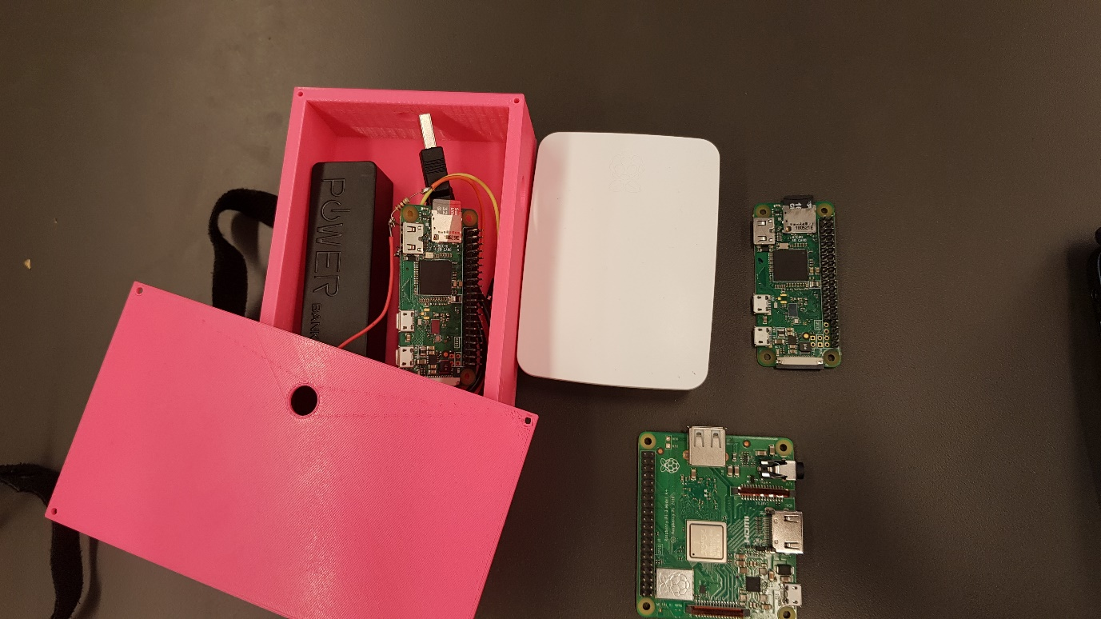

**Group members:** Caelin Waanders, Dennis Vermeer, Danja Verburg, Mark Rozing, Meriç Uçar

**Client:** RTVA

**Team Number:** RTV11

Table of contents

Introduction 2

Chapter 2. Setting up Vmix: 3

Chapter 3. Setting up the tally light case: 4

Chapter 4. Setting up the Wi-Fi access point and base station 7

Chapter 5. Troubleshooting guides 8

5.1 One of the tally lights doesn’t work (light stays off) 9

5.2 None of the tally lights light up 9

5.3 The tally lights turn on but don’t switch when the camera is switched on Vmix 9

5.4 The computer and the tally lights are connected with the base station but nothing is happening with the tally lights. 10

# 

# Introduction

This document will explain the working of the tally light system. It’s designed to be read and referenced by any user of the system. We advise you to read this document in full before initial start-up and to follow proper setup procedure to ensure the product works as intended.

The following points will be covered in this document:

* Setup for Vmix
* Setup for tally light case
* Setup of the Wi-Fi access point and base station
* Troubleshooting

The system is set up with one base station that manages the communication between itself and the computer that has Vmix open. The base station should also be located near the computer that has Vmix open. The tally lights will be attached to the cameras with velcro straps.

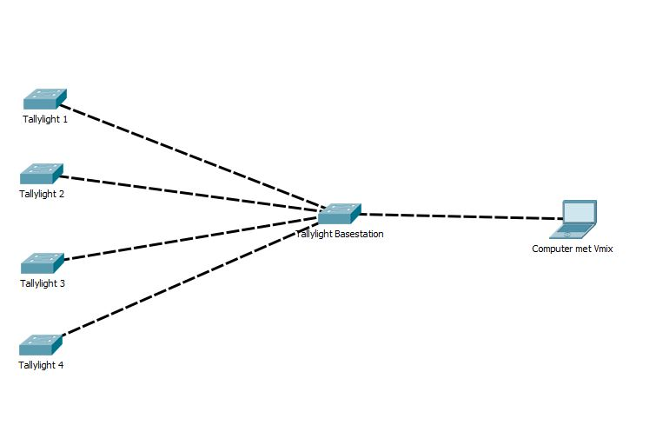

In this topology there are 4 tally lights connected to the base station. The base station will manage the lights using inputs from the computer. All devices are connected with each other through a wireless access point.

# Chapter 2. Setting up Vmix:

To connect the tally lights to Vmix you have to change the port number of the web controller in Vmix.

1. Open Vmix
2. Go to Settings in the top right corner
3. Click on Web Controller
4. Change the Port number to 8099

**Everytime** you open Vmix, you have to reassign the port number. Vmix opens the web controller on a HTTP connection and not a TCP connection. To manually adjust the port number follow the following steps: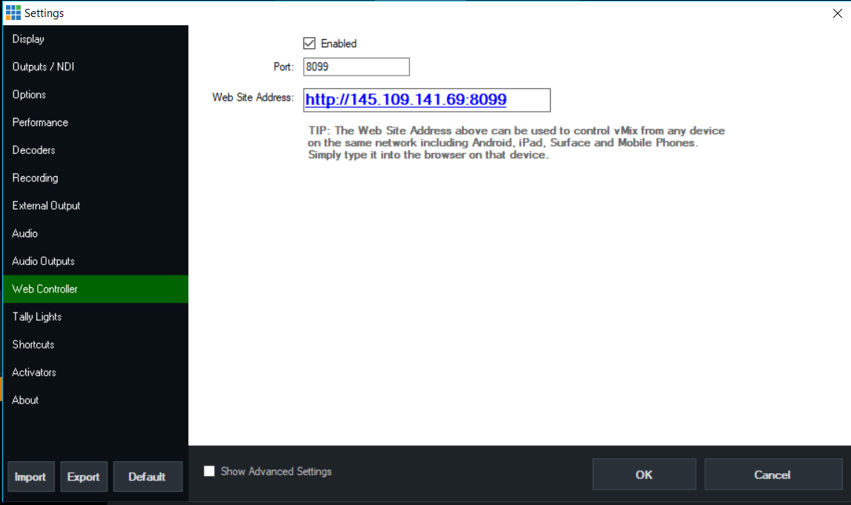

1. Go to Settings
2. Click on Web Controller
3. Change the port number to a random number, for example 8055
4. Click on OK
5. Go back to the Web Controller settings
6. Change the Port number back to 8099

# Chapter 3. Setting up the tally light case:

To store the tally light we designed a case. In this section the following things will be explained

* How to build the case
* How to attach the case to an object
* What to do when the battery runs out of charge

Building the tally light case

1. The case was designed to be modular. The process of building the case is quite simple. There are 3 parts as shown below. The 3rd object is a plate that you can attach to the tally light case so that you can mount the tally light to a camera.

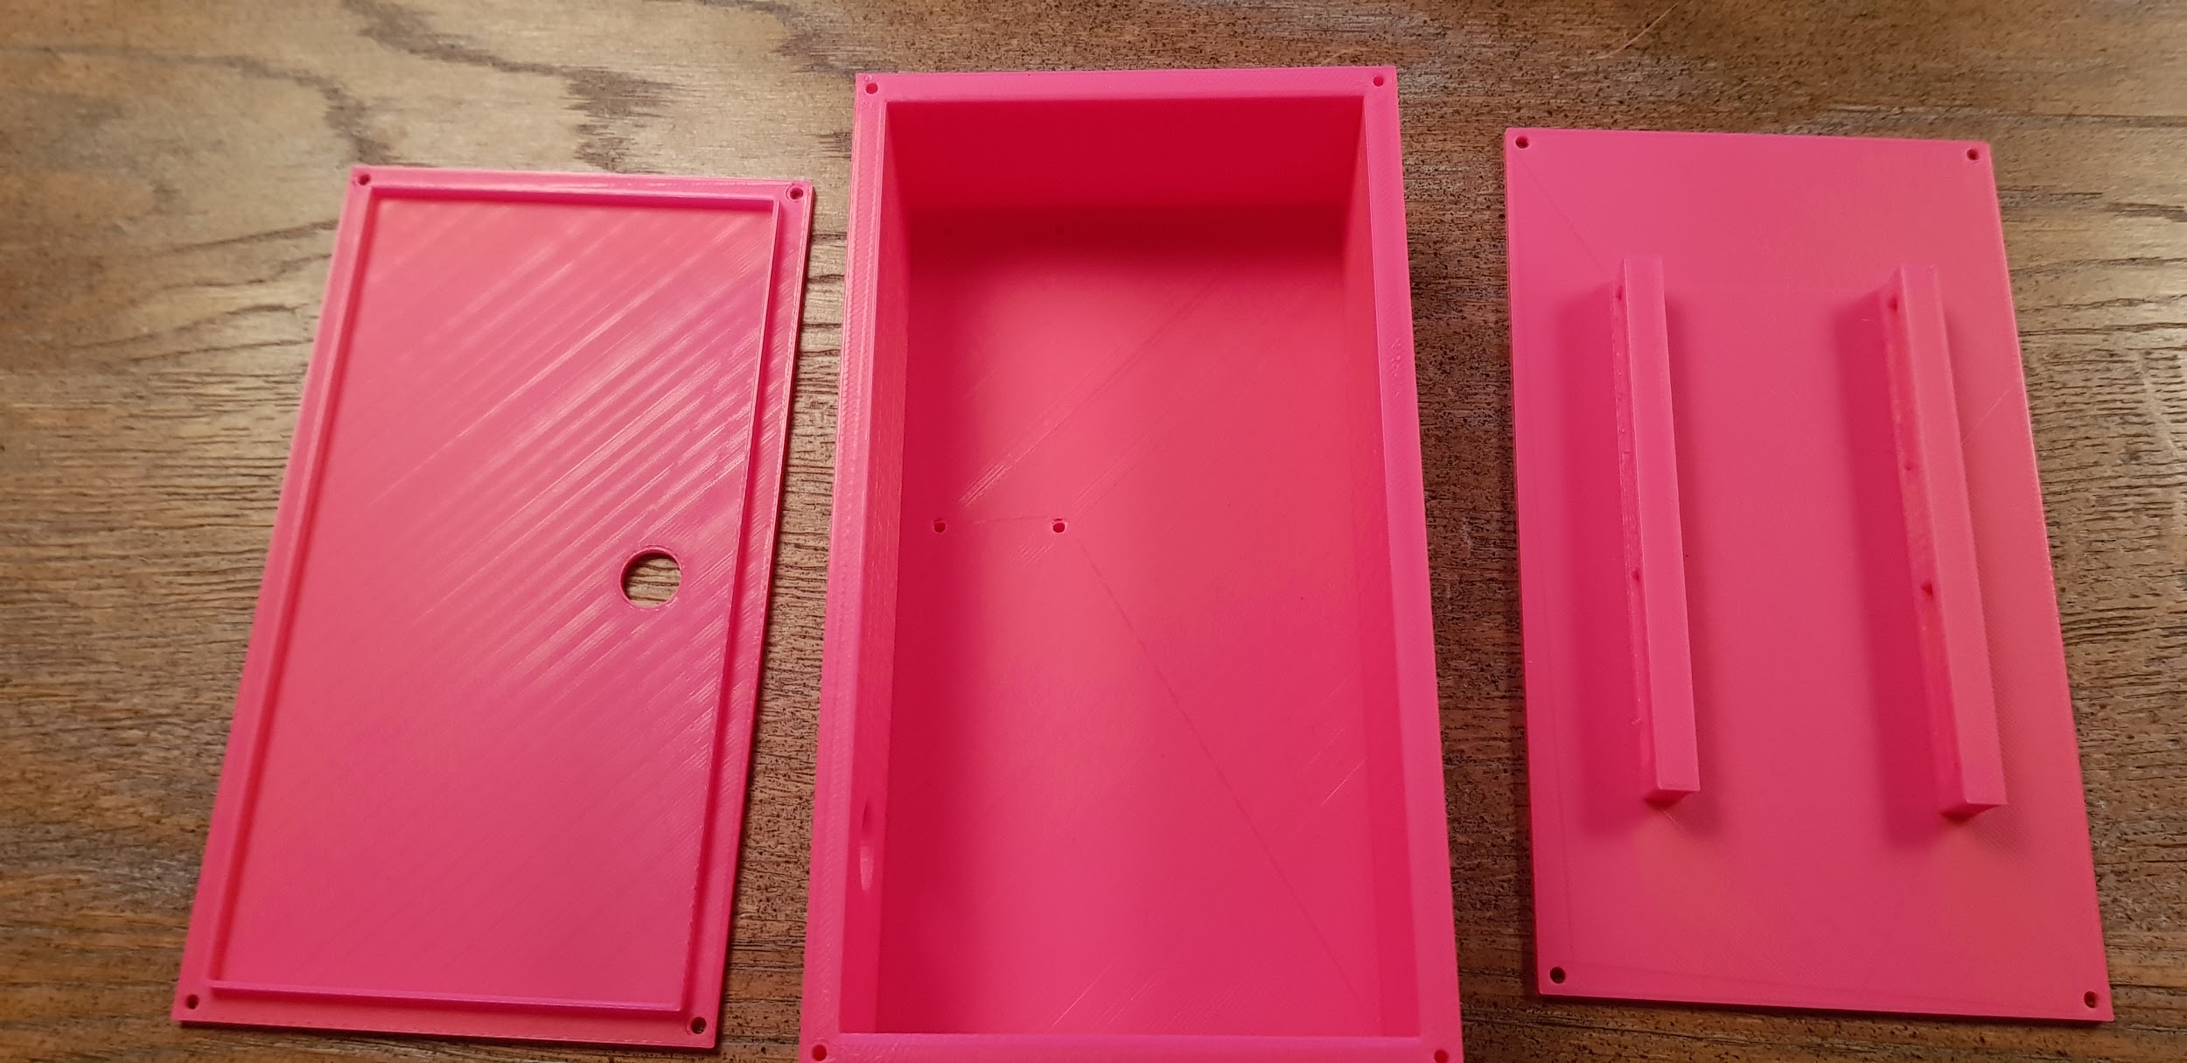

2. Place the lid on top as shown in the picture:

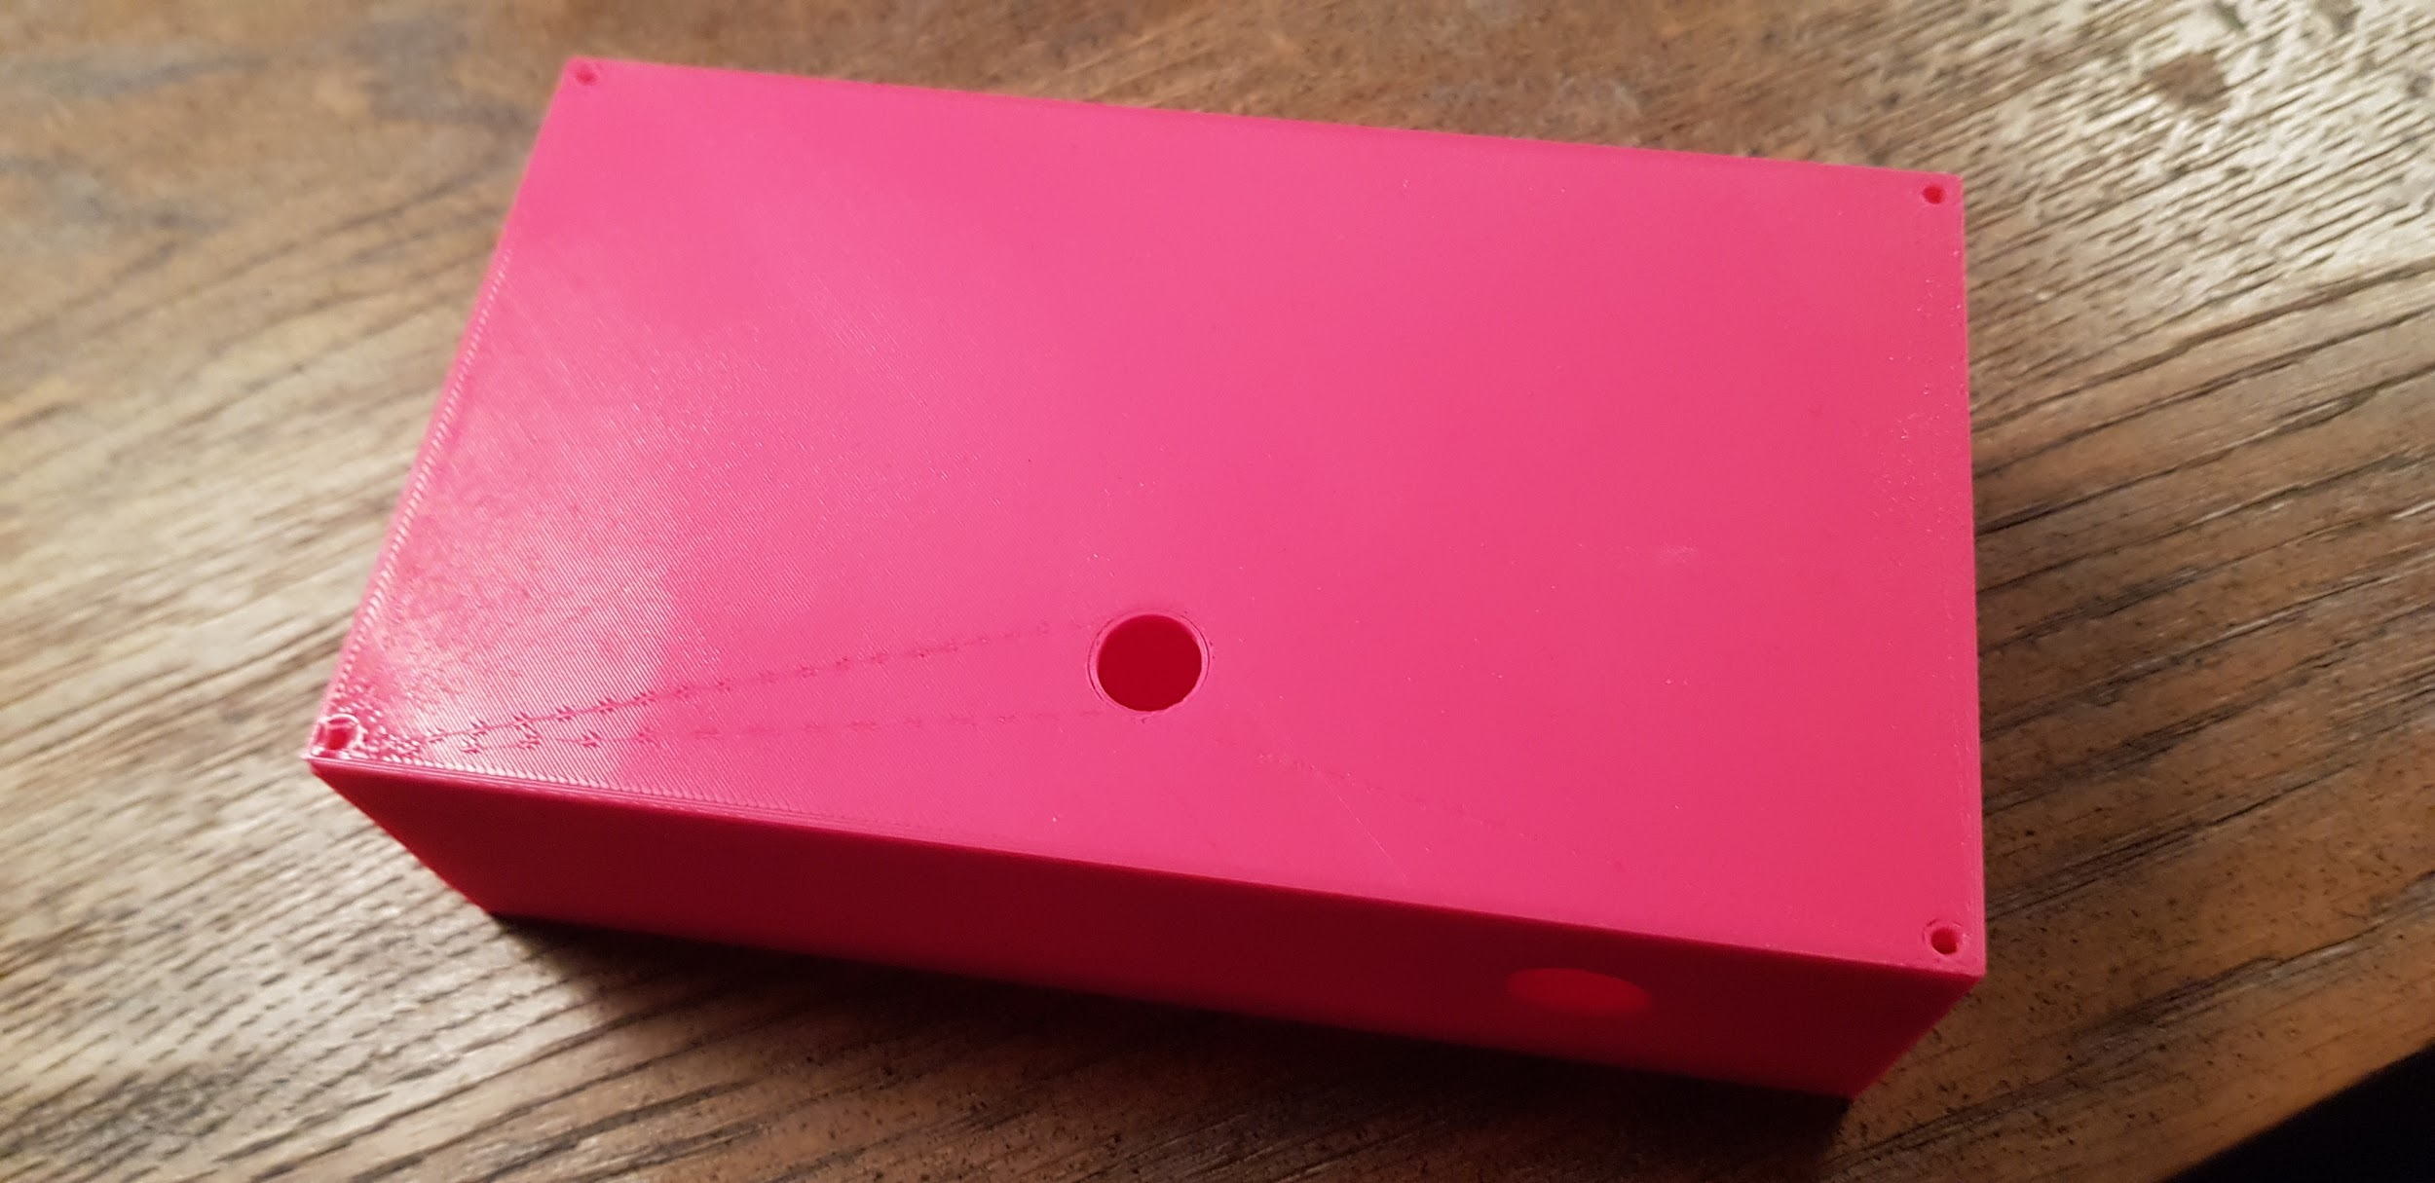

You can use the case as it is, but this is not recommended because it cannot be attached to an object or camera.

3. To mount the 3rd object you need to use the following screws:

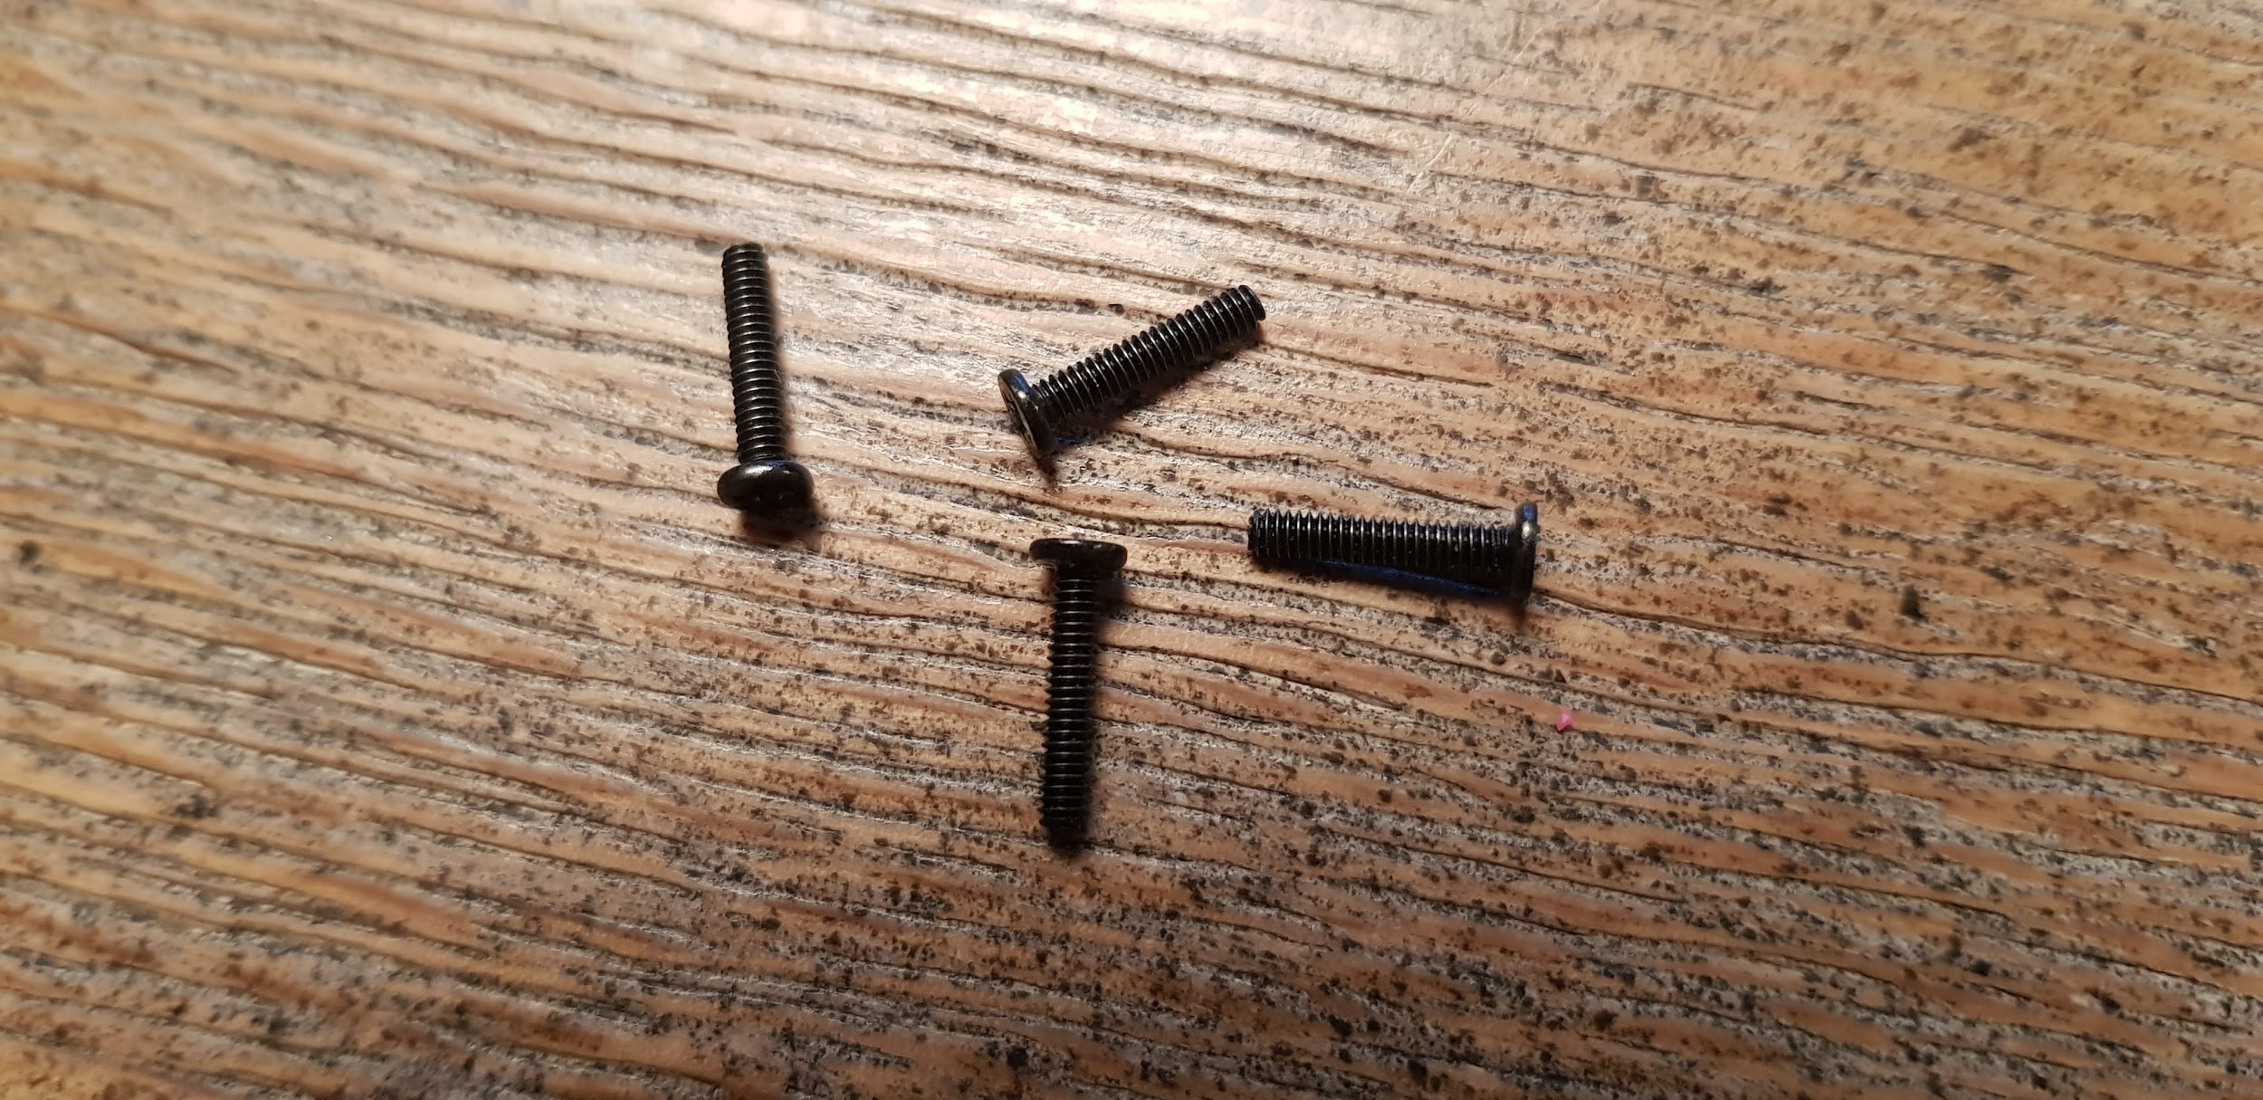

These screws are 8mm deep and 2.5mm wide.

4. On the last part of the case there are two protrusions. These can be used to hold the case in place attached to a camera. Use the supplied Velcro strips for this.

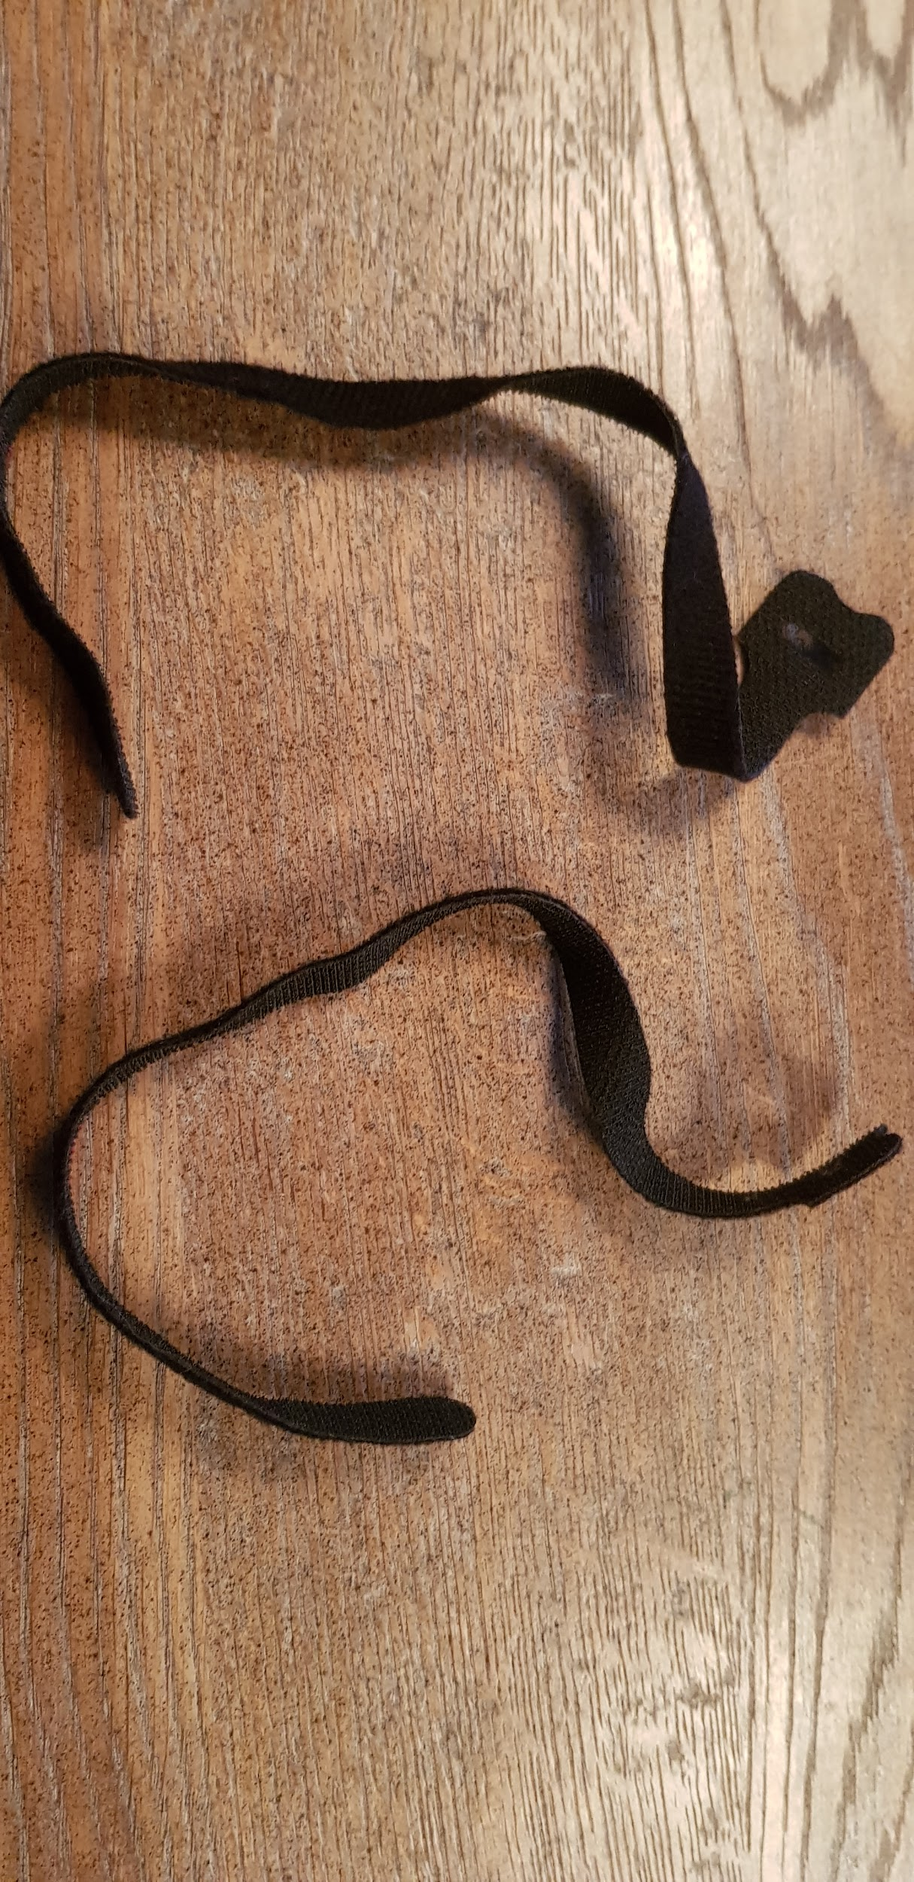

5. After doing so, your case should look something like this:

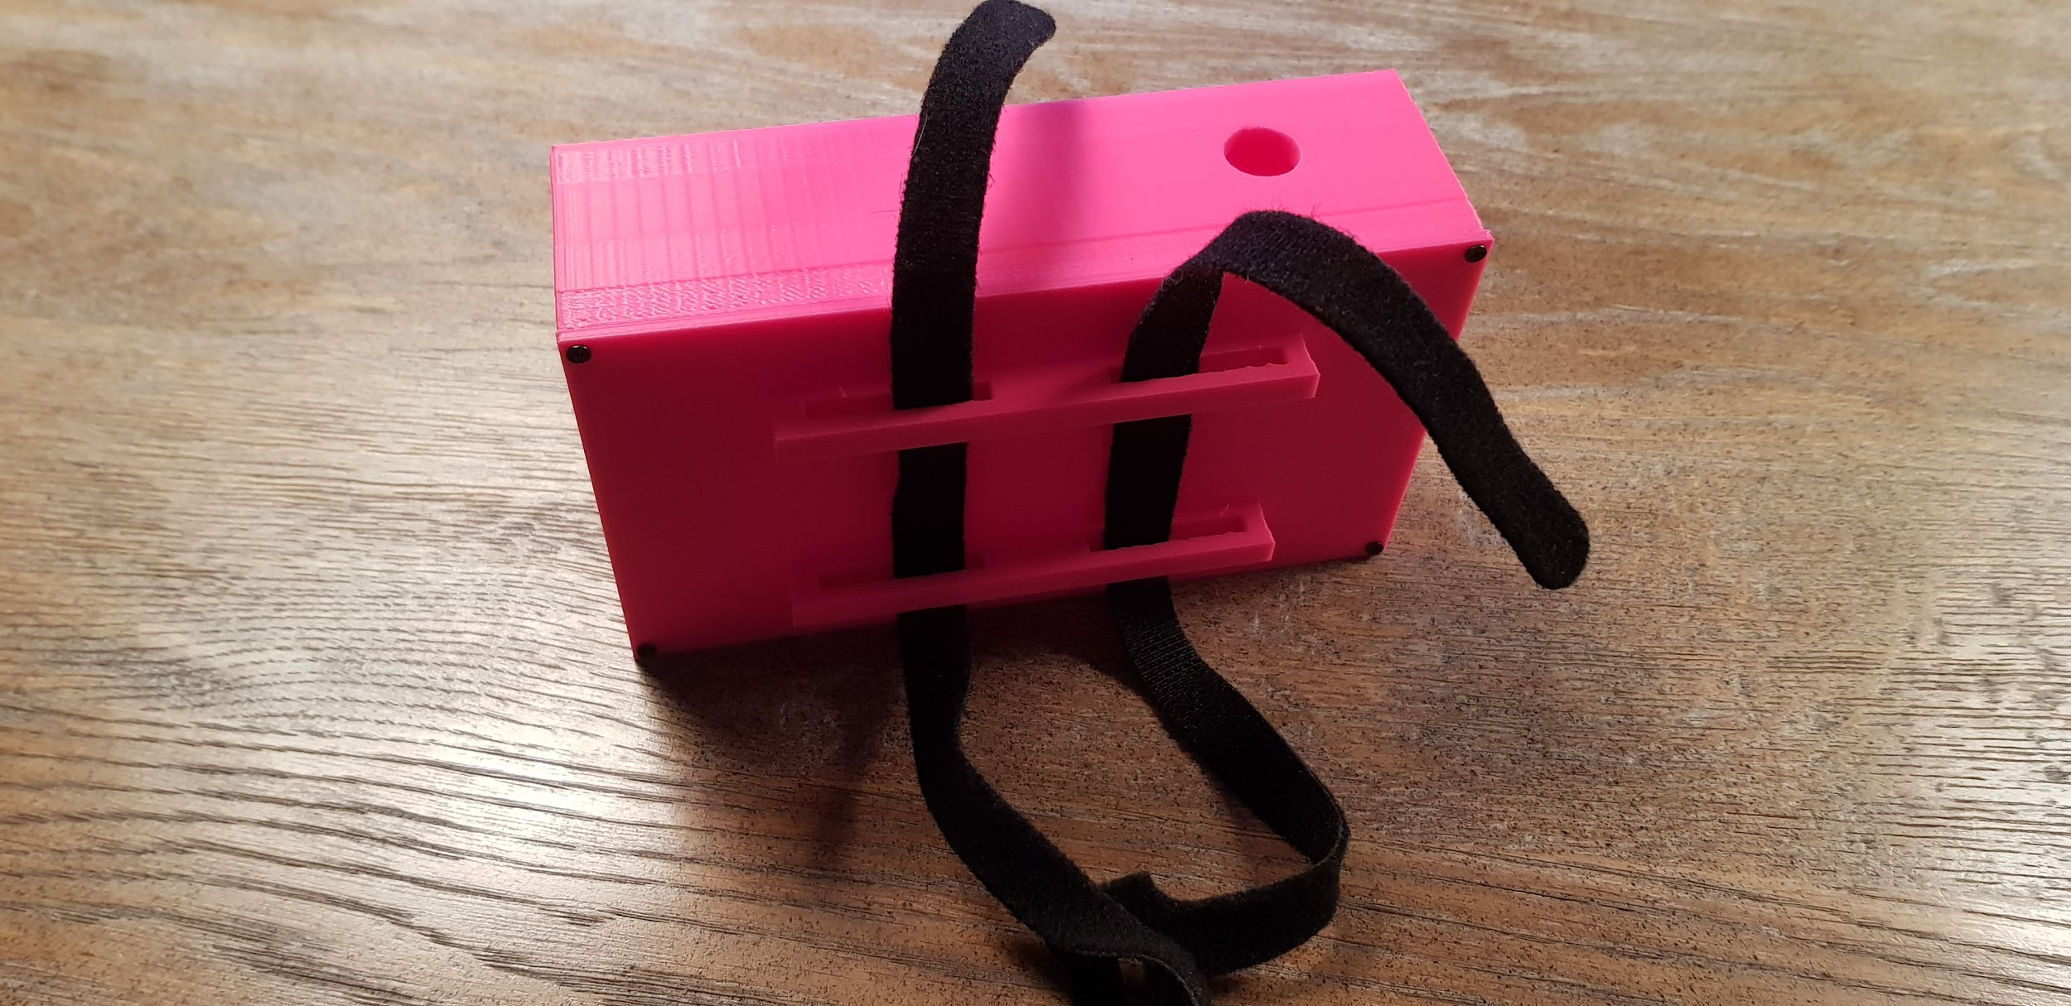

Now the case can be mounted to for example the tripod of a camera

How to charge the powerbank for the tally light:

To replace the battery you can take the following steps:

1. Remove the lid from the case.
2. Detach the powerbank from the Raspberry Pi
3. Charge the powerbank with the usb cord.
4. When the LED from the powerbank stops blinking it is done charging.
5. Connect the powerbank back to the Raspberry Pi.
6. Close the lid.

# Chapter 4. Setting up the Wi-Fi access point and base station

The tally lights receive their instructions from the base station through the Wi-Fi access point.

The Wi-Fi access point needs to be running before you can begin activating the tally light system.

**Acces point installation:**

* Simply plug in device with the white and red case shown here and wait 15 seconds for it to boot up.

* Next, Plug in the base-station, and wait another 15 seconds.

You are now ready to turn on the tally lights. Do not activate these BEFORE the Wi-Fi access point is active, as connection errors may occur. In this case, simply switch all devices off, and re-activate them in the correct order.

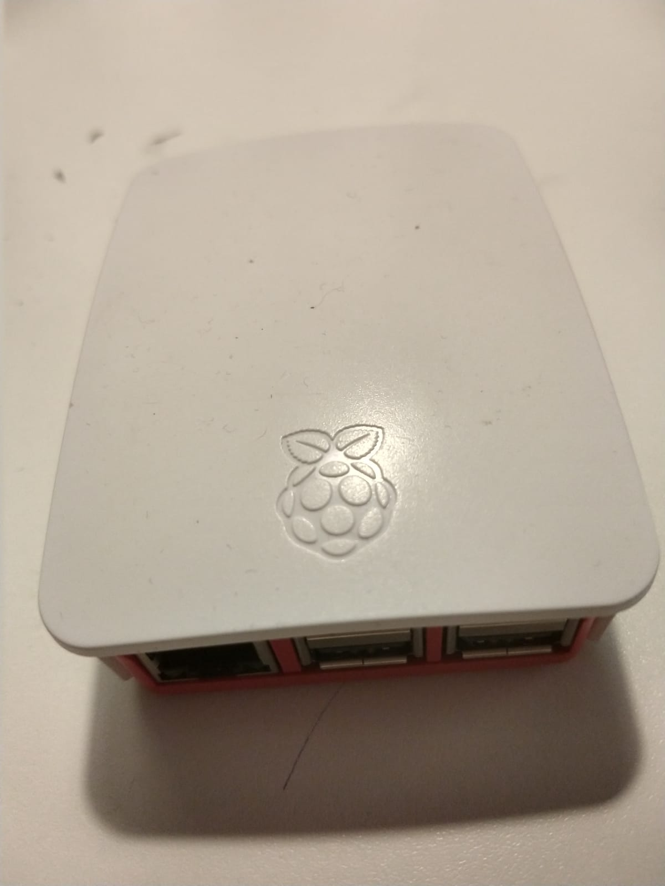

# Chapter 5. Troubleshooting guides

In this section I will be explaining what can be done when the system is not working. This will only cover the most occurring problems and not every problem that can occur.

## 5.1 One of the tally lights doesn’t work (light stays off)

Cause:

This can be caused by the following things:

1. The battery is dead from one of the tally lights

2. The Wi-Fi-access point has lost power.

Solution:

This problem can be resolved by one of these steps described below:

1. Open the case of the tally light that is giving the problems and check the LED indicator on the side. This indicator gives the current charge of the powerbank which powers the tally light.

2. Open the case of the tally light and replug the power cord so that it restart. This forces the pi to reconnect to the Wi-Fi-access point.

## 5.2 None of the tally lights light up

Cause:

This can be caused by the following things:

1. The base station has lost its power
2. The Vmix computer is not connected with the base station
3. Vmix has opened a http connection instead of a TCP

Solution

This problem can be resolved by one of these steps described below:

1. Check if the base station still has power. This can be seen by the red LED light. If the light is off the device doesn’t have power which might mean the power bank has ran out of charge.
2. Check of the computer still has a Wi-Fi connection with the base station. Without the Wi-Fi connection Vmix won’t be able to communicate with the tally lights.
3. Check if the web controller is running on port 8099, if it is already running on 8099 re-enter the port number.

## 5.3 The tally lights turn on but don’t switch when the camera is switched on Vmix

Cause:

This can be caused by the following things:

- The Vmix computer doesn’t have a connection with the base station

Solution:

This problem can be resolved by one of these steps described below:

1. Make sure the Vmix computer is connected with the Wi-Fi access point
2. Restart the Wi-Fi access point
3. Switch the port number (more information on chapter 2)

## 5.4 The computer and the tally lights are connected with the base station but nothing is happening with the tally lights.

Cause:

This can be caused by the following things:

- The base station has failed to run the script or is unable to access the tally lights

Solution:

This problem can be resolved by one of the steps described below:

- Unplug the power cord from the base station and plug it back after 1 minute. This will reset the system and clears out most problems