Harrison Hetler, Henry Nguyen, Tony Nguyen, Lei Wang
2297925, 2465007, 2134366, 2644844
EECS 448 Homework 5
Swapan Chakrabarti
April 24th, 2015

The source code of our program can be found at:
https://github.com/DimGreyWolf/448Hmwk5

Along this link there are also instructions how to run the program.

Software Development Methodology:
In order to produce our software, we have chosen to use the Extreme Programming methodology.

User Stories:
1) As a user I should be able to choose between five comparison analyzation methods to identify active and non-active drug compounds from given data files.

Tasks:

1.1) Provide a GUI for the user to select a comparison method.
1.2) Provide a class for the user to read in data files
1.3) Implement Euclidean Distance Comparison method
1.4) Implement Mahalnobis Database Comparison method
1.5) Implement Voting Euclidean Distance Comparison method
1.6) Implement Voting Mahalnobis Database Comparison method
1.7) Allow the user to see amount of Naa, Nan, Nna, Nnn drugs by their selected comparison method
1.8) Allow the user to see the ratio of Naa/Nan drugs by their selected comparison method
1.9) Provide a graph for the user to compare the efficiency in Naa/Nan ratio of our comparison methods all together.

Software Architecture:

In order to produce our software we have decided to structure our program in the manner of the MVC architecture pattern. As shown in the class diagram we have associated the classes DrugGraph, and Toolbar to the View responsibilities, DrugDatabase to the Model responsibilities, and DrugAnalysis to the Controller responsibilities.

Class Diagram:
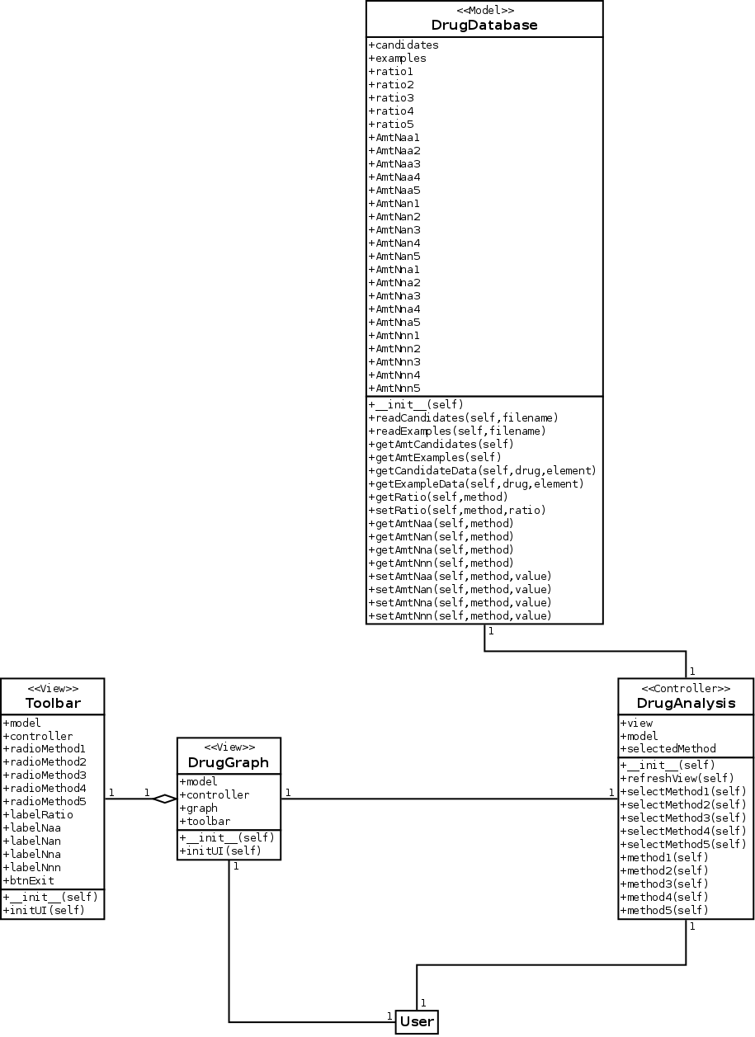

Tests:

Unit Test for DrugDatabase class
A unit test we have is contained in the python script named test_drug_database.py file. This script will test the file reading and data extraction capabilities of our DrugDatabase class. DrugDatabase represents the model class in our MVC architecture.

Input: Two given data files, named hw5db1.txt and hw5db2.txt
Tests:
1. If class is able to read in both files
2. If class is able to differentiate between elements within read files
Output: Formatted data that matches both data files

Conclusion:

Using Extreme Programming methodology and unit testing we were able to produce a drug analysis program using five comparison analyzation methods. The five methods we used to identify between active and non-active drugs within a given data file were: Euclidean Distance Comparison, Mahalnobis Database Comparison, Voting Euclidean Distance Comparison, Voting Mahanolbis Database Comparison, and a custom comparison technique we developed ourselves to improve our results.
TODO: EXPLAIN OUR CUSTOM COMPARISON TECHNIQUE

Our improvement in results is significant as it represents that we improved an algorithm to be more efficient in identifying drugs. This is beneficial to the medical community as it saves money and time by simply improving research results with the same comparison data. With an improved algorithm the benefits scale with the amount of drugs that need to be analyzed.

