# Circus Restaurant – Team 2

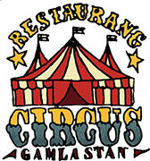

**Team Members**

1. Andreas
2. Dimitry
3. Kavitha
4. Manuel

**Project Details**

|  |  |
| --- | --- |
| **Project period** | 2 weeks |
| **Working Methodology** | Scrum |
| **Tool used** | **Sprint board :** Trello  **S/w :** Visual studio code IDE,  HTML, java script, CSS , Bootstrap, Jquery  **Source control :** Git  **Wireframe :** Balsamic |
| **Source** | Sprint 1 : <https://trello.com/b/ELyHp9Ow/sprint-1-team2>  Sprint 2 : <https://trello.com/b/Dj9A2Ofg/sprint-2>  Git Repository: https://github.com/DimPirogov/Circus |
| **Goal** | **Sprint 1 Goals:**   1. Research: 1. Prepare questions for survey 2. Survey: 1. Survey 200 peoples   2. Collect Answers   1. Analysis: 1. Analyse the answers . 2. Use some tools to prepare chart. 2. UX design: 1. Using Balsamic to design. 3. Git:   1. Learn, Practice  **Sprint 2 Goals:**   1. Git: 1. Use git version control throughout the project 2. Coding: 1. Coding according to wireframe   2. Members work separately  3. Update Trello board regularly based on progression.  4. Fix bugs  5. Discuss with team members if needed.   1. Finish project 2. Document preparation 3. Presentation for demo |

**How we worked together as a Team: (followed SCRUM)**

1. Daily stand-up meeting in the morning.

2. Meeting at the end of the day.

3. Meetings during the day if needed.

4. Discussed everything about the project.

5. Good collaboration, co-operation, dedication.

**Everyday progress:**

|  |  |
| --- | --- |
| Day 1 | Created backlogs in Trello Board  Discussed about Questionairre   * Brainstorming questions for market research. * Preparing research questions. * Survey 200 people. |
| Day 2 | Did competitor research   * [Texas Longhorn - Home away frome home](https://www.texaslonghorn.se/) * <https://pinchos.se/> * <http://www.babas.se/> * https://www.babas.nu/ * <https://espressohouse.com/> * <https://www.mcdonalds.com/se/sv-se.html> * <https://goldenhits.se/>   Compiled the research data  Wire-frame in Balsamic |
| Day 3 | Continued wire-framing the website  Saw market research presentation  Color scheme for website and Logo |
| Day 4 | Finished wire-framing the website  Started “gitting”  Logo design |
| Day 5 | Continued exploring Git hub  Sprint 1 review  Sprint 2 planning  Started building the website  Divided up the work load into separate tasks |
| Day 6 Day 7  Day 8  Day 9 | Discussion, Coding, update Trello, Fix bugs, Prepare Document  Prepare ppt for presentation |
| Day 10 | Git Finalize  Presentation |

|  |
| --- |
| **Questions for Market Research:** |
| **1.       Age range?** |
| o   18-25 |
| o   26-35 |
| o   36-50 |
| o   50+ |
| **2.       Gender** |
| o   Female |
| o   Male |
| o   Don’t want to answer |
| **3.       Would you come** |
| o   Alone |
| o   Partner |
| o   Family |
| o   Co-workers |
| o   Company conferences and events |
| **4.       Would you be willing to pay an entry fee?** |
| o   Yes |
| o   No |
| **5.       How much are people willing to spend in a lunch or dinner?** |
| o   Under 60 SEK |
| o   Between 60-120 SEK |
| o   Between 120-200 SEK |
| o   Over 200 SEK |
| **6.       Favorite food** |
| o   Fast food (Pizza, burger) |
| o   A la carte |
| o   Food experience and exotic menu |
| o   Circus theme |
| **7.       Drinks preferences** |
| o   Soft drinks |
| o   Natural juice |
| o   Alcohol and cocktails |
| o   Hot drinks (Te, Coffee, Cacao, Glögg) |
| **8.       Are you interested on day’s specials?** |
| o   Yes |
| o   No |
| **9.       Food requirements** |
| o   Allergies |
| o   Vegan/Vegetarian |
| o   Gluten free |
| o   Diabetes requirement |
| **10.   Are you willing to order thru an app at the restaurant?** |
| o   Yes |
| o   No |
| o   Sometimes |
| **11.   Pre-ordering before going to the restaurant?** |
| o   Yes |
| o   No |
| **12.   How would you like to place your order?** |
| o   Traditional way (menu and waitress) |
| o   Tablet at the table |
| o   Full incorporated screen at the table |
| **13.   Payment experience** |
| o   Pay by card |
| o   Swish |
| o   Cash |
| **14.   How much functionality would you like to have?** |
| o   Fully automated |
| o   I would like to have some degree of interaction with a person |
| **15.   What kind of menu options would you like to see?** |
| o   Premade menu |
| o   Premade with possible added options |
| o   Fully customized menu |
| **16.   Booking. Would you like to pre-book thru the system?** |
| o   Yes |
| o   No |
| **17.   If yes, would you like to book a specific table?** |
| o  I would like to choose my table |
| o  Any table will work |
| **18.   What do you think about the concept?** |
| o   Yes |
| o   No |
| o   I can give it a try |
| **19.   When would you be coming to our restaurant?** |
| o   Working days lunch hours |
| o   Working days after hours |
| o   Weekends |
| o   Evenings |
| **20.   Would you like to eat and watch a show?** |
| o   Yes |
| o   No |
| o   I can give it a try |
| **21.   If yes, would you like to eat and watch a show?** |
| o   Before |
| o   During |
| o   After |
|  |

**Competitor research:** 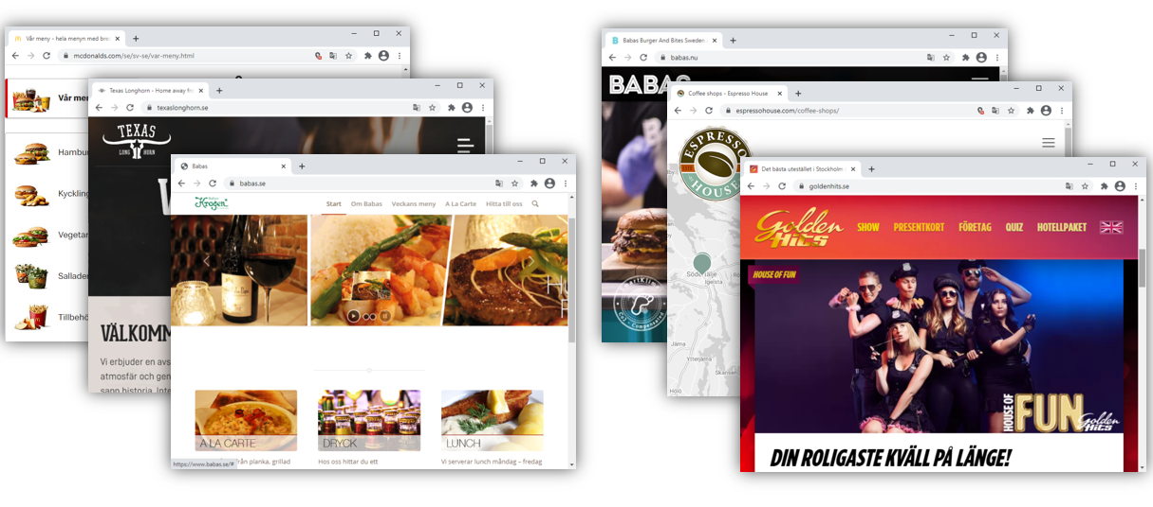

* [Texas Longhorn - Home away frome home](https://www.texaslonghorn.se/)
* <https://pinchos.se/>
* <http://www.babas.se/>
* https://www.babas.nu/
* <https://espressohouse.com/>
* <https://www.mcdonalds.com/se/sv-se.html>
* <https://goldenhits.se/>

|  |  |
| --- | --- |
| **Pros** | **cons** |
| * Eye catching video * Easy to navegate * Color schema tided to the logo * Restaurant menu easy and atractive * Address in Google map | * PDF menu without photos * Hard to find menu * Minimum funtionality * 3rd party service * Distracting animations * Too busy webpage |

**Analysis:**

**Demographics:**

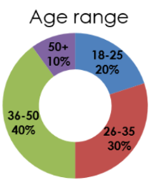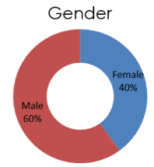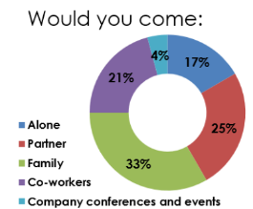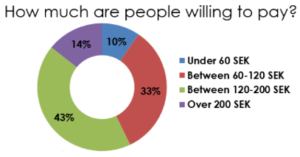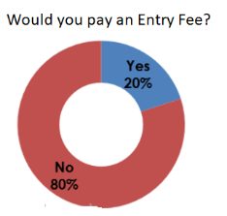

* Between 26 and 50 years’ old
* Couples and families
* Willing to spend 60~120 SEK
* Price sensitive, no entry fee

**Food Preferences:**

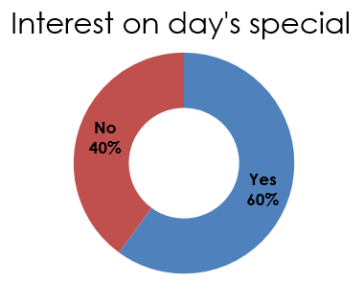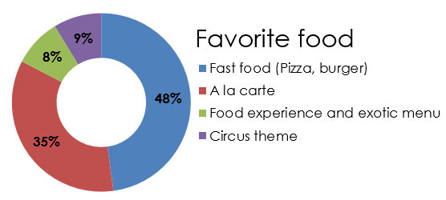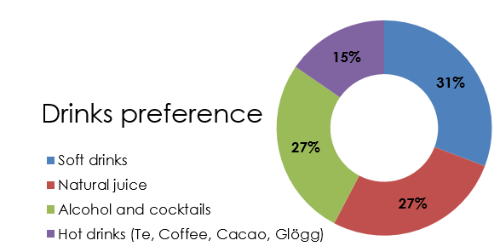

* Day’s special
* Fast food and menu
* All types of drinks

**Food Requirements:**

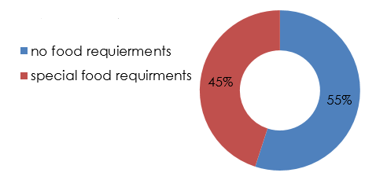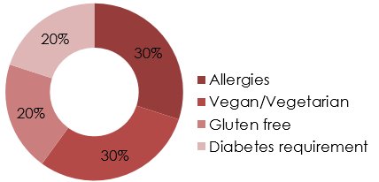

* 45% have food requirements
* Similar distributed

**Interest on the concept:**

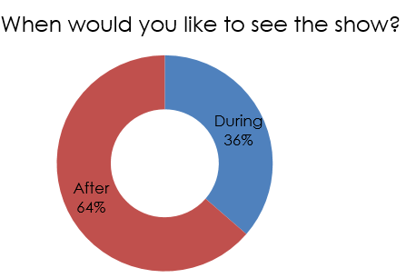 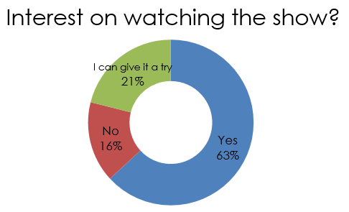

* 63% are interested
* Eat first, watch later

**Interested on automations:**

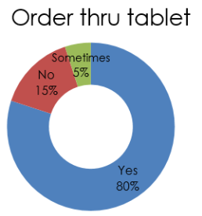 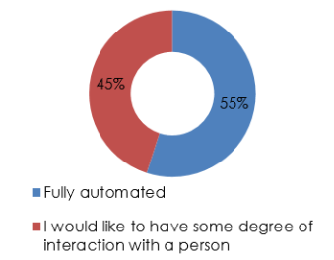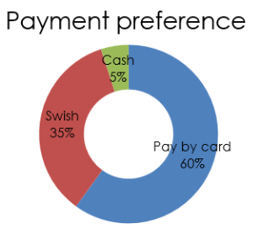

* There is interest on ordering thru tables
* People still want to have a waitress
* Trend is towards cashless

**Online Functionalities:**

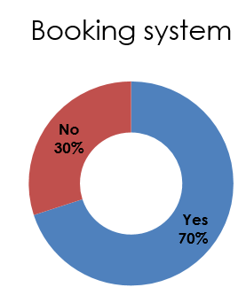

* 70% would like to book a table

**Colour scheme for website and Logo:**

 

blue: 0x557475

light yellow: 0xf4e7b3

dark yellow: 0xf8b936

red: 0xc42b26

dark red: 0x5c1113

**Overall wireframe design:**

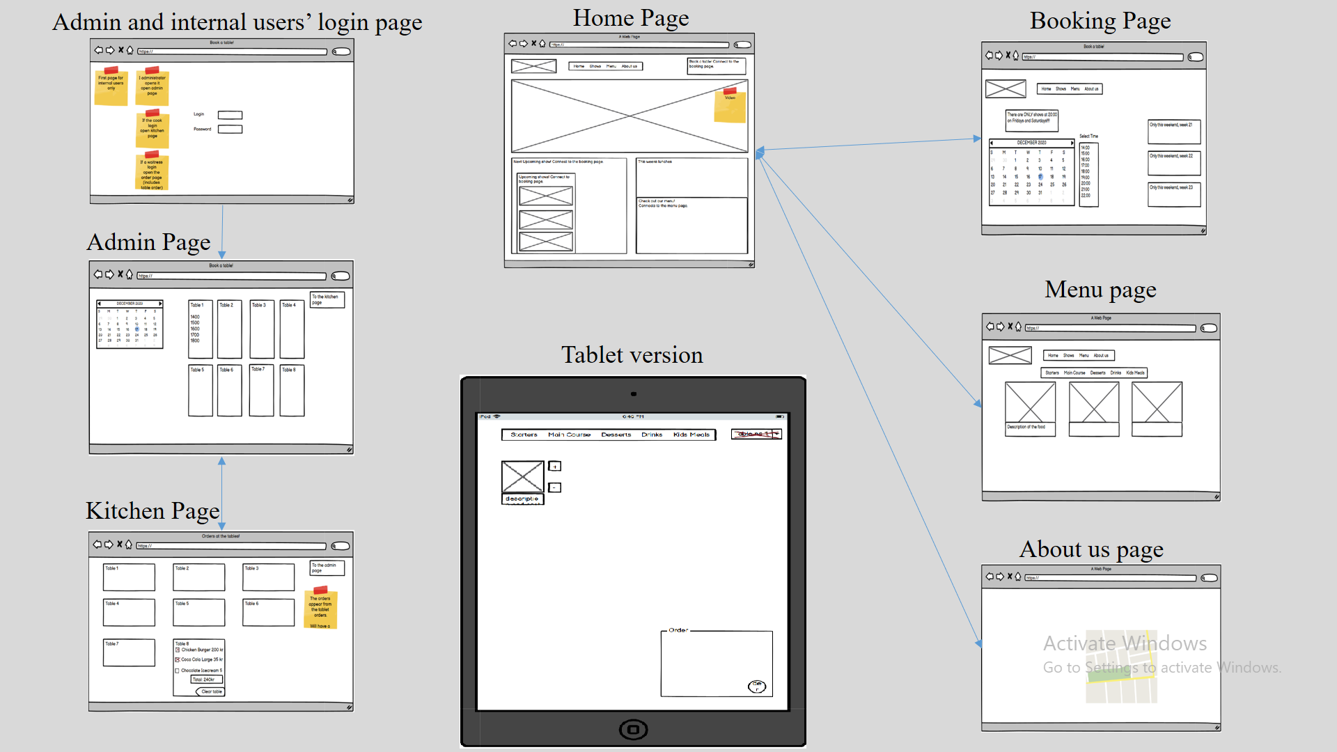

**Coding:**

We started doing coding as per wireframe design.

Below you can see the planned wireframe design and the final output now, with corresponding comments at the end for the modifications and the work we did.

**Web version:**

1. Home Page

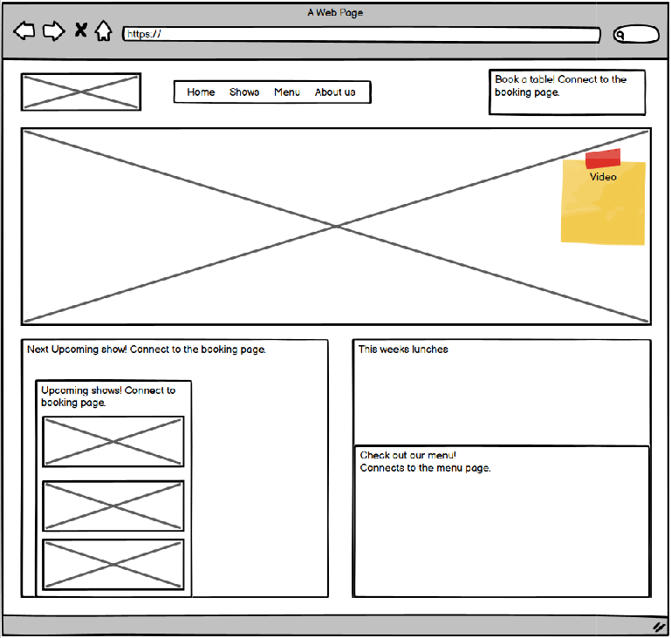

2. Booking Page

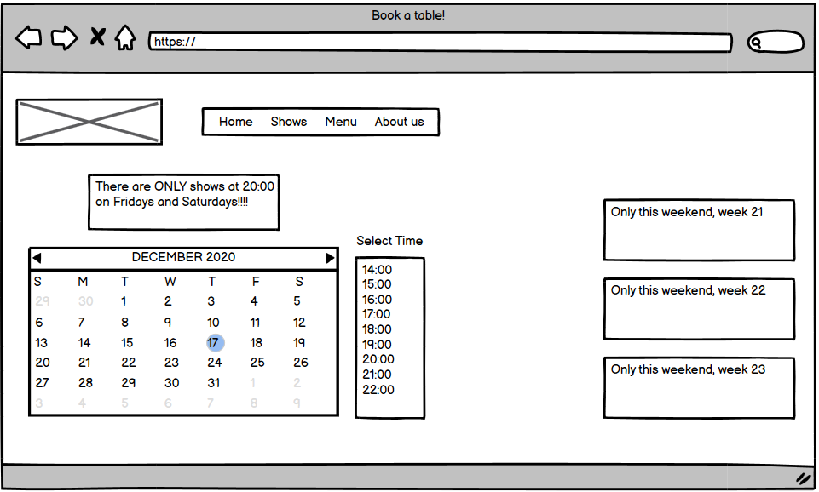

3. Admin Page

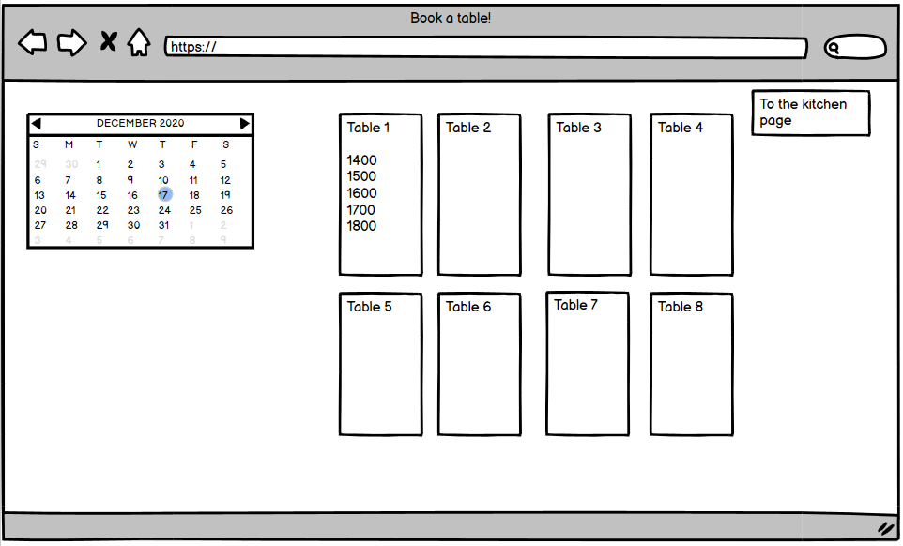

4. Kitchen Page

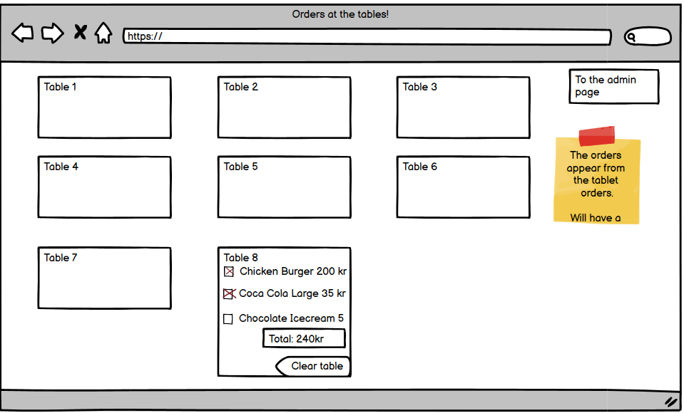

5. Menu page

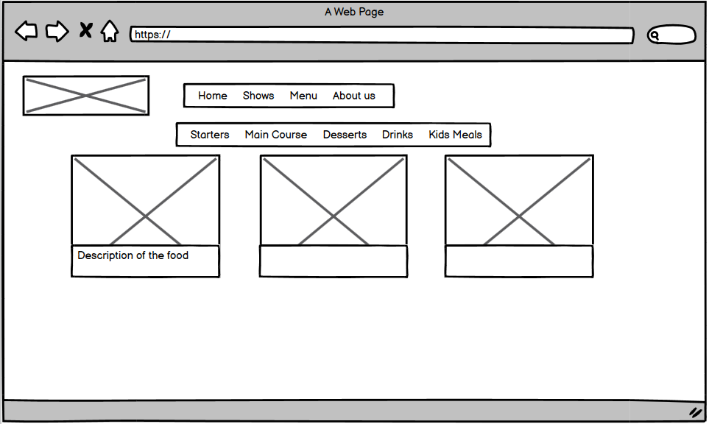

6. Admin and internal users’ login page

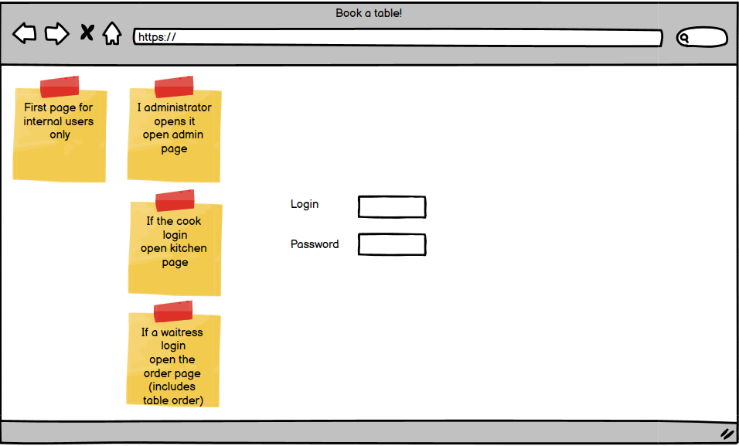

7. About us page

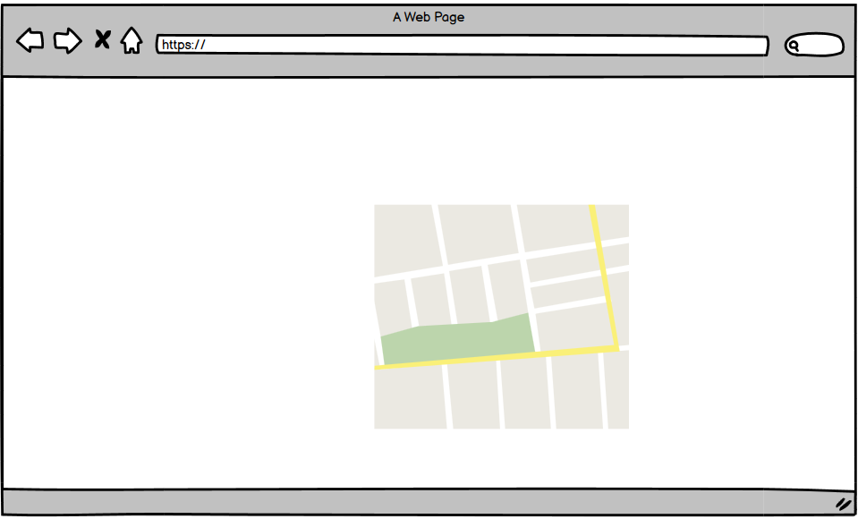

Tablet version:

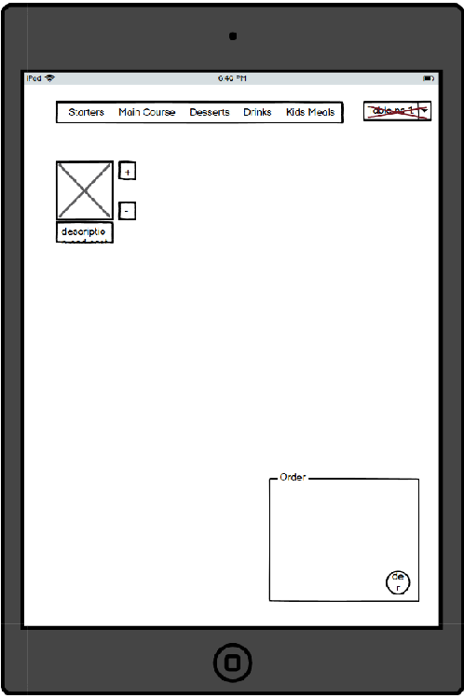

**Modified content:**

1.Table number in wireframe design is not implemented in real version. (Future work)

2. Changed the order details to be the whole width, instead of box in design.

3. Added count details and price of each item

4. Added the confirm button – to display message order placed with alert messge.

5. Added the food description with price.

6. Added the symbol for Vegan, Veg and No-sugar for particular items.

7. Added ingredients for one item Hjärta Pizza – they can select ingredients for the pizza.

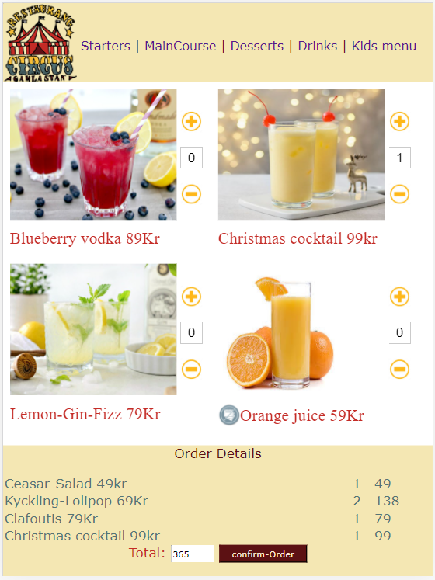

**Functionalities:**

Customer order food items at table using tablet.  
Customer can see all available food items by clicking menu.  
Customer can select quantity of food item by pressing plus and minus button.  
Customer can see the order details at the bottom with price.  
Customer can see the total price of food to be ordered.  
Customer can confirm the order by confirm button at the bottom.  
Customer can choose ingredients for Hjärta pizza with selected options.

