How Linux Works

A Linux system has three levels

- Hardware is at the base. Hardware includes the memory as one or more CPUs.

- Kernel. This is the core of the OS. The kernel is software residing in memory that tells the CPU where to look for its next task. Acting as a mediator, the kernel manages the hardware (especially main memory) and is the primary interface between the hardware and any running program.

- Processes. They are the running programs that the kernel manages. They collectively make up the system’s upper level, the user space.

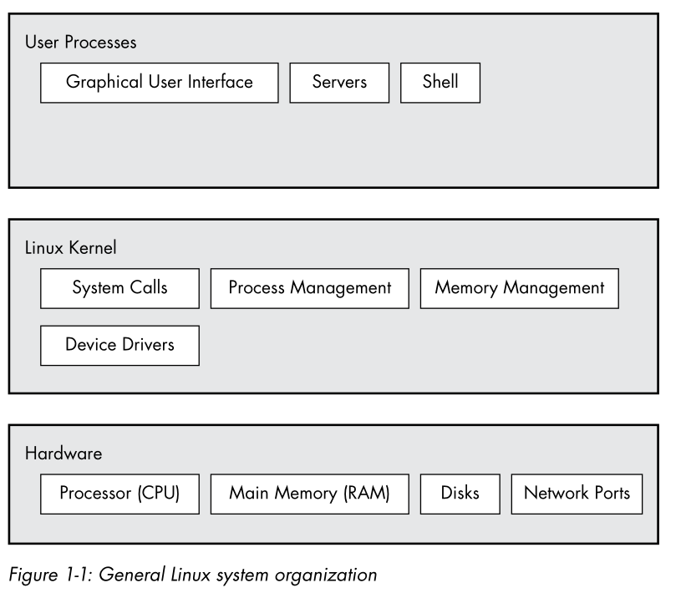
The critical difference between the kernel and processes is that the kernel runs in kernel mode and the user processes run in user mode. Code running in kernel mode has unrestricted access to main memory and CPU operations. This makes the kernel powerful and its privilege elevated which can corrupt and crash the entire system. The memory area that only the kernel can access is called the kernel space.

In contrast, user mode only restricts the access of processes to a usually small subset of main memory and safe CPU operations. The part of main memory that user processes can access is called the user space. This means that if a process encounters an error and crashes, it is unlikely to take down the entire system. In theory, a user process gone haywire can’t cause serious damage, but in reality, it depends on what you consider “serious damage,” as well as particular privileges of the process.

Hardware

Main memory is the most important. In its rawest form, main memory is just a big storage area for bits. This is where the running kernel and processes reside. All I/O from peripheral devices flow through the main memory. A CPU is just an operator on memory, it reads its instructions and data from the memory and writes data back out to the memory. Instead of describing state as the physical arrangement of bits, we can describe it as “what something has done or is doing at the moment.” Like “process is waiting for input.”

The term image refers to a particular physical arrangement of bits.

Kernel

Nearly everything that the kernel does revolves around the main memory. The kernel is in charge of managing tasks in four general system areas:

Processes – the kernel is responsible for determining which processes are allowed to use the CPU.

Memory – the kernel needs to keep track of all memory—what is currently allocated to a particular process, what might be shared between them, and what is free.

Device Drivers – the kernel acts as an interface between hardware and processes. It’s usually the job of the kernel to operate hardware.

System calls and support – processes normally use system calls to communicate with the kernel.

Process Management

Process management describes the starting, pausing, resuming, scheduling, and terminating of processes. On any OS, processes run “simultaneously.” However, these do not run concurrently. Many processes may be able to use the CPU, but only one process can actually use the CPU at any given time. In practice, each process uses the CPU only for a small fraction of a second then another process takes a turn. The act of process giving up control of the CPU to another process is called a context switch.

Each piece of time—called a time slice—gives a process enough time for significant computation. Because the slices are very short, they are imperceptible to our senses and the system appears to be running multiple processes concurrently (multitasking).

The context switch answers the important questions of when the kernel runs. The answer is that it runs between process time slices during a context switch.

Memory Management

The kernel must manage memory during a context switch. The following conditions must hold:

- The kernel must have its own private area in memory that user processes can’t access.
- Each use process needs its own section of memory.
- One user process may not access the private memory of another process
- User processes can share memory.
- Some memory in user processes can be read-only.
- The system can use more memory that is physically present by using disk space as auxiliary.

Modern CPUs include a memory management unit or MMU that enables a memory access scheme called virtual memory. When using virtual memory, a process does not directly access the memory by its physical location in the hardware. Instead, the kernel sets up each process to act as if it had an entire machine to itself. When the process accesses some of its memory, the MMU intercepts the access and uses a memory address map to translate the memory location from the process point of view into an actual physical memory location in the machine. The kernel must still initialize and continuously maintain and alter this memory address map.

The implementation of a memory address map is called a page table.

Device Drivers and Management

A device is typically accessible only in kernel mode because improper access could crash the machine. Different devices also rarely have the same programming interface, even if they perform the same function. Device drivers have traditionally been part of the kernel, and they strive to present a uniform interface to user processes in order to simplify software development.

System Calls and Support

System calls are just interactions between a process and the kernel. System calls or syscalls perform tasks that a user process cannot do well or at all. The acts of opening, reading, and writing files all involve system calls.

Two syscalls are important to understanding how processes start:

fork() - when a process calls fork(), the kernel creates a nearly identical copy of the process

exec() - when a process calls exec(program), the kernel loads and starts program, replacing the current process.

Other than init, all new user processes on a Linux system start as a result of fork(), and most of the time, you also run exec() to start a new program instead of running a copy of an existing process. When you enter ls into a terminal window, the shell that’s running inside the terminal window calls fork() to create a copy of the shell, and then the new copy of the shell calls exec(ls) to run ls.

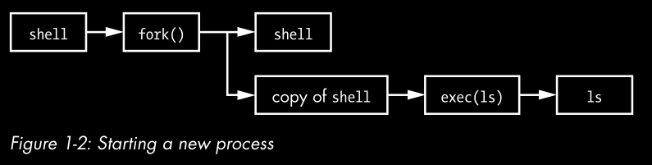

User Space

the main memory that the kernel allocates for use processes is called user space. Because a process is simply a state (or image) in memory, user space also refers to the memory for the entire collection of running processes.

Users

The Linux kernel supports the traditional concept of a Unix user. A user is an entity that can run processes and own files. A user is most often associated with a username but the kernel only manages by user IDs.

Users exist primarily to support permissions and boundaries. Every user-space process has a user owner, and processes are said to run as the owner. A user may terminate or alter its own processes but not of other users. Users may also own files and share them with other users.

The most important user is the root. The root user is an exception to the preceding rules because root may terminate and alter another user’s processes and access any file on the local system. For this reason, root is also known as the superuser. A person who can operate as root—that is, who has root access—is an administrator on a traditional Unix system.

BASIC COMMANDS AND DIRECTORY HIERARCHY

Linux is a Unix flavor at heart.

The Bourne Shell: /bin/sh

A shell is program that runs commands. Many important parts of the system are actually shell scripts—text files that contain a sequence of shell commands.

There are many different Unix shells, but all derive features from the Bourne shell (/bin/sh), a standard shell developed at Bell Labs for early versions of Unix. Every Unix system needs a version of the Bourne shell in order to function correctly.

Linux uses an enhanced version of the Bourne shell called bash or the “Bourne-again” shell.

The Shell Window

Open a shell window (often referred to as a terminal).

Standard I/O

Unix processes use I/O streams to read an write data. Processes read data from input streams and write data to output streams. Streams are very flexible. For example, the source of an input stream can be a file, a device, or a terminal window, or even the output stream from another process.

Standard output is similar. The kernel gives each process a standard output stream where it can write its output. The cat command always writes its output to the standard output. The standard output was connected to that terminal.

Standard input and output are often abbreviated as stdin and stdout.

Usual commands:

cd
pwd
cat
echo
ls
- ls -l
- ls -la
cp
mv
touch
mkdir
rmdir

Navigating Directories

The Unix directory hierarchy starts at /, also called the root directory. When you refer to a file or directory, you specify a path or pathname. When a path starts with /, it’s a full or absolute path.

A path component with .. specifies the parent of a dir. A path with . Means the current working dir.

A path not beginning with / is relative path.

Shell Globbing (“Wildcards”)

The shell can match simple patterns to file and directory names, a process known as globbing.

The shell matches arguments containing globs to filenames, substitutes the filenames for those arguments, and then runs the revised command line. The substitution is called expansion because the shell substitutes all matching filenames for a simplified expression

The ? Glob character instructs the shell to match exactly on arbitrary character. B?at matches Boat and Brat.

If you don’t want the shell to expand a glob in a command, enclose the glob in ‘’.

grep

the grep command prints the lines from a file or input stream that match an expression.

Grep root /etc/passwd

The grep is handy when operating on multiple files at once because it prints the filename in addition to the matching line.

Grep root /etc/*

-i flag for case-insentivie matches

-v flag to invert the search—that is, prints all lines that don’t match.

Egrep is also more powerful which is just grep -E

grpe understands regex, patterns grounded in computer science theory. Regex is more powerful than wildcard-style patterns.

- .* matches any number of chars, including none
- .+ matches any one or more chars
- . matches exactly one arbitrary character.

Less

comes in handy when the file’s output is long. You will see the contents of the file one screenful at a time.

Spacebar to go forward and press b to skip back one screenful. To quit, press q.

You can also search for text inside less. To search forward, /word, and to search backward, ?word.

- pwd

print working dir program simply outputs the name of the current working dir.

- diff

to see the difference between two text files

- file

if you see a file and are unsure of its format.

- find and locate

find dir -name file -print

locate searchers an index that the system builds periodically.

- head and tail

- sort

Use the passwd command to change your password.

You can also change your shell with the chsh command

Environment Variables

an environment variable is like a shell variable, but it’s not specific to the shell. All processes on Unix systems have environment variable storage.

The Command Path

PATH Is a special environment variable that contains the command path (or path for short), a list of system directories that the shell searches when trying to locate a command. For example, when you ls, the shell searches the directories listed in PATH for the ls program. If there are same names, the shell runs the first matching program.

- echo $PATH

To tell the shell to look for more places, change PATH.

- PATH=dir:$PATH

this will add the directory dir to the beginning of PATH

- PATH=$PATH:dir

This will append a directory name to the end of PATH.

Listing and Manipulating Processes

a process is just a running program. Each process on the system has a numeric process ID or pID.

- ps

PID – the process ID

TTY – the terminal device where the process is running.

STAT – the process status

TIME – the amount of CPU time in minutes and seconds that the process has used so far.

COMMAND – the command used to run the program.

PIDs are unique for each process running on a system. However, after a process terminates the kernel can eventually reuse the PID for a new process.

-ps aux

ps x – shows all running processes
ps ax – shows all processes on the system
ps u – include more detailed information on processes

ps w show full command names

To inspect the current shell process, you can use ps u $$ ($$ is a shell variable that evaluates to the current shell’s PID).

Process Termination

To terminate a process, you send it a signal—a message to a process from the kernl—with the kill command.

- kill pid

This uses the TERM signal.

- kill -STOP pid
freezes a process instead of terminating it. A stopped process is still in memory, ready to pick upt where it left off.

- kill -CONT pid
use CONT to continue running the process again

Using CTRL-C to terminate a process that is running is the same as using kill -INT (interrupt) signal.

The kernel gives most processes a change to clean up after themselves upon receiving signals (with the signal handler mechanism). However, some may choose a nonterminating action in response. If this happens and you really need to kill a process. Use

- kill -KILL or kill -9

Unlike other signals, KILL cannot be ignored; in fact, the OS doesn’t even give the process a chance. The kernel just terminates the process and forcibly removes it from memory. Use this only as last resort. You should not kill processes indiscriminately.

Job control

Shells support job control, a way to send TSTP and CONT signals to programs. This allows you to suspend and switch between programs you’re using.

To see processes use jobs

