INTRODUCTION TO GUI AND EVENT-DRIVEN APPLICATIONS

GUI vs Non-GUI Applications

Non-GUI Applications
- console-based
- application has control at all stages of execution. The application dictates the sequence of events
- user’s interaction with the application is pre-programmed
- application calls the OS to execute built-in language modules

GUI Applications
- windows / forms-based
- non-sequential program execution
- Event-driven
  - application sits in a process loop waiting for an event to execute
- application receives message from the OS that an event has occurred.

Event and Event Handlers

Events
- a notification from the OS that an action has occurred
- needs to be registered to work

Event Handlers
- methods that tell what should be done when an event occurs
- their order of executions differ in every program execution

Event-Driven Programming

- Event-driven programming involves a new type of controls—events
- Events are asynchronous, they manifest themselves by altering the state of execution environment. They are detected through this change.
- Event-driven programs have the following distinctions:
  - Control-structure is inverted—system has control, not the application
  - system waits for an event then calls the appropriate routine in the application
  - in GUI applications, one needs a set of classes or widgets, which can detect user’s input, and a set of classes called listeners or event handlers, which define what the system will do in response to an event.
  - Event-driven programs are not only GUI. Events can be generated by a stream of data such as XML-scanning API called SAX in Java.

Java Foundation Classes or JFC

- JFC
  - a set of GUI components for Java applications
  - encompasses a group of features for building GUIs
  - adds rich graphics functionality and interactivity to Java applications
- Features
  - Swing GUI components
  - Pluggable Look-and-Feel support
  - Accessibility API
  - Java 2D API
  - Internationalization

Java AWT
- Abstract Window Toolkit is an API to develop GUI or window-based applications in Java
- The Java.awt. Package provides classes for AWT API such as TextField, Label, etc…
- Maps general Java code to each OS’s real GUI system or native GUI system.

Java Swing
- part of JFC that is used to create window-based apps
- built on top of AWT API and entirely writte in Java.
- Paints GUI control itself pixel-by-pixel rather than handing off to OS
- Unlike AWT, Java Swing provides platform-independent and lighthweight components
- The javax.Swing package provides classes for java Swing API components.

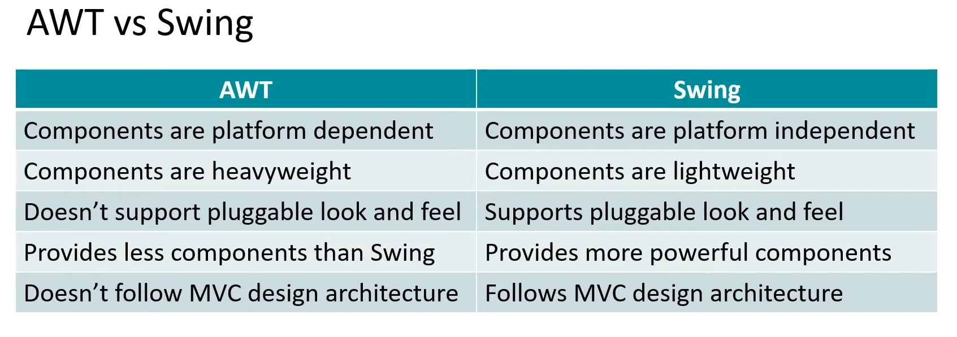
S

MVC or Model-View-Controller Pattern
- Software architecture pattern that separates the model, the UI, and control logic of an application in three distinct components

Model
- representation of domain data
- business logic
- persistence mechanism

View
- UI
- interaction elements
- presents the model in a suitable and human-friendly representation

Controller
- intermediary between the Model and the View
- Maps user actions to model actions
- responsible for receiving and handling events

Benefits
- organization
- rapid application development
- code reuse
- parallel development
- presents the same information in different ways
- the views and applications behavior should reflect the manipulations of data immediately
- allows different user interface standards or port it to to other environments where the application codes should not be affected

MVC Control Flow

- The user performs an action on the interface
- The controller takes the input event
- the controller notifies the user action to the model which may involve a change of the model’s state
- it generates a new view. The view takes the data model.
- The UI waits for another user interaction, which starts a new cycle.

MVC and Java GUI

Model
- made by the developer

View
- set of objects of classes that inherit from java.awt.Component

Controller
- the event processing thread which captures and propagates the event to the view and model
- uses classes of events that implements EventListener type interfaces

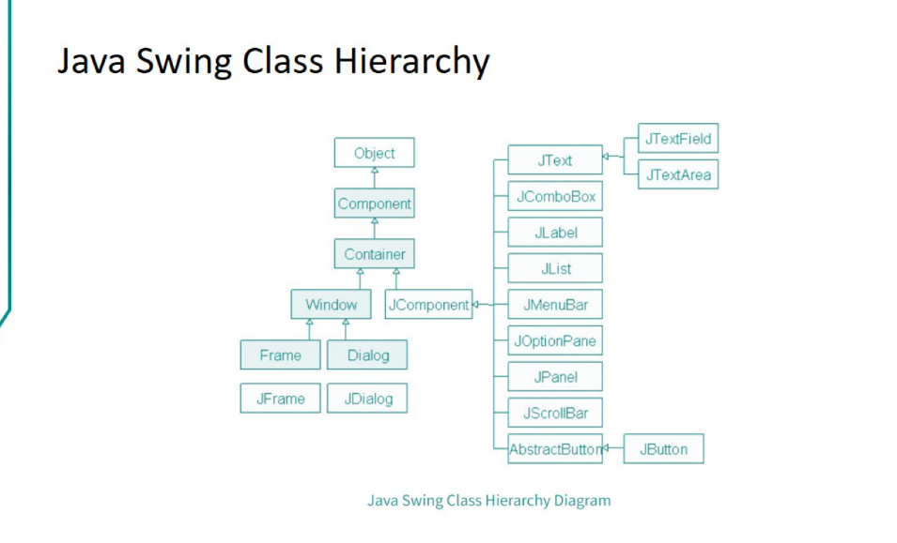
s

Java Event Handling

- Events are generated as a result of user interaction with the GUI components such as clicking and entering a char
- Event handling is the mechanism that controls the event and decides what should happen if an event occurs. This mechanism has a code which is known as an event handler, that is executed when an event occurs.
- Java uses the Delegation Event Model to handle the events. This model defines the standard mechanism to generate and handle the events.

Types of Events
- Foreground Events – these events require direct interaction with the user.
- Background Events – these events require indirect interaction of the end user. OS interrupts, hardware or software failure, and even operation completion.

Delegation Event Model Participants

Source
- the source is an object on which the event occurs
- responsible for providing information of the occurred event to it’s handler

Listener
- it is also known as event handlersresponsible for generating a response to an event
- the listener is an object that waits until it receives an event. Once the event is received, the listener processes the event and then returns.
- In this model, the listener needs to be registered with the source object so that the listener can receive the event notification.

Steps Involved

Step 1 – The user clicks the button and the event is generated

Step 2 – The object of concerned event class is created automatically and information about the source and the event get populated within the same object

Step 3 – Event object is forwarded to the method of the registered listener class

Step 4 – the method gets executed and returns

Containers

A container provides a space where a component can be placed.

Subclasses of Container are called as Containers:
- E.g., Jpanel and Jframe
- A default layout is present in each container which can be overridden using the setLayout method.

JFrame
- provides the basic top-level window you create for an applications.
- It provides a design or drawing area and a title bar, including a platform-specific window decorations.

JWindow Class
- a container that can be displayed anywhere on the user’s desktop
- does not have the title bar, window-management buttons, or other trimmings associated with a JFrame, but it is still a “first-class citizen” of the user’s desktop, and can exist anywhere on it

JPanel Class
- a generic lightweight container used to group GUI components together, simplifying layout and putting borders around groups of components.
- Constructors:

