Network Components

Every computer on a network is called a host or end device. The term hosts specifically refers to devices on the network that are assigned an IP.

Servers are computers that provide information to end devices:
- email servers
- web servers
- file servers

Clients are computers that send requests to the servers to retrieve information

Peer-to-Peer

It is possible for one computer to be a client and a server at the same time. In SOHOs, many computers function as the servers and clients on the network. This type of network is called a peer-to-peer network

Advantages:
- easy to set up
- less complex
- lower cost because network devices and servers are not required
- can be used for simple tasks such as transferring files

Disadvantages
- no centralized administration
- not as secure
- not scalable
- all devices may be both clients and servers which can slow performance

End Devices

Each end device on a network has an IP address. When an end device initiates communication, it uses the address of the destination end device to specify where to deliver the message.

An end device is either the source or destination of a message transmitted over the network.
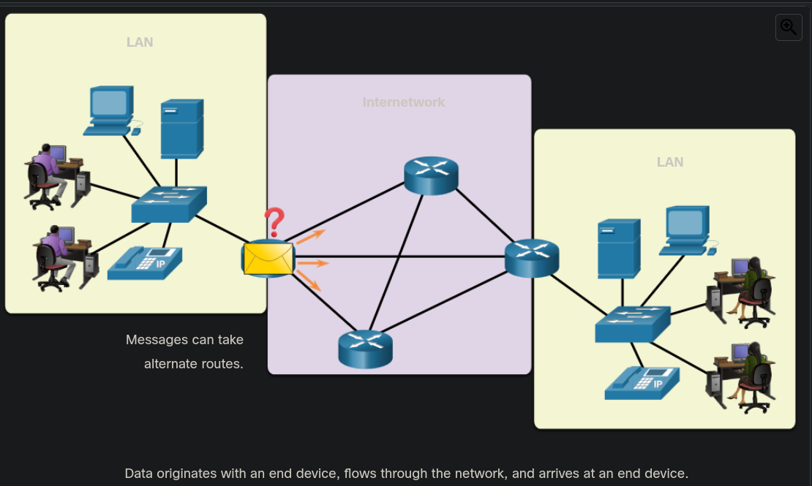
D

Intermediary Network Devices

Intermediary devices connect the individual end devices to the network. They can connect multiple individual networks to form an internetwork. These intermediary devices provide connectivity and ensure that data flows across the network.

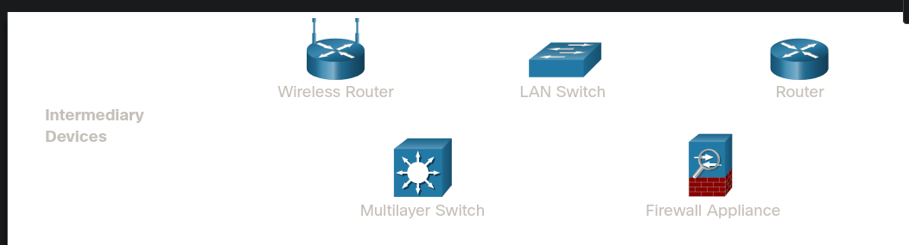
S

- Regenerate and re-transmit communication signals
- Maintain information about what pathways exist through the network and internetwork
- Notify other devices of errors and communication failures
- Direct data along other alternate pathways when there is a link failure
- Classify and direct messages according to priorities
- Permit or deny the flow of data, based on security settings

Network Media

Communication transmits across a network on media. The media provides the channel over which the message travels from source to destination.

Modern networks use:

- Metal wire within cables (Twisted pairs) – data is encoded into electrical impulses
- Glass or plastic fibers within cables (fiber-optic cable) – data is encoded into pulses of light
- Wireless transmission – data is encoded via modulation of specific frequencies of electromagnetic waves.

The four main criteria for choosing network media are:

- Maximum distance of the media to carry a signal
- What is the environment
- What is the amount of data and at what speed must it be transmitted
- What is the cost of the media and installation

Network Representations

A diagram provides an easy way to understand how devices connect. This is a topology diagram.

- Network Interface Card or NIC – an NIC physically connects the end device to the networks
- Physical Port – a connector or outlet on a networking device where the media connects to an end device or another networking device
- Interface- specialized ports on a networking device that connect to individual networks. Because routers connect networks, the ports on a router are referred to as network interfaces.

Often the terms port and interface are used interchangeably.

Topology Diagrams

Physical topology illustrate the physical location of intermediary devices and cable installation.

Logical topology diagrams illustrate devices, ports, and the addressing scheme of the network. Basically, the data flow within the network.

Networks of Many Sizes

Networks come in all sizes.

Small Home Networks – connect a few computers to each other and the Internet

Small Office / Home Office or SOHO – enables computers within a home or remote office to connect to a corporate networking

Medium to Large Network – many locations with hundreds or thousands of interconnected computers

World Wide Networks – connects hundreds of millions of computers of world-wide—such as the Internet

LANs and WANs

Network infrastructures vary greatly in terms of:

- Size of the are covered
- Number of users connected
- Number and types of services available
- Area of responsibility

Two most common types of networks

- LAN and WAN

Local Area Network or LANs

A LAN is a network infrastructure that spans a small geographical area
- Interconnect end devices in a limited area
- administered by a single organization or individual. Administrative control is enforced at the network level and governs the security and access control policies
- provide high-speed bandwidth to internal devices

A WAN is a network infrastructure that spans a wide geographical area. WANs are typically managed by service providers or SP or Internet Service Providers or ISPs
- Interconnect LANs over wide geographical areas
- typically administered by one or more service providers
- typically provide slower speed links between LANs.

The Internet

The internet is a worldwide collection of interconnected LANs and WANs

LANs are connected to each other using WANs

WANs may use copper wires, fiber optic cables, and wireless transmission

The Internet is not owned by any individual or group. The following groups were developed to help maintain structure on the Internet:

- IETF
- ICANN
- IAB

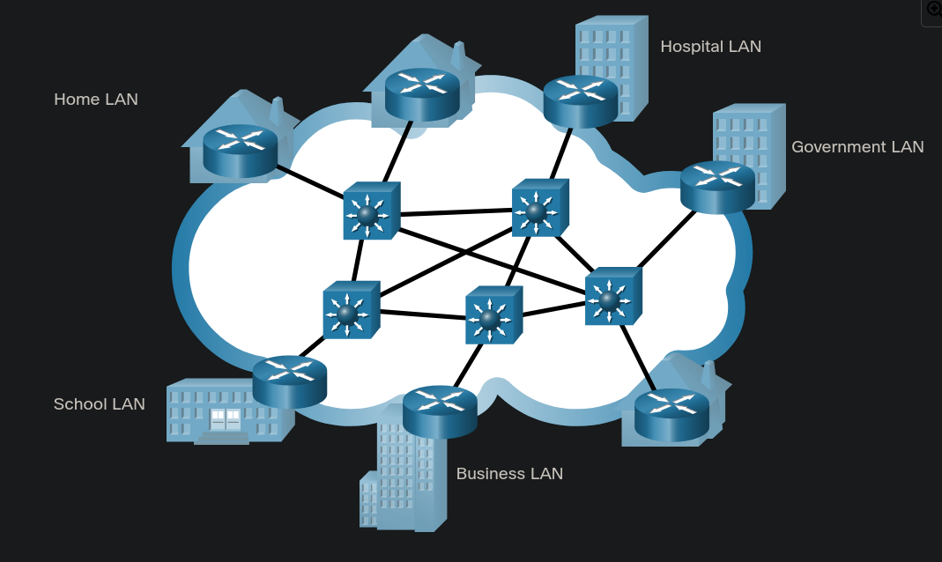
sdasda

Intranets and Extranets

Intranet is a term often used to refer to a private connection of LANs and WANs that belong to an organization. An intranet is designed to be accessible only by the organization’s members, employees, or others with authorization.

An organization might use an extranet to provide secure access to their network for individuals who work for a different organization that need access to their data on their network.

Internet – resources are accessible by everyone

