Motion
- a continuous change in position.

Position and Displacement

- Position is measured relative to a reference point:
- Ex. The origin, or zero point, of the x-axis
- With respect to the origin, we can determine the direction of motion either in the negative or positive direction.
- A change in position is called displacement (vector quantity).

When an object moves from x1 to x2, then it is said to undergo displacement.

unit is: meters

In this arrangement, the distance covered is irrelevant as displacement only considers the final and initial position

Average Velocity
- it is the ratio of displacement to the time interval which the displacement occurred. It is a vector quantity.

unit: m/s

In an x-t graph, it is the slope of the x-t graph.

An x-t graph is the graph of the position relative to time.

Average Speed
- is the ratio of the total distance covered to the time interval in which the distance was covered. It is a scalar quantity.

Instantaneous Velocity
- velocity at a given instant of time. It is a vector quantity. Obtained from average velocity by making very very short.

Acceleration
- acceleration is the change in velocity of a particle with respect to time. It is a vector quantity.
- basically when something “speeds up” or “speeds down.”

unit:

It is the slope of the v-t graph.

Average acceleration

Instantaneous acceleration

EQUATIONS OF KINEMATICS WITH CONSTANT ACCELERATION

SUVAT equations.

Equation for final position:

Equation for final velocity:

Equation for average velocity:

Equation for displacement using average velocity and time

Equation for final velocity squared:

FREE FALL

In the absence of air resistance, it is found that all bodies at the same location above the Earth fall vertically with the same acceleration.

If the distance of the fall is small compared to the radius of the Earth, then the acceleration remains essentially constant throughout descent.

This idealized motion is called free-fall and the acceleration of a freely falling body is called acceleration due to gravity.

This means that falling bodies increase velocity by 9.8 m/s

Freely falling bodes are either thrown vertically upward or released vertically downward under the action of their own weight.

The negative sign indicates direction where usually the downward direction indicates negative as an object is being thrown downward.

Note:

- an object thrown upward slows down and stops at the maximum height

- then it begins to fall with an acceleration equal to g.

- at a given displacement along the path of motion, magnitude of upward velocity is the same as magnitude of downward velocity, but they point in opposite directions.

- for that displacement, we say that there is symmetry, time the object goes up is the same as the time it goes down.

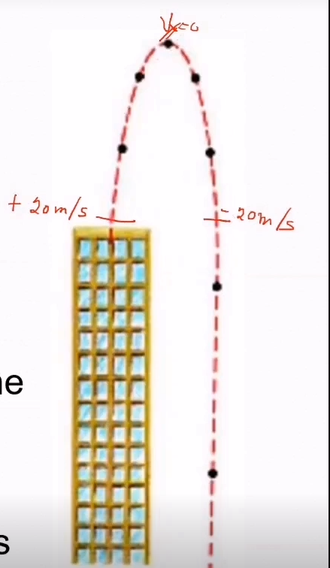

Equations of Free-fall

The same as the equations of kinematics but a = g

CIRCULAR MOTION

Uniform circular motion is the motion of an object traveling at a constant speed on a circular path

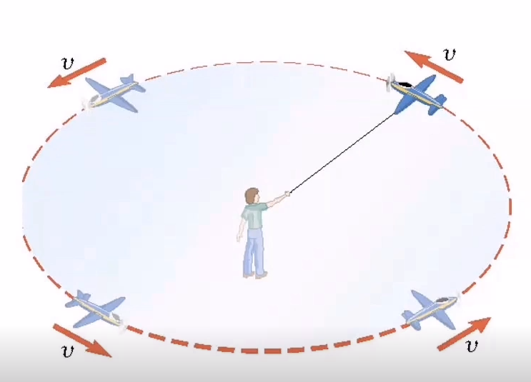

Let T be the time it takes for the object to travel once around the circle.

Basically, the entire distance that an object traverses for a circular motion is the circumference of the circle.

Frequency (f) – number of revolutions an object makes per unit of time

Period (T) = time for an object to complete one revolution

In uniform circular motion, the speed is constant, but the direction of the velocity vector is not constant.

