HW_2_3e.R

ermak

2025-02-15

n_simulations <- 10000  
n_rolls <- 100  
  
chi_squared_values <- numeric(n_simulations)  
  
for (i in 1:n_simulations) {  
 sample_rolls <- sample(1:6, n_rolls, replace = TRUE)  
   
 observed_counts <- table(factor(sample_rolls, levels = 1:6))  
   
 expected_count <- n_rolls / 6  
   
 chi_squared_values[i] <- sum((observed_counts - expected_count)^2 / expected_count)  
}  
  
hist(chi_squared_values, main = "Histogram of Chi-Squared Values (Simulations)",  
 xlab = "Chi-Squared Value", col = "lightblue", breaks = 50)

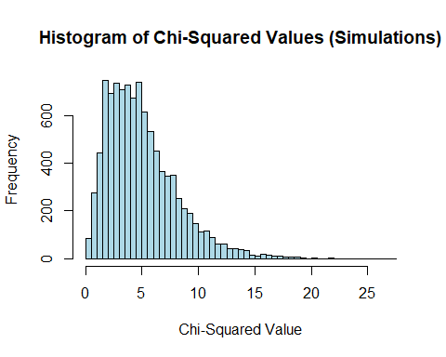

observed_chi_squared <- 11.24  
p_value <- mean(chi_squared_values >= observed_chi_squared)  
  
cat("Proportion of samples with chi-squared value at least as large as the observed:", p_value, "\n")

## Proportion of samples with chi-squared value at least as large as the observed: 0.045