TECHNICAL SPECIFICATION
POS Terminal Integration with HP Avatar Server
1. System Architecture and User Journey
Key Concept: Guest registration and user database management are hosted on our side. After registration, the system waits for a ticket sale event (activation token) from the POS terminal to enable RFID wristband binding to a child profile in our game system (to preserve game progress across interactive park attractions).

User Flow Diagram:
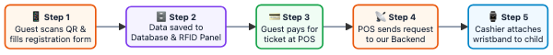
Step 1. Guest fills out registration form (on our side)
Upon entering the park, the guest scans a QR code with their smartphone and accesses a mobile web registration form. In the form, the guest:
- Enters phone number and verifies it via SMS.
- Agrees to park rules and loyalty program terms.
- Enters parent's full name and adds children details (name, date of birth).
Step 2. Data is stored in our database and appears in RFID Panel
Upon form submission, family data is automatically saved to our database and instantly appears in the web interface of the RFID Cashier Panel.
The RFID Cashier Panel is a web application running on the cashier's computer at the park. It displays a list of registered guest accounts:
- Parent Account: Full name, phone number.
- Linked Children: Name, date of birth, wristband status (Avatar / Bracelet / None).
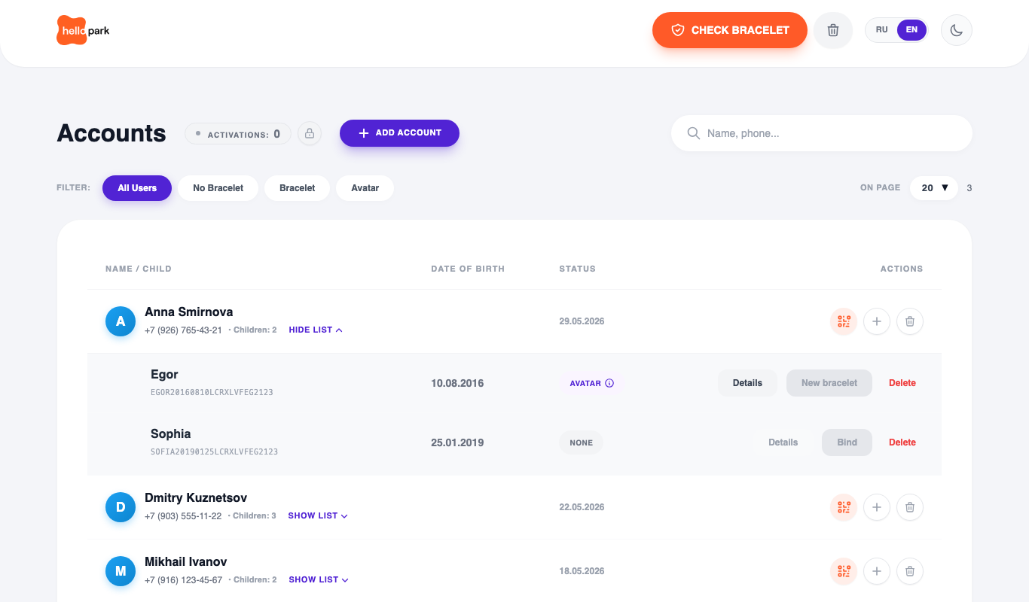
Fig. 1 — RFID Cashier Panel (registered accounts table)
Step 3. Guest pays for ticket at POS
The guest approaches the ticket desk and pays for admission tickets. At this stage, the cashier cannot bind a wristband to a child because no activation token is available yet.
The activation token is an authorization grant for wristband binding. It appears in the RFID panel only after the POS terminal confirms the payment by sending a request to our backend. Without an activation token, the wristband binding action is locked. This ensures wristbands are only issued to paying guests.
Step 4. POS terminal sends request to our backend (Integration)
This is the only step requiring implementation on the POS software side. Immediately after receipt fiscalization/printing, the POS terminal sends a single simple HTTP POST request to our server (see specification in Section 2.1 below).
Step 5. Cashier binds wristband to child
Upon receiving the event from the POS terminal, the activation token appears instantly in the RFID panel (available wristband counter increments). The cashier:
- Selects the child from the list.
- Taps a clean RFID wristband against the desktop USB/RFID reader.
- The wristband is linked to the child's profile — the child can now enter and play.
2. API Request Specifications
2.1 Receiving Payment Data from POS Terminal
The POS vendor must implement sending a ticket payment signal to our local server.
- When to send: Immediately upon successful payment and receipt printing/fiscalization on the POS terminal.
- Trigger condition: When the receipt contains at least 1 admission ticket (item from the 'Tickets' category). If the receipt contains only bar/café items or merchandise, no request is sent.
Request:
- Method: POST
- URL: https://<HP_LOCAL_SERVER_URL>/api/v1/pos/events
- Headers:
- Content-Type: application/json; charset=utf-8
- Authorization: Bearer <API_SECRET_KEY> — secret authorization token for the POS (provided by us upon connection). Without a valid key, the server rejects the request with HTTP 401 Unauthorized.
JSON Payload:
{
"receipt_number": "12345",
"count": 2
}

Parameters Description:
Parameter | Type | Required | Description & Example
receipt_number | String | Yes | Printed receipt number (e.g., "12345" or "00123")
count | Integer | Yes | Total number of paid tickets in the receipt (e.g., 1, 2, 3)

Server Response Format:
Upon successful processing, the backend responds with 200 OK:
{
"status": "ok"
}

If the authorization token is missing or invalid, the server responds with 401 Unauthorized and rejects the operation.
Fault Tolerance & Retries:
- Idempotency (Duplicate Protection): Transactions are uniquely identified by receipt_number. If a network timeout causes the POS terminal to retry sending the same receipt, the system will not create duplicate activation credits and will safely return 200 OK.
- Offline Queue on POS: If the backend is temporarily unreachable when closing a receipt, the POS module must store the payload in a local queue and automatically retry sending once connectivity is restored.
2.2 Guest Lookup & Authorization at POS
If the POS terminal needs to retrieve guest data, it sends a GET request to our cloud server:
GET https://<HP_SERVER>/api/user

The request parameter can be either:
- User ID (scanned from the QR code shown to the guest upon registration)
- Phone number
In response, our cloud returns the guest profile and linked children data.
2.3 Turnstiles and Access Control System (ACS / Time Tracking)
After wristband assignment, our system can send a notification request to a third-party Access Control System (ACS / Turnstiles):
POST request with parameters:
- user_id — User / Child identifier
- rfid — RFID wristband number
- date — Registration timestamp / date
2.4 New Guest Registration Webhook (CRM Integration)
Upon registration of a new guest, our server can trigger a webhook on a third-party CRM system to transfer user profile details:
- ID in our system (user_id)
- Contact details (phone number)
- Profile data (full name, gender, age, date of birth)

