**Полюга Дмитро Сергійович, ТІ-62**

**Варіант 13(10, 1, 2, 1, 2, 1)**

**Граматика мови програмування**

<program> ::= <declaration_list> begin <operators_list> end

<declaration_list> ::= <declaration_list> <declaration> ; | <declaration> ;

<declaration> ::= <variable_type> <variables_list>

<variable_type> ::= int | float

<variables_list> ::= <identifier> | <identifier> , <variables_list>

<operators_list> ::= <operators_list> <operator> ; | <operators_list> <label> : | <operator> ; | <label> :

<operator> ::= <assignment> | <user_input> | <user_output> | <loop> | <conditional_statement> | goto <label>

<user_input> ::= cin >> <identifier> | <user_input> >> <identifier>

<user_output> ::= cout << <identifier> | <user_output> << <identifier>

<loop> ::= for <identifier> = <expression> by <expression> to <expression> do: <operators_list> rof

<conditional_statement> ::= if <LR> then: <operators_list> fi

<assignment> ::= <identifier> = <expression>

<expression> ::= <T> | <expression> + <T> | <expression> - <T> | - <T>

<T> ::= <F> | <T> * <F> | <T> / <F>

<F> ::= <identifier> | <constant_fixed_accuracy> | ( <expression> )

<identifier> ::= <identifier> <character> | <identifier> <digit> | <character>

<character> ::= A | B | C | D | E | F | G | H | I | J | K | L | M | N | O | P | Q | R | S | T | U | V | W | X | Y | Z | a | b | c | d | e | f | g | h | i | j | k | l | m | n | o | p | q | r | s | t | u | v | w | x | y | z

<digit> ::= 0 | 1 | 2 | 3 | 4 | 5 | 6 | 7 | 8 | 9

<constant_fixed_accuracy> ::= <number> | . <number> | <number> . | <number> . <number>

<number > ::= <digit> | <number> <digit>

<LR> ::= <LR> or <LT> | <LT>

<LT> ::= <LT> and <LF> | <LF>

<LF> ::= <relation> | [ <LR> ] | not <LF>

<relation> ::= <expression> <relation_sign> <expression>

<relation_sign> ::= < | > | <= | >= | == | !=

<label> ::= # <identifier>

**Таблиця лексем мови програмування**

|  |  |
| --- | --- |
| Id | Name |
| 1 | int |
| 2 | float |
| 3 | begin |
| 4 | end |
| 5 | goto |
| 6 | cin |
| 7 | cout |
| 8 | for |
| 9 | by |
| 10 | to |
| 11 | do |
| 12 | rof |
| 13 | if |
| 14 | then |
| 15 | fi |
| 16 | ; |
| 17 | : |
| 18 | , |
| 19 | = |
| 20 | >> |
| 21 | << |
| 22 | > |
| 23 | < |
| 24 | >= |
| 25 | <= |
| 26 | == |
| 27 | != |
| 28 | + |
| 29 | - |
| 30 | * |
| 31 | / |
| 32 | ( |
| 33 | ) |
| 34 | or |
| 35 | and |
| 36 | not |
| 37 | [ |
| 38 | ] |
| 100 | IDN |
| 101 | CON |
| 102 | LAB |

**Показовий приклад програми**

float a, d, sum;  
 int q;  
 int i;  
begin  
 q = 56;  
 a = 1.2;  
 d = .7;  
 if a > 1 and q < 50 then:  
 goto #f;  
 fi;  
 a = (q + a + d) / 100;  
 #f:  
 sum = a / d + 1.2 * q;  
 for i = 20 by 1 to 30 do:  
 cout << i;  
 rof;  
end

**Вихідні таблиці лексичного аналізатора**

|  |  |  |  |  |  |  |
| --- | --- | --- | --- | --- | --- | --- |
| Token number | Line number | Token | IDN id | CON id | LAB id | TOK id |
| 0 | 0 | float |  |  |  | 2 |
| 1 | 0 | a | 0 |  |  | 100 |
| 2 | 0 | , |  |  |  | 18 |
| 3 | 0 | d | 1 |  |  | 100 |
| 4 | 0 | , |  |  |  | 18 |
| 5 | 0 | sum | 2 |  |  | 100 |
| 6 | 0 | ; |  |  |  | 16 |
| 7 | 1 | int |  |  |  | 1 |
| 8 | 1 | q | 3 |  |  | 100 |
| 9 | 1 | ; |  |  |  | 16 |
| 10 | 2 | int |  |  |  | 1 |
| 11 | 2 | i | 4 |  |  | 100 |
| 12 | 2 | ; |  |  |  | 16 |
| 13 | 3 | begin |  |  |  | 3 |
| 14 | 4 | q | 3 |  |  | 100 |
| 15 | 4 | = |  |  |  | 19 |
| 16 | 4 | 56 |  | 0 |  | 101 |
| 17 | 4 | ; |  |  |  | 16 |
| 18 | 5 | a | 0 |  |  | 100 |
| 19 | 5 | = |  |  |  | 19 |
| 20 | 5 | 1.2 |  | 1 |  | 101 |
| 21 | 5 | ; |  |  |  | 16 |
| 22 | 6 | d | 1 |  |  | 100 |
| 23 | 6 | = |  |  |  | 19 |
| 24 | 6 | 0.7 |  | 2 |  | 101 |
| 25 | 6 | ; |  |  |  | 16 |
| 26 | 7 | if |  |  |  | 13 |
| 27 | 7 | a | 0 |  |  | 100 |
| 28 | 7 | > |  |  |  | 22 |
| 29 | 7 | 1 |  | 3 |  | 101 |
| 30 | 7 | and |  |  |  | 35 |
| 31 | 7 | q | 3 |  |  | 100 |
| 32 | 7 | < |  |  |  | 23 |
| 33 | 7 | 50 |  | 4 |  | 101 |
| 34 | 7 | then |  |  |  | 14 |
| 35 | 7 | : |  |  |  | 17 |
| 36 | 8 | goto |  |  |  | 5 |
| 37 | 8 | #f |  |  | 0 | 102 |
| 38 | 8 | ; |  |  |  | 16 |
| 39 | 9 | fi |  |  |  | 15 |
| 40 | 9 | ; |  |  |  | 16 |
| 41 | 10 | a | 0 |  |  | 100 |
| 42 | 10 | = |  |  |  | 19 |
| 43 | 10 | ( |  |  |  | 32 |
| 44 | 10 | q | 3 |  |  | 100 |
| 45 | 10 | + |  |  |  | 28 |
| 46 | 10 | a | 0 |  |  | 100 |
| 47 | 10 | + |  |  |  | 28 |
| 48 | 10 | d | 1 |  |  | 100 |
| 49 | 10 | ) |  |  |  | 33 |
| 50 | 10 | / |  |  |  | 31 |
| 51 | 10 | 100 |  | 5 |  | 101 |
| 52 | 10 | ; |  |  |  | 16 |
| 53 | 11 | #f |  |  | 0 | 102 |
| 54 | 11 | : |  |  |  | 17 |
| 55 | 12 | sum | 2 |  |  | 100 |
| 56 | 12 | = |  |  |  | 19 |
| 57 | 12 | a | 0 |  |  | 100 |
| 58 | 12 | / |  |  |  | 31 |
| 59 | 12 | d | 1 |  |  | 100 |
| 60 | 12 | + |  |  |  | 28 |
| 61 | 12 | 1.2 |  | 1 |  | 101 |
| 62 | 12 | * |  |  |  | 30 |
| 63 | 12 | q | 3 |  |  | 100 |
| 64 | 12 | ; |  |  |  | 16 |
| 65 | 13 | for |  |  |  | 8 |
| 66 | 13 | i | 4 |  |  | 100 |
| 67 | 13 | = |  |  |  | 19 |
| 68 | 13 | 20 |  | 6 |  | 101 |
| 69 | 13 | by |  |  |  | 9 |
| 70 | 13 | 1 |  | 3 |  | 101 |
| 71 | 13 | to |  |  |  | 10 |
| 72 | 13 | 30 |  | 7 |  | 101 |
| 73 | 13 | do |  |  |  | 11 |
| 74 | 13 | : |  |  |  | 17 |
| 75 | 14 | cout |  |  |  | 7 |
| 76 | 14 | << |  |  |  | 21 |
| 77 | 14 | i | 4 |  |  | 100 |
| 78 | 14 | ; |  |  |  | 16 |
| 79 | 15 | rof |  |  |  | 12 |
| 80 | 15 | ; |  |  |  | 16 |
| 81 | 17 | end |  |  |  | 4 |

1 – *головна таблиця*

|  |  |
| --- | --- |
| IDN number | IDN |
| 0 | a |
| 1 | d |
| 2 | sum |
| 3 | q |
| 4 | i |

2 – *таблиця ідентифікаторів*

|  |  |  |
| --- | --- | --- |
| CON number | CON | CON type |
| 0 | 56 | int |
| 1 | 1.2 | float |
| 2 | 0.7 | float |
| 3 | 1 | int |
| 4 | 50 | int |
| 5 | 100 | int |
| 6 | 20 | int |
| 7 | 30 | int |

3 – *таблиця констант*

|  |  |
| --- | --- |
| LAB number | LAB |
| 0 | #f |

3 – *таблиця міток*

**Спрощена граматика мови програмування**

program = declaration_list "begin" operators_list "end".

declaration_list = declaration ";" {declaration ";"}.

declaration = type variables_list.

type = "int" | "float".

variables_list = "identifier" ("," variables_list | ).

operators_list = (operator ";" | "label" ":") {operator ";" | "label" ":"}.

operator = assignment | input | output | loop | conditional_statement | "goto" "label".

input = "cin" ">>" "identifier" {">>" "identifier"}.

output = "cout" "<<" "identifier" {"<<" "identifier"}.

loop = "for" "identifier" "=" expression "by" expression "to" expression "do" ":" operators_list "rof".

conditional_statement = "if" LR "then" ":" operators_list "fi".

assignment = "identifier" "=" expression.

expression = (T | "-" T) {"+" T | "-" T}.

T = F {"*" F | "/" F}.

F = "identifier" | "constant_fixed_accuracy" | "(" expression ")".

LR = LT {"or" LT}.

LT = LF {"and" LF}.

LF = relation | "[" LR "]" | "not" LF.

relation = expression relation_sign expression.

relation_sign = ">" | "<" | ">=" | "<=" | "==" | "!=".

**Скінченний автомат у вигляді діаграми станів**

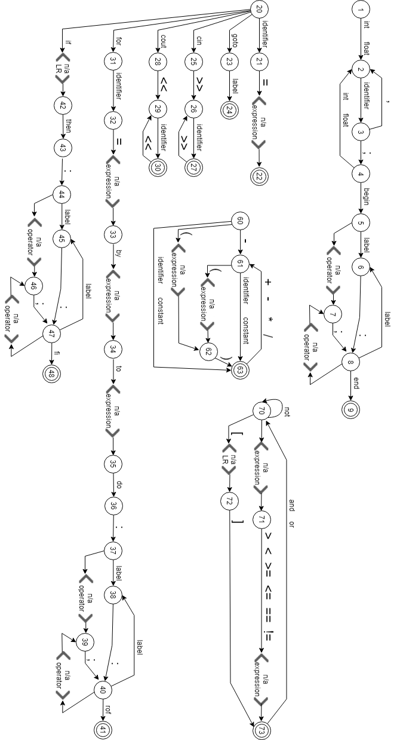

**Скінченний автомат у вигляді таблиці переходів**

|  |  |  |  |  |
| --- | --- | --- | --- | --- |
| **alpha** | **label** | **stack** | **beta** | **semantic subroutine** |
| 1 | int |  | 2 | [≠]err |
| float |  |
| 2 | identifier |  | 3 | [≠]err |
| 3 | , |  | 2 | [≠]err |
| ; |  | 4 |
| 4 | int |  | 2 | [≠]err |
| float |  |
| begin |  | 5 |
| 5 | label |  | 6 | [≠]<п/а operator> ↓7 (b: 20) |
| 6 | : |  | 8 | [≠]err |
| 7 | ; |  | 8 | [≠]err |
| 8 | label |  | 6 | [≠]<п/а operator> ↓7 (b: 20) |
| end |  | 9 |
| 9 |  |  |  | [≠]exit |
| 20 | identifier |  | 21 | [≠]err |
| goto |  | 23 |
| cin |  | 25 |
| cout |  | 28 |
| for |  | 31 |
| if | 42 | 70 (<п/а LR>) |
| 21 | = | 22 | 60 (<п/а expression>) | [≠]err |
| 22 |  |  |  | [≠]exit |
| 23 | label |  | 24 | [≠]err |
| 24 |  |  |  | [≠]exit |
| 25 | >> |  | 26 | [≠]err |
| 26 | identifier |  | 27 | [≠]err |
| 27 | >> |  | 26 | [≠]exit |
| 28 | << |  | 29 | [≠]err |
| 29 | identifier |  | 30 | [≠]err |
| 30 | << |  | 28 | [≠]exit |
| 31 | identifier |  | 32 | [≠]err |
| 32 | = | 33 | 60 (<п/а expression>) | [≠]err |
| 33 | by | 34 | 60 (<п/а expression>) | [≠]err |
| 34 | to | 35 | 60 (<п/а expression>) | [≠]err |
| 35 | do |  | 36 | [≠]err |
| 36 | : |  | 37 | [≠]err |
| 37 | label |  | 38 | [≠]<п/а operator> ↓39 (b: 20) |
| 38 | : |  | 40 | [≠]err |
| 39 | ; |  | 40 | [≠]err |
| 40 | label |  | 38 | [≠]<п/а operator> ↓39 (b: 20) |
| rof |  | 41 |
| 41 |  |  |  | [≠]exit |
| 42 | then |  | 43 | [≠]err |
| 43 | : |  | 44 | [≠]err |
| 44 | label |  | 45 | [≠]<п/а operator> ↓46 (b: 20) |
| 45 | : |  | 47 | [≠]err |
| 46 | ; |  | 47 | [≠]err |
| 47 | label |  | 45 | [≠]<п/а operator> ↓46 (b: 20) |
| fi |  | 48 |
| 48 |  |  |  | [≠]exit |
| 60 | - |  | 61 | [≠]err |
| ( | 62 | 60 (<п/а expression>) |
| identifier |  | 63 |
| constant |  |
| 61 | ( | 62 | 60 (<п/а expression>) | [≠]err |
| identifier |  | 63 |
| constant |  |
| 62 | ) |  | 63 | [≠]err |
| 63 | + |  | 61 | [≠]exit |
| - |  |
| * |  |
| / |  |
| 70 | not |  | 70 | [≠]<п/а expression> ↓71 (b: 60) |
| [ | 72 | 70 (<п/а LR>) |
| 71 | > | 73 | 60 (<п/а expression>) | [≠]err |
| < |
| >= |
| <= |
| == |
| != |
| 72 | ] |  | 73 | [≠]err |
| 73 | and |  | 70 | [≠]exit |
| or |  |