First, we named our shell project **project** as in figure below (attached with this report the shell code):

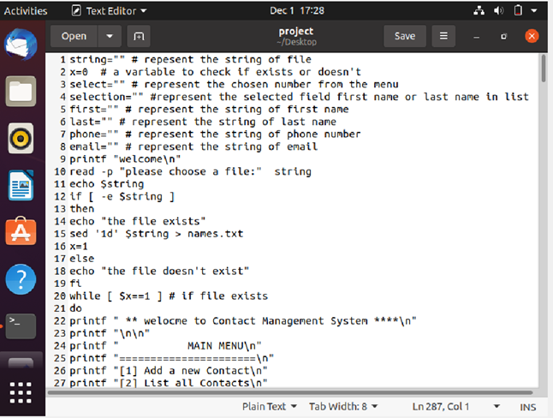

Figure 1

After running the project:

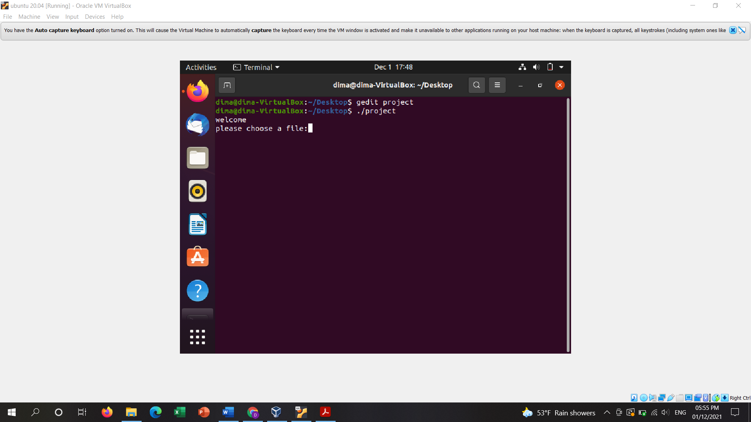

Choosing contact.txt file

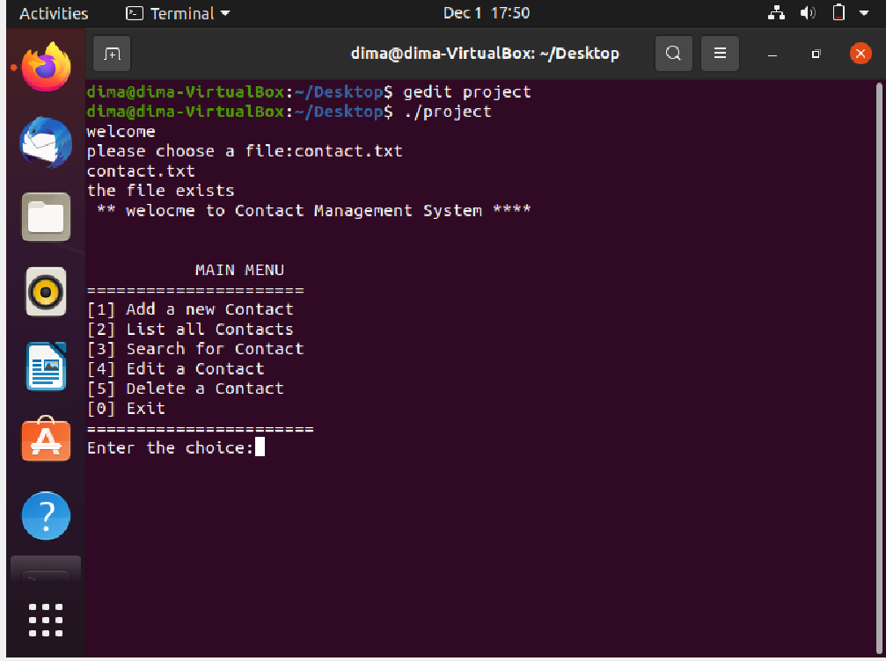

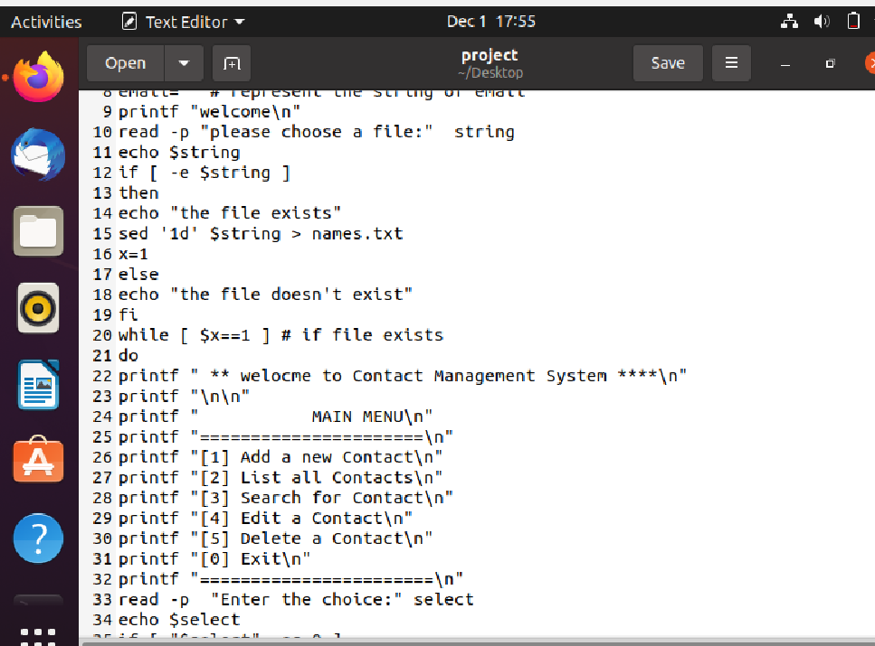After choosing contact.txt it will check whether the file exits or doesn’t exit. Then will print the menu to select an operation from it

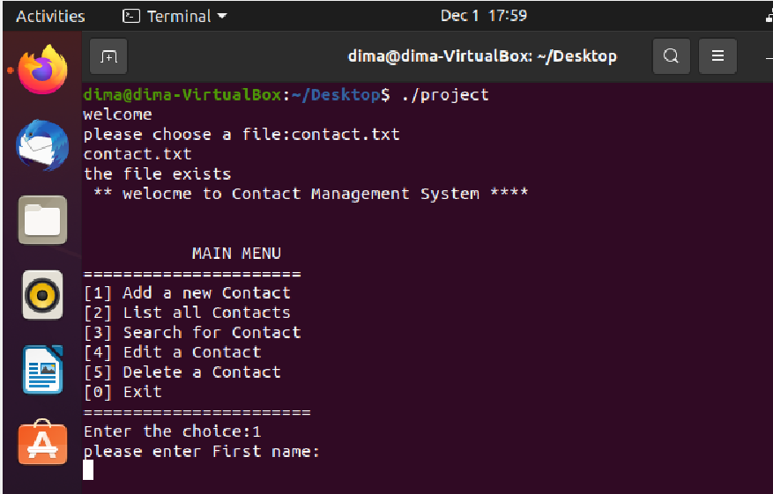First, we select 1 from the menu to add a new contact

I have to enter the first name and it will check if it’s valid or not

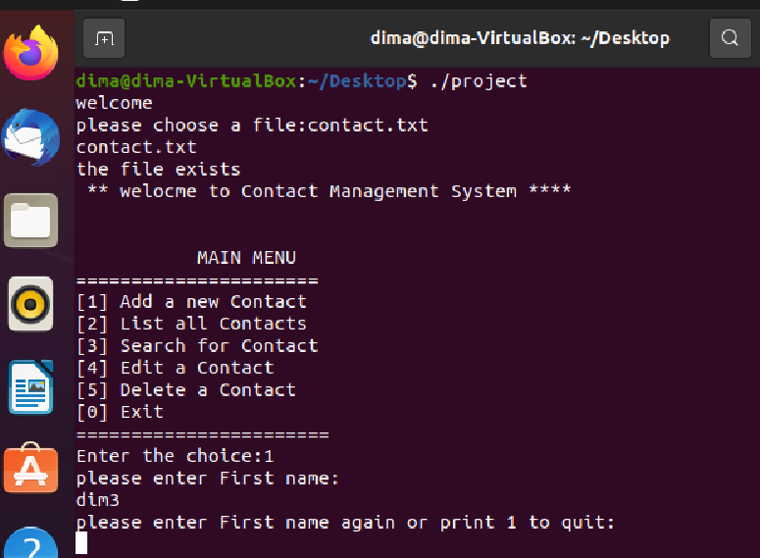

Dim3 is invalid name since it has number in it so the user can write it again or quit if I print 1 it will show the menu again as in figure

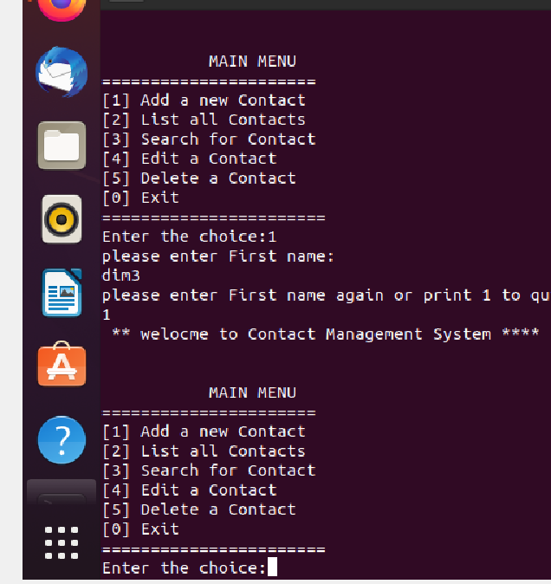

If I write the first name again it will check if it’s valid or not the second time

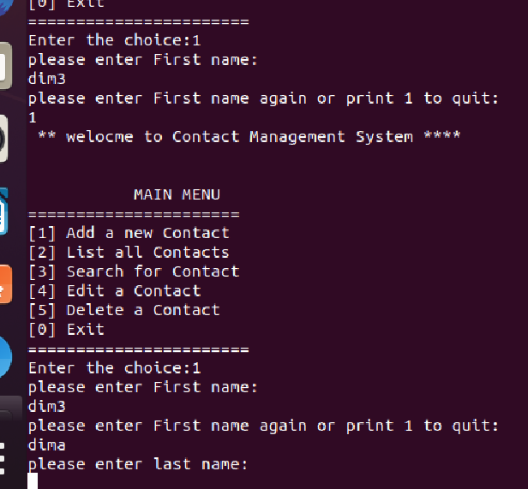

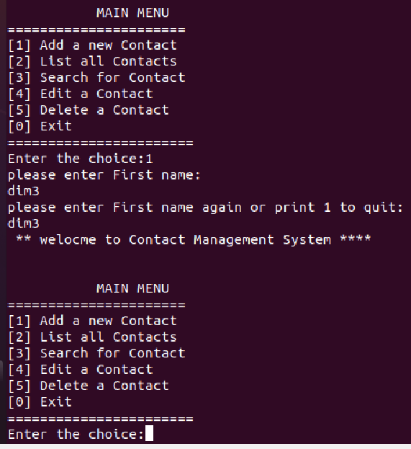If it was not valid for the second time it will get out and write the menu again

all of these steps of checking are in the code with comments down below

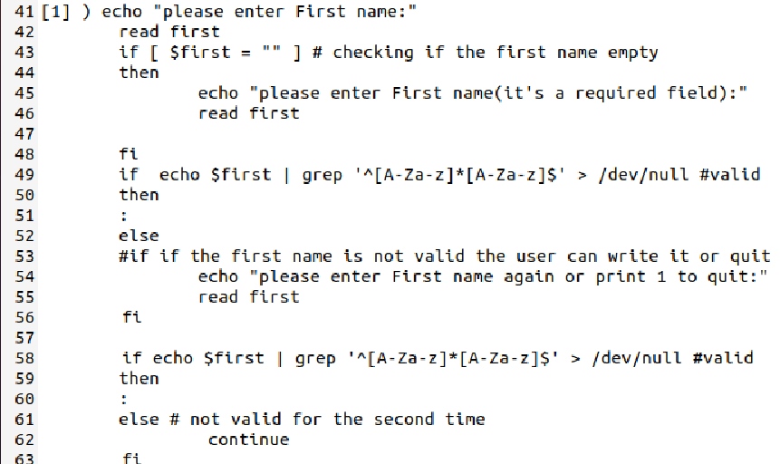

if it was valid I could write the last name or leave it empty since it’s an optional field

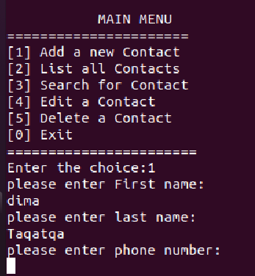

If I leave it empty

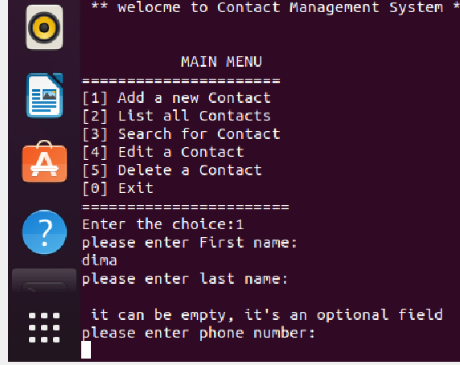

If I wrote it wrong it will give the user the choice to try it again or not

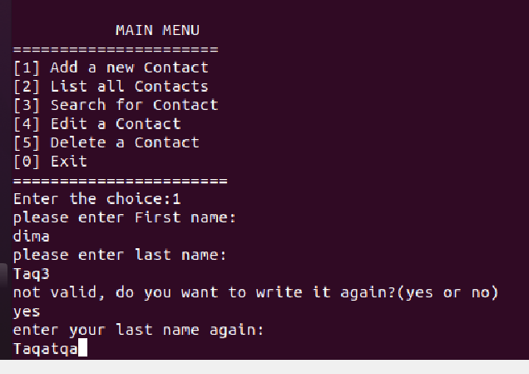

all of these steps of checking are in the code with comments down below

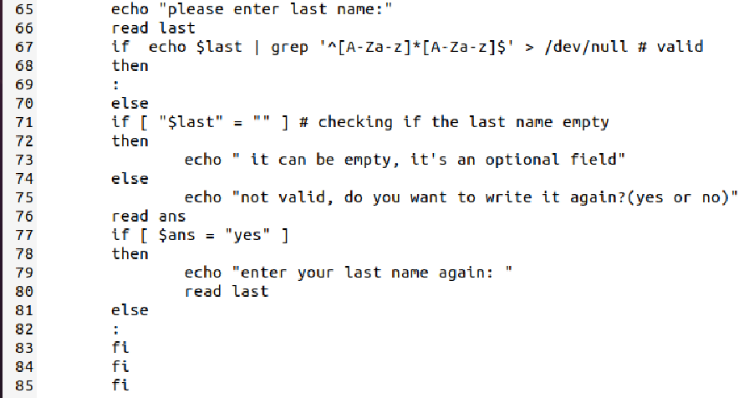

Then the user should write the phone number since it’s a required field and check if it’s valid or not.

Phone number must contain 9 or 10 digits to be valid if it’s not the user should write it again

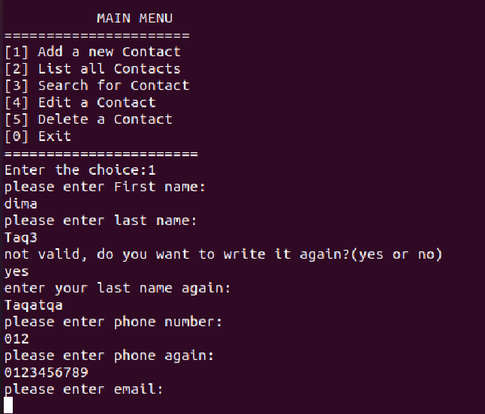

all of these steps of checking are in the code with comments down below

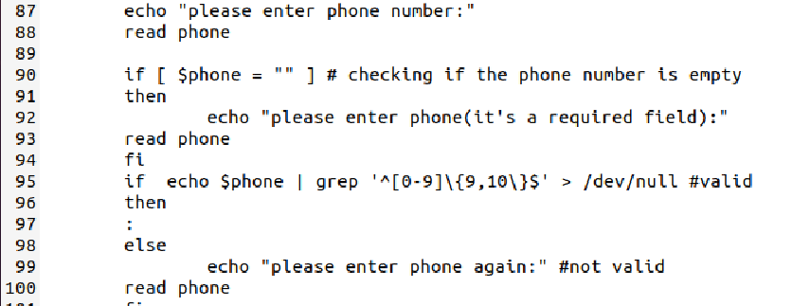

Then the user could write email or not since it’s an optional field and check if it’s valid or not

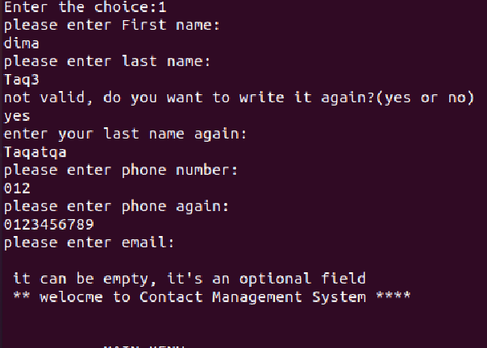

if it was not valid (email pattern is email@gggg.cc) the user should write it again

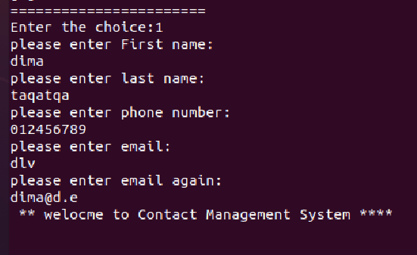

all of these steps of checking are in the code with comments down below

note: contact.txt contains

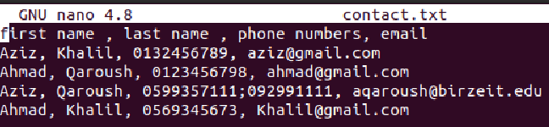

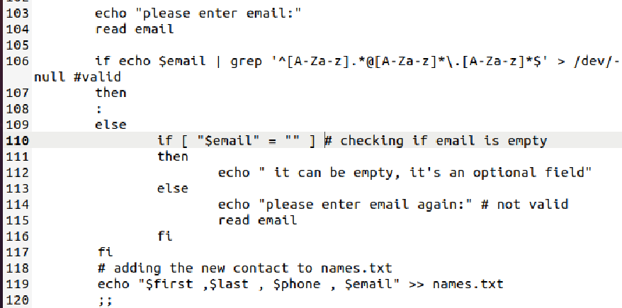

After adding a new contact, the main menu will show again to choose from it again

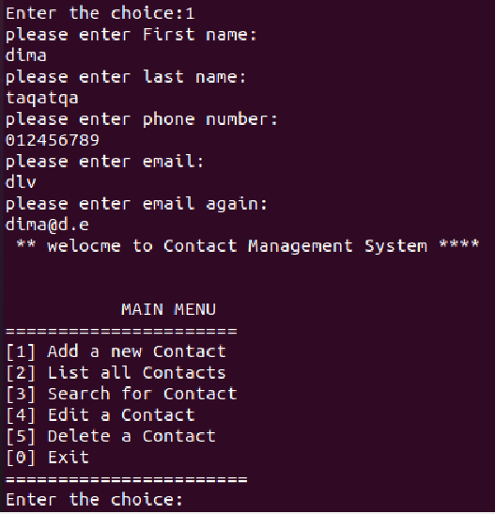

Now we will choose 2 in order to list contacts

It will ask us to list based on first name or last name, if we chose first name for example

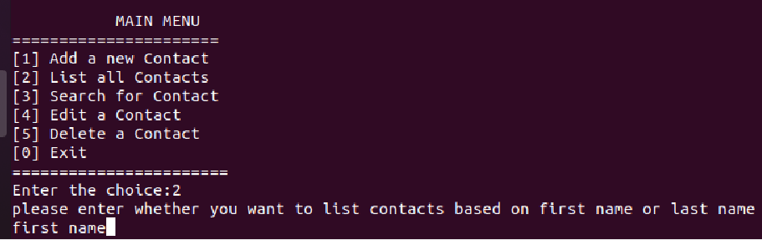

then it will ask us to choose the fields to list

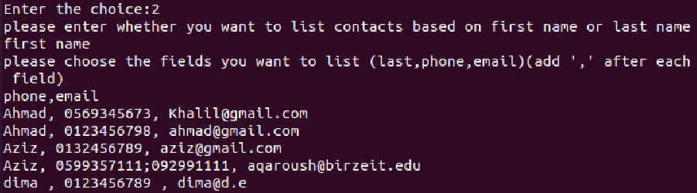

all of these steps of checking are in the code with comments down below

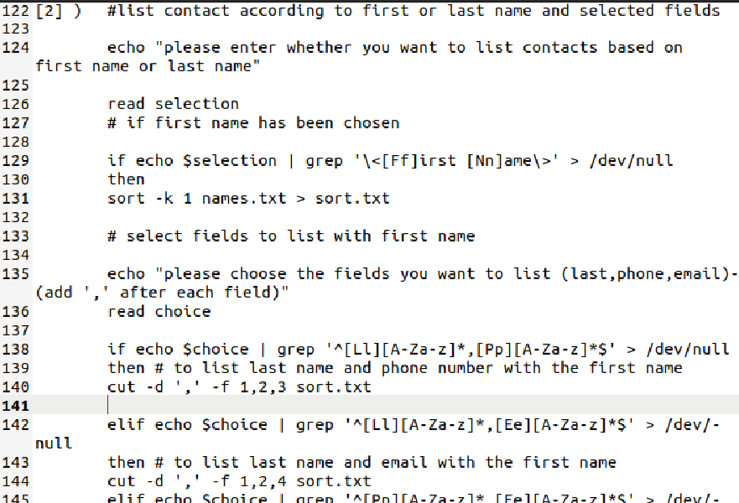

Then the main menu will show again, this time we will choose 3 in order to search for a contact

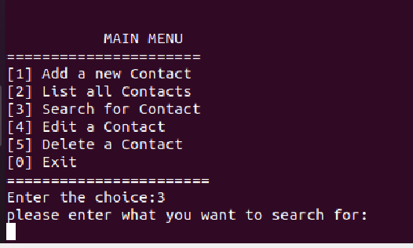

We can search for any contact or part of it and it will search and grep it

For example @birzeit.edu

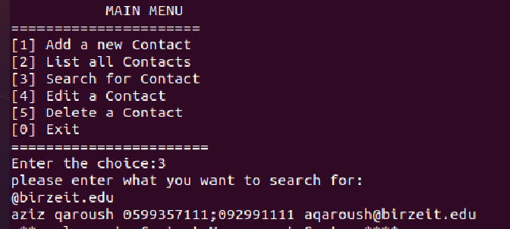

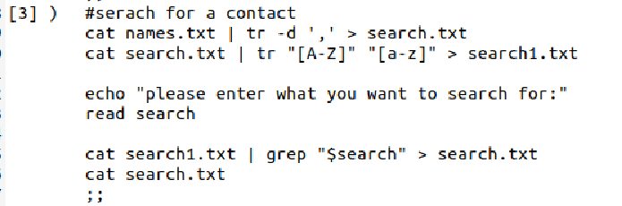code:

The main menu will show again, now we will choose 4 to edit a contact

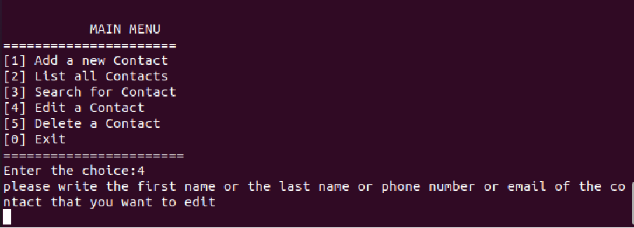

then we write the first name or last name or phone number or email of the contact that we want to edit in order to search for it first

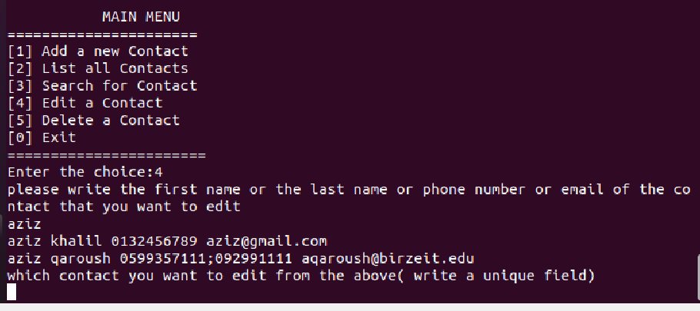

Since there is two contact has the same name the user has to select which one by entering a unique field like phone number or email

Then it will ask the user if he/she want to edit this contact

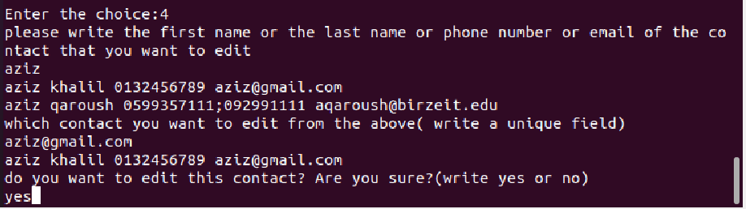

if the answer is yes , a menu of fields will show to choose which field the user want to edit

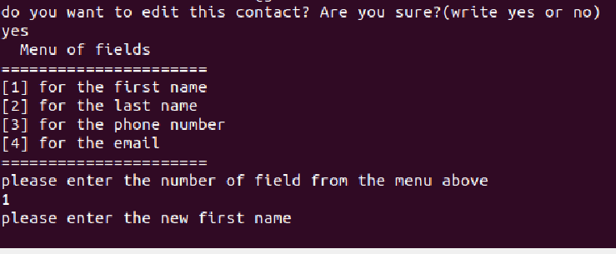

I chose 1 to edit the first name and it will ask the user to enter the new first name

Now **aziz** is the same contact with a new first name **omar and the main menu will show again**

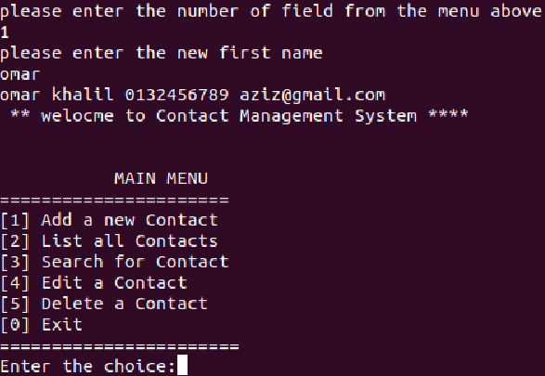

Code:

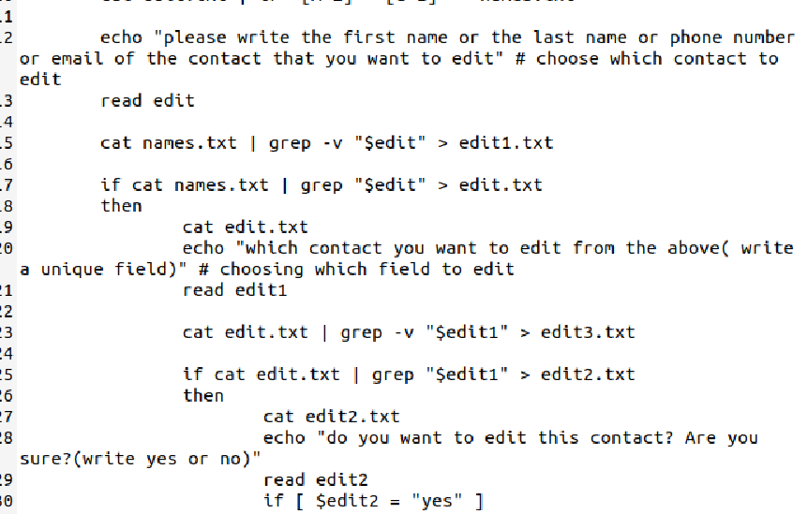

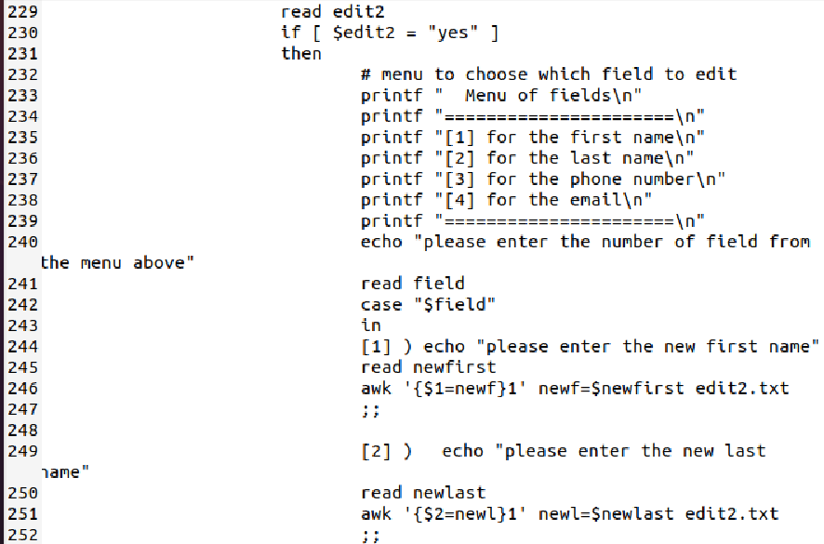

Now I will choose 5 from the menu in order to delete a contact

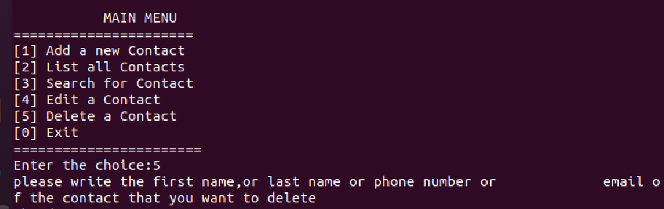

It will ask me to enter a first or last name or phone number or email in order to search for the contact first then delete it. For example, I wrote ahmad

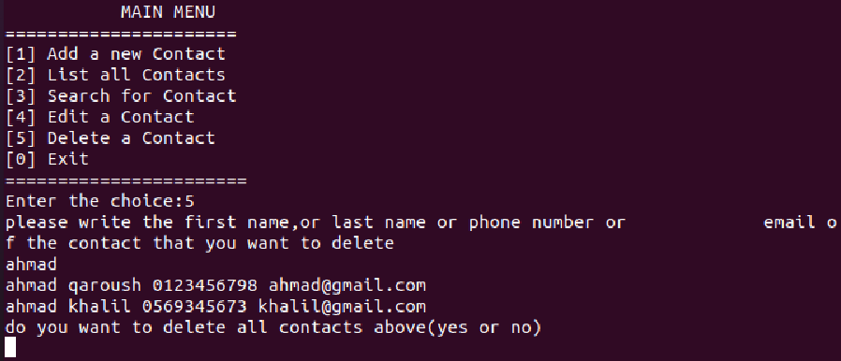

Since there is two ahmad it will ask the user if he\she wants to delete both or one contact

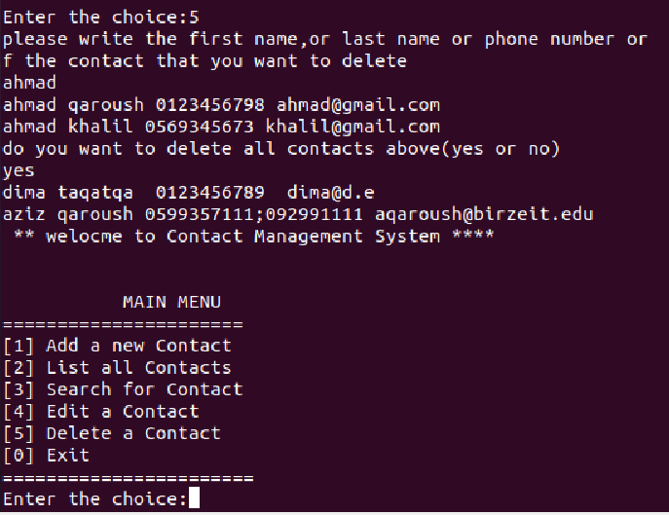

On the figure above after deleting both contacts only two contacts left and the menu will show again

Code: