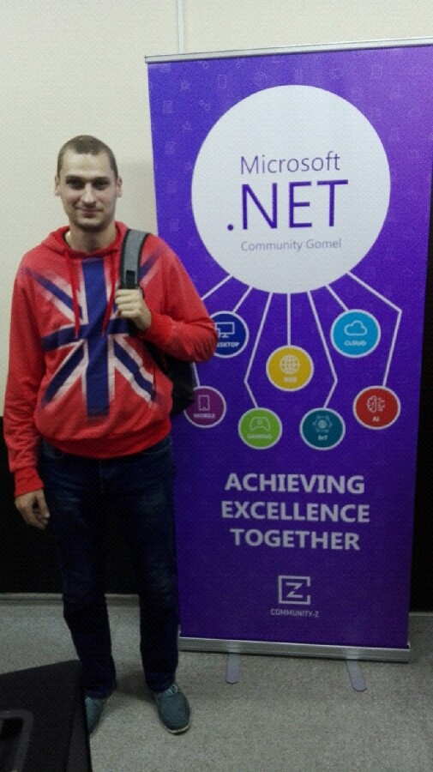 |  | Tereshchenko Dmitriy  Male  Tel.: +375 (44) 797 78 84  Email: dmitriy.tereshchenko1989@mail.ru  Skype: live:.cid.7f101b70b6ca2bdb  Reside in: Gomel  Citizenship: Belarus  Marital status: unmarried
Desired position and salary
Junior .NET developer

Employment: full time
Work schedule: full day

About me:
I studied external training from EPAM company (Gomel).  Programming languages and technologies: C#, WPF, ADO.NET, SQL.  Operating Systems: Windows  Frameworks and Libraries: Entity Framework 6, Entity Framework Core, Ninject, AutoMapper.  Development Environments and Tools: Microsoft Visual Studio, Microsoft SQL Server Management Studio, Visual Studio Code  Application/Web Servers: IIS  Database: MS SQL, MySQL  English: Pre-intermediate level. |  |  |  |  | Experience:  No work experiences in IT.
Education
2020 | STEP Computer Academy  Software development, Software developer
Professional development, courses
2019 | Microsoft Imagine Academy – Microsoft Database Fundamentals
2019 | Microsoft Imagine Academy – Using Data in Software Applications
2018 | Cisco Networking Academy – IT Essentials: PC Hardware and Software (CCITE)
Electronic certificates
Languages | Russian — native  English — Pre-intermediate level

