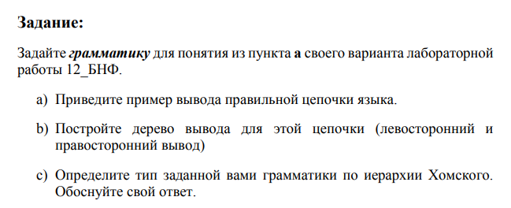

1.23 e5

а) < real_number >::= [<Sign>] <Digit> {<Digit>} [“.”<Digit> {<Digit>}]

[<Exponent> [<Sign>] <Digit> {<Digit>}]

<Digit>::= '0' | '1' | '2' | '3' | '4' | '5' | '6' | '7' | '8' | '9'

<Sign>::= '+' | '-'

<Exponent>::= 'E' | 'e'

Грамматика:

G = <T, N, P, S>

G = <{0, 1, 2, 3, 4, 5, 6, 7, 8, 9, +, -}, {F, T, S, M, K, E}, P, S>

S -> T | -T | +T

T -> FMFEF

F -> K | KF

K -> 0 | 1 | 2 | 3 | 4 | 5 | 6 | 7 | 8 | 9

M -> “.”

E -> e | E

Левосторонний вывод:

S -> T -> FMFEF -> KMFEF - > KMKFEF - > KMKKEF- > KMKKEK - >

1MKKEK - > 1.KKEK - > 1.2KEK -> 1.23EK - > 1.23E4

Правосторонний вывод:

S -> T - > FMFEF - > FMFEK ->FMKFEK -> FMKKEK - >KMKKEK ->

5MKKEK - > 5.KKEK - > 5.6KEK -> 5.67EK - > 5.67E8

Дерево вывода:

