Webpagina Inhoud
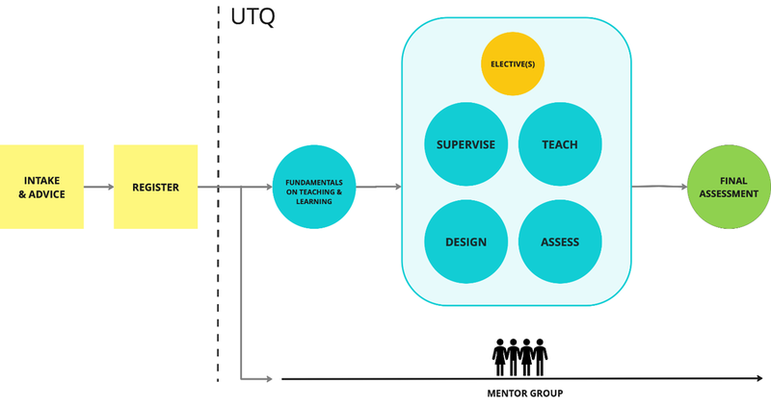
Afbeeldingsbron: https://t.e7096c671.entry.domains/JLpa_9qPAxlQc2gmiSbjLz1cXAg=/800x423/filters:strip_exif()/https%3A%2F%2Ffilelist.tudelft.nl%2FWebsections%2FTeaching%2520Learning%2520Services%2FDidactics%2FUTQ%2520Trajectory.png%3Fhash%3Db17cb48256
University Teaching Qualification <header 1>
The University Teaching Qualification (UTQ), or Basis kwalificatie Onderwijs (BKO) in Dutch, certifies the didactic competences of lecturers in academic education across the Netherlands. Recognised by all fourteen Dutch universities, the UTQ track ensures that educators possess core skills in five competency domains: designing, teaching and supervising, assessment, evaluating, and professionalisation. The programme addresses common challenges new educators face, such as:
- “How do I structure my lecture?"
- "How can I make my lessons engaging?"
- "How do I keep my students motivated?"
- "How do I assess if my Learning Objectives are met?"
- "How do I address issues like group participation?"
+ UTQ Competences (4TU) <Accordion>
The UTQ involves the development and documentation of five didactic competences in a personal UTQ dossier. After completion the teacher is able to:
Competence 1: Designing or Redesigning Education
- Explain how their course is embedded in the curriculum or degree programme as a whole.
- Design teaching based on the principles of ‘constructive alignment’.
- Design active, effective, and efficient learning methods and learning materials.
- Design their teaching with respect to the specific (curricular) characteristics and needs of the students.
- Design their teaching in a practically and logistically feasible (doable) way.
Competence 2: Teaching and Supervising
- Prepare an educational meeting.
- Conduct an educational meeting and reflect on their performance.
- Supervise students, individually and in groups.
Competence 3: Assessment
- Design and implement the assessment of student development and learning outcomes.
- Analyse the assessment results and draw conclusions.
Competence 4: Evaluating Teaching
- Conduct an evaluation and collect information (data) purposefully to improve their teaching.
- Analyse evaluation results, draw conclusions, and pinpoint areas for improvement.
Competence 5: Professionalisation
- Formulate their own vision on teaching and student learning.
- Manage their work as a teacher and collaborate in a teaching team.
- Reflect on their work as a teacher and on their future professional development in teaching.
UTQ trajectory <header 2>

Afbeeldingsbron: https://t.e7096c671.entry.domains/JLpa_9qPAxlQc2gmiSbjLz1cXAg=/800x423/filters:strip_exif()/https%3A%2F%2Ffilelist.tudelft.nl%2FWebsections%2FTeaching%2520Learning%2520Services%2FDidactics%2FUTQ%2520Trajectory.png%3Fhash%3Db17cb48256
Based on your submitted intake form and intake meeting, we will determine how the programme can fit your personal situation best. After the intake, you will join a mentor group and begin following the UTQ trajectory, which include electives and four compulsory modules (DESIGN, SUPERVISE, TEACH, ASSESS, Electives). The diagram above outlines the UTQ pathway, illustrating the sequence of modules.
Note: If you began your UTQ before 1 March 2025, you may complete it under the previous UTQ programme structure. For questions, contact your UTQ mentor or email Teaching-Support@tudelft.nl if you do not have one.
The TU Delft UTQ programme has a modular set-up. For each completed core module, you receive a partial certificate for one of the 4TU UTQ competences. These certificates can be obtained independently and in any order. The UTQ assignments are based on your own teaching experience, with Professionalisation as a continuous competence threading through the programme. After completing all four partial certificates and electives, you conclude with a Final Assessment meeting focusing on the Professionalisation competence.
Practical information <header 2>
Target group | All newly appointed staff with UFO profile HGL, UHD, UD, or Teacher who, at the time of appointment:have less than five years of teaching experience;are appointed for more than 0.2 FTE;have a substantial teaching remit;have not yet acquired the UTQ;are not eligible for exemption based on a comparable qualification.
Study load | 160 hours
Duration | On average 1.5 years. You need to complete the UTQ within three years (according to TUD HR policy) from your date of appointment.
Course fee | € 3000
Language | The programme is taught in English, unless the entire course group consists of Dutch speakers.
UTQ Partial certificates | If you already obtained a UTQ partial certificate on the competence Teaching and/or Supervising at another university in the Netherlands, you do not need to join the UTQ TEACH/SUPERVISE module and write the Proof of Competence that is related to the partial certificate.

Overview of required educational tasks <header 3>
To develop competencies within the UTQ trajectory, participants should have relevant teaching experience and tasks during the time they participate in the UTQ programme. Required tasks are as follows:
Competence/Partial Certificate | Required (Current) Teaching Tasks
All | > 0.2 FTE teaching practice (e.g. lectures, tutorials, or other forms of education).
Teaching | Please note that part of the assessment for this module is an observation of your lesson. It is essential that you take this module one period ahead of a teaching period so that your observation is easy to schedule.
Supervising | Supervising students (thesis or internship, BSc, MSc or PhD level).
(Re)designing and evaluating teaching | Involvement in an already running course (teaching or coordinating).
Assessment | Involvement in an already running course (teaching or coordinating).Bring exam-/assignment data; data collected from a formal examination or test used to evaluate the performance of all students (number of points per question in Exams/number of points per criterion in an Assignment).
If you lack suitable tasks, please consult your supervisor.
Guidance and assessment <header 3>
Module trainers provide coaching, and during the modules and in the mentor group, you will collaborate with lecturers from other faculties. Trainers and peers will offer feedback on your assignments. Upon completing each module, trainers will issue the partial certificates.The Final Assessment will be conducted by a committee.
Apply for the UTQ programme <header 3>
- Manager approval: make sure you have your manager's approval before registration.
- Complete the intake form: submit the intake form, after which you will receive an advice or invitation for a personal intake meeting within three weeks.
- Register for the Fundamentals module: choose a date and register for the Fundamentals module and join the mentor group via the Opleidingsportaal.
- Register for the modules and electives: sign up for your chosen modules and electives, in your own preferred order, via the Opleidingsportaal.
FAQ <header 2>

What are the costs of the UTQ? <header 3>
I started the UTQ in the old programme before March 2025. How can i finish it? <header 3>
Are UTQ courses online or on campus? <header 3>
What is Blended Learning? <header 3>
Can I do multiple modules at once? <header 3>
Do I need to take the modules in a specific order? <header 3>
I would like to de-register for the UTQ or one of the modules. Is this possible, what can I do and what are the consequences? <header 3>
I would like to register for one of the modules, but it is already full? What can I do? <header 3>
What is the group size of the UTQ modules? <header 3>
How long does each of the modules take? <header 3>
Is the UTQ time consuming? <header 3>
How can I finish each of the UTQ modules? <header 3>
How does the UTQ exemption procedure work? <header 3>
I am a PhD candidate, can I participate in the UTQ programme? <header 3>
Do I have to take the UTQ? <header 3>
Who is UTQ for? <header 3>
What is the duration of the UTQ trajectory? <header 3>
Frequently Asked Questions
What are the costs of the UTQ? <FAQ>
I started the UTQ in the old programme before March 2025. How can i finish it? <FAQ>
Are UTQ courses online or on campus? <FAQ>
What is Blended Learning? <FAQ>
Can I do multiple modules at once? <FAQ>
Do I need to take the modules in a specific order? <FAQ>
I would like to de-register for the UTQ or one of the modules. Is this possible, what can I do and what are the consequences? <FAQ>
I would like to register for one of the modules, but it is already full? What can I do? <FAQ>
What is the group size of the UTQ modules? <FAQ>
How long does each of the modules take? <FAQ>
Is the UTQ time consuming? <FAQ>
How can I finish each of the UTQ modules? <FAQ>
How does the UTQ exemption procedure work? <FAQ>
I am a PhD candidate, can I participate in the UTQ programme? <FAQ>
Do I have to take the UTQ? <FAQ>
Who is UTQ for? <FAQ>
What is the duration of the UTQ trajectory? <FAQ>

