ITC4214 Midterm Assignment Report

Dimitrios Mantzaridis
The American College of Greece
ITC4214: Internet Programming
Prof. Leonardos Mageiros
February 24, 2026

Contents
The Task Allocation System 3
tasks.html 3
tasks.js 3
style.css 5

The Task Allocation System
The task allocation system is mainly comprised of the tasks.html and tasks.js files. With some style-related elements to be found at the style.css.

1.1. tasks.html
tasks.html starts with the typical <!DOCTYPE html>, declaring to the browser that the document uses HTML5 and should be rendered in standard mode. Then the lang="en" is used to signal to the browser that the site is written in English. This helps with accessibility and translation purposes. Next, <link rel="stylesheet" href="style.css"> is used to connect the html file to the style.css files, which contains all the stylistic aspects of the webpage. After that, the <meta charset="UTF-8" /> tag is used to indicate that the document’s characters should be interpreted using UTF-8. Lastly, before closing the head, all the relevant JavaScript files are linked using the “defer” keyword.
The body starts with the <div id="header-placeholder"></div> tag. This creates a placeholder element that will be then used by the header.js file, which will in turn inject the html code related to the header of the page. Then, the <main> tag is used to identify the main part of the page (area between header and footer). The main page is divided between <section> tabs, that are used to separate each part in a semantic sense.
The first section has the id="task-form" and contains all the task-related input boxes and menus. These include the task name, Description, due date, and priority. Lastly, the “Task Button” is used to submit all the inserted data to the server.
The second section is the “task-summary” area, which is used to provide the numbers of the total, completed, and pending tasks.
The third section includes the tasks-list. This section starts with all the necessary filter options. These include filtering by priority, status, and sorting by due date or task name. After that, the task-table is created, that will be used to present all the tasks created by the users.
In this manner, the main section of the page is closed, and a footer placeholder is created, which operates in the same manner as the header placeholder.

1.2. tasks.js
The JavaScript file that supports the tasks.html starts with an event listener. What this does is that it waits for the HTML page to be “loaded” (turned into a Document Object Model) before proceeding with the execution of the JavaScript code. This part of the code can of course be considered redundant, as the “defer” keyword used to insert the JavaScript files into the html files serves the same purpose. However, I decided to keep it in my JavaScript files, as an extra safety measure, or for cases where the code might need to be reused under other circumstances (dynamic script loading).
After that, the necessary variables are declared using the “const” keyword. This keyword is used to ensure that accidental reassignment will be avoided while at the same time the element itself will be able to be modified. This, JSON.parse() is utilized to take the strings stored in localStorage and turn them into usable JavaScript objects. In this case, it creates arrays. At this point, we use the “let” keyword, as the arrays created may be later reassigned, sliced, or replaced, things that would not be possible if they were declared as constants.
What follows is the declaration of functions. saveTasks() converts the “tasks” array into a string that can be saved in the localStorage. The saveActivity() function works the same way, but also checks if the taskActivity array has more than 10 entries, and if it does, it keeps the last 10. This is done as it was decided that the “Latest Activity” element of the home screen should keep the 10 latest task-related actions taken by the user. Next, the updateSummary() function, counts the total tasks by calculating the length of the “tasks” array. Creates a new array and calculates its length as well in order to find the number of the completed tasks, and then subtracts the completed tasks from the total to find the number of the pending tasks. Having done that, the related elements of the html page are updated, so that the proper numbers are displayed. Lastly, the renderTasks() function is the core of the task manager UI. It starts by removing all rows from the table, in order to render the latest task list. Next, the “filteredTasks” array is created as a shallow copy of the “tasks” array, so that the “tasks” array is not affected by the changes made during filtering. Next, the priority value is checked, and if anything other than ALL is selected, only tasks matching that priority are kept. The status filter works in a similar way, checking the selected status filter and keeping only the tasks that are pending or completed, based on the filter. After that, the sorting is carried out by turning the array contents to strings and then if the sorting is done by name these strings are arranged alphabetically, or if it is done by date, then the dates are subtracted and if the difference is positive then a comes after b, while if it is negative, b comes after a. Next, the table’s rows are created by creating a relevant html table data entry for each task, which will then be appended as children to the table created in the tasks.html. The table buttons are also created for each row. After that, the complete button is created. Once clicked, it toggles the task’s “completed” status, it records the action in tasksActivity, it saves the task and activity in localStorage, it re-renders the table and updates the summary, and it fires up an event for the dashboard. The delete button that comes after works in a similar way, removing the task from the “tasks” array, recording the deletion in taskActivity, saves, re-renders, and updates the summary and dashboard. After that, the edit button replaces the normal row display with editable input fields, so that the user can make changes. This is done by temporally inserting HTML code in the relevant task and row fields, and either saving the new values and updating the task activity table, or simply re-rendering the task table without saving, in case the user cancels the procedure.
Afterwards, event listeners are added that fire up when the filters or sorting options are clicked.
Lastly, the eventListener corresponding to the “submit” button of the form is added. When fired up, it starts by preventing the default form behavior. By default, submitting a form reloads the page or sends a request to a server. By using the e.preventDefault(); option we ensure that we can handle the form entirely with JavaScript. After that, the input values are read, a new “task” object is created with the inserted data and entered in the “tasks” array, the updated activity array is stored in localStorage, as well as the new “tasks” array, and the “tasksUpdated” event is triggered. Having done that, the fields are reset so that the user can enter new data, the table is refreshed to include the new task, and the summary is updated to include the correct numbers.
The initial render part also calls the renderTasks() and updateSummary() functions to initialize the relevant elements.

1.3 style.css
The style.css contains the css code related to the entire website, but in this section we will focus on the parts related to the tasks page. We begin with the form, summary and task table sections. There, the padding, margin, shadow, border radius and background color are set. After that, all the input and text areas inside the form are modified. Each input is set up to take a full line, each input stretches to fill the form’s width, and then space between the inputs (margin-bottom) is implemented as well as space inside the input (padding) so that the letters do not touch the edges.

Latest Activity Section
For the latest activity tracking, a suitable container is first created in the index.html. Then, this list is targeted by a querySelector found in recentActivity.js and populated. In order for it to be populated, every time an activity takes place, a relevant entry is created in the local storage, as was shown in the “Tasks” section of the report. Thus, these entries are read, and each activity is rendered as an item on the list. It is worth mentioning that the “activityList.prepend(li);” is used in order to have the newest activity appear at the top of the list.

Personal Page
For the personal page I decided to create a FAQ page.
For the first extra component, I decided to implement the Frequently Asked Question boxes as an accordion (when a question is clicked, its answer is shown/hidden). To do that, I start by selecting all the elements with the “faq-question” class, looping through each one of them, and adding a “click” event to each one. Then, I get the corresponding answer for each element, and hide all other answers. The way this is done is by looping through the answers, and hiding the ones that have not been just clicked. Lastly, the last answer is toggled, that means that if it is currently visible, it gets hidden (blocked), while if it was hidden, it becomes shown.
The second component I utilized was a “visitors today” counter. It should be noted that this is a local counter, basing its data on local storage and therefore only counting the sessions joined by a single computer in a day. It was created to emulate an actual counter, that would require an API implementation. It starts by getting today’s date, turning it into a string, and keeping only the 10 first elements (since the date will be in a “2026-03-04T12:34:56.789Z” format). It then gets the visit date from the local storage. After that, an “if” statement is used to decide about whether to keep counting or reset the counter. If the two strings are the same, then we are on the same day, the previous count is loaded from local storage, converted into a number, and the counting continues. It should be noted that the “|| 0” is used for cases where there is no faqVisitors variable in the local storage. If the day has changed, then the count is reset to 0, and then incremented. Lastly, the updated values are saved and the UI is updated as well.
The third extra component I decided to implement was a “Helpful” button, where the users can indicate if a question was particularly helpful to them. Once again, this functionality mimics the button’s functionality, as it uses local storage, and thus the number of upvotes is not general, but based on the device that runs the program each time. In order to have a proper functionality of this button, backend procedures should be implemented. It starts by grabbing all faq-like class buttons, then it loops through each button, finds the button’s FAQ parent by going up the DOM tree and gets the faq id by reading the equivalent HTML part (<div class = “faq-item” data-id = “faq1”>). Then, it gets the counter display element, by finding the span with the “like-count” class. Afterwards, it loads the saved likes from local storage by searching for a unique key like “faq-like-faq1”, and displays the current count. After that part, comes the button click behavior. Once a “Helpful” button is clicked, the count is increased, the UI is updated, a unique key is created (the one used to load the saved likes as mentioned above) and the new count value is stored in local storage.

Google Lighthouse Results

Home page
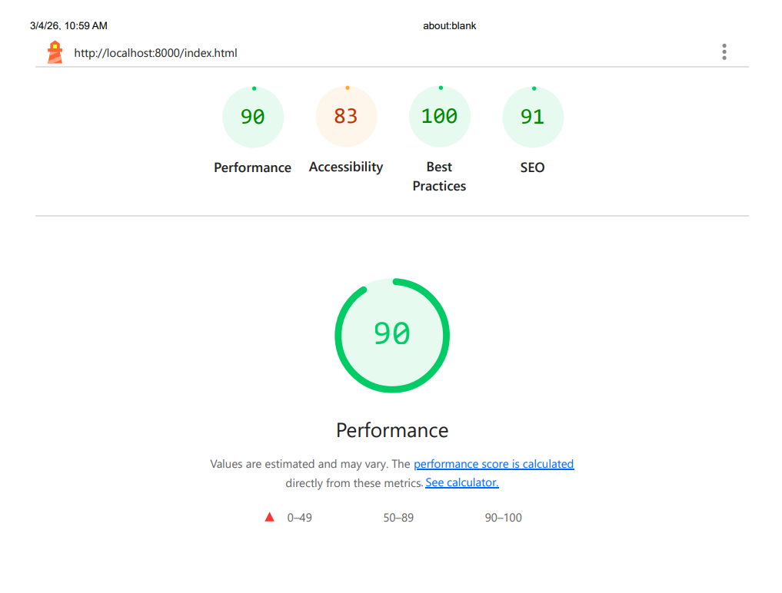
Figure 1: The results of the home page.
As we can see, the home page is generally good, only having an 83 in Accessibility. This is due to a lack of associated labels to the form elements.

Tasks page
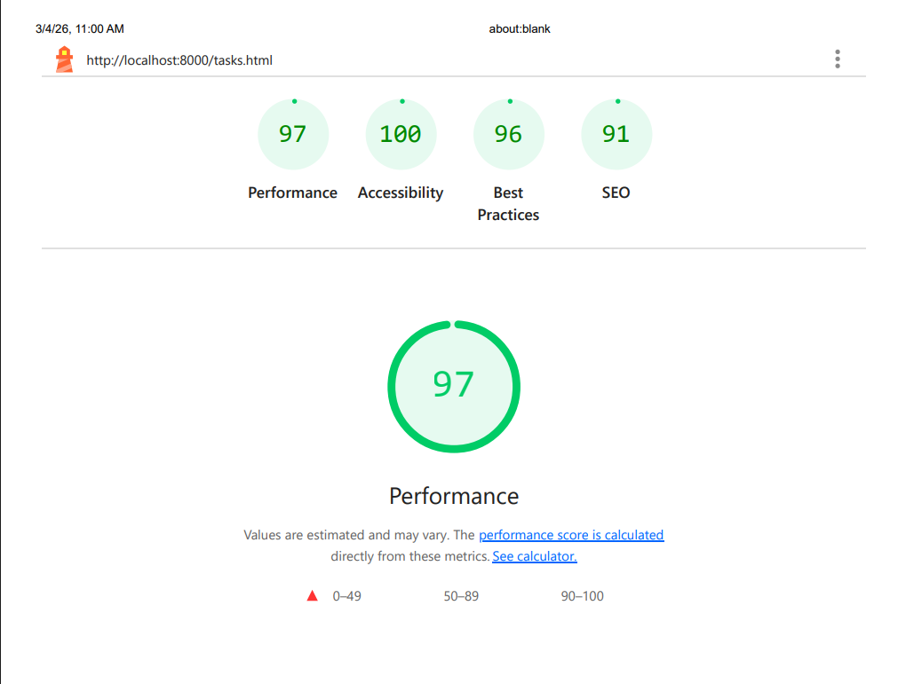
Figure 2: The results of the Tasks page
The tasks page is also quite well made, scoring over 90 in every category.

About page
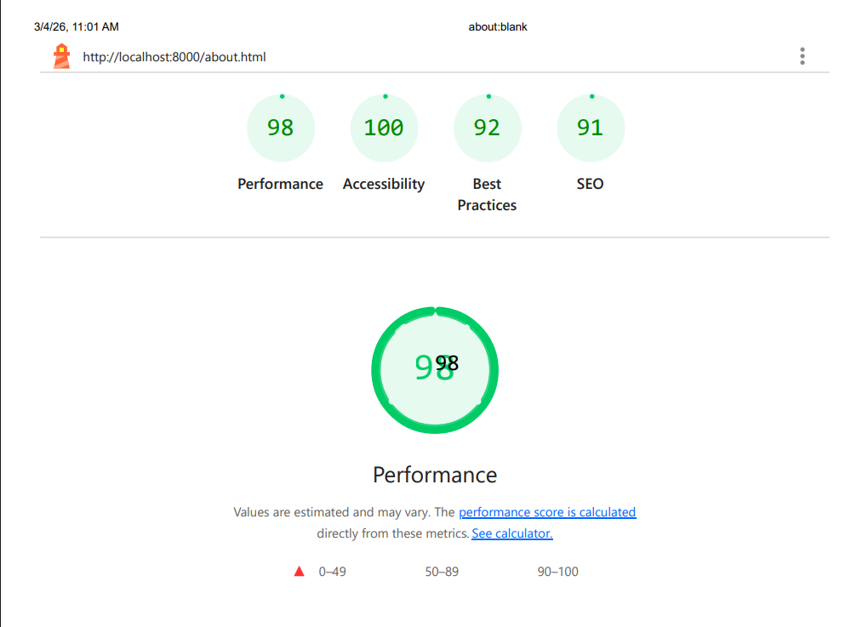
Figure 3: The results of the About page.
The about page is also over 90 in every aspect.

Contact page
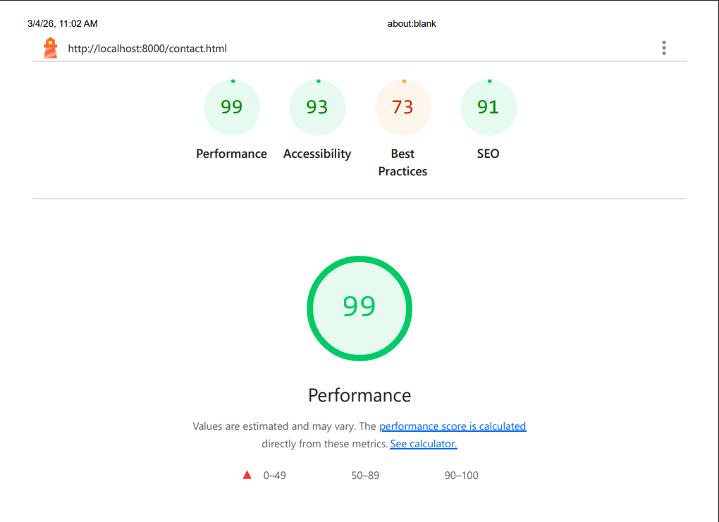
Figure 4: The results of the Contact page.
Although the Contact page has high scores on three of the four categories, it is lacking when it comes to “Best Practices”. This is because it uses third-party cookies, browser errors are logged to the console, and issues were logged in the “Issues” panel in Chrome Devtools.

FAQ page
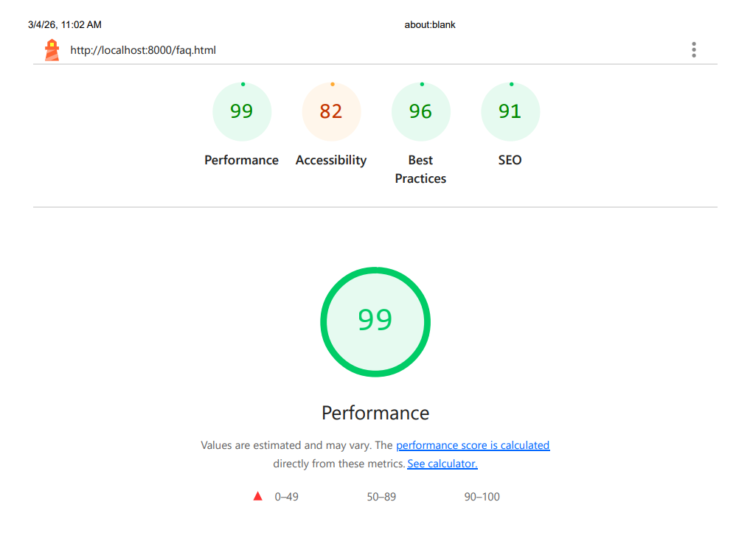
Figure 5: The results of the FAQ page.
The FAQ page is satisfactory on three out of the four aspects, suffering an 82 at Accessibility, due to the background and foreground colors not having a sufficient contrast ratio.

Reflection
A challenge faced while making this site had to do with the implementation of the weather API. Initially, due to some error done in my behalf, I was not able to properly fetch information for the weather widget required of us. After some research I came to the conclusion that this could be happening due to the Cross-Origin Resource Sharing policy not allowing my script (which was running from a folder in my computer) to get the data it required using the fetch() function. My initial solution was to create mock data instead of taking it from the API server. Upon consulting with my peers however I found out that no one else had faced such an issue. Taking this into consideration I decided to carry out some more research into the topic, and discovered that the openweathermap API I used to get the data for my widget did allow for CORS. Knowing that, I deleted the part associating with data-generation, and replaced it once more with a fetch() function. This time it worked, which led me to the conclusion that the initial failure to provide proper weather data was created due to my mistake instead of any other factor.
In general, the site was built using techniques and knowledge covered in class. During the making of this exercise, I also made use of Google and ChatGPT, in order to find answers to questions, conduct troubleshooting, and take advice regarding various parts of the site. Combining these online resources with the slides provided by the professor helped me better understand the nuances and operation of HTML, CSS, and JavaScript.

