Tugas Pemulihan Jaringan Error:
- Lakukan ping test antar perangkat (PC1 ke PC2 dan ke Server).
- Catat hasil error yang muncul dan identifikasi kemungkinan penyebab.
- Perbaiki semua gangguan agar jaringan kembali normal.
- Buat laporan singkat berisi:
  - Jenis gangguan
  - Penyebab gangguan
  - Langkah perbaikan
  - Tindakan pencegahan

Tabel Configuration Network
NOTE: HOST NEED IS BASED ON UNIT + GATEWAY FOR ACCROS TRAFIC
NOTE: SUBNETMASK FROM /CIDR = /30 = 4IP = 256 BITS – 4 = 252
Subnet | Kebutuhan Host | Prefix | Network ID | Range Host | Broadcast | SUBNET MASK
A | 1 | /30 | 192.168.10.0 | 192.168.10.1 - 192.168.10.2 | 192.168.10.3 | 255.255.255.252
B | 2 | /30 | 192.168.10.4 | 192.168.10.5 - 192.168.10.6 | 192.168.10.7 | 255.255.255.252

RUANG | UNIT | IP ADDRESS | SUBNET MASK | DEFAULT GATEWAY
RUANG A | PC-1 | 192.168.10.2 | 255.255.255.252 | 192.168.10.1
RUANG B | PC-2 | 192.168.10.6 | 255.255.255.252 | 192.168.10.5
 | SERVER | 192.168.10.5 | 255.255.255.252 | 192.168.10.5

ILUSTRATIONS:
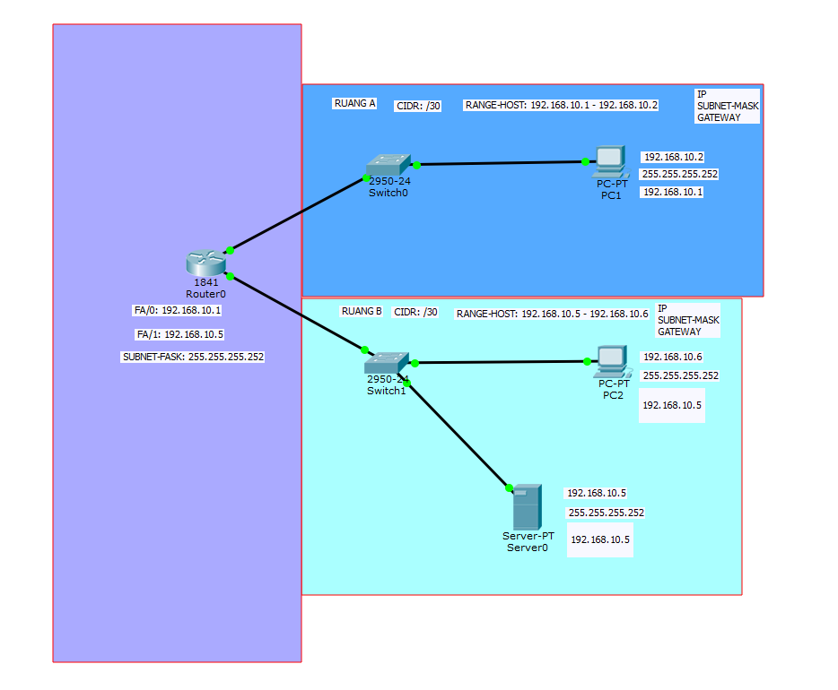
NETWORK RESPONSE:
RESPONSE ROUTER INTO DEVICE CONNECTION
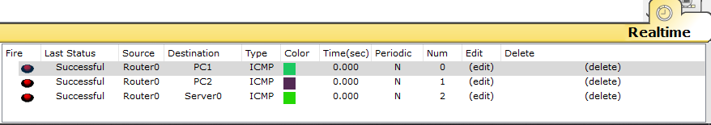
RESPONSE DEVICE INTO DEVICE CONNECTION
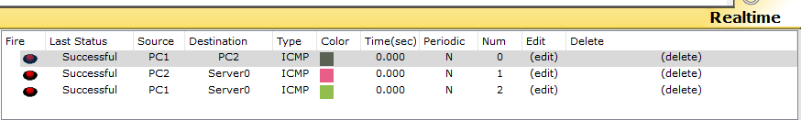

Tabel NETWORK LOGGING

ERROR-ID | ROOT CAUSE | RELATION | LOG-ERR | TYPE ISSUE | STATUS(WIP/DONE) | ACTION | PREVENTION ACTION
ERR-1 | PC-2 is missing the IP Address and Subnet Mask configuration. | PC-1-TO-PC-2  ROUTER-PC-2 | PC2 HAS NO FUNCTIONAL PORTS. | Configuration Error | DONE | - Set up the CIDR as required.  - Assign the IP and Subnet Mask to the PC2 port based on the established configuration.  - Perform a Ping Test to confirm cross-device connectivity. | Analyze the required number of IP Address and setup the network configuration use VLSM  Implement Integration test, by testing connection between cross device
ERR-2 | SERVER HAS MISSMATCH IP,SUBNET-MASK AND EMPTY GATEWAY | PC-1-TO-SERVER  ROUTER-SERVER | FAILED | CONFIGURATION ERROR | DONE | - Set up the CIDR as required.  - Assign the IP and Subnet Mask to the PC2 port based on the established configuration.  - Perform a Ping Test to confirm cross-device connectivity. | Analyze the required number of IP Address and setup the network configuration use VLSM  Implement Integration test, by testing connection between cross device
ERR-3 | ROUTER HAS LENGTH IP ADDRES AND SUBNET MASK NOT IDEAL | ROUTER |  | PEFORMANCE | DONE | - SETUP IP ADDRES AND SUBNET MASK BASED ON VLSM Best Pratice  - Assign the IP and Subnet Mask to the PC2 port based on the established vlsm configuration.  - Perform a Ping Test to confirm cross-device connectivity. | Analyze the required number of IP Address and setup the network configuration use VLSM

