NAMA : NADIA NURHALISA

NIM : 123220189

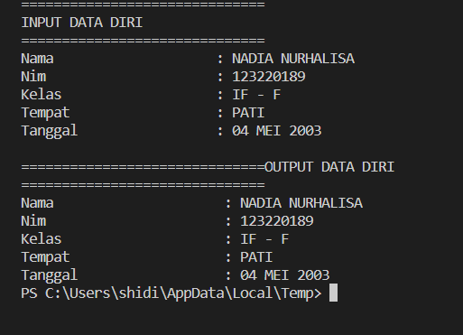

#include <iostream>

#include <iomanip>

using namespace std;

int main () {

    cout << string (30,'=') ;

    cout << "\nINPUT DATA DIRI\n";

    cout << string (30,'=');

    char Nama [30] , Nim [30] , Kelas [15] , Tempat [30], Tanggal [20];

    cout << "\nNama \t\t\t: " ;

    cin.getline (Nama , 30);

     cout << "Nim \t\t\t: " ;

    cin.getline (Nim, 30);

    cout << "Kelas \t\t\t: " ;

    cin.getline (Kelas, 15);

     cout << "Tempat \t\t\t: " ;

    cin.getline (Tempat , 30);

     cout << "Tanggal \t\t: " ;

    cin.getline (Tanggal, 20);

    cout << endl;

    cout << string (30, '=');

    cout << "OUTPUT DATA DIRI\n";

    cout << string (30, '=');

    cout << endl << "Nama \t\t\t : " << Nama ;

    cout << endl << "Nim \t\t\t : " << Nim ;

    cout << endl << "Kelas \t\t\t : " << Kelas;

    cout << endl << "Tempat \t\t\t : " << Tempat;

    cout << endl << "Tanggal \t\t : " << Tanggal;

}