Task 2. Report
1. Measure model performance using a classification report and visualise the Confusion Matrix.
I evaluated my TF-IDF and Logistic Regression model on 35,069 records, using a stratified 20% split of the UNSW-NB15 training CSV. The remaining 140,272 records were used for training. My model achieved 81.36% accuracy. The classification report is shown below.
Class | Precision | Recall | F1-score | Support
Normal | 0.6772 | 0.7954 | 0.7316 | 11,200
Attack | 0.8955 | 0.8221 | 0.8572 | 23,869
Macro avg | 0.7863 | 0.8088 | 0.7944 | 35,069
Weighted avg | 0.8258 | 0.8136 | 0.8171 | 35,069
The confusion matrix shows 8,909 normal flows and 19,623 attacks classified correctly. I also recorded 2,291 normal flows incorrectly flagged as attacks and 4,246 attacks incorrectly classified as Normal. Attack recall was 82.21%, so the model detected most attacks but still missed a substantial number.
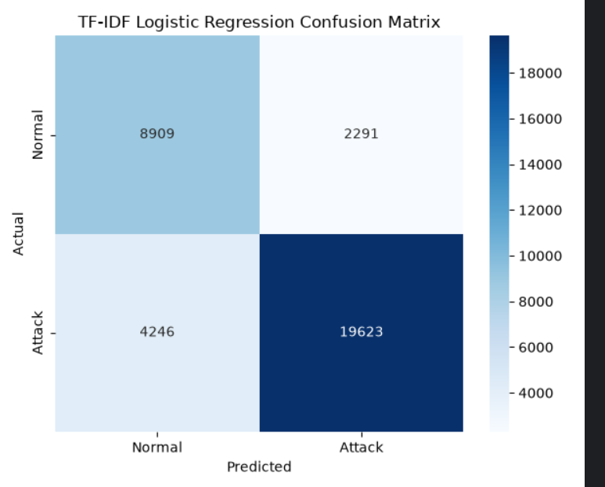
2. Identify the False Negatives. In a real SOC, why are these more dangerous than False Positives?
I found 4,246 false negatives: records labelled Attack that my model predicted as Normal. My false negative rate was 4,246 / (4,246 + 19,623) = 17.79%. Examples included "tcp - FIN", "tcp - CON", "udp - CON" and "tcp ftp-data FIN". For "tcp - FIN", the predicted attack probability was about 0.4276, below the 0.5 decision threshold.
I consider these errors particularly dangerous in a SOC because an attack may receive no alert and continue without investigation. This can delay incident response and allow further damage. False positives also matter: my model generated 2,291 unnecessary alerts, giving a false positive rate of 20.46%. They waste analysts' time and may cause alert fatigue, but false negatives directly hide malicious activity.
3. Interpret the Model. Which proto, service and state tokens are the strongest attack predictors?
My model learned associations between the tokens and the Normal/Attack labels. Positive coefficients increase the Attack score. The strongest protocol tokens were sctp (+5.3192), unas (+3.5215) and ospf (+1.7253). The strongest service tokens were dns (+3.7396), dhcp (+2.6885) and pop3 (+2.4897). INT was the strongest state token, with a coefficient of +4.5169. Overall, sctp, INT and dns had the largest positive coefficients.
I also found strong negative coefficients for arp (-11.4702), CON (-7.8181) and udp (-7.4793). These tokens reduced the model's Attack score, but they do not guarantee that a connection is safe. Only three categorical features are used, so flows with the same document receive the same prediction even when their actual labels differ.
I would use the positive tokens as starting points for candidate IDS rules, preferably combined with other traffic conditions. I would validate each rule on separate traffic and measure both missed attacks and false alerts before deployment. These coefficients describe patterns in this dataset; they do not mean that every DNS or SCTP connection is malicious.

