Task_4

- Create PayKey symmetric key in the AdventureWorks database using DESX algorithm. The key must be encrypted with password P@ssw0rd.
- Create the copy of the HumanResources.EmployeePayHistory table in the AdventureWorks database. The name of copy will be HumanResources.EmployeePayHistoryEncrypted1, and the all data in it must be encrypted using created symmetric key.
- Run the qurey to get all data from the HumanResources.EmployeePayHistoryEncrypted1 encrypted table.

Tasks examples
Create PayKey symmetric key in the AdventureWorks database using DESX algorithm. The key must be encrypted with password P@ssw0rd.

use AdventureWorks
go
create symmetric key AKey1
with ALGORITHM = DES
encryption by password='key1'

Command(s) completed successfully.

The sample script to create the encrypted copy of the HumanResources.EmployeePayHistory table:

use AdventureWorks
go
create table AdventureWorks.Sales.StoreContactEncrypted1
(CustomerID nvarchar(100),
ContactID nvarchar(100),
ContactTypeID nvarchar(100),
rowguid nvarchar(100),
ModifiedDate nvarchar(100))
go
-- open symmetric key
open symmetric key AKey1 decryption by password='key1';
Command(s) completed successfully.

-- insert data into table using INSERT INTO
INSERT INTO AdventureWorks.Sales.StoreContactEncrypted1
(CustomerID,ContactID,ContactTypeID,rowguid,ModifiedDate)
select
EncryptByKey(Key_GUID('AKey1'),CONVERT (nvarchar(100),CustomerID)),
EncryptByKey(Key_GUID('AKey1'),CONVERT (nvarchar(100),ContactID)),
EncryptByKey(Key_GUID('AKey1'),CONVERT (nvarchar(100),ContactTypeID)),
EncryptByKey(Key_GUID('AKey1'),CONVERT (nvarchar(100),rowguid)),
EncryptByKey(Key_GUID('AKey1'),CONVERT (nvarchar(100),ModifiedDate))
from AdventureWorks.Sales.StoreContact

(753 row(s) affected)

select *from AdventureWorks.Sales.StoreContactEncrypted1
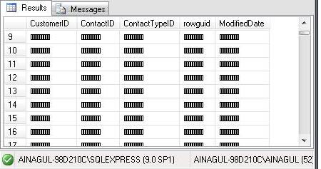

The script to select data from Sales.StoreContactEncrypted encrypted table:

open symmetric key AKey1
decryption by password='key1';
select
CONVERT(nvarchar(100), DecryptByKey(CustomerID)) AS CustomerID,
CONVERT (nvarchar(100), DecryptByKey (ContactID)) AS ContactID,
CONVERT (nvarchar(100), DecryptByKey(ContactTypeID)) AS ContactTypeID,
CONVERT (nvarchar(100), DecryptByKey(rowguid)) AS rowguid,
CONVERT (nvarchar(100),DecryptByKey(ModifiedDate)) AS ModifiedDate
from AdventureWorks.Sales.StoreContactEncrypted1

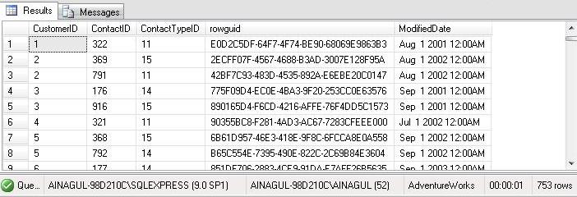

Information encruption in the tables.
Certificate

create table dbo.Secrettable(Secret nvarchar(100))
Command(s) completed successfully.

CREATE CERTIFICATE Certl
ENCRYPTION BY PASSWORD = '111'
WITH SUBJECT = 'Vyberite shifr',
START_DATE = '09/09/2010';
Command(s) completed successfully.

CREATE MASTER KEY ENCRYPTION BY PASSWORD = '111';
INSERT INTO SecretTable
values(EncryptByCert(Cert_ID('Certl'),
N'Secret data'));

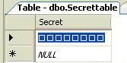

The result of each execution is:(1 row(s) affected)
The result after 3-times execution is:

select * from SecretTable

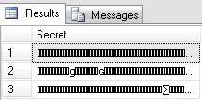

SELECT (Convert(Nvarchar(100), DecryptByCert(Cert_ID('Certl'),
Secret, N'111'))) FROM SecretTable;

----------------------------------------------
Secret data
Secret data
Secret data

(3 row(s) affected)

Data type conversion into nvarchar:
You can use DecryptByCert function to decrypt the encrypted data. The problem is that the function returns extended information in varbinary data type. Therefore, you need to convert this data type into nvarchar.

Create asymmetric key:

CREATE ASYMMETRIC KEY Asym_Key WITH ALGORITHM = RSA_1024
ENCRYPTION BY PASSWORD = '111';
INSERT INTO SecretTable
values (EncryptByAsymKey (AsymKey_ID ('Asym_Key') , N'Secret data'));
select * from SecretTable

Secret
----------------------------------------------------------------------------------------------------
ႈ췄皌䟽啜ꢣ믽趿फ़醥ꢖ䣸ᵏ텁쐶ꝫ趯핀걃雵땓೾膭鐮䊤㡅ᨦ払쁑䉾檻嗕帷ꈻ휧괾玕㱦峉쬤鑰囏瞉쥔ꔑ苅᫯縷᷏괾猦脌ʾ孄�勆ኬ冀䟘㦨鎨
�䇭ꛭ␧뻵㞙䜫灁ꄣ龙髗g鬯玂쑒胼䗝ꭺ�ɢ䰯뇓藑Ⱉ욅䭮칍屘䂔挡븮듴醈䩨誠퐅㜑쵢蟻䩮᫴紺ᐆ緷鯧ฤ誽ሔ焅䋈ᯗ歛ᢚ驈�핪ꆱꉒ揔⏠
퇝ᗈ㝎螿빔寭錂﹨㯙ⳬᗥ蜍痿湞拸볯䪈喞鶬ᣚ⧕꥙ᵥᡮ봩嶳期諐症ܴ윣ᐧហ﷑˔짥Վ㩧∑�蠀藈ꅑ퓺꒲䒮⠆뻅꒩깬㵤﨓䋝䎦ﯩ䀓
嬲⿷쎄垴䝫靐둨Ⱪ뺏巷람憈啳靺㒦矅㉉ﺏ詂匱쓂ᖫ啵雊꼴♏ﶗ빛▼Ⴡ˸戳ꥋꛍ㧯齉ჱ慺⤢㓥ꍀ袅꫕笺夆㱤癈䃷肋늓䴒닖�꟟놲赉თ謐኱ེ
৷ᅺ㖡ퟡ䟌䜘岩ᓀ婆ꭑ䰬鈩Ꮿⱹ犒醓ᰝ愉쵯쩢쎩֜΢ᄄ飽踳噭꟧崟㤋씢턼煰琕ଚᐲ뗽㲮Ȏഏ⽲쀨㳱절ꁬ嘂䃅찛쒉፞ᜒ划蹮暠蘴䕿

(5 row(s) affected)

SELECT (Convert(Nvarchar(100), DecryptByAsymKey(AsymKey_ID('Asym_Key'),
Secret, N'111'))) FROM SecretTable;
----------------------------------------------------------------------------------------------------
NULL
NULL
NULL
Secret data
Secret data

(5 row(s) affected)
Create symmetric key:

CREATE SYMMETRIC KEY Sym_Key WITH ALGORITHM=TRIPLE_DES
ENCRYPTION BY PASSWORD ='111';
OPEN SYMMETRIC KEY Sym_Key DECRYPTION BY PASSWORD = '111';
INSERT INTO SecretTable values(EncryptByKey(Key_GUID('Sym_Key'),
N'Secret data'));
select * from SecretTable
SELECT (Convert(Nvarchar(100), DecryptByKey(Secret))) FROM SecretTable;

----------------------------------------------------------------------------------------------------
NULL
NULL
NULL
Secret data
Secret data
Secret data
(6 row(s) affected)

