1. It is a list of matches presented on the matchday page <http://www.tennisexplorer.com/matches/?type=all&year=2021&month=12&day=07>. Let’s create a list of links, which can be used in a further dive into details of each match (see steps 3-6). Using the info button we will find a link to every single match.

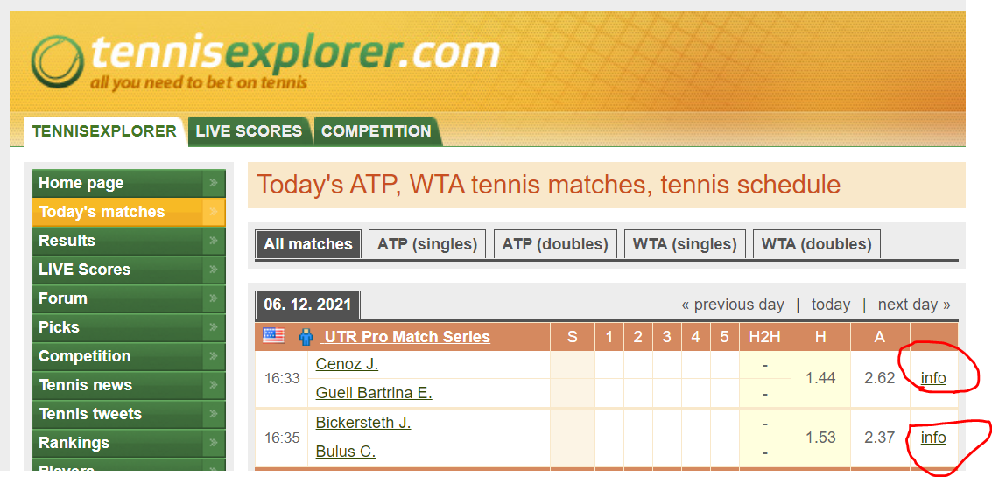

1. That’s what we get by clicking info button <http://www.tennisexplorer.com/match-detail/?id=2007904>

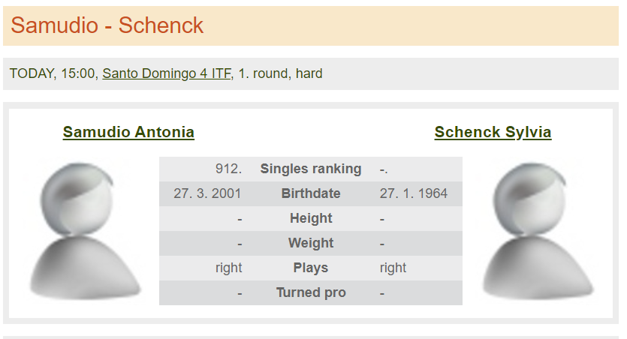

1. Personal info of both competitors (top of our projected dashboard) to get basic information about them. Sometimes even difference in ages provides all necessary information to take a right decision about match.

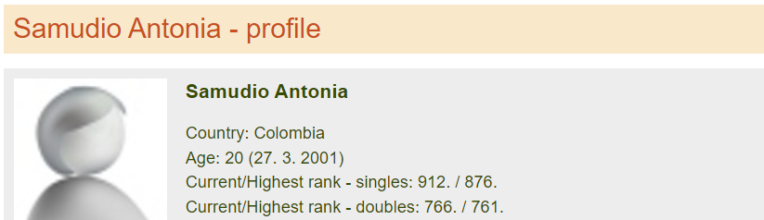

* Samudio Antonia
* Age: 20
* Current/Highest rank - singles: 912 / 876
* Current/Highest rank - doubles: 766 / 761
* Schenck Sylvia
* Age: 57
* Current/Highest rank - singles: - / 594
* Current/Highest rank - doubles: - / 605

Studying web-page source code to get an allocation of personal info for scraping:

*<div style="text-align: center;"><a href="/facebook/" target="_blank"><img src="/sites/en/res/img/fbbanner.png?serial=1"/></a></div>*

*<div style="margin-top: 2px; font-size: 9px; text-align: center;"><a href="/facebook/" target="_blank">TennisExplorer</a> on Facebook</div>*

*</div>*

*<div id="center">*

*<h1 class="bg">Samudio - Schenck</h1>*

*<div class="box boxBasic lGray"><span class="upper">Today</span>, 15:30, <a href="/santo-domingo-4-itf/2021/wta-women/">Santo Domingo 4 ITF</a>, 1. round, hard<iframe src="https://www.facebook.com/plugins/like.php?href=http://www.tennisexplorer.com/match-detail/?id=2007904&amp;layout=button_count&amp;show_faces=false&amp;width=82&amp;height=20&amp;action=like&amp;font=arial&amp;colorscheme=light&amp;locale=en_EN" scrolling="no" frameborder="0" class="game-fblike" allowTransparency="true"></iframe></div>*

*<div class="box boxBasic lGray"><div class="wSpacer"></div><table class="result gDetail noMgB" cellspacing="0">*

*<thead>*

*<tr>*

*<th class="plName" colspan="2"><a href="/player/samudio-7f6b4">Samudio Antonia</a></th>*

*<td class="gScore">&nbsp;</td>*

*<th class="plName" colspan="2"><a href="/player/schenck">Schenck Sylvia</a></th>*

*</tr>*

*<tr class="wSpacer">*

*<td colspan="5">&nbsp;</td>*

*</tr>*

*</thead>*

1. Carrer (win/lose) total results and separate results on each surface (Career - Player1, Career - Player2).

*<div id="balMenu-2-data" class="none">*

*<table class="result balance" cellspacing="0">*

*<thead>*

*<tr class="head">*

*<th class="year">Year</th>*

*<th>Summary</th>*

*<th>Clay</th>*

*<th>Hard</th>*

*<th>Indoors</th>*

*<th>Grass</th>*

*<th>Not set</th>*

*</tr>*

*</thead>*

*<tfoot>*

*<tr class="summary">*

*<td>Summary:</td>*

*<td><a href="/player/samudio-7f6b4/?annual=all">23/41</a></td>*

*<td><a href="/player/samudio-7f6b4/?annual=all&amp;surface=2">19/30</a></td>*

*<td><a href="/player/samudio-7f6b4/?annual=all&amp;surface=4">4/11</a></td>*

*<td>-</td>*

*<td>-</td>*

*<td>-</td>*

*</tr>*

*</tfoot>*

*……………………….*

*</div>*

*<div id="balMenu-3-data" class="none">*

*<table class="result balance" cellspacing="0">*

*<thead>*

*<tr class="head">*

*<th class="year">Year</th>*

*<th>Summary</th>*

*<th>Clay</th>*

*<th>Hard</th>*

*<th>Indoors</th>*

*<th>Grass</th>*

*<th>Not set</th>*

*</tr>*

*</thead>*

*<tfoot>*

*<tr class="summary">*

*<td>Summary:</td>*

*<td><a href="/player/schenck/?annual=all">15/62</a></td>*

*<td><a href="/player/schenck/?annual=all&amp;surface=2">0/2</a></td>*

*<td><a href="/player/schenck/?annual=all&amp;surface=4">15/57</a></td>*

*<td><a href="/player/schenck/?annual=all&amp;surface=1">0/3</a></td>*

*<td>-</td>*

*<td>-</td>*

*</tr>*

*</tfoot>*

1. Info about match odds is located in this piece of code

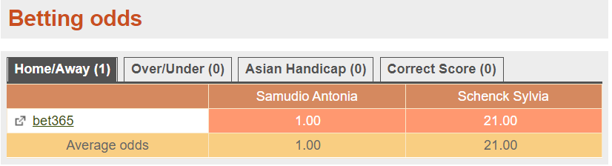

*</div></div></div><div class="clr">&nbsp;</div><h2 class="bg">Head-to-head</h2><div class="box lGray"><div class="inner"><div class="content"><div class="no-data">No head-to-head record.</div></div></div></div><div class="clr">&nbsp;</div><h2 class="bg">Betting odds</h2>*

*<div class="box lGray"><div class="inner"><div class="content"><ul class="tabs"><li id="oddsMenu-1" class="set"><a onclick="cTabMenu('oddsMenu-', 1, 4, true, true);return false;">Home/Away (1)</a></li><li id="oddsMenu-2"><a onclick="cTabMenu('oddsMenu-', 2, 4, true, true);return false;">Over/Under (0)</a></li><li id="oddsMenu-3"><a onclick="cTabMenu('oddsMenu-', 3, 4, true, true);return false;">Asian Handicap (0)</a></li><li id="oddsMenu-4"><a onclick="cTabMenu('oddsMenu-', 4, 4, true, true);return false;">Correct Score (0)</a></li></ul><div id="oddsMenu-1-data"><table class="result balance " cellspacing="0">*

*<tbody>*

*<tr class="head">*

*<td class="tl"> </td>*

*<td class="k1">Samudio Antonia</td>*

*<td class="k2">Schenck Sylvia</td>*

*</tr>*

*<tr class="one">*

*<td class="first tl"><a href="https://www.bet365.com/olp/open-account?affiliate=365_033297" onclick="window.open(this.href, '_blank');return false;" class="icons"><span class="i eLink">&nbsp;</span><span class="t">bet365</span></a></td>*

*<td class="k1 best-betrate"><div class="odds-in">1.00</div></td>*

*<td class="k2 best-betrate"><div class="odds-in">21.00</div></td>*

*</tr>*

*<tr class="average">*

*<td>Average odds</td>*

*<td class="k1"><div class="odds-in">1.00</div></td>*

*<td class="k2"><div class="odds-in">21.00</div></td>*

*</tr>*

*</tbody>*

1. Getting info about last 10 matches of each competitor / detail results by sets and games / list of competitors in these matches to get full information about the competitor’s class (creating block 2 and block 3 of the result Dashboard)

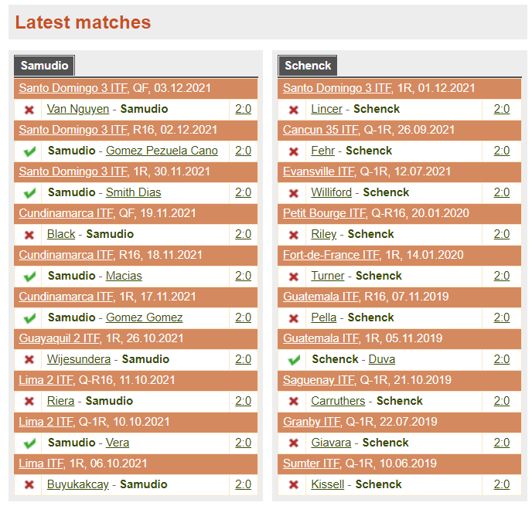

*<table class="result mutual" cellspacing="0">*

*<tbody>*

*<tr class="head">*

*<td class="tl" colspan="3"><a class="u" href="/santo-domingo-3-itf/2021/wta-women/">Santo Domingo 3 ITF</a>, <span class="help" title="quarterfinal">QF</span>, 03.12.2021</td>*

*</tr>*

*<tr class="one">*

*<td class="first icon-result lose">&nbsp;</td>*

*<td class="tl"><a href="/player/van-nguyen/">Van Nguyen</a> - <a href="/player/samudio-7f6b4/" class="notU"><strong>Samudio</strong></a></td>*

*<td class="score"><a href="/match-detail/?id=2006824" title="6-0, 6-0">2:0</a></td>*

*</tr>*

*...............*

*<tr class="head">*

*<td class="tl" colspan="3"><a class="u" href="/lima-itf/2021/wta-women/">Lima ITF</a>, <span class="help" title="1. round">1R</span>, 06.10.2021</td>*

*</tr>*

*<tr class="two">*

*<td class="first icon-result lose">&nbsp;</td>*

*<td class="tl"><a href="/player/buyukakcay/">Buyukakcay</a> - <a href="/player/samudio-7f6b4/" class="notU"><strong>Samudio</strong></a></td>*

*<td class="score"><a href="/match-detail/?id=1987711" title="6-2, 6-0">2:0</a></td>*

*</tr>*

*</tbody>*

*</table>*

*</div></div></div>*

*<div class="clr">&nbsp;</div>*

*</div>*

*<div class="half-r">*

*<div class="box tbl lGray"><div class="inner"><div class="content">*

*<ul class="tabs"><li class="set"><span class="tab">Schenck</span></li></ul>*

*<table class="result mutual" cellspacing="0">*

*<tbody>*

*<tr class="head">*

*<td class="tl" colspan="3"><a class="u" href="/santo-domingo-3-itf/2021/wta-women/">Santo Domingo 3 ITF</a>, <span class="help" title="1. round">1R</span>, 01.12.2021</td>*

*</tr>*

*<tr class="one">*

*<td class="first icon-result lose">&nbsp;</td>*

*<td class="tl"><a href="/player/lincer/">Lincer</a> - <a href="/player/schenck/" class="notU"><strong>Schenck</strong></a></td>*

*<td class="score"><a href="/match-detail/?id=2006276" title="6-0, 6-0">2:0</a></td>*

*</tr>*

*...............*

*<tr class="head">*

*<td class="tl" colspan="3"><a class="u" href="/sumter-itf/2019/wta-women/">Sumter ITF</a>, <span class="help" title="Qualification - 1. round">Q-1R</span>, 10.06.2019</td>*

*</tr>*

*<tr class="two">*

*<td class="first icon-result lose">&nbsp;</td>*

*<td class="tl"><a href="/player/kissell-c6d6b/">Kissell</a> - <a href="/player/schenck/" class="notU"><strong>Schenck</strong></a></td>*

*<td class="score"><a href="/match-detail/?id=1799581" title="6-1, 6-1">2:0</a></td>*

*</tr>*

*</tbody>*

*</table>*

1. Finalizing dashboard (some steps before may be splitted to make code and logic easy readable).