Ministerul Educaţiei, al Culturii și Cercetării al Republicii Moldova

Universitatea Tehnică a Moldovei

Departamentul Informatică și Ingineria Sistemelor

**RAPORT**

Lucrarea de laborator nr.4

***BAZE DE DATE***

­­­

A efectuat:

st. gr. C-171 Melniciuc.D

A verificat:

dr., conf.univ. Focsa.P

Chişinău 2018

***Tema:****PHP*

SQL(crearea bazei de date):

CREATE TABLE `autor` (

`idAutor` int(11) NOT NULL,

`idPoveste` int(11) NOT NULL,

`idCarte` int(11) NOT NULL,

`nume` varchar(255) NOT NULL,

`prenume` varchar(255) NOT NULL,

`dob` int(11) NOT NULL

) ENGINE=InnoDB DEFAULT CHARSET=latin1;

CREATE TABLE `bazadedate` (

`idNew` int(6) UNSIGNED NOT NULL

) ENGINE=InnoDB DEFAULT CHARSET=latin1;

CREATE TABLE `carti` (

`idCarte` int(11) NOT NULL,

`numeC` varchar(255) NOT NULL,

`an` int(11) NOT NULL

) ENGINE=InnoDB DEFAULT CHARSET=latin1;

CREATE TABLE `personaje` (

`idPersonaj` int(11) NOT NULL,

`numePers` varchar(255) NOT NULL

) ENGINE=InnoDB DEFAULT CHARSET=latin1;

CREATE TABLE `povesti` (

`idPoveste` int(11) NOT NULL,

`idPersonaj` int(11) NOT NULL,

`numePoveste` varchar(255) NOT NULL

) ENGINE=InnoDB DEFAULT CHARSET=latin1;

ALTER TABLE `autor`

ADD PRIMARY KEY (`idAutor`),

ADD KEY `idPoveste` (`idPoveste`),

ADD KEY `idCarte` (`idCarte`);

ALTER TABLE `bazadedate`

ADD PRIMARY KEY (`idNew`);

ALTER TABLE `carti`

ADD PRIMARY KEY (`idCarte`);

ALTER TABLE `personaje`

ADD PRIMARY KEY (`idPersonaj`);

ALTER TABLE `povesti`

ADD PRIMARY KEY (`idPoveste`),

ADD KEY `idPersonaj` (`idPersonaj`);

ALTER TABLE `autor`

ADD CONSTRAINT `autor_ibfk_1` FOREIGN KEY (`idPoveste`) REFERENCES `povesti` (`idPoveste`),

ADD CONSTRAINT `autor_ibfk_2` FOREIGN KEY (`idCarte`) REFERENCES `carti` (`idCarte`);

ALTER TABLE `povesti`

ADD CONSTRAINT `povesti_ibfk_1` FOREIGN KEY (`idPersonaj`) REFERENCES `personaje` (`idPersonaj`);

COMMIT;

***Codul PHP:***

**Pagina principala:**

***index.php***

<!DOCTYPE html>

<html>

<head>

<title></title>

<link rel="stylesheet" type="text/css" href="style.css">

</head>

<body background="p1.jpg">

<div class="header">

<h2><i>CRUD</i></h2></div> <br>

<div class="content">

<a href="create2.php" class="ex" style="text-decoration: none;">create(insert)</a> <br>

<a href="show.php" class="ex" style="text-decoration: none;">read(select)</a> <br>

<a href="update2.php" class="ex" style="text-decoration: none;">update(update)</a> <br>

<a href="delete2.php" class="ex" style="text-decoration: none;">delete(delete)</a> <br>

</div>

</body>

</html>

**Pagina cu stiluri(**css**):**

**style.php**

body {

font-size: 120%;

background-image: url("p1.jpg");

}

.home {

width: 30%;

margin: 0px 0px;

position: absolute;

}

.header {

width: 30%;

margin: 40px 410px;

color: white;

background: #2A2F29;

text-align: center;

border: 1px solid #B0C4DE;

border-bottom: none;

border-radius: 5px 5px 2px 2px;

padding: 15px;

}

.content {

width: 30%;

margin: -62px 410px;

padding: 15px;

border: 1px solid #B0C4DE;

background: white;

border-radius: 0px 0px 5px 10px;

text-align: center;

}

a.ex:hover, a.b:active{color: red;}

table#t01 tr:nth-child(even) {

background-color: #eee;

}

table#t01 tr:nth-child(odd) {

background-color: #fff;

}

table#t01 th {

background-color: black;

color: white;

}

.textBlock {

width: 30%;

margin: 40px 410px 50px;

color: white;

background: #2A2F29;

border: 1px solid #B0C4DE;

border-radius: 5px 5px 5px 5px;

padding: 25px;

padding-bottom: 50px;

}

.input input {

height: 30px;

width: 93%;

padding: 5px 10px;

font-size: 16px;

border-radius: 5px;

border: 1px solid gray;

}

.btn {

padding: 20px;

font-size: 15px;

color: white;

background: #4D4949;

border: none;

border-radius: 5px;

}

**Conexiunea cu baza de date:**

***db.php***

<?php

$connection = mysqli_connect('localhost', 'root', '', 'lab4');

if($connection == false){

echo "not conected <br>";

echo mysqli_connect_error();

die();

}

?>

**Crearea unei inscrieri(*insert*):**

***create.php***

<?php include 'db.php'; ?>

<!DOCTYPE html>

<html>

<head>

<link rel="stylesheet" type="text/css" href="style.css">

</head>

<body background="p1.jpg">

<a href="index.php" class = "ex">(home)</a>

<div class="textBlock">

<form method="post" action="create.php">

<label><h2>intoruceti numele tabelului nou:</h2></label> <br>

<div class="input"><input type="text" name="tab"></div> <br>

<div class="input"><button type="submit" class = "btn" name="input">submit</button></div>

</form>

<a href="http://localhost/phpmyadmin/db_structure.php?server=1&db=lab4" class = "ex" target="_blank">tabelele existente</a>

</div>

<?php

include 'db.php';

$sql = "SHWO TABLES";

$result = $connection -> query($sql);

?>

</body>

</html>

***create2.php***

<!DOCTYPE html>

<html>

<head>

<link rel="stylesheet" type="text/css" href="style.css">

</head>

<body background="p1.jpg">

<a href="index.php" class = "ex">(home)</a>

<div class="textBlock">

<?php

include 'db.php';

$tab = "";

$tab = $_POST['tab'];

$sql = "CREATE TABLE $tab (

idNew INT(6) UNSIGNED AUTO_INCREMENT PRIMARY KEY

)";

if ($connection->query($sql) === TRUE) {

echo "tabel tab creat cu succes";

} else {

echo "error creating table: " . $connection->error;

}

echo '

<html><body><br>

<a href="http://localhost/phpmyadmin/db_structure.php?server=1&db=lab4" class = "ex" target="_blank">redirect</a>

</body>

</html>';

?>

</div>

</body>

</html>

**Cirirea(*select*):**

***show.php***

<!DOCTYPE html>

<html>

<head>

<link rel="stylesheet" type="text/css" href="style.css">

</head>

<body background="p1.jpg">

<a href="index.php" class = "ex">(home)</a>

<?php

include 'db.php';

$sql = "SELECT * FROM autor";

$result = $connection -> query($sql);

if($result->num_rows > 0){

while($row = $result->fetch_assoc()){

echo '<div class="textBlock" align="center">' .

'<table id="t01" border = "2px">' .

'<tr>' .

'<th>' .'idAutor: '. '</th>' .

'<th>' . $row['idAutor']. '</th>' .

'</tr>' .

'<tr>' .

'<th>' . '<br>idpoveste: '. '</th>' .

'<th>' . $row['idPoveste']. '</th>' .

'</tr>' .

'<tr>' .

'<th>' . '<br>idCarte: '. '</th>' .

'<th>' . $row['idCarte']. '</th>' .

'</tr>' .

'<tr>' .

'<th>' . '<br>nume: '. '</th>' .

'<th>' . $row['nume']. '</th>' .

'</tr>' .

'<tr>' .

'<th>' . '<br>prenume: '. '</th>' .

'<th>' . $row['prenume']. '</th>' .

'</tr>' .

'<tr>' .

'<th>' . '<br>anul nasterii: '. '</th>' .

'<th>' . $row['dob']. '</th>' .

'</tr>' .

"<br><br>" .

'</table>' . '</div>';

}

}else{

echo 'o rezultate';

}

?>

</body>

</html>

**Modificarea(*update*):**

***update.php***

<?php include 'db.php'; ?>

<!DOCTYPE html>

<html>

<body>

<link rel="stylesheet" type="text/css" href="style.css">

</head>

<body background="p1.jpg">

<a href="index.php" class = "ex">(home)</a>

<div class="textBlock">

<form method="post" action="update.php">

<label><h2>intoruceti nume la carte:</h2></label> <br>

<div class="input"><input type="text" name="nume"></div> <br>

<label><h2>intoruceti anul:</h2></label> <br>

<div class="input"><input type="text" name="an"></div> <br>

<div class="input"><button type="submit" class = "btn" name="input">submit</button></div>

</form>

</div>

<br>

</body>

</html>

***update2.php***

<!DOCTYPE html>

<html>

<head>

<link rel="stylesheet" type="text/css" href="style.css">

</head>

<body background="p1.jpg">

<a href="index.php" class = "ex">(home)</a>

<div class="textBlock" align="center">

<?php

include 'db.php';

$nume = "";

$nume = $_POST['nume'];

$an = "";

$an = $_POST['an'];

$sql = "UPDATE `carti`

SET numeC = '$nume', an = '$an' WHERE idCarte = 3

";

if ($connection -> query($sql) === TRUE) {

echo "update facut cu succes";

echo '

<html>

<body>

<br>

<a href="http://localhost/phpmyadmin/sql.php?server=1&db=lab4&table=carti&pos=0" class = "ex" target="_blank">redirect</a>

</body>

</html>';

}else{

echo "errpr updating ". $connection->error;

}

?>

</body>

</html>

**Stergerea(*delete)*:**

***delete.php***

<!DOCTYPE html>

<html>

<head>

<link rel="stylesheet" type="text/css" href="style.css">

</head>

<body background="p1.jpg">

<a href="index.php" class = "ex">(home)</a>

<div class="textBlock" align="center">

<br><h2>daca doriti sa stregeti apasati delete personajului cu id 6</h2><br>

<a href="http://localhost/phpmyadmin/sql.php?server=1&db=lab4&table=personaje&pos=0" class = "ex">tab original</a>

<div class="input"><button class="btn"><a href="delete.php" class = "ex">(delete) </a></button></div>

</body>

</html>

***delete2.php***

<!DOCTYPE html>

<html>

<head>

<link rel="stylesheet" type="text/css" href="style.css">

</head>

<body background="p1.jpg">

<a href="index.php" class = "ex">(home)</a>

<div class="textBlock" align="center">

<?php

include 'db.php';

$sql = "DELETE FROM personaje WHERE idPersonaj = 6";

if ($connection->query($sql) === TRUE) {

echo "stergerea a fost efectuata cu succes<br>presonaj cu id 5 sa sters";

} else {

echo "Error deleting record: " . $connection->error;

}

?>

<html>

<body>

<br>

<a href="http://localhost/phpmyadmin/sql.php?server=1&db=lab4&table=personaje&pos=0" class = "ex">tabelele dupa stergere</a>

<br>

</body>

</html>

***ScreenShot-uri:***

***Pagina principal***

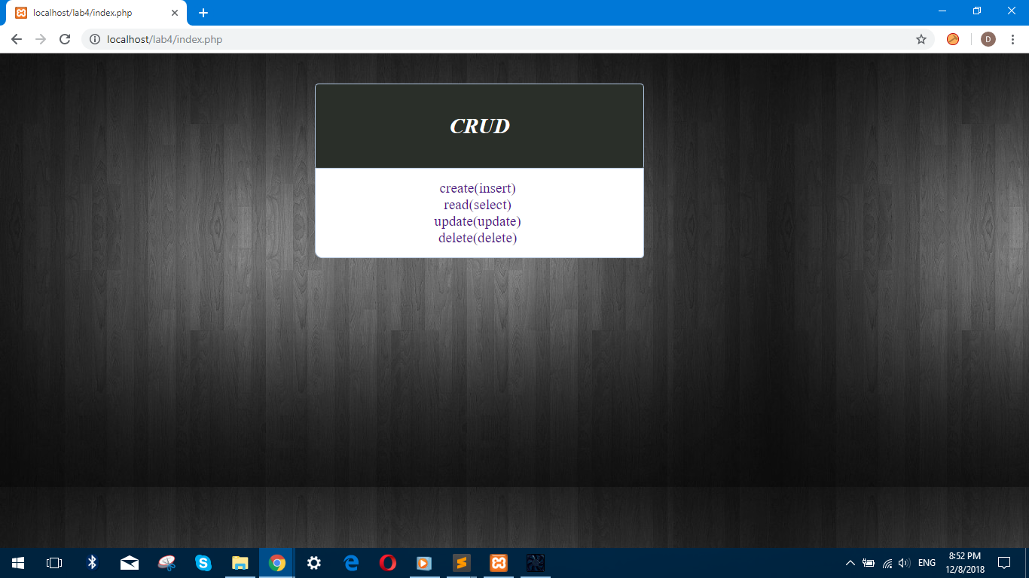

***Crearea***

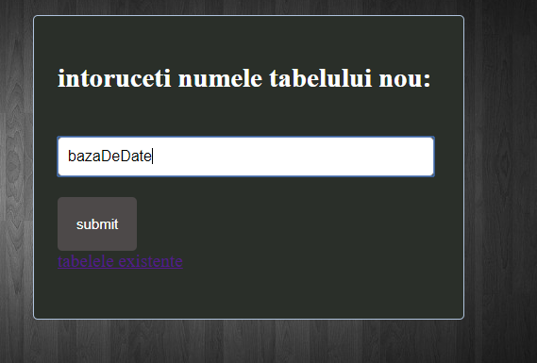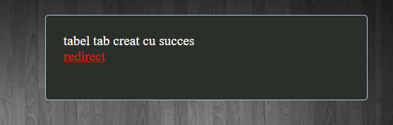

***Table inainte de creare***

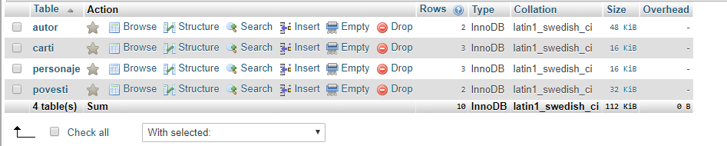

***Table dupa creare***

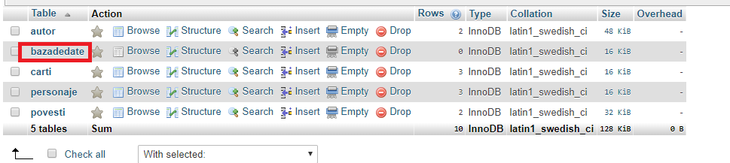

***Afisarea***

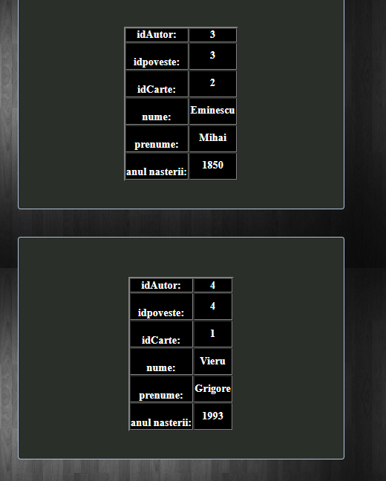

***Modificare***

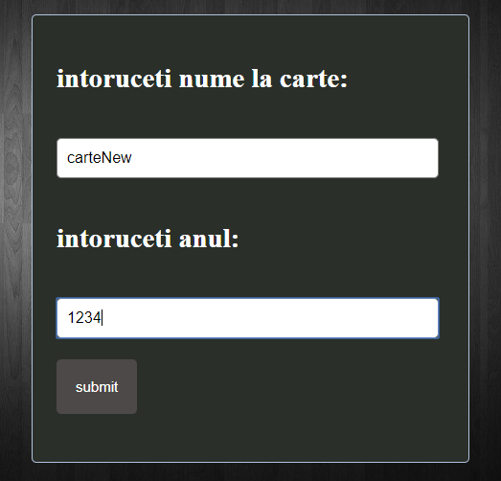

***Table inainte de modificare***

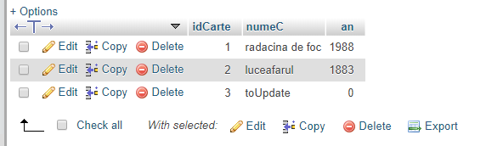

***Table dupa modificare***



***Stergerea***

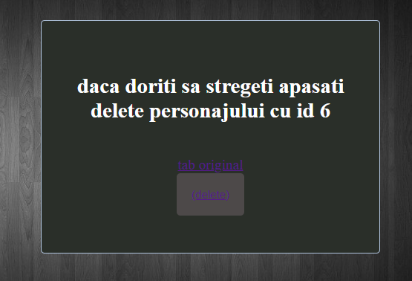

***Table inainte de modificare*** ***Table dupa modificare***

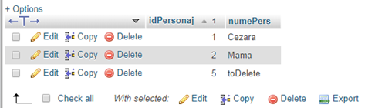

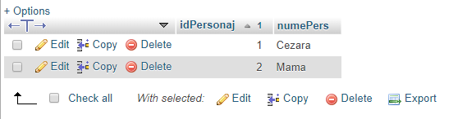

***Concluzie:***

In urma efectuarii laboratorului au fost obtinute anumite abilitati in domeniu BD si anume studierea PHP si utilizarea operetiilor CRUD.