Ministerul Educaţiei, al Culturii și Cercetării al Republicii Moldova

Universitatea Tehnică a Moldovei

Departamentul Informatică și Ingineria Sistemelor

**RAPORT**

Lucrarea de laborator nr.3

Metode și Modele de Calcul

A efectuat:

st. gr. C-171 D. Melniciuc

A verificat:

Lect. univ. A. Turcan

**1:**

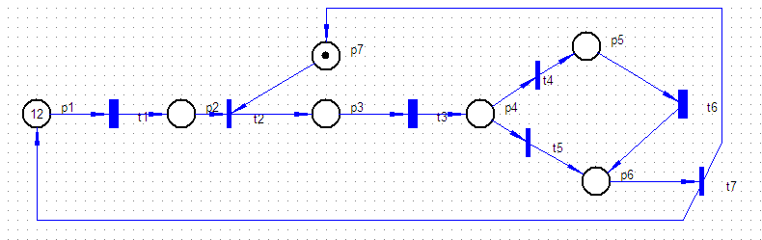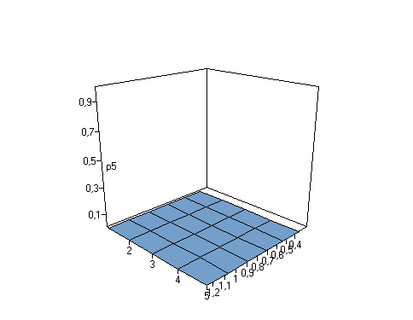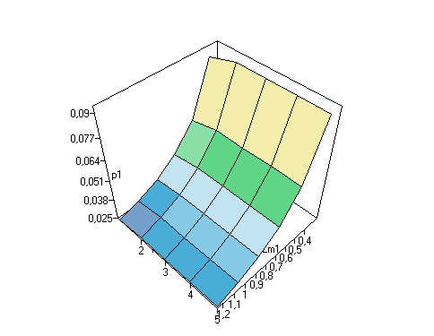

**3D:**

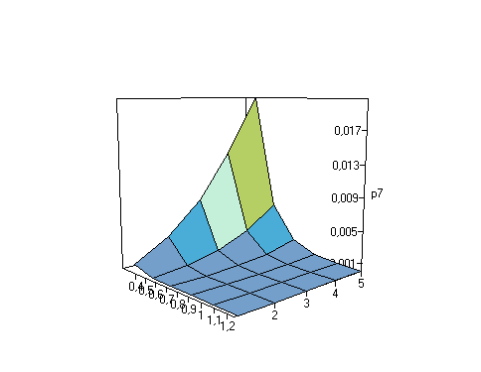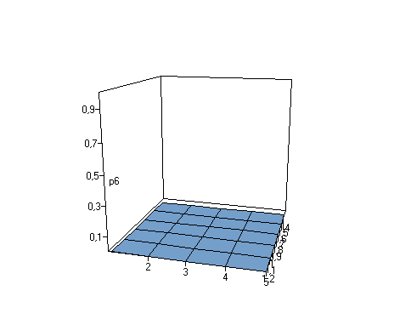

Graf:

M0 = [12,0,0,0,0,0,1] [t1,t2>M1;\\1;

M1 = [11,0,1,0,0,0,0] [t1>M2;t3,t4>M4;t3,t5,t7>M0;\\1;0.230769230769231;0.769230769230769;

M2 = [10,1,1,0,0,0,0] [t1>M3;t3,t4>M6;t3,t5,t7,t2>M1;\\1;0.230769230769231;0.769230769230769;

M3 = [9,2,1,0,0,0,0] [t1>M5;t3,t4>M8;t3,t5,t7,t2>M2;\\1;0.230769230769231;0.769230769230769;

M4 = [11,0,0,0,1,0,0] [t1>M6;t6,t7>M0;\\1;1;

M5 = [8,3,1,0,0,0,0] [t1>M7;t3,t4>M10;t3,t5,t7,t2>M3;\\1;0.230769230769231;0.769230769230769;

M6 = [10,1,0,0,1,0,0] [t1>M8;t6,t7,t2>M1;\\1;1;

M7 = [7,4,1,0,0,0,0] [t1>M9;t3,t4>M12;t3,t5,t7,t2>M5;\\1;0.230769230769231;0.769230769230769;

M8 = [9,2,0,0,1,0,0] [t1>M10;t6,t7,t2>M2;\\1;1;

M9 = [6,5,1,0,0,0,0] [t1>M11;t3,t4>M14;t3,t5,t7,t2>M7;\\1;0.230769230769231;0.769230769230769;

M10 = [8,3,0,0,1,0,0] [t1>M12;t6,t7,t2>M3;\\1;1;

M11 = [5,6,1,0,0,0,0] [t1>M13;t3,t4>M16;t3,t5,t7,t2>M9;\\1;0.230769230769231;0.769230769230769;

M12 = [7,4,0,0,1,0,0] [t1>M14;t6,t7,t2>M5;\\1;1;

M13 = [4,7,1,0,0,0,0] [t1>M15;t3,t4>M18;t3,t5,t7,t2>M11;\\1;0.230769230769231;0.769230769230769;

M14 = [6,5,0,0,1,0,0] [t1>M16;t6,t7,t2>M7;\\1;1;

M15 = [3,8,1,0,0,0,0] [t1>M17;t3,t4>M20;t3,t5,t7,t2>M13;\\1;0.230769230769231;0.769230769230769;

M16 = [5,6,0,0,1,0,0] [t1>M18;t6,t7,t2>M9;\\1;1;

M17 = [2,9,1,0,0,0,0] [t1>M19;t3,t4>M22;t3,t5,t7,t2>M15;\\1;0.230769230769231;0.769230769230769;

M18 = [4,7,0,0,1,0,0] [t1>M20;t6,t7,t2>M11;\\1;1;

M19 = [1,10,1,0,0,0,0] [t1>M21;t3,t4>M23;t3,t5,t7,t2>M17;\\1;0.230769230769231;0.769230769230769;

M20 = [3,8,0,0,1,0,0] [t1>M22;t6,t7,t2>M13;\\1;1;

M21 = [0,11,1,0,0,0,0] [t3,t4>M24;t3,t5,t7,t2>M19;\\0.230769230769231;0.769230769230769;

M22 = [2,9,0,0,1,0,0] [t1>M23;t6,t7,t2>M15;\\1;1;

M23 = [1,10,0,0,1,0,0] [t1>M24;t6,t7,t2>M17;\\1;1;

M24 = [0,11,0,0,1,0,0] [t6,t7,t2>M19;\\1;

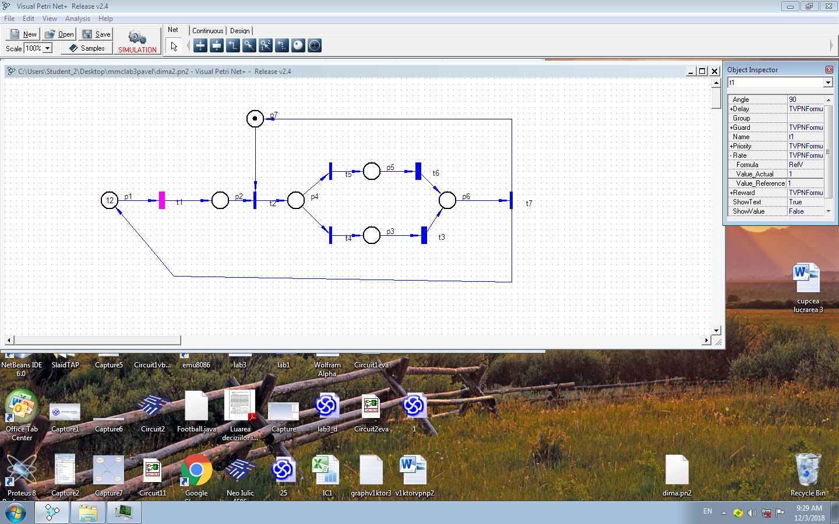

**2:**

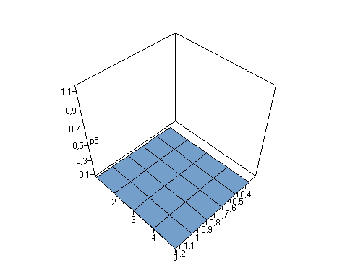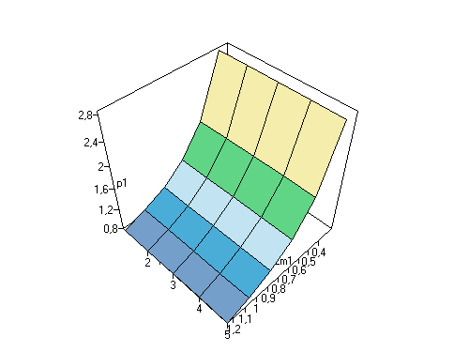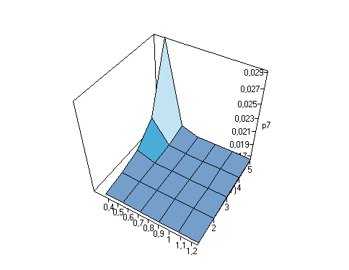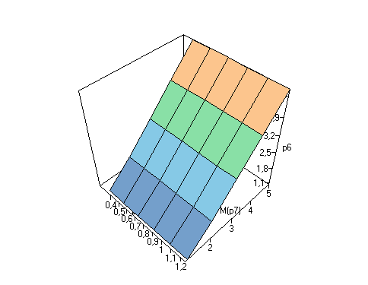

PositionsList: p1;p2;p3;p4;p5;p6;p7;

M0 = [12,0,0,0,0,0,1] [t1,t2,t4>M1;t1,t2,t5>M2;\\0.230769230769231;0.769230769230769;

M1 = [11,0,1,0,0,0,0] [t1>M3;t3,t7>M0;\\1;1;

M2 = [11,0,0,0,1,0,0] [t1>M4;t6,t7>M0;\\1;1;

M3 = [10,1,1,0,0,0,0] [t1>M5;t3,t7,t2,t4>M1;t3,t7,t2,t5>M2;\\1;0.230769230769231;0.769230769230769;

M4 = [10,1,0,0,1,0,0] [t1>M6;t6,t7,t2,t4>M1;t6,t7,t2,t5>M2;\\1;0.230769230769231;0.769230769230769;

M5 = [9,2,1,0,0,0,0] [t1>M7;t3,t7,t2,t4>M3;t3,t7,t2,t5>M4;\\1;0.230769230769231;0.769230769230769;

M6 = [9,2,0,0,1,0,0] [t1>M8;t6,t7,t2,t4>M3;t6,t7,t2,t5>M4;\\1;0.230769230769231;0.769230769230769;

M7 = [8,3,1,0,0,0,0] [t1>M9;t3,t7,t2,t4>M5;t3,t7,t2,t5>M6;\\1;0.230769230769231;0.769230769230769;

M8 = [8,3,0,0,1,0,0] [t1>M10;t6,t7,t2,t4>M5;t6,t7,t2,t5>M6;\\1;0.230769230769231;0.769230769230769;

M9 = [7,4,1,0,0,0,0] [t1>M11;t3,t7,t2,t4>M7;t3,t7,t2,t5>M8;\\1;0.230769230769231;0.769230769230769;

M10 = [7,4,0,0,1,0,0] [t1>M12;t6,t7,t2,t4>M7;t6,t7,t2,t5>M8;\\1;0.230769230769231;0.769230769230769;

M11 = [6,5,1,0,0,0,0] [t1>M13;t3,t7,t2,t4>M9;t3,t7,t2,t5>M10;\\1;0.230769230769231;0.769230769230769;

M12 = [6,5,0,0,1,0,0] [t1>M14;t6,t7,t2,t4>M9;t6,t7,t2,t5>M10;\\1;0.230769230769231;0.769230769230769;

M13 = [5,6,1,0,0,0,0] [t1>M15;t3,t7,t2,t4>M11;t3,t7,t2,t5>M12;\\1;0.230769230769231;0.769230769230769;

M14 = [5,6,0,0,1,0,0] [t1>M16;t6,t7,t2,t4>M11;t6,t7,t2,t5>M12;\\1;0.230769230769231;0.769230769230769;

M15 = [4,7,1,0,0,0,0] [t1>M17;t3,t7,t2,t4>M13;t3,t7,t2,t5>M14;\\1;0.230769230769231;0.769230769230769;

M16 = [4,7,0,0,1,0,0] [t1>M18;t6,t7,t2,t4>M13;t6,t7,t2,t5>M14;\\1;0.230769230769231;0.769230769230769;

M17 = [3,8,1,0,0,0,0] [t1>M19;t3,t7,t2,t4>M15;t3,t7,t2,t5>M16;\\1;0.230769230769231;0.769230769230769;

M18 = [3,8,0,0,1,0,0] [t1>M20;t6,t7,t2,t4>M15;t6,t7,t2,t5>M16;\\1;0.230769230769231;0.769230769230769;

M19 = [2,9,1,0,0,0,0] [t1>M21;t3,t7,t2,t4>M17;t3,t7,t2,t5>M18;\\1;0.230769230769231;0.769230769230769;

M20 = [2,9,0,0,1,0,0] [t1>M22;t6,t7,t2,t4>M17;t6,t7,t2,t5>M18;\\1;0.230769230769231;0.769230769230769;

M21 = [1,10,1,0,0,0,0] [t1>M23;t3,t7,t2,t4>M19;t3,t7,t2,t5>M20;\\1;0.230769230769231;0.769230769230769;

M22 = [1,10,0,0,1,0,0] [t1>M24;t6,t7,t2,t4>M19;t6,t7,t2,t5>M20;\\1;0.230769230769231;0.769230769230769;

M23 = [0,11,1,0,0,0,0] [t3,t7,t2,t4>M21;t3,t7,t2,t5>M22;\\0.230769230769231;0.769230769230769;

M24 = [0,11,0,0,1,0,0] [t6,t7,t2,t4>M21;t6,t7,t2,t5>M22;\\0.230769230769231;0.769230769230769;

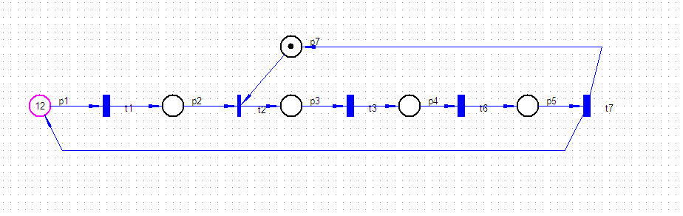

**3:**

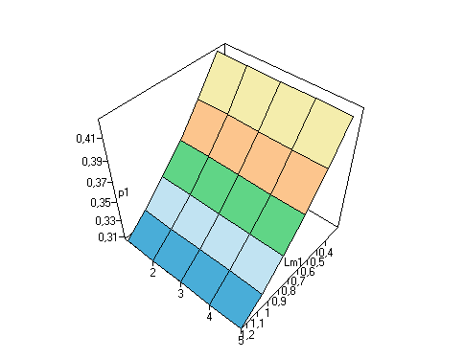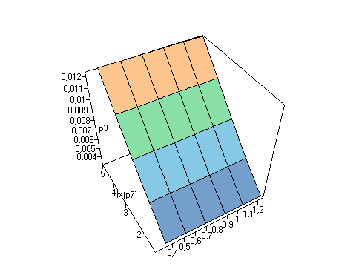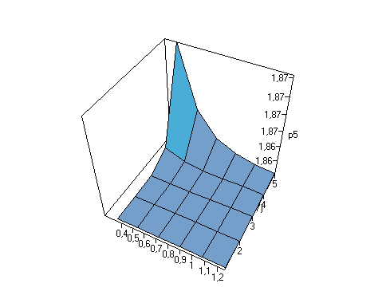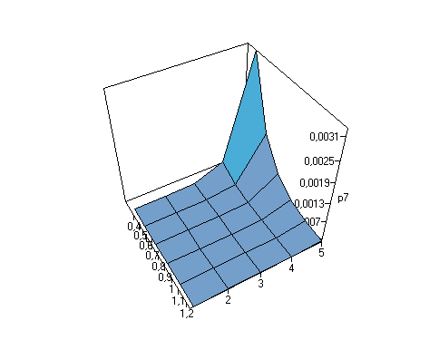

**4:**

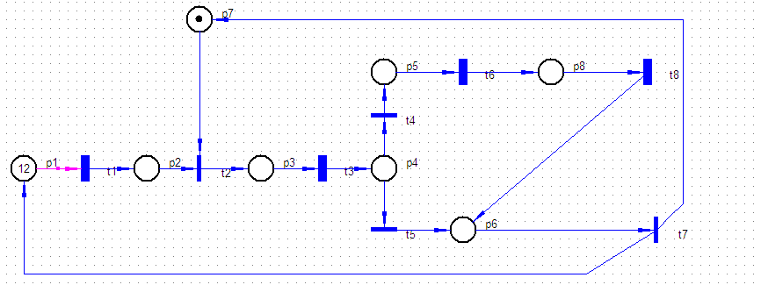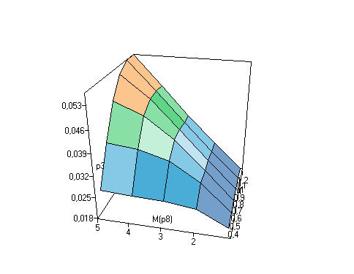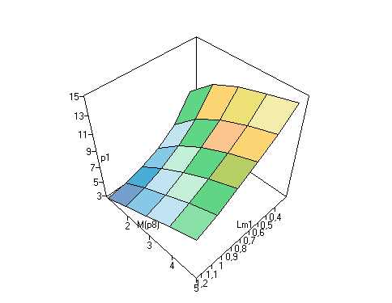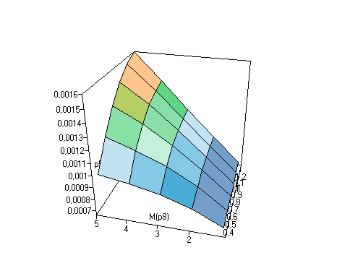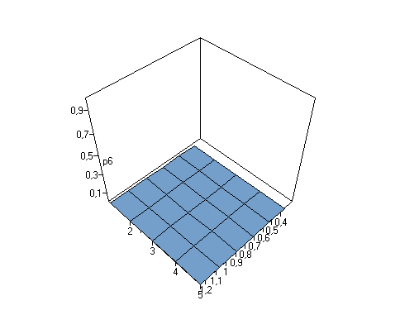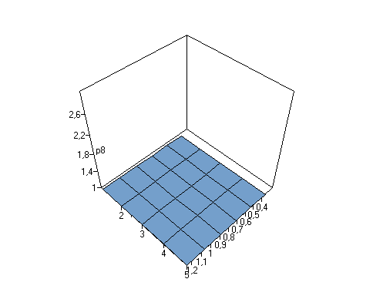

; Reachability graph file. Generated by VPNP

; Generated from C:\Users\Student_2\Desktop\mmclab3pavel\dima4.pn2 - Visual Petri Net+ - Release v2.4 Petri net file.

Totally found markings number = 37

PositionsList: p1;p2;p3;p4;p5;p6;p7;p8;

M0 = [12,0,0,0,0,0,1,0] [t1,t2>M1;\\1;

M1 = [11,0,1,0,0,0,0,0] [t1>M2;t3,t4>M4;t3,t5,t7>M0;\\1;0,230769230769231;0,769230769230769;

M2 = [10,1,1,0,0,0,0,0] [t1>M3;t3,t4>M6;t3,t5,t7,t2>M1;\\1;0,230769230769231;0,769230769230769;

M3 = [9,2,1,0,0,0,0,0] [t1>M5;t3,t4>M9;t3,t5,t7,t2>M2;\\1;0,230769230769231;0,769230769230769;

M4 = [11,0,0,0,1,0,0,0] [t1>M6;t6>M7;\\1;1;

M5 = [8,3,1,0,0,0,0,0] [t1>M8;t3,t4>M12;t3,t5,t7,t2>M3;\\1;0,230769230769231;0,769230769230769;

M6 = [10,1,0,0,1,0,0,0] [t1>M9;t6>M10;\\1;1;

M7 = [11,0,0,0,0,0,0,1] [t1>M10;t8,t7>M0;\\1;1;

M8 = [7,4,1,0,0,0,0,0] [t1>M11;t3,t4>M15;t3,t5,t7,t2>M5;\\1;0,230769230769231;0,769230769230769;

M9 = [9,2,0,0,1,0,0,0] [t1>M12;t6>M13;\\1;1;

M10 = [10,1,0,0,0,0,0,1] [t1>M13;t8,t7,t2>M1;\\1;1;

M11 = [6,5,1,0,0,0,0,0] [t1>M14;t3,t4>M18;t3,t5,t7,t2>M8;\\1;0,230769230769231;0,769230769230769;

M12 = [8,3,0,0,1,0,0,0] [t1>M15;t6>M16;\\1;1;

M13 = [9,2,0,0,0,0,0,1] [t1>M16;t8,t7,t2>M2;\\1;1;

M14 = [5,6,1,0,0,0,0,0] [t1>M17;t3,t4>M21;t3,t5,t7,t2>M11;\\1;0,230769230769231;0,769230769230769;

M15 = [7,4,0,0,1,0,0,0] [t1>M18;t6>M19;\\1;1;

M16 = [8,3,0,0,0,0,0,1] [t1>M19;t8,t7,t2>M3;\\1;1;

M17 = [4,7,1,0,0,0,0,0] [t1>M20;t3,t4>M24;t3,t5,t7,t2>M14;\\1;0,230769230769231;0,769230769230769;

M18 = [6,5,0,0,1,0,0,0] [t1>M21;t6>M22;\\1;1;

M19 = [7,4,0,0,0,0,0,1] [t1>M22;t8,t7,t2>M5;\\1;1;

M20 = [3,8,1,0,0,0,0,0] [t1>M23;t3,t4>M27;t3,t5,t7,t2>M17;\\1;0,230769230769231;0,769230769230769;

M21 = [5,6,0,0,1,0,0,0] [t1>M24;t6>M25;\\1;1;

M22 = [6,5,0,0,0,0,0,1] [t1>M25;t8,t7,t2>M8;\\1;1;

M23 = [2,9,1,0,0,0,0,0] [t1>M26;t3,t4>M30;t3,t5,t7,t2>M20;\\1;0,230769230769231;0,769230769230769;

M24 = [4,7,0,0,1,0,0,0] [t1>M27;t6>M28;\\1;1;

M25 = [5,6,0,0,0,0,0,1] [t1>M28;t8,t7,t2>M11;\\1;1;

M26 = [1,10,1,0,0,0,0,0] [t1>M29;t3,t4>M32;t3,t5,t7,t2>M23;\\1;0,230769230769231;0,769230769230769;

M27 = [3,8,0,0,1,0,0,0] [t1>M30;t6>M31;\\1;1;

M28 = [4,7,0,0,0,0,0,1] [t1>M31;t8,t7,t2>M14;\\1;1;

M29 = [0,11,1,0,0,0,0,0] [t3,t4>M34;t3,t5,t7,t2>M26;\\0,230769230769231;0,769230769230769;

M30 = [2,9,0,0,1,0,0,0] [t1>M32;t6>M33;\\1;1;

M31 = [3,8,0,0,0,0,0,1] [t1>M33;t8,t7,t2>M17;\\1;1;

M32 = [1,10,0,0,1,0,0,0] [t1>M34;t6>M35;\\1;1;

M33 = [2,9,0,0,0,0,0,1] [t1>M35;t8,t7,t2>M20;\\1;1;

M34 = [0,11,0,0,1,0,0,0] [t6>M36;\\1;

M35 = [1,10,0,0,0,0,0,1] [t1>M36;t8,t7,t2>M23;\\1;1;

M36 = [0,11,0,0,0,0,0,1] [t8,t7,t2>M26;\\1;