Ministerul Educaţiei, al Culturii și Cercetării al Republicii Moldova

Universitatea Tehnică a Moldovei

Departamentul Informatică și Ingineria Sistemelor

**RAPORT**

Lucrarea de laborator nr.1

Metode și Modele de Calcul

A efectuat:

st. gr. C-171 D. Melniciuc

A verificat:

Lect. univ. D. Istrati

Chişinău 2018

***Scopul lucrarii practice:***

Sa se separe toate radacinile reale ale ecuatiei f(x) unde este o functie realä de variabilá realä.

Sa determine radacina reala a ecuatiei date cu ajutorul metodei injumatatirii intervalului cu eroare < 0.001

Sa precizeze radacina obtinuta utilizând:

-metoda aproximatiilor successive

-metoda tangentelor (Newton)  
  
-metoda secantelor.

Så se compare rezultatele luånd in consideratie numărul de iteratii, metoda aproximatlor succesive,

**Varianta 2:**



***ScreenShot-uri:***

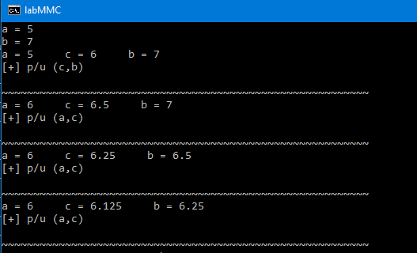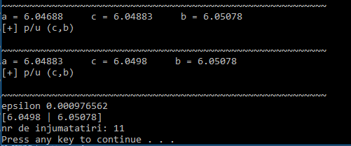

***Aproximatie succesiva***

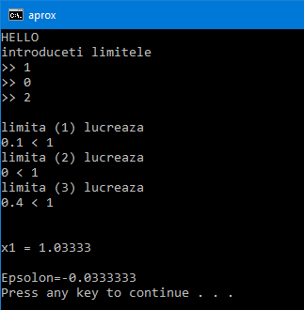

***Newton***

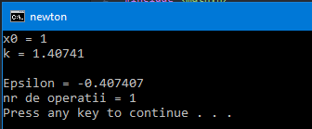

***Secante:***

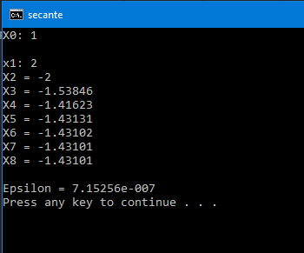

***Codul programelor:***

*#include <iostream>*

*#include <math.h>*

*#include <windows.h>*

*using namespace std;*

*float functie (float x)*

*{*

*return x*x*x-30*x-40;*

*}*

*int main ()*

*{*

*float a, b, c, g, h;*

*cout<< "a = ";*

*cin>>a;*

*cout<< "b = ";*

*cin>>b;*

*int i = 0;*

*for(;;){*

*++i;*

*c=(a+b)/2;*

*g=functie(a)*functie(c);*

*h=functie(b)*functie(c);*

*cout<<"a = "<<a<<" "<<" c = "<<c<<" "<<" b = "<<b<<endl;*

*if(g<0){*

*b = c;*

*cout<<"[+] p/u (a,c)"<<endl;*

*}*

*if(h<0){*

*a = c;*

*cout<<"[+] p/u (c,b)"<<endl;*

*}*

*if (g > 0 && h > 0) {*

*cout<<"\n[-] intervalul ("<< a << "|" << b <<") nu merge"<<endl;*

*exit(1);*

*}*

*cout<<"\n~~~~~~~~~~~~~~~~~~~~~~~~~~~~~~~~~~~~~~~~~~~~~~~~~~~~~~~~~~"<<endl;*

*if((b-a) < 0.001){*

*cout<<"epsilon "<<b-a<<endl;*

*cout<<"["<<a<<" | "<<b<<"]\n";*

*cout<<"nr de injumatatiri: "<<i<<endl;*

*system("pause");*

*exit(1);*

*}*

*}*

*}*

***Aproximativ succesiv:***

*#include <iostream>*

*#include <math.h>*

*using namespace std;*

*float Fi (float x)*

*{*

*float f;*

*f=pow(x,3)/30+4/3;*

*return f;*

*}*

*int Fi_d(float a, float b, float c)*

*{*

*int i=0;*

*float d,f,g;*

*d=pow(a,2)/10;*

*if(d<1) {*

*cout<<"\nlimita (1) lucreaza\n";*

*cout<<d<<" < 1 \n";*

*i++;*

*}*

*f=pow(b,2)/10;*

*if(f<1){*

*cout<<"limita (2) lucreaza\n";*

*cout<<f<<" < 1 \n";*

*i++;*

*}*

*g=pow(c,2)/10;*

*if(g<1){*

*cout<<"limita (3) lucreaza\n";*

*cout<<g<<" < 1 \n";*

*i++;*

*}*

*cout<<endl;*

*cout<<endl;*

*return i;*

*}*

*int main()*

*{*

*cout<<"HELLO\n";*

*float a,b,c;*

*cout<< "introduceti limitele \n>> ";*

*cin>>a; cout<<">> ";*

*cin>>b; cout<<">> ";*

*cin>>c;*

*int d = Fi_d(a,b,c);*

*if(d==3)*

*{*

*int m=0;*

*int v=1;*

*float y=a;*

*float x;*

*float k;*

*while(m==0)*

*{*

*x=Fi(y);*

*k=y-x;*

*y=x;*

*cout<<"x"<<v<<" = "<<x<<endl;*

*v++;*

*if(k<0.001){*

*m=1;*

*cout<<"\nEpsolon="<<k;*

*}*

*}*

*}*

*else{*

*cout<<"eroare";*

*exit (1);*

*}*

*}*

***Newton:***

*#include <iostream>*

*#include <math.h>*

*using namespace std;*

*float funct (float x)*

*{*

*float f;*

*f=pow(x,3)-30*x+40;*

*return f;*

*}*

*float functD (float x)*

*{*

*float f;*

*f=3*pow(x,2)-30;*

*return f;*

*}*

*int main()*

*{*

*float x;*

*cout<<"x0 = ";*

*cin>>x;*

*int i = 0;*

*float k,a,b,e;*

*for (;;)*

*{*

*++i;*

*a = funct(x);*

*b = functD(x);*

*k = x - (a/b);*

*cout<<"k = "<<k<<endl;*

*e = x - k;*

*x = k;*

*if(e < 0.001)*

*{*

*cout<<"\nEpsilon = "<<e;*

*cout<<"\nnr de operatii = "<<i;*

*cout<<"\n";*

*system("pause");*

*exit(1);*

*}*

*}*

*return 0;*

*}*

***Secante:***

*#include <iostream>*

*#include <math.h>*

*using namespace std;*

*float Fi (float x)*

*{*

*return x*x*x-30*x-40;*

*}*

*int main()*

*{*

*cout<<"X0: ";*

*float x0;*

*cin>>x0;*

*cout<<"\nx1: ";*

*float x1;*

*cin>>x1;*

*int m=0;*

*float x,k,j,l,e,b;*

*int i=2;*

*while(m==0)*

*{*

*j=Fi(x1);*

*l=Fi(x0);*

*k=x1-((j*(x1-x0))/(j-l));*

*cout <<"X"<<i<<" = "<<k<<endl;*

*e=x1-x0;*

*x0=x1;*

*x1=k;*

*i++;*

*b=abs(e);*

*if(b<0.000001)*

*{*

*m=1;*

*cout<<"\nEpsilon = "<<b;*

*}*

*}*

*}*

***Concluzie:***

In urma efectuarii laboratorului au fost obtinute anumite abilitati in domeniu MMC si anume studierea urmatoarelor metode: injumatatirea intervalului, aproximare succesiva si metoda Newton.