Ministerul Educaţiei, al Culturii și Cercetării al Republicii Moldova

Universitatea Tehnică a Moldovei

Departamentul Informatică și Ingineria Sistemelor

**RAPORT**

Lucrarea de laborator nr.2

Metode și Modele de Calcul

A efectuat:

st. gr. C-171 D. Melniciuc

A verificat:

Lect. univ. D. Istrati

Chişinău 2018

***Scopul lucrarii practice:***

Sa rezolvesistemul de ecuatii liniare Ax = b utilizind:

Metoda eliminatii Gauss

Metoda lui Cholesky

Metoda iterative a lui Jacobi

Metoda iterative Gauss-Seidel

***ScreenShot-uri:***

*Metoda Jacobi 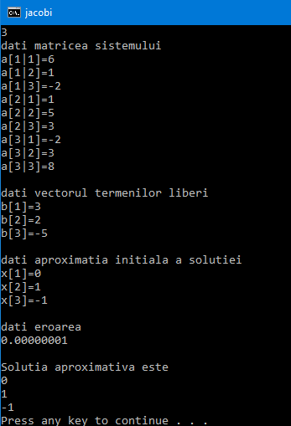 Metoda Cholesky*

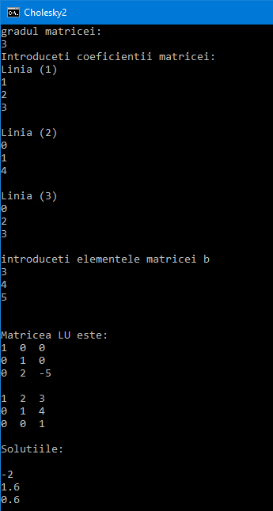

*Metoda Gauss – Seidel Metoda Gauss*

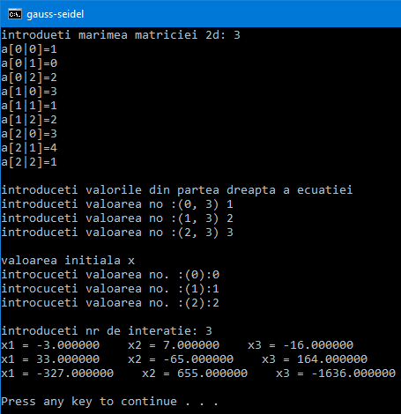

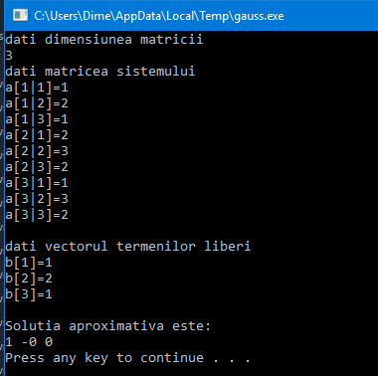

***Codul programului:***

***Metoda Gauss – Seidel***

*#include<iostream>*

*#include<conio.h>*

*using namespace std;*

*int main(void)*

*{*

*float a[10][10], b[10], x[10], y[10];*

*int n = 0, m = 0, i = 0, j = 0;*

*cout << "introdueti marimea matriciei 2d: ";*

*cin >> n;*

*for (i = 0; i < n; i++){*

*for (j = 0; j < n; j++)*

*{*

*cout << "a[" << i <<"|"<< j << "]=";*

*cin >> a[i][j];*

*}*

*}*

*cout << "\nintroduceti valorile din partea dreapta a ecuatiei\n";*

*for (i = 0; i < n; i++){*

*cout << "introduceti valoarea no :(" << i << ", " << j << ") ";*

*cin >> b[i];*

*}*

*cout << "\nvaloarea initiala x\n";*

*for (i = 0; i < n; i++){*

*cout << "introcuceti valoarea no. :(" << i<<"):";*

*cin >> x[i];*

*}*

*cout << "\nintroduceti nr de interatie: ";*

*cin >> m;*

*while (m > 0){*

*for (i = 0; i < n; i++)*

*{*

*y[i] = (b[i] / a[i][i]);*

*for (j = 0; j < n; j++)*

*{*

*if (j == i)*

*continue;*

*y[i] = y[i] - ((a[i][j] / a[i][i]) * x[j]);*

*x[i] = y[i];*

*}*

*printf("x%d = %f ", i + 1, y[i]);*

*}*

*cout << "\n";*

*m--;*

*}*

*return 0;*

*}*

***Metoda Gauss***

*#include <iostream>*

*#include <math.h>*

*using namespace std;*

*#define max 15*

*int main(void)*

*{*

*float s;*

*float a[max + 1][max + 1][max + 1], b[max + 1][max + 1], x[max + 1];*

*int n, i, j, k;*

*cout << "dati dimensiunea matricii" << endl; cin >> n;*

*cout << "dati matricea sistemului " << endl;*

*for (i = 1; i <= n; i++)*

*for (j = 1; j <= n; j++){*

*cout << "a[" << i <<"|"<< j << "]=";*

*cin >> a[i][j][1];*

*}*

*cout << endl;*

*cout << "dati vectorul termenilor liberi " << endl;*

*for (i = 1; i <= n; i++){*

*cout << "b[" << i << "]=";*

*cin >> b[i][1];*

*}*

*cout << endl;*

*for (k = 1; k <= n - 1; k++){*

*for (i = 1; i <= n; i++)*

*for (j = 1; j <= n; j++){*

*if (i <= k)a[i][j][k + 1] = a[i][j][k];*

*else if (j <= k)a[i][j][k + 1] = 0;*

*else a[i][j][k + 1] = a[i][j][k] - a[i][k][k] * a[k][j][k] / a[k][k][k];*

*}*

*for (i = 1; i <= n; i++)*

*if (i <= k)b[i][k + 1] = b[i][k];*

*else b[i][k + 1] = b[i][k] - a[i][k][k] * b[k][k] / a[k][k][k];*

*}*

*x[n] = b[n][n] / a[n][n][n];*

*for (i = n - 1; i >= 1; i--)*

*{*

*s = 0;*

*for (j = i + 1; j <= n; j++)*

*s = s + a[i][j][i] * x[j];*

*x[i] = (b[i][i] - s) / a[i][i][i];*

*}cout << "Solutia aproximativa este:" << endl;*

*for (i = 1; i <= n; i++)*

*cout << x[i] << ' ';*

*cout << endl;*

*system("pause");*

*}*

***Metoda Jacobi***

*#include <iostream>*

*#include <math.h>*

*using namespace std;*

*#define max 10*

*int main()*

*{*

*float s, s1, eps;*

*float a[max + 1][max + 1], b[max + 1], x[max + 1], y[max + 1];*

*int n, i, j;*

*cout << "dati numarul de ecuatii si necunoscute " << endl; cin >> n;*

*cout << "dati matricea sistemului " << endl;*

*for (i = 1; i <= n; i++)*

*for (j = 1; j <= n; j++){*

*cout << "a[" << i <<"|"<< j << "]=";*

*cin >> a[i][j];*

*}*

*cout << endl;*

*cout << "dati vectorul termenilor liberi " << endl;*

*for (i = 1; i <= n; i++){*

*cout << "b[" << i << "]=";*

*cin >> b[i];*

*}*

*cout << endl;*

*cout << "dati aproximatia initiala a solutiei " << endl;*

*for (i = 1; i <= n; i++){*

*cout << "x[" << i << "]=";*

*cin >> y[i];*

*}*

*cout << endl;*

*cout << "dati eroarea " << endl; cin >> eps; cout << endl;*

*s = eps + 1;*

*while (s >= eps){*

*for (i = 1; i <= n; i++)*

*{*

*s1 = 0;*

*for (j = 1; j <= n; j++)*

*if (j != i)s1 = s1 + a[i][j] * y[j]; x[i] = (b[i] - s1) / a[i][i];*

*}*

*s = 0;*

*for (i = 1; i <= n; i++)*

*s = s + abs(x[i] - y[i]);*

*for (i = 1; i <= n; i++)*

*y[i] = x[i];*

*}*

*cout << "Solutia aproximativa este " << endl;*

*for (i = 1; i <= n; i++)*

*cout << x[i] << endl;*

*system("pause");*

*}*

***Metoda Cholesky***

*#include <iostream>*

*#include <conio.h>*

*using namespace std;*

*int main()*

*{*

*int n,i,k,j,p;*

*float a[10][10],l[10][10]={0},u[10][10]={0},sum,b[10],z[10]={0},x[10]={0};*

*// clrscr();*

*cout<<"gradul matricei: "<<endl;*

*cin>>n;*

*cout<<"Introduceti coeficientii matricei: ";*

*for(i=1;i<=n;i++)*

*{*

*cout<<"\nLinia ("<<i<<") \n";*

*for(j=1;j<=n;j++)*

*cin>>a[i][j];*

*}*

*cout<<"\nintroduceti elementele matricei b"<<endl;*

*for(i=1;i<=n;i++)*

*cin>>b[i];*

*for(k=1;k<=n;k++)*

*{*

*u[k][k]=1;*

*for(i=k;i<=n;i++)*

*{*

*sum=0;*

*for(p=1;p<=k-1;p++)*

*sum+=l[i][p]*u[p][k];*

*l[i][k]=a[i][k]-sum;*

*}*

*for(j=k+1;j<=n;j++)*

*{*

*sum=0;*

*for(p=1;p<=k-1;p++)*

*sum+=l[k][p]*u[p][j];*

*u[k][j]=(a[k][j]-sum)/l[k][k];*

*}*

*}*

*//******** Displaying LU matrix**********//*

*cout<<endl<<endl<<"Matricea LU este: "<<endl;*

*for(i=1;i<=n;i++)*

*{*

*for(j=1;j<=n;j++)*

*cout<<l[i][j]<<" ";*

*cout<<endl;*

*}*

*cout<<endl;*

*for(i=1;i<=n;i++)*

*{*

*for(j=1;j<=n;j++)*

*cout<<u[i][j]<<" ";*

*cout<<endl;*

*}*

*for(i=1;i<=n;i++)*

*{ //forward subtitution method*

*sum=0;*

*for(p=1;p<i;p++)*

*sum+=l[i][p]*z[p];*

*z[i]=(b[i]-sum)/l[i][i];*

*}*

*for(i=n;i>0;i--)*

*{*

*sum=0;*

*for(p=n;p>i;p--)*

*sum+=u[i][p]*x[p];*

*x[i]=(z[i]-sum)/u[i][i];*

*}*

*cout<<endl<<"Solutiile: "<<endl;*

*for(i=1;i<=n;i++)*

*cout<<endl<<x[i];*

*getch();*

*return 0;*

*}*

***Concluzie:***

*In urma efectuarii laboratorului au fost obtinute anumite abilitati in domeniu MMC si rezolvarea sistemelor de ecuatie utilizind metodele eliminatii Gauss, metoda lui Cholesky. metoda iterative a lui Jacobi si metoda iterative Gauss-Seidel*