Ministerul Educaţiei, al Culturii și Cercetării al Republicii Moldova

Universitatea Tehnică a Moldovei

Departamentul Informatică și Ingineria Sistemelor

**RAPORT**

Lucrarea de laborator nr.3

Metode și Modele de Calcul

A efectuat:

st. gr. C-171 D. Melniciuc

A verificat:

Lect. univ. E.Gutuleac

Chişinău 2019

***Laborator №1***

**Rețelele Petri** sunt o reprezentare matematică a sistemelor discrete distribuite. Definite de către [Carl Adam Petri](https://ro.wikipedia.org/w/index.php?title=Carl_Adam_Petri&action=edit&redlink=1) în anii 1960 în teza sa de doctorat, rețelele Petri au abilitatea de a generaliza teoria automatelor, prin expresivitatea lor ridicată în domeniul evenimentelor concurente.

O rețea Petri este un [graf orientat](https://ro.wikipedia.org/wiki/Graf_orientat" \o "Graf orientat) bipartit, ale cărui noduri sunt *locuri* sau *tranziții*. Fiecare arc al acestui graf leagă un loc și o tranziție. Nu există arce între două locuri și nici între două tranziții. Dacă de la un loc *L* există un arc orientat spre o tranziție *T*, atunci *L* este *loc de intrare* pentru *T*; invers, dacă arcul este orientat de la tranziția *T* la locul *L*, atunci *L* este *loc de ieșire* pentru *T*. Locurile pot conține un număr variabil de jetoane, iar întreaga distribuție a jetoanelor în locurile rețelei se numește *marcaj*. Tranzițiile se produc consumând jetoane din locurile de intrare și producându-le în cele de ieșire.

Execuția unei rețele Petri este un proces nedeterminist. La execuție, se analizează la fiecare pas tranzițiile active. O tranziție se numește *activă* în momentul în care fiecare din locurile sale de intrare conține cel puțin un jeton. Execuția unei tranziții presupune modificarea marcajului rețelei, prin eliminarea câte unui jeton din fiecare loc de intrare și adăugarea câte unui jeton în fiecare loc de ieșire. O singură tranziție se poate executa la un anumit pas

Rețelele Petri de o complexitate mai mare au capabilitatea de a introduce ierarhii în rețele.

### **Rețele Petri colorate**

Jetoanele într-o rețea Petri standard nu se disting între ele ca și aparență vizuală. Pentru acest lucru se folosesc rețelele Petri colorate (în [engleză](https://ro.wikipedia.org/wiki/Limba_englez%C4%83" \o "Limba engleză) *Colored Petri Nets*, deseori regăsite sub acronimul CPN). Activarea unei tranziții este determinată în totalitate de prezența jetoanelor în locurile de intrare.

Rețelele Petri stocastice adaugă capacitatea de reprezentare a evenimentelor nedeterministe ca moment al producerii.

## **Probleme reprezentabile prin rețele Petri**

Marea majoritate a problemelor reprezentabile cu rețele Petri sunt deterministe (prezența unei soluții poate fi anticipată prin aplicarea unui algoritm), cum are fi cazul problemelor de acoperire, rezolvate prin implementarea Arborelui Karp-Miller.

Problemele de prezență (în [engleză](https://ro.wikipedia.org/wiki/Limba_englez%C4%83" \o "Limba engleză) *reachability problem*; determinarea dacă într-o rețea un anumit punct este accesibil) sunt cunoscute a fi deterministe dar implementările oferă timpi exponețiali în rezolvări.

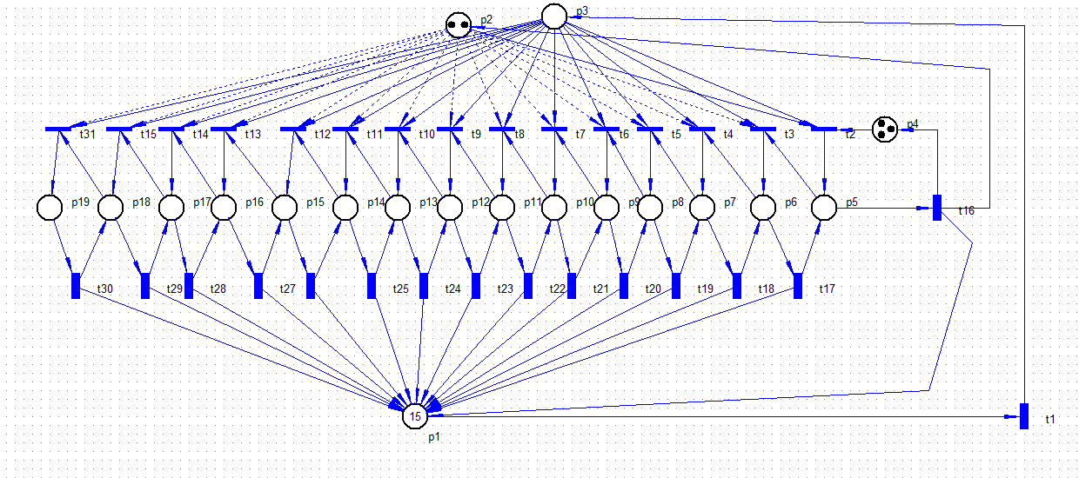

Totally found markings number = 273

PositionsList: p1;p2;p3;p4;p5;p6;p7;p8;p9;p10;p11;p12;p13;p14;p15;p16;p17;p18;p19;p20;

M0 = [16,2,0,3,0,0,0,0,0,0,0,0,0,0,0,0,0,0,0,0] [t1>M1;\\1;

M1 = [15,2,1,3,0,0,0,0,0,0,0,0,0,0,0,0,0,0,0,0] [t1>M2;t2>M3;\\1;0;

M2 = [14,2,2,3,0,0,0,0,0,0,0,0,0,0,0,0,0,0,0,0] [t1>M4;t2>M5;\\1;0;

M3 = [15,1,0,2,1,0,0,0,0,0,0,0,0,0,0,0,0,0,0,0] [t1>M5;t16>M0;\\1;1;

M4 = [13,2,3,3,0,0,0,0,0,0,0,0,0,0,0,0,0,0,0,0] [t1>M6;t2>M7;\\1;0;

M5 = [14,1,1,2,1,0,0,0,0,0,0,0,0,0,0,0,0,0,0,0] [t1>M7;t2>M8;t3>M9;t16>M1;\\1;0;0;1;

M6 = [12,2,4,3,0,0,0,0,0,0,0,0,0,0,0,0,0,0,0,0] [t1>M10;t2>M11;\\1;0;

M7 = [13,1,2,2,1,0,0,0,0,0,0,0,0,0,0,0,0,0,0,0] [t1>M11;t2>M12;t3>M13;t16>M2;\\1;0;0;1;

M8 = [14,0,0,1,2,0,0,0,0,0,0,0,0,0,0,0,0,0,0,0] [t1>M12;t16>M3;\\1;1;

M9 = [14,1,0,2,0,1,0,0,0,0,0,0,0,0,0,0,0,0,0,0] [t1>M13;t17>M3;\\1;1;

M10 = [11,2,5,3,0,0,0,0,0,0,0,0,0,0,0,0,0,0,0,0] [t1>M14;t2>M15;\\1;0;

M11 = [12,1,3,2,1,0,0,0,0,0,0,0,0,0,0,0,0,0,0,0] [t1>M15;t2>M16;t3>M17;t16>M4;\\1;0;0;1;

M12 = [13,0,1,1,2,0,0,0,0,0,0,0,0,0,0,0,0,0,0,0] [t1>M16;t16>M5;\\1;1;

M13 = [13,1,1,2,0,1,0,0,0,0,0,0,0,0,0,0,0,0,0,0] [t1>M17;t2>M18;t4>M19;t17>M5;\\1;0;0;1;

M14 = [10,2,6,3,0,0,0,0,0,0,0,0,0,0,0,0,0,0,0,0] [t1>M20;t2>M21;\\1;0;

M15 = [11,1,4,2,1,0,0,0,0,0,0,0,0,0,0,0,0,0,0,0] [t1>M21;t2>M22;t3>M23;t16>M6;\\1;0;0;1;

M16 = [12,0,2,1,2,0,0,0,0,0,0,0,0,0,0,0,0,0,0,0] [t1>M22;t16>M7;\\1;1;

M17 = [12,1,2,2,0,1,0,0,0,0,0,0,0,0,0,0,0,0,0,0] [t1>M23;t2>M24;t4>M25;t17>M7;\\1;0;0;1;

M18 = [13,0,0,1,1,1,0,0,0,0,0,0,0,0,0,0,0,0,0,0] [t1>M24;t17>M8;t16>M9;\\1;1;1;

M19 = [13,1,0,2,0,0,1,0,0,0,0,0,0,0,0,0,0,0,0,0] [t1>M25;t18>M9;\\1;1;

M20 = [9,2,7,3,0,0,0,0,0,0,0,0,0,0,0,0,0,0,0,0] [t1>M26;t2>M27;\\1;0;

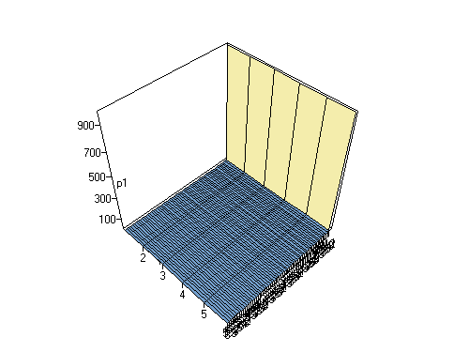



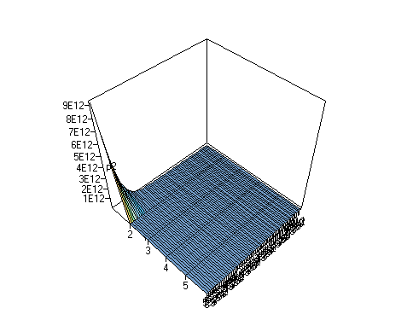

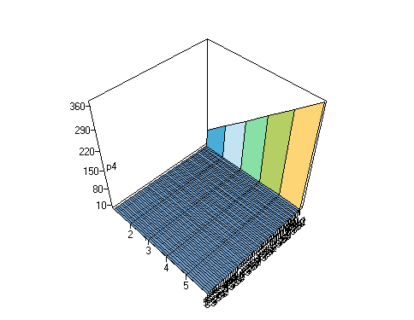

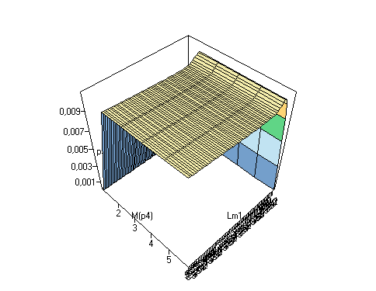



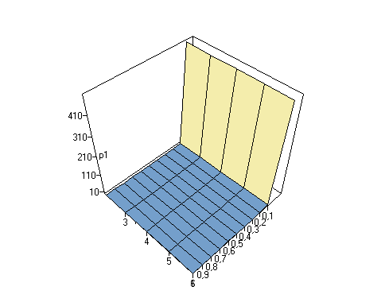

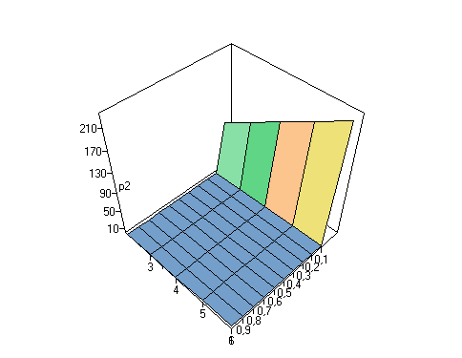

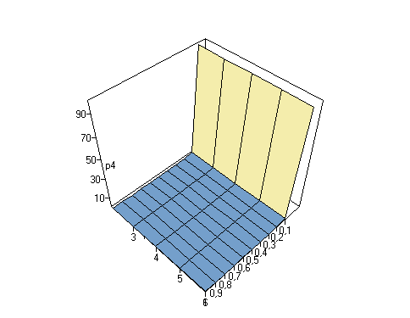

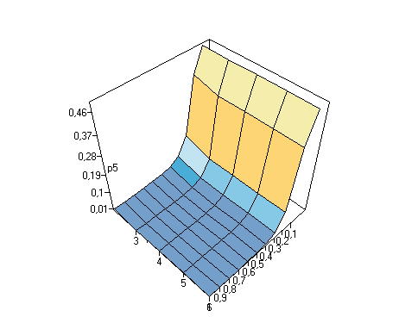

***Laborator №2***

În [matematică](https://ro.wikipedia.org/wiki/Matematic%C4%83" \o "Matematică), un **proces Markov**, sau un **lanț Markov**, este un [proces stochastic](https://ro.wikipedia.org/wiki/Proces_stochastic" \o "Proces stochastic) care are proprietatea că, dată fiind starea sa prezentă, stările viitoare sunt independente de cele trecute.[[1]](https://ro.wikipedia.org/wiki/Lan%C8%9B_Markov#cite_note-1) Această proprietate se numește **proprietatea Markov**. Cu alte cuvinte, starea curentă a unui astfel de proces reține toată informația despre întreaga evoluție a procesului. Lanțurile Markov au fost denumite după matematicianul rus [Andrei Markov](https://ro.wikipedia.org/wiki/Andrei_Markov" \o "Andrei Markov).

Într-un proces Markov, la fiecare moment, sistemul își poate schimba sau păstra starea, în conformitate cu o anumită distribuție de probabilitate. Schimbările de stare sunt numite *tranziții*. Un exemplu simplu de proces Markov este parcurgerea aleatoare a nodurilor unui [graf](https://ro.wikipedia.org/wiki/Graf" \o "Graf), tranzițiile fiind trecerea de la un nod la unul din succesorii săi, cu probabilitate egală, indiferent de nodurile parcurse până în acel moment.

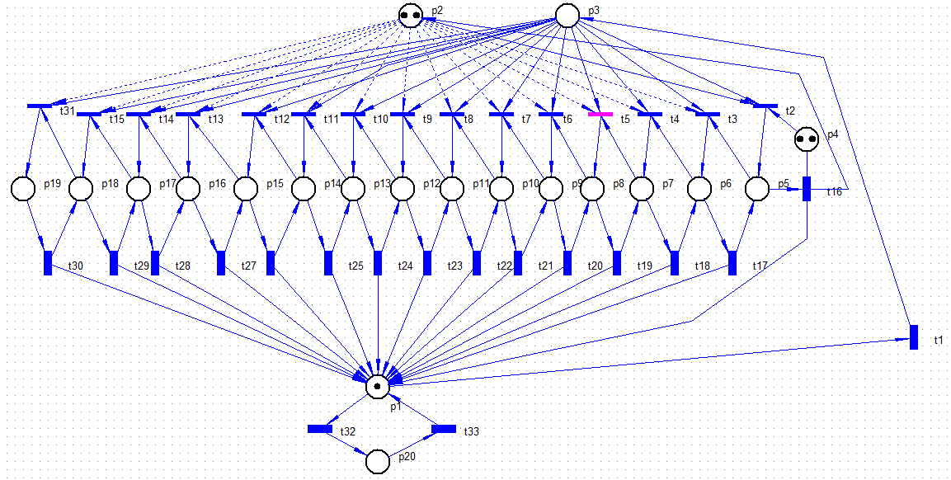

Totally found markings number = 696

PositionsList: p1;p2;p3;p4;p5;p6;p7;p8;p9;p10;p11;p12;p13;p14;p15;p16;p17;p18;p19;p20;

M0 = [15,2,0,2,0,0,0,0,0,0,0,0,0,0,0,0,0,0,0,0] [t32>M1;t1,t2>M2;\\1;1;

M1 = [14,2,0,2,0,0,0,0,0,0,0,0,0,0,0,0,0,0,0,1] [t32>M3;t33>M0;t1,t2>M4;\\1;1;1;

M2 = [14,1,0,1,1,0,0,0,0,0,0,0,0,0,0,0,0,0,0,0] [t16>M0;t32>M4;t1,t2>M6;t1,t3>M7;\\1;1;0.5;0.5;

M3 = [13,2,0,2,0,0,0,0,0,0,0,0,0,0,0,0,0,0,0,2] [t32>M5;t33>M1;t1,t2>M8;\\1;1;1;

M4 = [13,1,0,1,1,0,0,0,0,0,0,0,0,0,0,0,0,0,0,1] [t16>M1;t32>M8;t33>M2;t1,t2>M11;t1,t3>M12;\\1;1;1;0.5;0.5;

M5 = [12,2,0,2,0,0,0,0,0,0,0,0,0,0,0,0,0,0,0,3] [t32>M9;t33>M3;t1,t2>M13;\\1;1;1;

M6 = [13,0,0,0,2,0,0,0,0,0,0,0,0,0,0,0,0,0,0,0] [t1>M10;t16>M2;t32>M11;\\1;1;1;

M7 = [13,1,0,1,0,1,0,0,0,0,0,0,0,0,0,0,0,0,0,0] [t17>M2;t32>M12;t1,t2>M18;t1,t4>M19;\\1;1;0.5;0.5;

M8 = [12,1,0,1,1,0,0,0,0,0,0,0,0,0,0,0,0,0,0,2] [t16>M3;t32>M13;t33>M4;t1,t2>M17;t1,t3>M20;\\1;1;1;0.5;0.5;

M9 = [11,2,0,2,0,0,0,0,0,0,0,0,0,0,0,0,0,0,0,4] [t32>M14;t33>M5;t1,t2>M21;\\1;1;1;

M10 = [12,0,1,0,2,0,0,0,0,0,0,0,0,0,0,0,0,0,0,0] [t1>M15;t32>M16;t16,t2>M6;t16,t3>M7;\\1;1;0.5;0.5;

M11 = [12,0,0,0,2,0,0,0,0,0,0,0,0,0,0,0,0,0,0,1] [t1>M16;t16>M4;t32>M17;t33>M6;\\1;1;1;1;

M12 = [12,1,0,1,0,1,0,0,0,0,0,0,0,0,0,0,0,0,0,1] [t17>M4;t32>M20;t33>M7;t1,t2>M28;t1,t4>M29;\\1;1;1;0.5;0.5;

M13 = [11,1,0,1,1,0,0,0,0,0,0,0,0,0,0,0,0,0,0,3] [t16>M5;t32>M21;t33>M8;t1,t2>M26;t1,t3>M30;\\1;1;1;0.5;0.5;

M14 = [10,2,0,2,0,0,0,0,0,0,0,0,0,0,0,0,0,0,0,5] [t32>M22;t33>M9;t1,t2>M31;\\1;1;1;

M15 = [11,0,2,0,2,0,0,0,0,0,0,0,0,0,0,0,0,0,0,0] [t1>M23;t32>M24;t16,t2>M10;t16,t3,t2>M18;t16,t3,t4>M19;\\1;1;0.5;0.25;0.25;

M16 = [11,0,1,0,2,0,0,0,0,0,0,0,0,0,0,0,0,0,0,1] [t1>M24;t32>M25;t33>M10;t16,t2>M11;t16,t3>M12;\\1;1;1;0.5;0.5;

M17 = [11,0,0,0,2,0,0,0,0,0,0,0,0,0,0,0,0,0,0,2] [t1>M25;t16>M8;t32>M26;t33>M11;\\1;1;1;1;

M18 = [12,0,0,0,1,1,0,0,0,0,0,0,0,0,0,0,0,0,0,0] [t1>M27;t16>M7;t17>M6;t32>M28;\\1;1;1;1;

M19 = [12,1,0,1,0,0,1,0,0,0,0,0,0,0,0,0,0,0,0,0] [t18>M7;t32>M29;t1,t2>M41;t1,t5>M42;\\1;1;0.5;0.5;

M20 = [11,1,0,1,0,1,0,0,0,0,0,0,0,0,0,0,0,0,0,2] [t17>M8;t32>M30;t33>M12;t1,t2>M40;t1,t4>M43;\\1;1;1;0.5;0.5;

****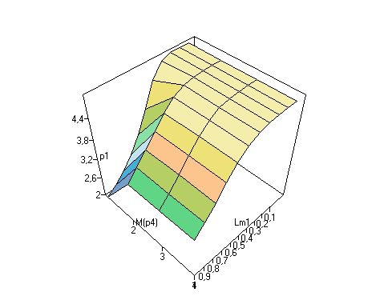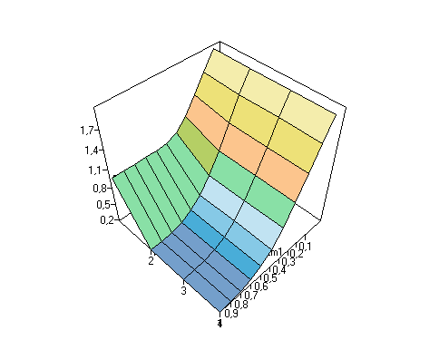



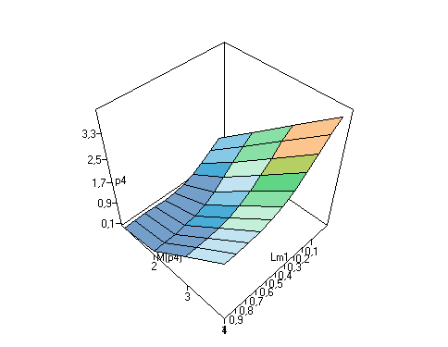

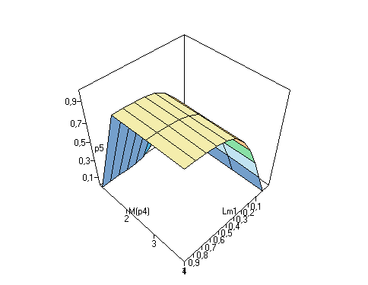

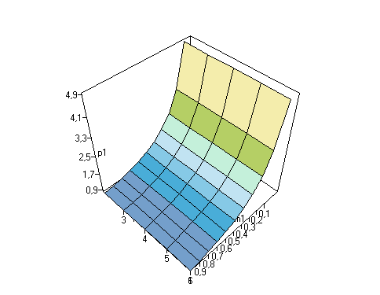

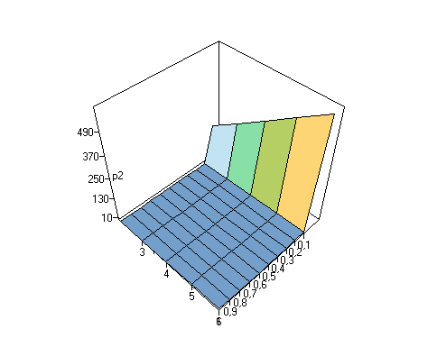



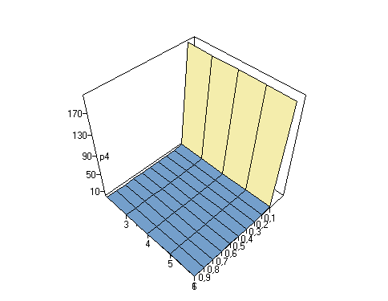



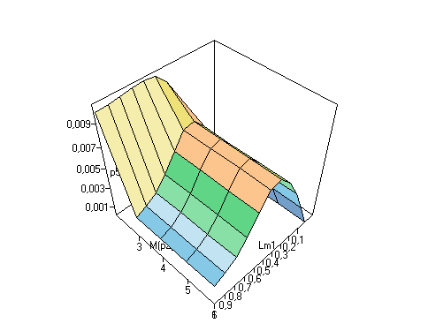



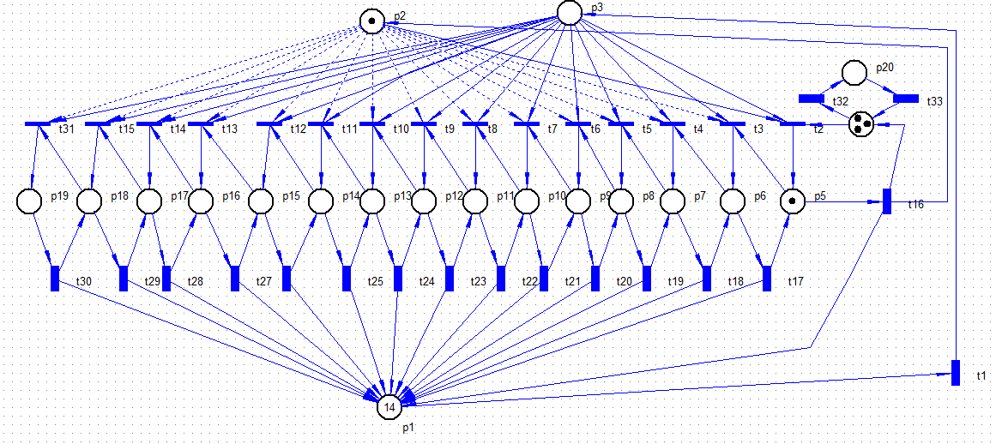

; Reachability graph file. Generated by VPNP

Totally found markings number = 395

PositionsList: p1;p2;p3;p4;p5;p6;p7;p8;p9;p10;p11;p12;p13;p14;p15;p16;p17;p18;p19;p20;

M0 = [14,1,0,3,1,0,0,0,0,0,0,0,0,0,0,0,0,0,0,0] [t16>M1;t32>M2;t1,t2>M3;t1,t3>M4;\\1;1;0.5;0.5;

M1 = [15,2,0,4,0,0,0,0,0,0,0,0,0,0,0,0,0,0,0,0] [t32>M5;t1,t2>M0;\\1;1;

M2 = [14,1,0,2,1,0,0,0,0,0,0,0,0,0,0,0,0,0,0,1] [t16>M5;t32>M6;t33>M0;t1,t2>M8;t1,t3>M9;\\1;1;1;0.5;0.5;

M3 = [13,0,0,2,2,0,0,0,0,0,0,0,0,0,0,0,0,0,0,0] [t1>M7;t16>M0;t32>M8;\\1;1;1;

M4 = [13,1,0,3,0,1,0,0,0,0,0,0,0,0,0,0,0,0,0,0] [t17>M0;t32>M9;t1,t2>M15;t1,t4>M16;\\1;1;0.5;0.5;

M5 = [15,2,0,3,0,0,0,0,0,0,0,0,0,0,0,0,0,0,0,1] [t32>M10;t33>M1;t1,t2>M2;\\1;1;1;

M6 = [14,1,0,1,1,0,0,0,0,0,0,0,0,0,0,0,0,0,0,2] [t16>M10;t32>M11;t33>M2;t1,t2>M14;t1,t3>M17;\\1;1;1;0.5;0.5;

M7 = [12,0,1,2,2,0,0,0,0,0,0,0,0,0,0,0,0,0,0,0] [t1>M12;t32>M13;t16,t2>M3;t16,t3>M4;\\1;1;0.5;0.5;

M8 = [13,0,0,1,2,0,0,0,0,0,0,0,0,0,0,0,0,0,0,1] [t1>M13;t16>M2;t32>M14;t33>M3;\\1;1;1;1;

M9 = [13,1,0,2,0,1,0,0,0,0,0,0,0,0,0,0,0,0,0,1] [t17>M2;t32>M17;t33>M4;t1,t2>M23;t1,t4>M24;\\1;1;1;0.5;0.5;

M10 = [15,2,0,2,0,0,0,0,0,0,0,0,0,0,0,0,0,0,0,2] [t32>M18;t33>M5;t1,t2>M6;\\1;1;1;

M11 = [14,1,0,0,1,0,0,0,0,0,0,0,0,0,0,0,0,0,0,3] [t16>M18;t33>M6;t1,t3>M25;\\1;1;1;

M12 = [11,0,2,2,2,0,0,0,0,0,0,0,0,0,0,0,0,0,0,0] [t1>M19;t32>M20;t16,t2>M7;t16,t3,t2>M15;t16,t3,t4>M16;\\1;1;0.5;0.25;0.25;

M13 = [12,0,1,1,2,0,0,0,0,0,0,0,0,0,0,0,0,0,0,1] [t1>M20;t32>M21;t33>M7;t16,t2>M8;t16,t3>M9;\\1;1;1;0.5;0.5;

M14 = [13,0,0,0,2,0,0,0,0,0,0,0,0,0,0,0,0,0,0,2] [t1>M21;t16>M6;t33>M8;\\1;1;1;

M15 = [12,0,0,2,1,1,0,0,0,0,0,0,0,0,0,0,0,0,0,0] [t1>M22;t16>M4;t17>M3;t32>M23;\\1;1;1;1;

M16 = [12,1,0,3,0,0,1,0,0,0,0,0,0,0,0,0,0,0,0,0] [t18>M4;t32>M24;t1,t2>M33;t1,t5>M34;\\1;1;0.5;0.5;

M17 = [13,1,0,1,0,1,0,0,0,0,0,0,0,0,0,0,0,0,0,2] [t17>M6;t32>M25;t33>M9;t1,t2>M32;t1,t4>M35;\\1;1;1;0.5;0.5;

M18 = [15,2,0,1,0,0,0,0,0,0,0,0,0,0,0,0,0,0,0,3] [t32>M26;t33>M10;t1,t2>M11;\\1;1;1;

M19 = [10,0,3,2,2,0,0,0,0,0,0,0,0,0,0,0,0,0,0,0] [t1>M27;t32>M28;t16,t2>M12;t16,t3,t2>M22;t16,t3,t4,t2>M33;t16,t3,t4,t5>M34;\\1;1;0.5;0.25;0.125;0.125;

M20 = [11,0,2,1,2,0,0,0,0,0,0,0,0,0,0,0,0,0,0,1] [t1>M28;t32>M29;t33>M12;t16,t2>M13;t16,t3,t2>M23;t16,t3,t4>M24;\\1;1;1;0.5;0.25;0.25;

; Reachability graph file. Generated by VPNP

Totally found markings number = 395

PositionsList: p1;p2;p3;p4;p5;p6;p7;p8;p9;p10;p11;p12;p13;p14;p15;p16;p17;p18;p19;p20;

M0 = [14,1,0,3,1,0,0,0,0,0,0,0,0,0,0,0,0,0,0,0] [t16>M1;t32>M2;t1,t2>M3;t1,t3>M4;\\1;1;0.5;0.5;

M1 = [15,2,0,4,0,0,0,0,0,0,0,0,0,0,0,0,0,0,0,0] [t32>M5;t1,t2>M0;\\1;1;

M2 = [14,1,0,2,1,0,0,0,0,0,0,0,0,0,0,0,0,0,0,1] [t16>M5;t32>M6;t33>M0;t1,t2>M8;t1,t3>M9;\\1;1;1;0.5;0.5;

M3 = [13,0,0,2,2,0,0,0,0,0,0,0,0,0,0,0,0,0,0,0] [t1>M7;t16>M0;t32>M8;\\1;1;1;

M4 = [13,1,0,3,0,1,0,0,0,0,0,0,0,0,0,0,0,0,0,0] [t17>M0;t32>M9;t1,t2>M15;t1,t4>M16;\\1;1;0.5;0.5;

M5 = [15,2,0,3,0,0,0,0,0,0,0,0,0,0,0,0,0,0,0,1] [t32>M10;t33>M1;t1,t2>M2;\\1;1;1;

M6 = [14,1,0,1,1,0,0,0,0,0,0,0,0,0,0,0,0,0,0,2] [t16>M10;t32>M11;t33>M2;t1,t2>M14;t1,t3>M17;\\1;1;1;0.5;0.5;

M7 = [12,0,1,2,2,0,0,0,0,0,0,0,0,0,0,0,0,0,0,0] [t1>M12;t32>M13;t16,t2>M3;t16,t3>M4;\\1;1;0.5;0.5;

M8 = [13,0,0,1,2,0,0,0,0,0,0,0,0,0,0,0,0,0,0,1] [t1>M13;t16>M2;t32>M14;t33>M3;\\1;1;1;1;

M9 = [13,1,0,2,0,1,0,0,0,0,0,0,0,0,0,0,0,0,0,1] [t17>M2;t32>M17;t33>M4;t1,t2>M23;t1,t4>M24;\\1;1;1;0.5;0.5;

M10 = [15,2,0,2,0,0,0,0,0,0,0,0,0,0,0,0,0,0,0,2] [t32>M18;t33>M5;t1,t2>M6;\\1;1;1;

M11 = [14,1,0,0,1,0,0,0,0,0,0,0,0,0,0,0,0,0,0,3] [t16>M18;t33>M6;t1,t3>M25;\\1;1;1;

M12 = [11,0,2,2,2,0,0,0,0,0,0,0,0,0,0,0,0,0,0,0] [t1>M19;t32>M20;t16,t2>M7;t16,t3,t2>M15;t16,t3,t4>M16;\\1;1;0.5;0.25;0.25;

M13 = [12,0,1,1,2,0,0,0,0,0,0,0,0,0,0,0,0,0,0,1] [t1>M20;t32>M21;t33>M7;t16,t2>M8;t16,t3>M9;\\1;1;1;0.5;0.5;

M14 = [13,0,0,0,2,0,0,0,0,0,0,0,0,0,0,0,0,0,0,2] [t1>M21;t16>M6;t33>M8;\\1;1;1;

M15 = [12,0,0,2,1,1,0,0,0,0,0,0,0,0,0,0,0,0,0,0] [t1>M22;t16>M4;t17>M3;t32>M23;\\1;1;1;1;

M16 = [12,1,0,3,0,0,1,0,0,0,0,0,0,0,0,0,0,0,0,0] [t18>M4;t32>M24;t1,t2>M33;t1,t5>M34;\\1;1;0.5;0.5;

M17 = [13,1,0,1,0,1,0,0,0,0,0,0,0,0,0,0,0,0,0,2] [t17>M6;t32>M25;t33>M9;t1,t2>M32;t1,t4>M35;\\1;1;1;0.5;0.5;

M18 = [15,2,0,1,0,0,0,0,0,0,0,0,0,0,0,0,0,0,0,3] [t32>M26;t33>M10;t1,t2>M11;\\1;1;1;

M19 = [10,0,3,2,2,0,0,0,0,0,0,0,0,0,0,0,0,0,0,0] [t1>M27;t32>M28;t16,t2>M12;t16,t3,t2>M22;t16,t3,t4,t2>M33;t16,t3,t4,t5>M34;\\1;1;0.5;0.25;0.125;0.125;

M20 = [11,0,2,1,2,0,0,0,0,0,0,0,0,0,0,0,0,0,0,1] [t1>M28;t32>M29;t33>M12;t16,t2>M13;t16,t3,t2>M23;t16,t3,t4>M24;\\1;1;1;0.5;0.25;0.25;

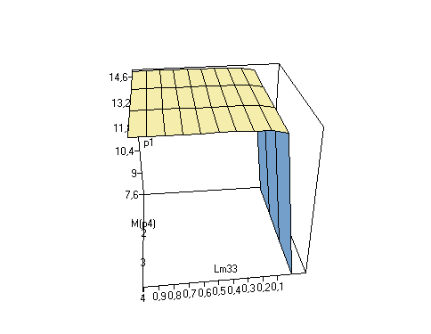



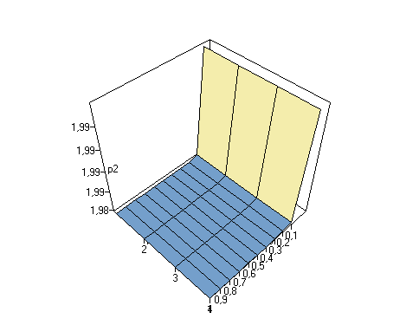

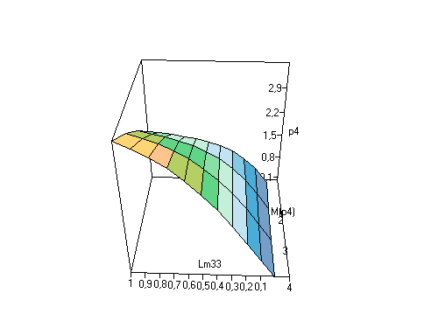

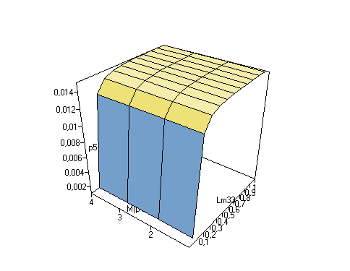















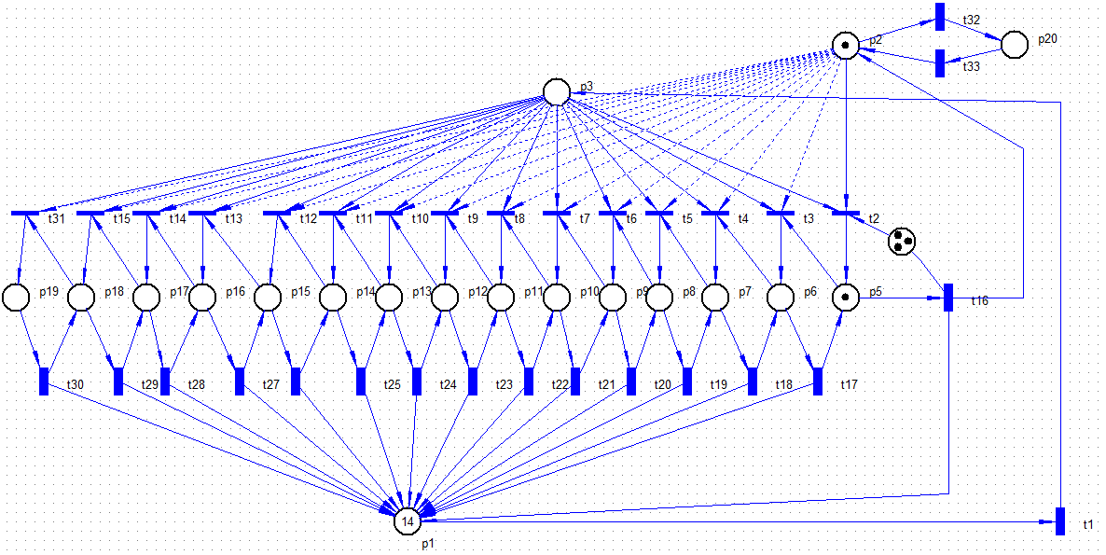

; Reachability graph file. Generated by VPNP

Totally found markings number = 258

PositionsList: p1;p2;p3;p4;p5;p6;p7;p8;p9;p10;p11;p12;p13;p14;p15;p16;p17;p18;p19;p20;

M0 = [14,1,0,3,1,0,0,0,0,0,0,0,0,0,0,0,0,0,0,0] [t16>M1;t32>M2;t1,t2>M3;t1,t3>M4;\\1;1;0.5;0.5;

M1 = [15,2,0,4,0,0,0,0,0,0,0,0,0,0,0,0,0,0,0,0] [t32>M5;t1,t2>M0;\\1;1;

M2 = [14,0,0,3,1,0,0,0,0,0,0,0,0,0,0,0,0,0,0,1] [t1>M6;t16>M5;t33>M0;\\1;1;1;

M3 = [13,0,0,2,2,0,0,0,0,0,0,0,0,0,0,0,0,0,0,0] [t1>M7;t16>M0;\\1;1;

M4 = [13,1,0,3,0,1,0,0,0,0,0,0,0,0,0,0,0,0,0,0] [t17>M0;t32>M8;t1,t2>M12;t1,t4>M13;\\1;1;0.5;0.5;

M5 = [15,1,0,4,0,0,0,0,0,0,0,0,0,0,0,0,0,0,0,1] [t32>M9;t33>M1;t1,t2>M2;\\1;1;1;

M6 = [13,0,1,3,1,0,0,0,0,0,0,0,0,0,0,0,0,0,0,1] [t1>M10;t33,t2>M3;t33,t3>M4;t16,t2>M2;\\1;0.5;0.5;1;

M7 = [12,0,1,2,2,0,0,0,0,0,0,0,0,0,0,0,0,0,0,0] [t1>M11;t16,t2>M3;t16,t3>M4;\\1;0.5;0.5;

M8 = [13,0,0,3,0,1,0,0,0,0,0,0,0,0,0,0,0,0,0,1] [t1>M14;t17>M2;t33>M4;\\1;1;1;

M9 = [15,0,0,4,0,0,0,0,0,0,0,0,0,0,0,0,0,0,0,2] [t1>M15;t33>M5;\\1;1;

M10 = [12,0,2,3,1,0,0,0,0,0,0,0,0,0,0,0,0,0,0,1] [t1>M16;t16,t2>M6;t33,t2>M7;t33,t3,t2>M12;t33,t3,t4>M13;\\1;1;0.5;0.25;0.25;

M11 = [11,0,2,2,2,0,0,0,0,0,0,0,0,0,0,0,0,0,0,0] [t1>M17;t16,t2>M7;t16,t3,t2>M12;t16,t3,t4>M13;\\1;0.5;0.25;0.25;

M12 = [12,0,0,2,1,1,0,0,0,0,0,0,0,0,0,0,0,0,0,0] [t1>M18;t16>M4;t17>M3;\\1;1;1;

M13 = [12,1,0,3,0,0,1,0,0,0,0,0,0,0,0,0,0,0,0,0] [t18>M4;t32>M19;t1,t2>M25;t1,t5>M26;\\1;1;0.5;0.5;

M14 = [12,0,1,3,0,1,0,0,0,0,0,0,0,0,0,0,0,0,0,1] [t1>M20;t17>M6;t33,t2>M12;t33,t4>M13;\\1;1;0.5;0.5;

M15 = [14,0,1,4,0,0,0,0,0,0,0,0,0,0,0,0,0,0,0,2] [t1>M21;t33,t2>M2;\\1;1;

M16 = [11,0,3,3,1,0,0,0,0,0,0,0,0,0,0,0,0,0,0,1] [t1>M22;t16,t2>M10;t33,t2>M11;t33,t3,t2>M18;t33,t3,t4,t2>M25;t33,t3,t4,t5>M26;\\1;1;0.5;0.25;0.125;0.125;

M17 = [10,0,3,2,2,0,0,0,0,0,0,0,0,0,0,0,0,0,0,0] [t1>M23;t16,t2>M11;t16,t3,t2>M18;t16,t3,t4,t2>M25;t16,t3,t4,t5>M26;\\1;0.5;0.25;0.125;0.125;

M18 = [11,0,1,2,1,1,0,0,0,0,0,0,0,0,0,0,0,0,0,0] [t1>M24;t17>M7;t16,t2>M12;t16,t4>M13;\\1;1;0.5;0.5;

M19 = [12,0,0,3,0,0,1,0,0,0,0,0,0,0,0,0,0,0,0,1] [t1>M27;t18>M8;t33>M13;\\1;1;1;

M20 = [11,0,2,3,0,1,0,0,0,0,0,0,0,0,0,0,0,0,0,1] [t1>M28;t17>M10;t33,t2>M18;t33,t4,t2>M25;t33,t4,t5>M26;\\1;1;0.5;0.25;0.25;

; Reachability graph file. Generated by VPNP

Totally found markings number = 258

PositionsList: p1;p2;p3;p4;p5;p6;p7;p8;p9;p10;p11;p12;p13;p14;p15;p16;p17;p18;p19;p20;

M0 = [14,1,0,3,1,0,0,0,0,0,0,0,0,0,0,0,0,0,0,0] [t16>M1;t32>M2;t1,t2>M3;t1,t3>M4;\\1;1;0.5;0.5;

M1 = [15,2,0,4,0,0,0,0,0,0,0,0,0,0,0,0,0,0,0,0] [t32>M5;t1,t2>M0;\\1;1;

M2 = [14,0,0,3,1,0,0,0,0,0,0,0,0,0,0,0,0,0,0,1] [t1>M6;t16>M5;t33>M0;\\1;1;1;

M3 = [13,0,0,2,2,0,0,0,0,0,0,0,0,0,0,0,0,0,0,0] [t1>M7;t16>M0;\\1;1;

M4 = [13,1,0,3,0,1,0,0,0,0,0,0,0,0,0,0,0,0,0,0] [t17>M0;t32>M8;t1,t2>M12;t1,t4>M13;\\1;1;0.5;0.5;

M5 = [15,1,0,4,0,0,0,0,0,0,0,0,0,0,0,0,0,0,0,1] [t32>M9;t33>M1;t1,t2>M2;\\1;1;1;

M6 = [13,0,1,3,1,0,0,0,0,0,0,0,0,0,0,0,0,0,0,1] [t1>M10;t33,t2>M3;t33,t3>M4;t16,t2>M2;\\1;0.5;0.5;1;

M7 = [12,0,1,2,2,0,0,0,0,0,0,0,0,0,0,0,0,0,0,0] [t1>M11;t16,t2>M3;t16,t3>M4;\\1;0.5;0.5;

M8 = [13,0,0,3,0,1,0,0,0,0,0,0,0,0,0,0,0,0,0,1] [t1>M14;t17>M2;t33>M4;\\1;1;1;

M9 = [15,0,0,4,0,0,0,0,0,0,0,0,0,0,0,0,0,0,0,2] [t1>M15;t33>M5;\\1;1;

M10 = [12,0,2,3,1,0,0,0,0,0,0,0,0,0,0,0,0,0,0,1] [t1>M16;t16,t2>M6;t33,t2>M7;t33,t3,t2>M12;t33,t3,t4>M13;\\1;1;0.5;0.25;0.25;

M11 = [11,0,2,2,2,0,0,0,0,0,0,0,0,0,0,0,0,0,0,0] [t1>M17;t16,t2>M7;t16,t3,t2>M12;t16,t3,t4>M13;\\1;0.5;0.25;0.25;

M12 = [12,0,0,2,1,1,0,0,0,0,0,0,0,0,0,0,0,0,0,0] [t1>M18;t16>M4;t17>M3;\\1;1;1;

M13 = [12,1,0,3,0,0,1,0,0,0,0,0,0,0,0,0,0,0,0,0] [t18>M4;t32>M19;t1,t2>M25;t1,t5>M26;\\1;1;0.5;0.5;

M14 = [12,0,1,3,0,1,0,0,0,0,0,0,0,0,0,0,0,0,0,1] [t1>M20;t17>M6;t33,t2>M12;t33,t4>M13;\\1;1;0.5;0.5;

M15 = [14,0,1,4,0,0,0,0,0,0,0,0,0,0,0,0,0,0,0,2] [t1>M21;t33,t2>M2;\\1;1;

M16 = [11,0,3,3,1,0,0,0,0,0,0,0,0,0,0,0,0,0,0,1] [t1>M22;t16,t2>M10;t33,t2>M11;t33,t3,t2>M18;t33,t3,t4,t2>M25;t33,t3,t4,t5>M26;\\1;1;0.5;0.25;0.125;0.125;

M17 = [10,0,3,2,2,0,0,0,0,0,0,0,0,0,0,0,0,0,0,0] [t1>M23;t16,t2>M11;t16,t3,t2>M18;t16,t3,t4,t2>M25;t16,t3,t4,t5>M26;\\1;0.5;0.25;0.125;0.125;

M18 = [11,0,1,2,1,1,0,0,0,0,0,0,0,0,0,0,0,0,0,0] [t1>M24;t17>M7;t16,t2>M12;t16,t4>M13;\\1;1;0.5;0.5;

M19 = [12,0,0,3,0,0,1,0,0,0,0,0,0,0,0,0,0,0,0,1] [t1>M27;t18>M8;t33>M13;\\1;1;1;

M20 = [11,0,2,3,0,1,0,0,0,0,0,0,0,0,0,0,0,0,0,1] [t1>M28;t17>M10;t33,t2>M18;t33,t4,t2>M25;t33,t4,t5>M26;\\1;1;0.5;0.25;0.25;

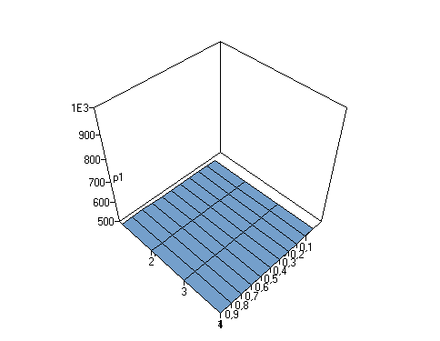



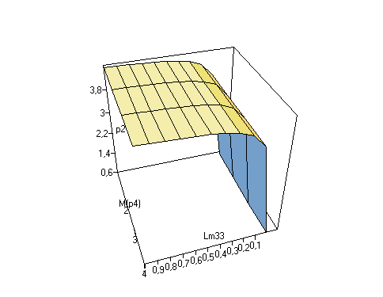



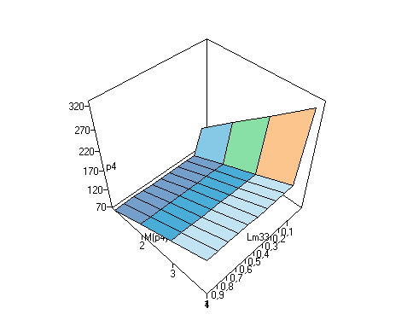



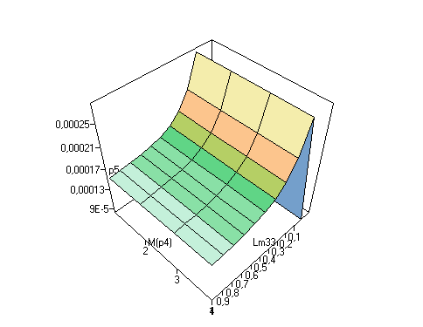

















***Concluzie:***

In urma efectuarii laboratorului au fost obtinute anumite abilitati in domeniu EP si anume studierea lantului Markov si retelele Petri.