; Reachability graph file. Generated by VPNP

; Generated from C:\Documents and Settings\student\Desktop\New Folder\VPNP_v2.4\Samples\Gutu.pn2 - Visual Petri Net+ - Release v2.4 Petri net file.

Totally found markings number = 273

PositionsList: p1;p2;p3;p4;p5;p6;p7;p8;p9;p10;p11;p12;p13;p14;p15;p16;p17;p18;p19;p20;

M0 = [16,2,0,3,0,0,0,0,0,0,0,0,0,0,0,0,0,0,0,0] [t1>M1;\\1;

M1 = [15,2,1,3,0,0,0,0,0,0,0,0,0,0,0,0,0,0,0,0] [t1>M2;t2>M3;\\1;0;

M2 = [14,2,2,3,0,0,0,0,0,0,0,0,0,0,0,0,0,0,0,0] [t1>M4;t2>M5;\\1;0;

M3 = [15,1,0,2,1,0,0,0,0,0,0,0,0,0,0,0,0,0,0,0] [t1>M5;t16>M0;\\1;1;

M4 = [13,2,3,3,0,0,0,0,0,0,0,0,0,0,0,0,0,0,0,0] [t1>M6;t2>M7;\\1;0;

M5 = [14,1,1,2,1,0,0,0,0,0,0,0,0,0,0,0,0,0,0,0] [t1>M7;t2>M8;t3>M9;t16>M1;\\1;0;0;1;

M6 = [12,2,4,3,0,0,0,0,0,0,0,0,0,0,0,0,0,0,0,0] [t1>M10;t2>M11;\\1;0;

M7 = [13,1,2,2,1,0,0,0,0,0,0,0,0,0,0,0,0,0,0,0] [t1>M11;t2>M12;t3>M13;t16>M2;\\1;0;0;1;

M8 = [14,0,0,1,2,0,0,0,0,0,0,0,0,0,0,0,0,0,0,0] [t1>M12;t16>M3;\\1;1;

M9 = [14,1,0,2,0,1,0,0,0,0,0,0,0,0,0,0,0,0,0,0] [t1>M13;t17>M3;\\1;1;

M10 = [11,2,5,3,0,0,0,0,0,0,0,0,0,0,0,0,0,0,0,0] [t1>M14;t2>M15;\\1;0;

M11 = [12,1,3,2,1,0,0,0,0,0,0,0,0,0,0,0,0,0,0,0] [t1>M15;t2>M16;t3>M17;t16>M4;\\1;0;0;1;

M12 = [13,0,1,1,2,0,0,0,0,0,0,0,0,0,0,0,0,0,0,0] [t1>M16;t16>M5;\\1;1;

M13 = [13,1,1,2,0,1,0,0,0,0,0,0,0,0,0,0,0,0,0,0] [t1>M17;t2>M18;t4>M19;t17>M5;\\1;0;0;1;

M14 = [10,2,6,3,0,0,0,0,0,0,0,0,0,0,0,0,0,0,0,0] [t1>M20;t2>M21;\\1;0;

M15 = [11,1,4,2,1,0,0,0,0,0,0,0,0,0,0,0,0,0,0,0] [t1>M21;t2>M22;t3>M23;t16>M6;\\1;0;0;1;

M16 = [12,0,2,1,2,0,0,0,0,0,0,0,0,0,0,0,0,0,0,0] [t1>M22;t16>M7;\\1;1;

M17 = [12,1,2,2,0,1,0,0,0,0,0,0,0,0,0,0,0,0,0,0] [t1>M23;t2>M24;t4>M25;t17>M7;\\1;0;0;1;

M18 = [13,0,0,1,1,1,0,0,0,0,0,0,0,0,0,0,0,0,0,0] [t1>M24;t17>M8;t16>M9;\\1;1;1;

M19 = [13,1,0,2,0,0,1,0,0,0,0,0,0,0,0,0,0,0,0,0] [t1>M25;t18>M9;\\1;1;

M20 = [9,2,7,3,0,0,0,0,0,0,0,0,0,0,0,0,0,0,0,0] [t1>M26;t2>M27;\\1;0;



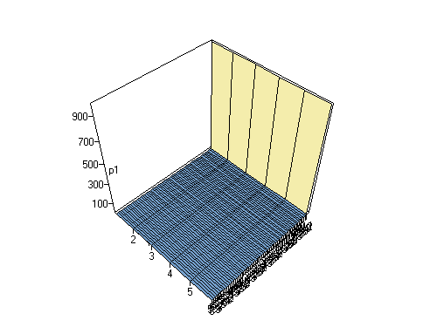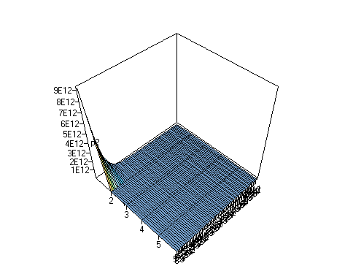

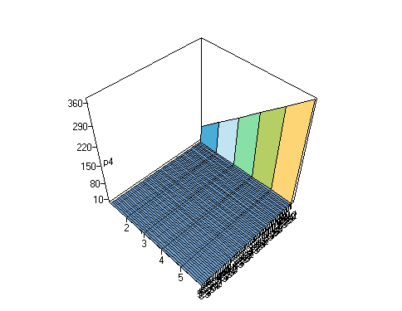



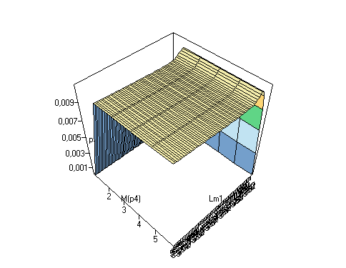

M(p2)



