Ministerul Educaţiei, al Culturii și Cercetării al Republicii Moldova

Universitatea Tehnică a Moldovei

Departamentul Informatică și Ingineria Sistemelor

**RAPORT**

Lucrarea de laborator nr.2

Grafica pe Calculator

A efectuat:

st. gr. C-171 D. Melniciuc

A verificat:

Lect. univ. A. Turcan

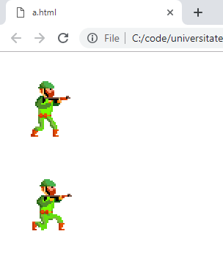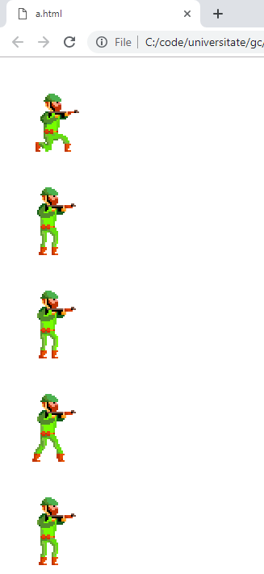

***Codul programului:***

<!DOCTYPE html>

<html>

<head>

<meta charset="utf-8">

<style>

.crouch {

height: 128px;

width: 128px;

background: url("crouch.png");

animation: walk 1s steps(8) infinite;

}

.crouch_Idle {

height: 128px;

width: 128px;

background: url("crouch_Idle.png");

animation: walk 1s steps(8) infinite;

}

.crouchShoot {

height: 128px;

width: 128px;

background: url("crouchShootBelt.png");

animation: walk 1s steps(8) infinite;

}

.dead {

height: 128px;

width: 128px;

background: url("dead.png");

animation: walk 1s steps(8) infinite;

}

.idle {

height: 128px;

width: 128px;

background: url("idle.png");

animation: walk 1s steps(8) infinite;

}

.jump {

height: 128px;

width: 128px;

background: url("jump.png");

animation: walk 1s steps(8) infinite;

}

.shoot {

height: 128px;

width: 128px;

background: url("shootNoEyes.png");

animation: walk 1s steps(8) infinite;

}

.walk {

height: 128px;

width: 128px;

background: url("walk.png");

animation: walk 1s steps(8) infinite;

}

@keyframes walk {

0% {

background-position: 0px;

}

100% {

background-position: -1024px;

}

}

</style>

</head>

<body>

<script type="text/javascript">

document.onkeydown = function(event) {

var key_press = String.fromCharCode(event.keyCode);

var key_code = event.keyCode;

document.getElementById('kp').innerHTML = key_press;

document.getElementById('kc').innerHTML = key_code;

var status = document.getElementById('status');

status.innerHTML = "KEY: " + key_press;

}

document.onkeyup = function (event) {

var key_press = String.fromCharCode(event.keyCode);

var status = document.getElementById('status');

status.innerHTML = "up event: " + key_press;

}

</script>

<script type="text/javascript">

var x = event.keyCode;

if (x == 68)

<div class="crouch"> </div>

if (x == 67)

<div class="crouch"> </div>

if (x == 90)

<div class="crouch_Idle"> </div>

if (x == 88)

<div class="crouchShoot"> </div>

if (x == 73)

<div class="idle"> </div>

if (x == 74)

<div class="jump"> </div>

if (x == 83)

<div class="shoot"> </div>

if (x == 87)

<div class="walk"> </div>

</script>

<div class="crouch"> </div>

<div class="crouch_Idle"> </div>

<div class="crouchShoot"> </div>

<div class="idle"> </div>

<div class="jump"> </div>

<div class="shoot"> </div>

<div class="walk"> </div>

<div class="character"> </div>

</body>

</html>