Ministerul Educaţiei, al Culturii și Cercetării al Republicii Moldova

Universitatea Tehnică a Moldovei

Departamentul Informatică și Ingineria Sistemelor

**RAPORT**

Lucrarea de laborator nr.2

Inteligenta Artificiala

A efectuat:

st. gr. C-171 D. Melniciuc

A verificat:

dr., conf.univ. T. Bumbu

Chişinău 2020

Problema alesa :

Convertirea gradelor Celsius in Fahrenheit

Codul :

import os

import sys

import time

import random

import numpy as np

import math

gl = 0

alfa = 0.1

prag = 0.1

tanh_Values = 1

while gl == 0:

os.system('cls')

print("1) Neuron de tip McCulloch-Pitts" )

print("2) Neuron Recurent" )

print("3) Neuron Spiking" )

op1 = 0

while op1 == 0:

opIn = str(input("\n>> "))

if opIn.isnumeric():

op = int(opIn)

if op > 3 or op < 1 :

print("[-] no such option")

else:

op1 = 1

else:

print("[-] error with user input")

# Neuron de tip McCulloch-Pitts

if op == 1:

randVal = random.uniform(-0.5, 0.0)

print("\nrandVal", randVal)

print("\n")

weight = 1

out = 0.51

# Celsius to Fahrenheit

# (1°C × 9/5) + 32 = 33.8°F

# (33.8°F − 32) × 5/9 = 1°C

temp = 1

while out < 33.7999:

temp += 1

out = (randVal*weight * 1) + 32

err = out - 33.8

weightNew = weight + (err * alfa * 0.01)

weight = weightNew

print("out ", out)

print("weight: ", weight)

print("nr de iteratii: ", temp)

# Neuron Recurent"

if op == 2:

randVal = random.uniform(-3.5, 0.0)

print("\nrandVal", randVal)

print("\n")

weight = 1

out = 0.51

# Celsius to Fahrenheit

# (1°C × 9/5) + 32 = 33.8°F

# (33.8°F − 32) × 5/9 = 1°C

temp = 1

for z in range (10000):

temp += 1

out = (randVal*weight * 1) + 32

err = out - 33.8

weightNew = weight + (err * alfa)

weight = weightNew

tanh_Values = np.tanh(tanh_Values * weight)

if tanh_Values >= 0.6:

break

print("out ", out)

print("tanh_Values ", tanh_Values)

print("\n")

if err == 0:

break;

print("tanh_Values ", tanh_Values)

print("nr de iteratii: ", temp)

print("\n")

# Neuron Spiking

if op == 3:

result = []

for i in range(100):

randVal = random.uniform(0.0, 1.0)

result.append(randVal)

print(result, "\n")

suma = 0.0

prag = 2.6

for x in range(len(result)):

suma += result[x]

if suma > prag:

print("[",x ,"] ", suma - prag)

suma = 0

break

print("\n\n\n\n~~~~~~~~~~~~~~~~~~~~~~~~~~~~~~~~~~~~~~~~~~ \n")

print("x-exit, other than x - get another Neuron: ")

print("\n~~~~~~~~~~~~~~~~~~~~~~~~~~~~~~~~~~~~~~~~~~ \n\n")

inp2 = input()

if inp2 == "x":

ch = 1

exit(1)

else:

ch = 0

Screenshot-uri :

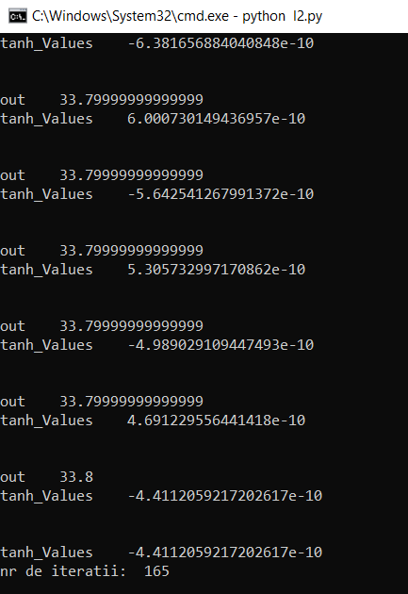Neuron Recurent Neuron Spiking

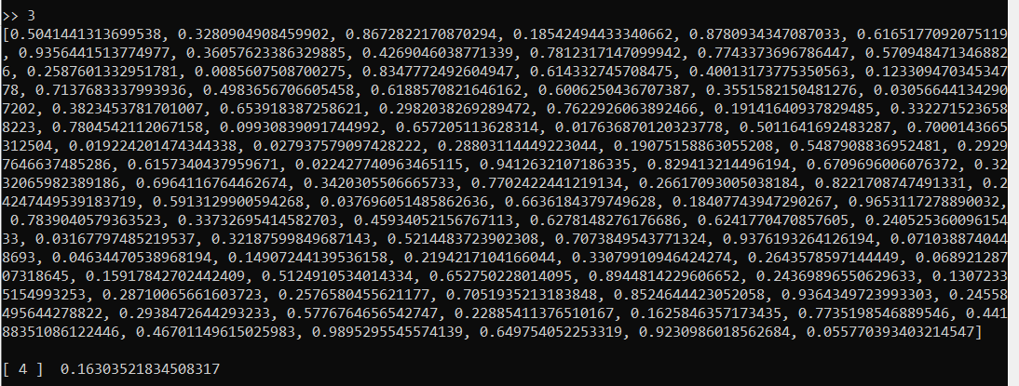

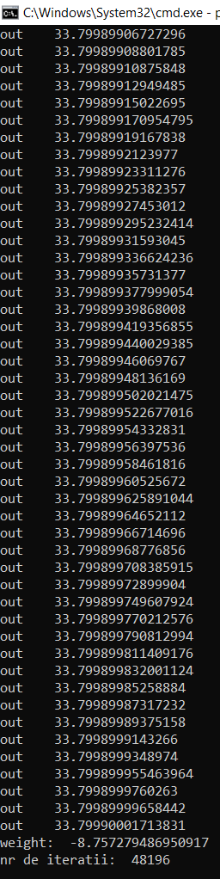Neuron de tip McCulloch-Pitts

Concluzie :

In urma efectuarii laboratorului au fost obtinute anumite abilitati in domeniu IA si anume studierea neuronilor de tip McCulloch-Pitts, Recurent si Spiking. Intelegerea inteligentei afritifiale a devenit mai larga dupa efectuarea labortorului.