Ministerul Educaţiei, al Culturii și Cercetării al Republicii Moldova

Universitatea Tehnică a Moldovei

Departamentul Informatică și Ingineria Sistemelor

**RAPORT**

Lucrarea de laborator nr.4-5

Inteligenta Artificiala

A efectuat:

st. gr. C-171 D. Melniciuc

A verificat:

dr., conf.univ. T. Bumbu

Chişinău 2020

Problema alesa:

Relatia dintre investitii in Research and development si venitul la 50 start-up-uri.

Codul:

import matplotlib.pyplot as plt

import numpy as np

import pandas as pd

from sklearn import datasets, linear_model

from sklearn.model_selection import KFold

import os

os.system('cls')

def get_data(file_name):

data = pd.read_csv(file_name)

print(data.describe())

print("\n")

x = []

y = []

for rd, value in zip(data['R&D Spend'],data['Profit']):

x.append([float(rd)])

y.append(float(value))

return x,y

# Function for Fitting our data to Linear model

def linear_model_main(x, y, predict_value):

# Create linear regression object

regr = linear_model.LinearRegression()

regr.fit(x, y)

# predict_outcome = regr.predict(predict_value.reshape(1, 1))

predict_outcome = regr.predict(predict_value)

predictions = {}

predictions['intercept'] = regr.intercept_

predictions['coefficient'] = regr.coef_

predictions['predicted_value'] = predict_outcome

return predictions

# Function to show the resutls of linear fit model

def show_linear_line(x, y):

# Create linear regression object

regr = linear_model.LinearRegression()

regr.fit(x, y)

plt.xlabel("Research and development")

plt.ylabel("Profit")

plt.scatter(x, y)

plt.plot(x,regr.predict(x),color='red',linewidth=4)

# plt.xticks(())

# plt.yticks(())

plt.show()

x, y = get_data('50_Startups.csv')

predictvalue = [[0]]

result = linear_model_main(x, y, predictvalue)

print ("Intercept value: " , result['intercept'])

print ("coefficient: " , result['coefficient'])

print ("Predicted value: " , result['predicted_value'])

show_linear_line(x, y)

Screenshot-uri: 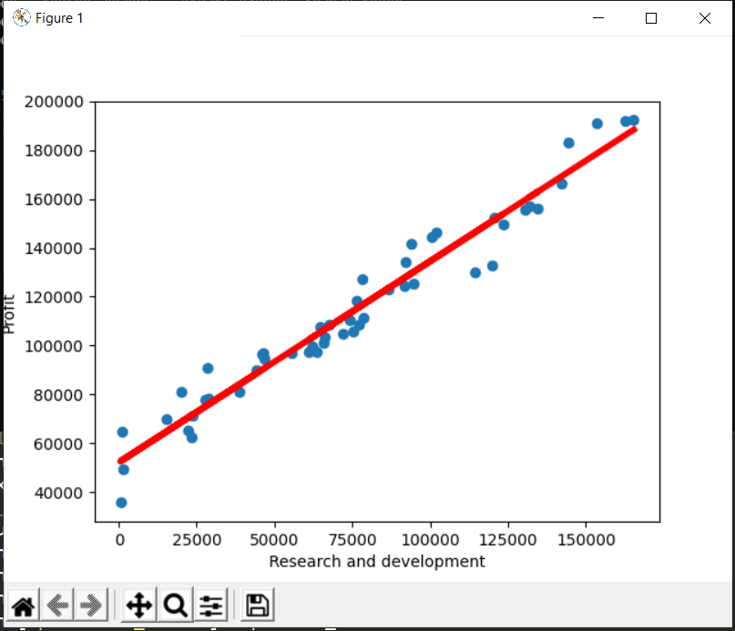

Concluzie:

In urma efectuarii laboratorului am initializat un model de invatare automate asupra unui set de date.

Am aplicat regresia liniara asupra setului de date cu informatii despre 50 de start-up-uri si am aflat relatia dintre suma investita si profitul start-up-urilor.