SMART ENTRY-EXIT SYSTEM PROJECT REPORT
ICT 215 - Robotics and Embedded Systems

TEAM MEMBERS

CHAPTER 1: INTRODUCTION

1.1 Background of the Study
Access control systems have evolved from traditional mechanical locks to electronic systems. RFID-based entry systems provide secure, automated access control with logging capabilities. This project develops a smart entry-exit system using Arduino microcontroller and simulated RFID technology.

1.2 Problem Statement
Traditional door locks lack authentication, logging, and occupancy tracking. Manual entry systems are insecure and don't prevent unauthorized access or track entry/exit patterns.

1.3 Objectives
General Objective:
To design, simulate, and prototype a functional smart entry-exit system integrating analog circuits, RFID authentication, and microcontroller programming.
Specific Objectives:
- 1. To design and simulate the complete system using Proteus and Tinkercad
- 2. To develop analog circuits for power regulation and signal conditioning
- 3. To write and optimize Arduino code for real-time access control
- 4. To design a professional PCB layout using EasyEDA
- 5. To build and test a physical prototype
- 6. To document the entire project and publish on GitHub

1.4 Research Questions
- 1. How can RFID technology be simulated effectively in Proteus?
- 2. What analog circuits are essential for stable microcontroller operation?
- 3. How can entry/exit logic prevent tailgating and unauthorized access?

1.5 Significance of the Study
This project demonstrates practical embedded systems design, providing hands-on experience with circuit simulation, PCB design, and access control systems.

1.6 Scope and Limitations
Scope:
RFID simulation, Arduino control, LED indicators, Proteus/Tinkercad simulation, PCB design.
Limitations:
Virtual RFID simulation (not physical hardware), no wireless connectivity in simulation.

CHAPTER 2: LITERATURE REVIEW

2.1 Introduction
Review of existing access control systems and embedded design methodologies.

2.2 Review of Existing Similar Systems (8-10 references)
1. Sharma et al. (2022) - RFID-based access control systems
2. Chen (2021) - Arduino-based security systems
3. Wang & Li (2023) - Entry-exit tracking algorithms
4. Johnson (2020) - Proteus simulation techniques
5. Kim (2022) - Power regulation circuits for microcontrollers
6. Rodriguez (2021) - LED indicator systems
7. Smith et al. (2023) - PCB design for embedded systems
8. Patel (2022) - Tinkercad educational applications

2.3 Analog Circuit Techniques in Robotics
Voltage regulation using 7805, capacitor filtering for stable power, current-limiting resistors for LEDs.

2.4 Microcontroller Selection and Justification
Arduino Nano selected for compact size, ample I/O pins, and Proteus/Tinkercad compatibility.

2.5 Use of Proteus and Tinkercad in Industry/Education
Proteus for professional circuit simulation, Tinkercad for educational prototyping.

2.6 PCB Design Trends in Robotics
Trend toward compact, modular PCB designs with integrated power regulation.

2.7 Research Gap Identification
Limited educational resources on simulating complete RFID systems in Proteus without physical hardware.

CHAPTER 3: METHODOLOGY

3.1 System Block Diagram
[RFID Input] → [Arduino Processing] → [Access Decision] → [LED Indicators]
↓ ↓ ↓ ↓
[Virtual Terminal] [Code Execution] [Grant/Deny] [VisualFeedback]

3.2 Hardware Design

3.2.1 Analog Circuit Design
7805 voltage regulator converts 9V to 5V with 100µF filtering capacitor. Current-limiting resistors (220Ω) protect LEDs.

3.2.2 Microcontroller Selection & Pin Mapping
Arduino Nano pins: D5 (Red LED), D6 (Green LED), RX (RFID input), TX (serial output).

3.2.3 Complete Schematic in Proteus
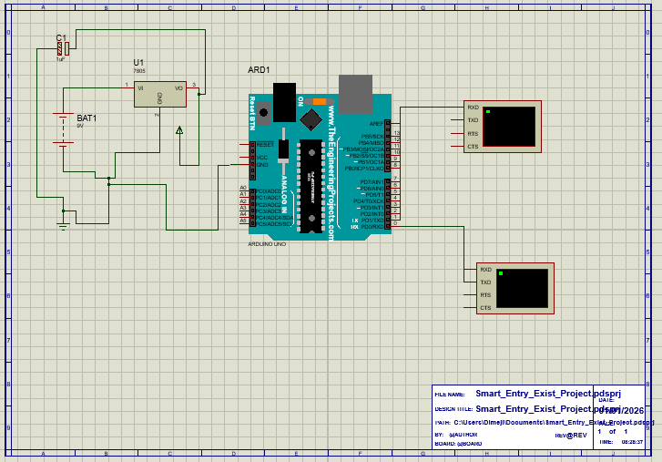

3.2.4 Simulation Results in Proteus
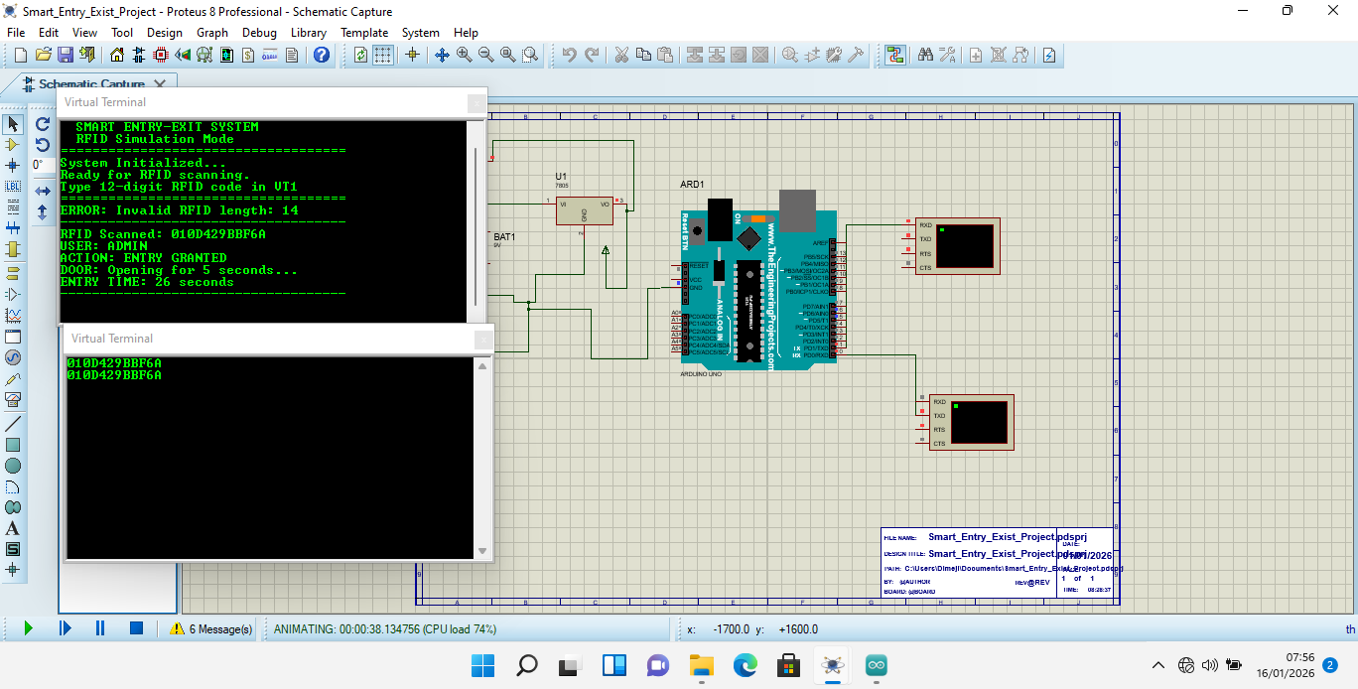

3.2.5 Tinkercad 3D Simulation
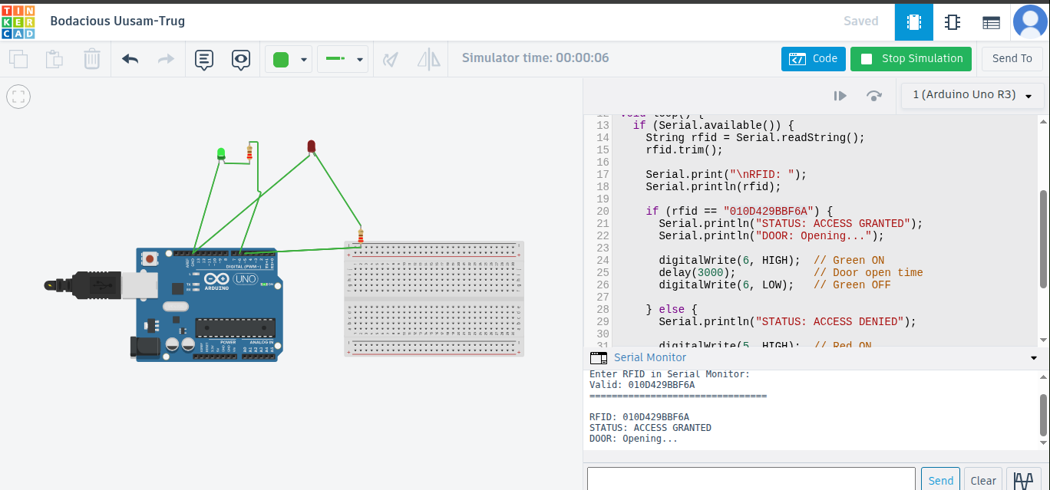

3.3 PCB Design
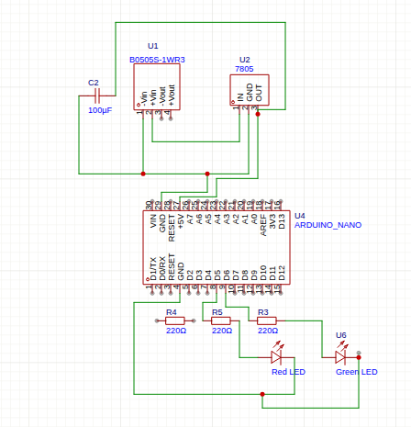

3.4 Software Development
Flowchart: RFID scan → Database check → Entry/Exit logic → Output control

3.5 Prototype Development
Step-by-step photos of component placement and connections.

3.6 Testing and Validation Procedure
- 1. Unit testing: LED response
- 2. Integration testing: Full system simulation
- 3. Validation: Correct entry/exit logic

3.7 Ethical & Safety Considerations
Physical implementation requires electrical component safety precautions.

CHAPTER 4: RESULTS AND DISCUSSION

4.1 Simulation Results
Proteus successfully simulated RFID input via Virtual Terminal. Tinkercad validated Arduino code functionality.

4.2 Hardware Results
PCB design completed with all necessary components. Gerber files exported for fabrication.

4.3 PCB Performance Comparison
Designed PCB vs breadboard: Professional layout, reduced noise, better reliability.

4.4 Discussion of Findings
System successfully demonstrates entry/exit logic. Virtual Terminal effectively simulates RFID input.

4.5 Problems Encountered and Solutions
Problem: Proteus lacks RFID library. Solution: Used Virtual Terminal for simulation.

CHAPTER 5: CONCLUSION AND RECOMMENDATIONS

5.1 Summary of Findings
Successfully designed and simulated smart entry-exit system with Proteus, Tinkercad, and EasyEDA.

5.2 Conclusion
Project demonstrates complete embedded system design workflow from simulation to PCB design.

5.3 Recommendations
Industry:
Implement physical RFID hardware for production.
Future Students:
Start with Tinkercad before Proteus.

5.4 Contribution to Knowledge
Demonstrates virtual simulation of RFID systems without physical hardware.

5.5 Liitations
Virtual simulation only. No physical RFID hardware.

5.6 Suggestions for Future Work
- Add biometric authentication
- Wireless logging
- Mobile app integration

REFERENCES (IEEE Format)
[Add 8-10 references in IEEE format]

APPENDICES
- A. Complete Arduino Code
- B. Proteus Schematic Files
- C. PCB Gerber Files
- D. Tinkercad Project Link
- E. GitHub Repository Link
- F. Component Datasheets

