# Relational Databases with MySQL Week 4 Coding Assignment

**Points possible:** 70

|  |  |  |
| --- | --- | --- |
| Category | Criteria | % of Grade |
| Functionality | Does the code work? | 25 |
| Organization | Is the code clean and organized? Proper use of white space, syntax, and consistency are utilized. Names and comments are concise and clear. | 25 |
| Creativity | Student solved the problems presented in the assignment using creativity and out of the box thinking. | 25 |
| Completeness | All requirements of the assignment are complete. | 25 |

**Instructions:** Using a text editor of your choice, write the queries that accomplishes the objectives listed below. Take screenshots of the queries and results and paste them in this document where instructed below. Create a new repository on GitHub for this week’s assignments and push this document, with your Java project code, to the repository. Add the URL for this week’s repository to this document where instructed and submit this document to your instructor when complete.

**Coding Steps:**

Write 5 stored procedures for the employees database.

Write a description of what each stored procedure does and how to use it.

Procedures should use constructs you learned about from your research assignment and be more than just queries.

**Screenshots:**

This procedure identifies the minimum salary for an employee based on their title. To use it you call the procedure “minSalaryByTitle” and pass in the title.

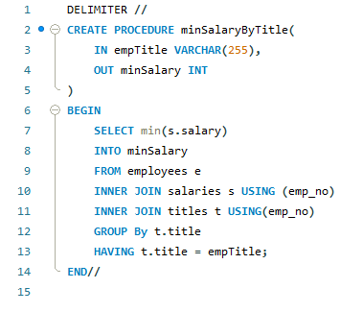

This procedure counts the number of employees who make over $50,000 using only an out parameter. To use it, you call the “NumEmpOver50k” procedure. It does not require any input but will output an int value.

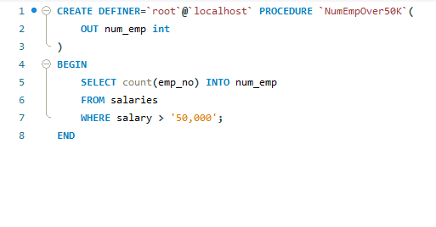

This procedure evaluates to YES if the average salary in the departement is greater than 50,000 using IF conditions. To use it, call the procedure, inputting the dept_name to show the value of the OUT parameter AvgSalaryOver50K.

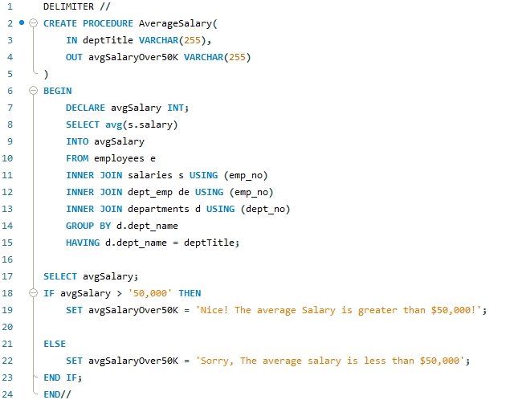

In this procedure, The while loop would terminate once an employees income exceeds $200,000. The employee number is required as input and the final salary before $200,000 is the output.

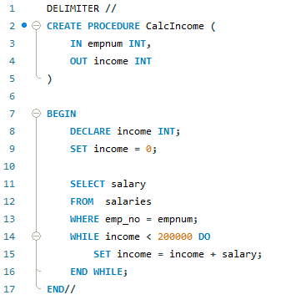

This stored procedure uses a simple loop to add the numbers 1 through 50 into a new column called “numbers” in the employees table. In order to call it, you must enter a number (50) for the input.

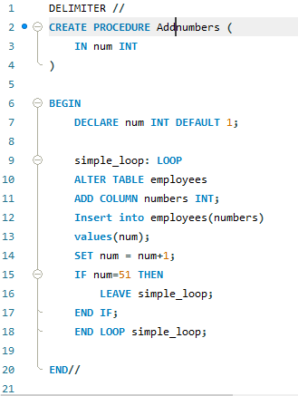

**URL to GitHub Repository:**