St10372889  
julie kaulumba

Poe

Manual

Welcome to the user manual for our recipe management application! After following the instructions in the ReadMe file, you'll be taken to the main window of the app. From here, you can:

- Create a new recipe by clicking the "Add Recipe" button and filling in the recipe details, steps, and ingredients.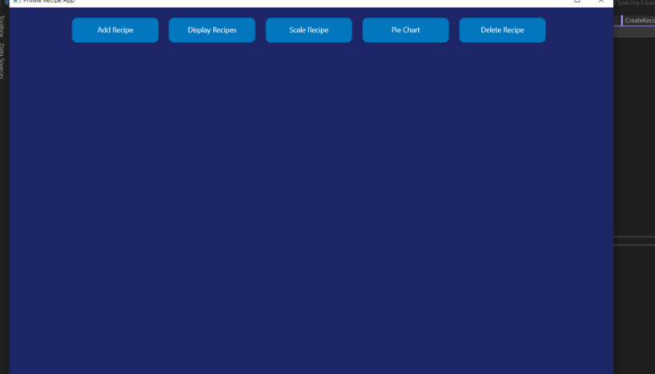

- View your recipes by clicking the "Display Recipes" button, which will show you a table with your added recipes and their total calories.

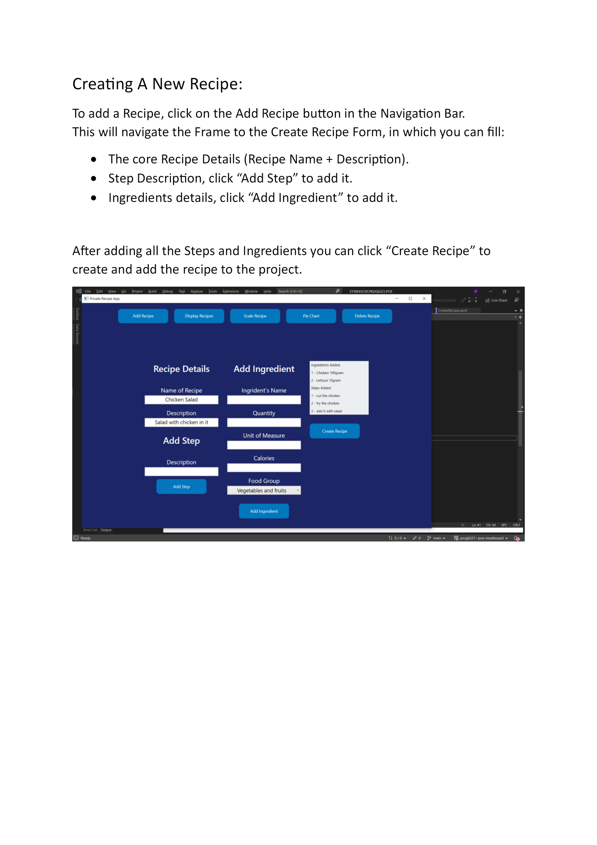

- Scale a recipe by selecting it from the combo box, choosing a scale factor, and clicking the "Scale Recipe" button.

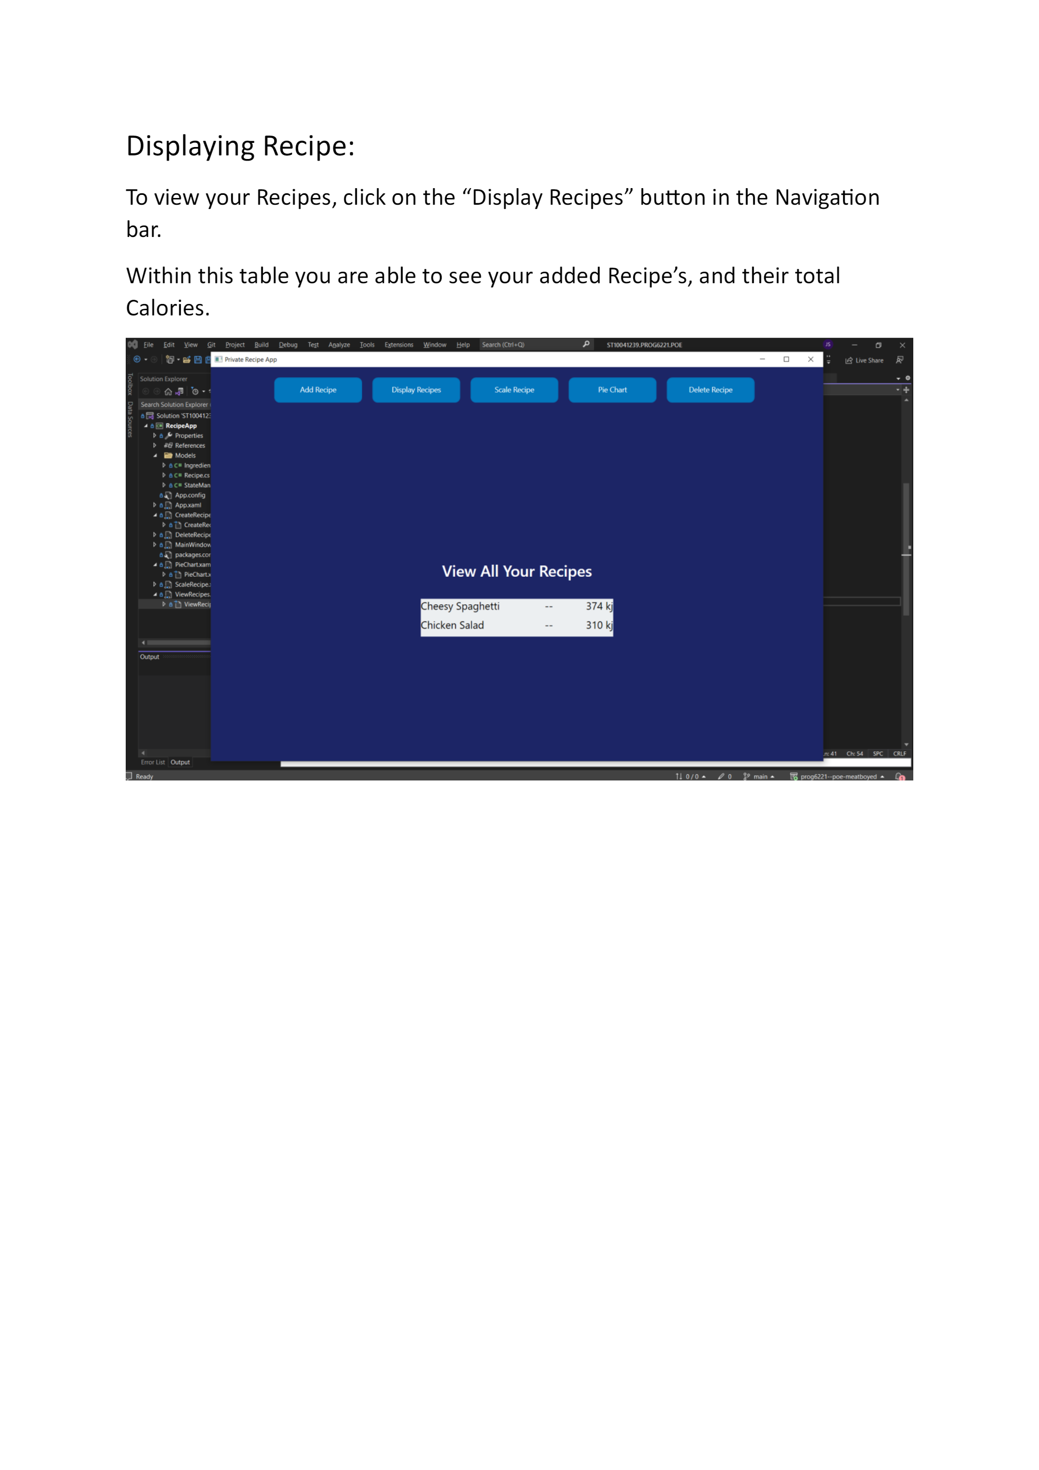

- Delete a recipe by selecting it from the combo box and clicking the "Delete Recipe" button.