1. 991

* 99110 => 13219

1321 🡪 2432

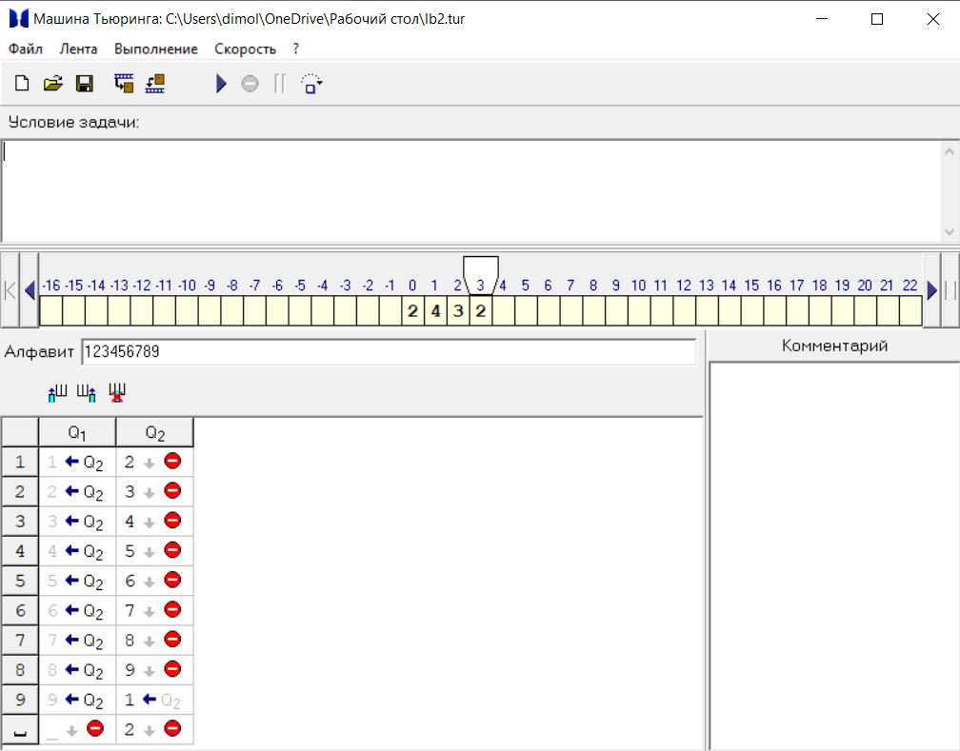

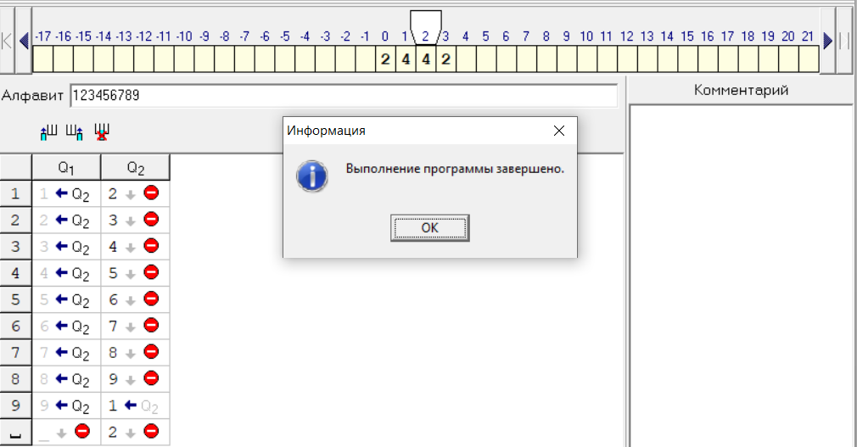

* 2442 🡪 1331
* 13319 =>100010

1. 9999

* 799910 => 118679
* 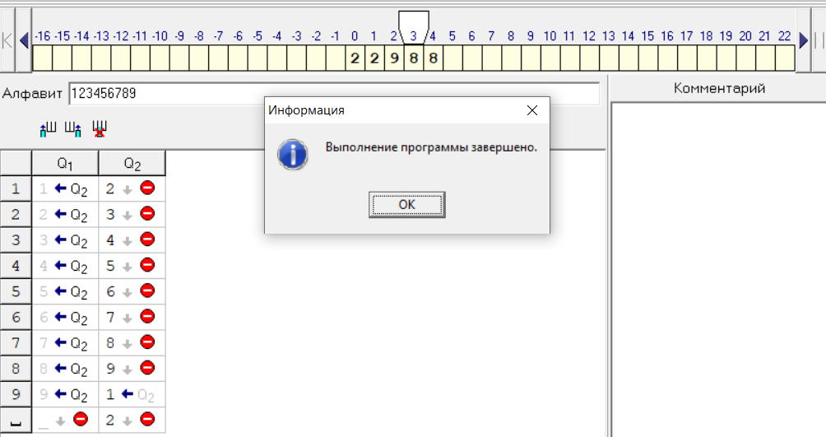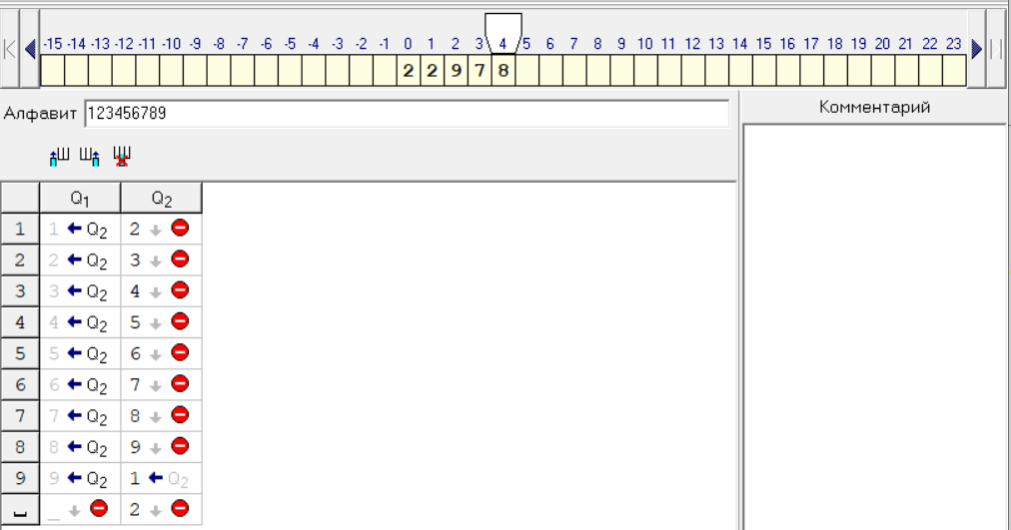11867 🡪 22978
* 22988 🡪 11877
* 118779 => 800810

1. 5831

* 583110 => 78889
* 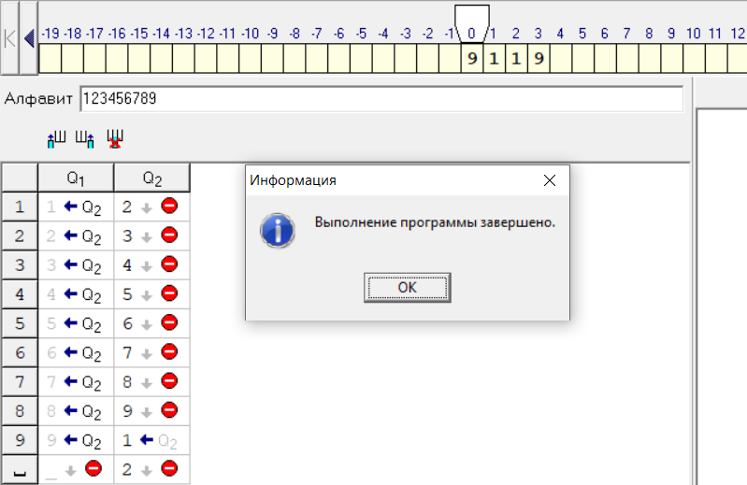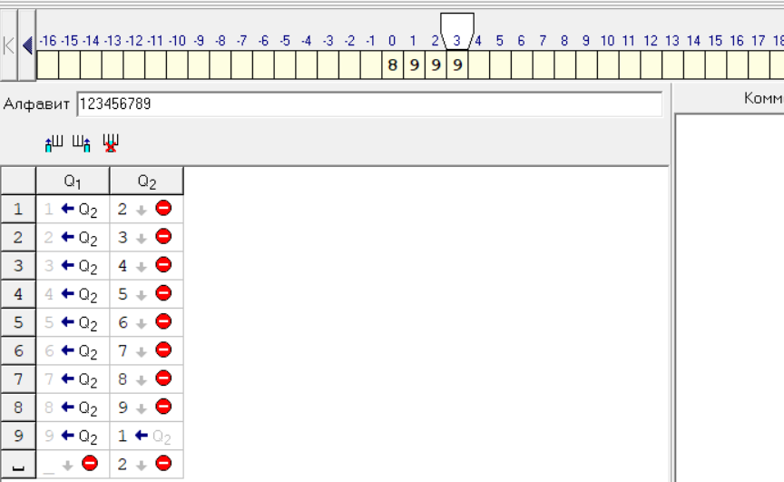7888 🡪 8999
* 9119 🡪 8008
* 80089 => 584010