GAME DESIGN

- MOTE (multi-online-tile-editor)

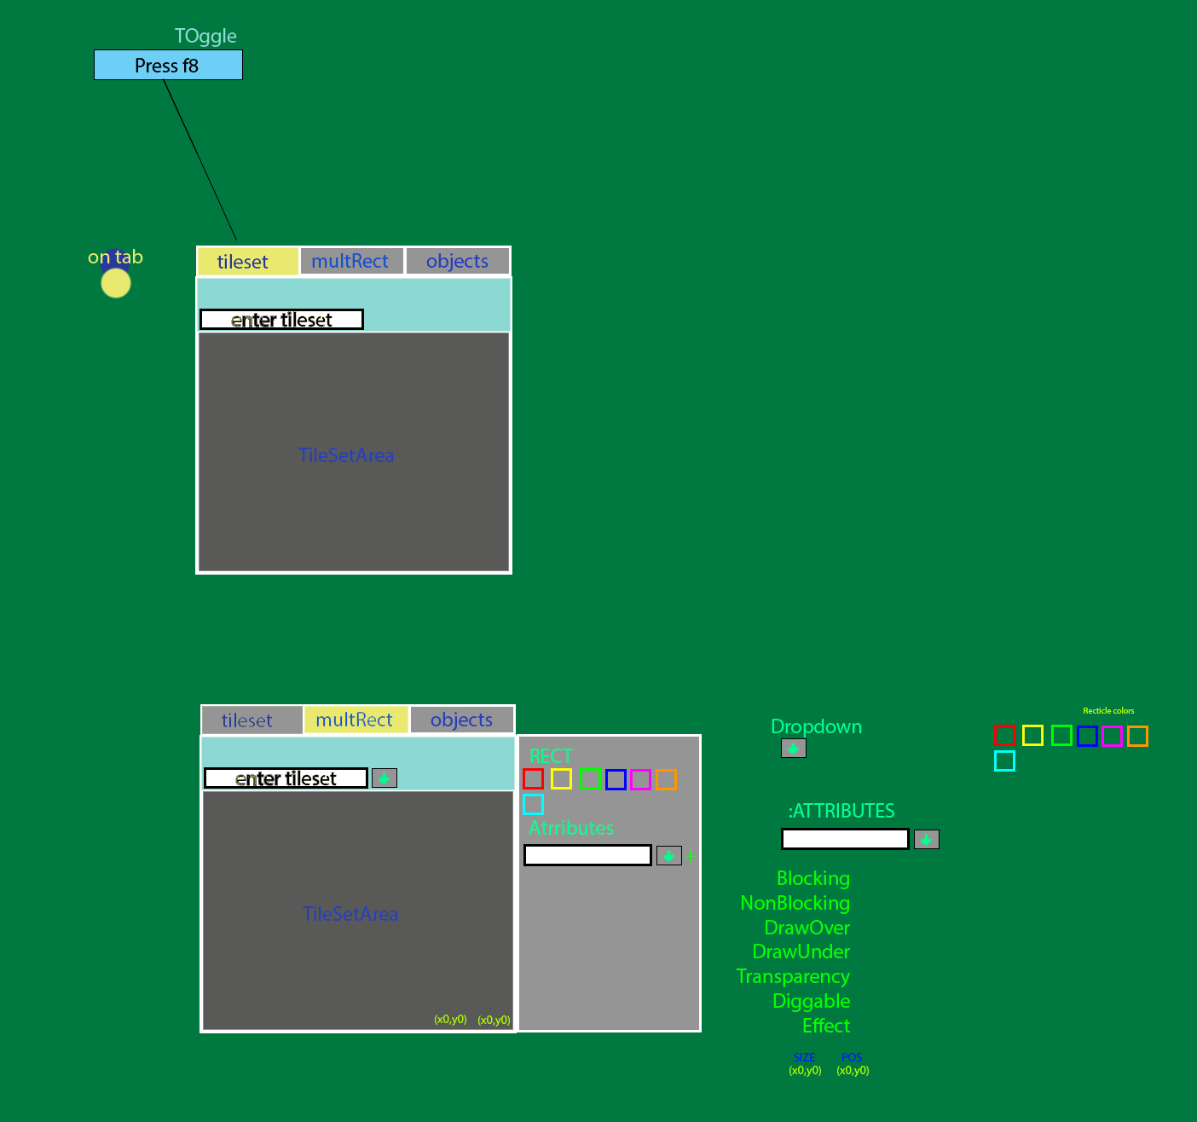

- Staff Terminal

- Object Database

- Server Synchronization

- Animator with sound

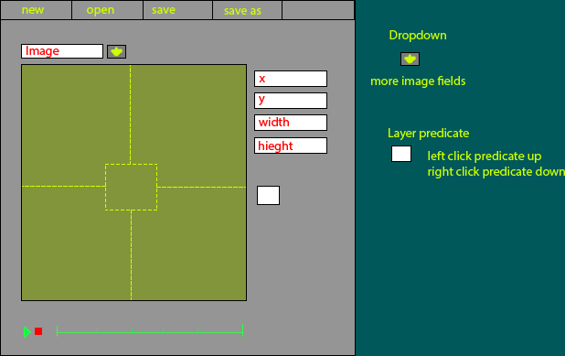

- C++ & python NPC scripting

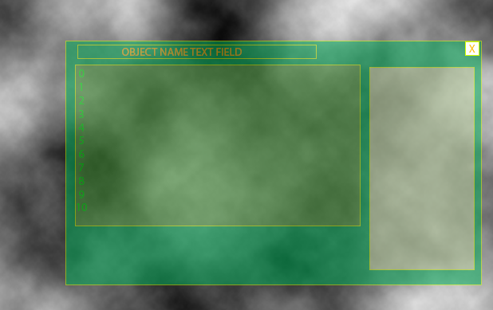

The Object Editor will have also the Scripting as well as Attributes and the Staff terminal will also allow for Scripting and be able to interact with objects and systems