Images can be send to dmitrij.vinokour@fau.de
Thank you very much for your help, I appreciate it a lot! :)

Rules for creating an electrical circuits:

1. The circuit should be drawn on white paper. (Checkered paper allowed; would be great to have both)
2. The circuit topology doesn’t have to make sense, but the circuit should be closed.
3. Only vertical and horizontal wires are allowed.
4. Please keep the components more or less balanced. (e.g. 3 components from each one including grounds)
5. Please do not use skip connections.
6. An image of your desk background is also highly appreciated.

Allowed components (horizontal examples, those can also be vertical) :
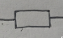
Resistor:

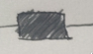
Inductor:

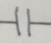
Capacitor:

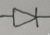
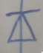
Diode: or

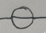
Voltage Source:

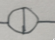
Current Source:

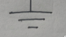
Ground: can be placed left, right, top or bottom (see example)

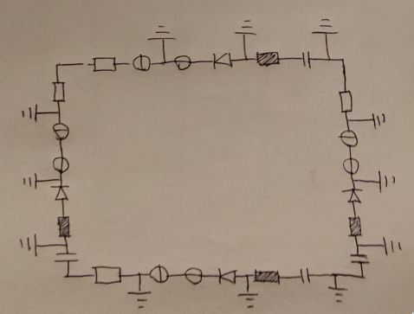
Example:

