# General HowTo

1. Login into Virtual Client.
   1. Login into your SAP Learning Hub Account.
   2. You can get Login-credentials from Dimitri.
   3. Test your exam software (it is preinstalled).
2. Adjust script as described in the next chapter.
   1. Set your screenshot timer to the time you need for the exam.
3. Start script on your local PC.
4. Go to Fullscreen in Virtual Client.
5. Start your exam.

# Setup the Power Shell File

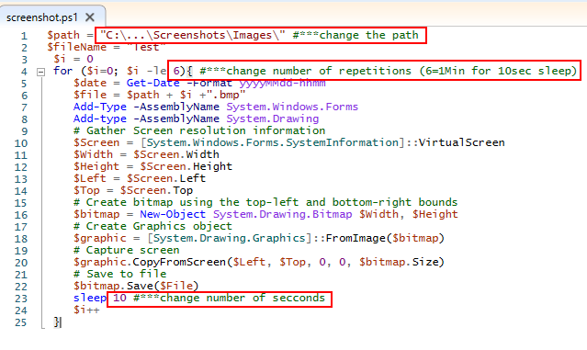

1. Unzip the files in the prefered location.
2. Change the path where you want to save the pictures.
3. Change number of repetitions and sleep time in seconds
   1. If you want to run the program for 2 hours and make a screenshot every 10 seconds, set the counter to 10 * 6 * 2 = 120
4. Open CMD and run:

powershell.exe -windowstyle hidden -file C:\...\Screenshots\screenshot.ps1

* 1. Change the path, to the path of you program.