## Start Backend Server

## Server Start

1. Start service
   1. Start Flask server
      1. Run change server settings
2. Start StableDiffusion server

## Windows Service

## Flask Server

To run the Flask server, you need to start it in a virtual environment

|  |
| --- |
| Start Virtual Env |
| *TBD – start virtual env*  *Cd python*  *Python api.py* |

## Run NSFW detection

The relative paths are dependent on where the application is started from. Start the server always from most top folder level.

Api.py:

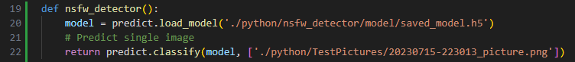

|  |
| --- |
| Start Virtual Env |
| *(NSFW) C:\Users\Rybak\Desktop\react\PicGenApp>python python/api.py* |

Note: if the server is running on local host and you want to access it on own pc. Open the port in the firewall:



## Picture Generation Server

The server used is part of Automatic1111 webui. For the web UI a FastAPI interface is used with a full backend integration.

Automatic1111 main repository: <https://github.com/AUTOMATIC1111/stable-diffusion-webui>

|  |
| --- |
| Start Server |
| *CD into main stable diffusion folder of Automatic1111*  *Run: C:\...\StableDiffusion>python launch.py --nowebui --listen* |

To check the interfaces on local machine

## Modify BE settings

Run changeBackenSettings.py to switch the model of the server.

|  |
| --- |
| Modify settings |
| cd python  python changeBackenSettings.py |

# Start Conda ENV

|  |
| --- |
| Modify settings |
| (NSFW) C:\Users\Rybak\Desktop\react\PicGenApp>conda.bat activate  PS C:\Users\Rybak\Desktop\react\PicGenApp> conda activate NSFW  PS C:\Users\Rybak\Desktop\react\PicGenApp> & C:/Users/Rybak/.conda/envs/NSFW/python.exe c:/Users/Rybak/Desktop/react/PicGenApp/python/api.py |