Online Food Order (Delivery)

UML Use Case Diagram for Driver

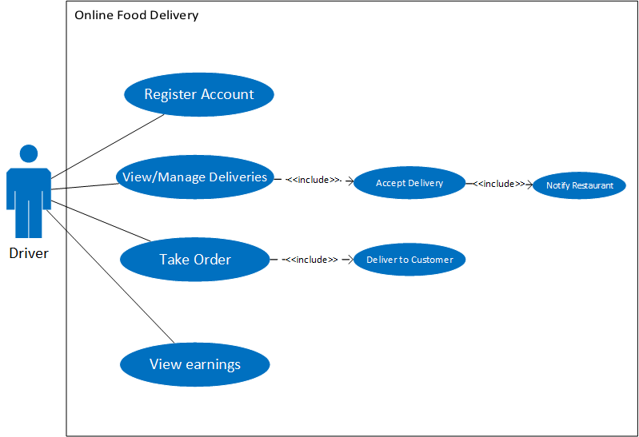

UML Use Case Diagram for Customer

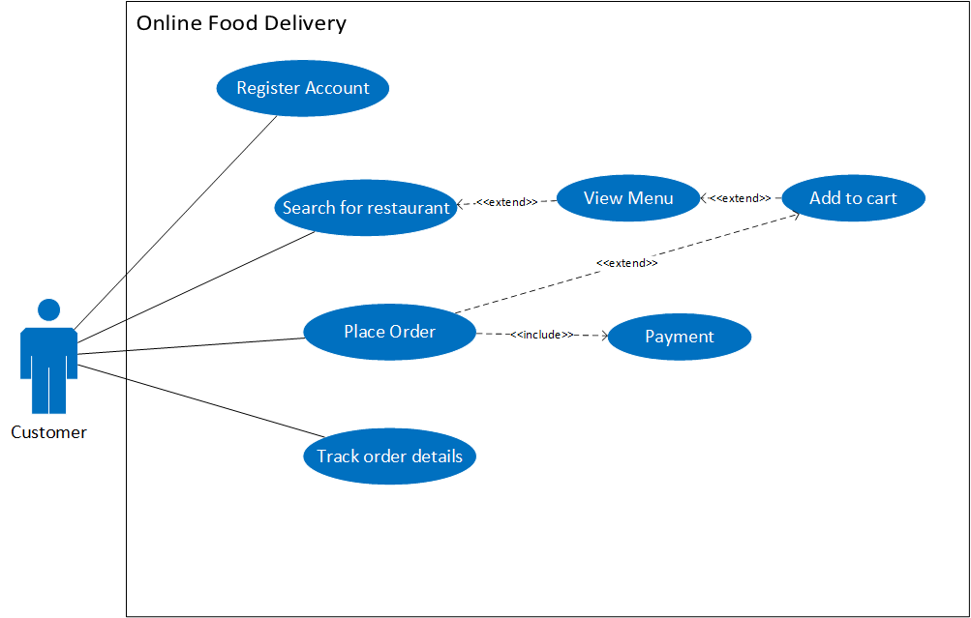

UML Use Case Diagram for Restaurant

