**Bug ID**: BUG001  
**Title**: Pie Chart Does Not Match Dataset  
**Description**: Top 8 countries shown in pie chart are not consistent with values in bottom table.  
**Steps to Reproduce**:

1. Open the dashboard “Top-5 Inflation”.
2. Note the countries in the pie chart.
3. Close the dashboard “Top-5 Inflation”.
4. Click the inflation column in bottom table on the main page in order to sort the data by inflation.
5. Cross-check the Pie chart with inflation column in bottom table on the main page.  
   **Expected Result**: Pie chart and table values should align.  
   **Actual Result**: Discrepancy noted.  
   **Severity**: High  
   **Screenshot**: 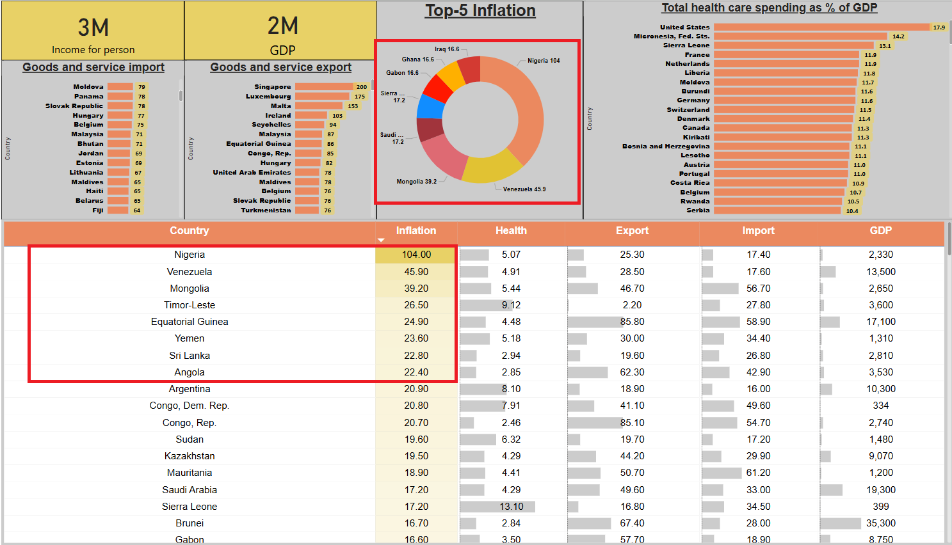

**Bug ID**: BUG002  
**Title**: The Pie Chart title does not match the requirements (Page description)   
**Description**: The title of the Top 8 countries pie chart is not consistent with the requirements (Page description)

**Steps to Reproduce**:

1. Check the requirements

**Expected Result**: The Pie chart title to be “Top-8 Inflation”  
**Actual Result**: The Pie chart title is “Top-5 Inflation”

**Severity**: Low  
**Screenshot**: