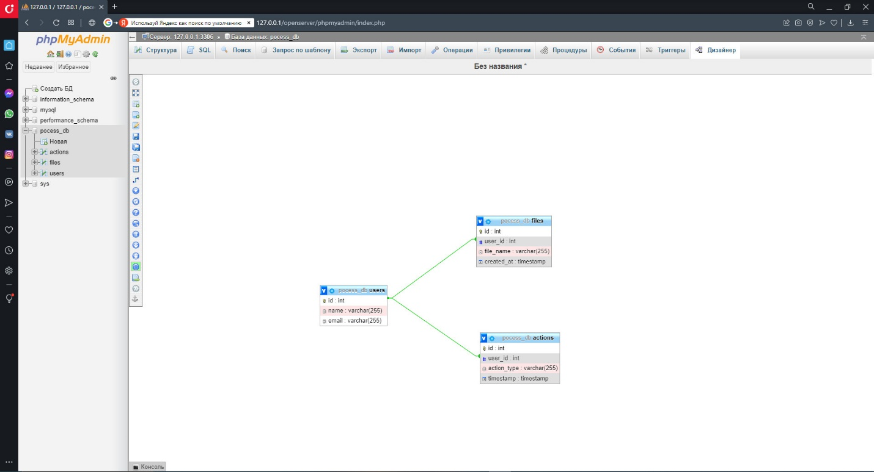

<https://github.com/Dimitrescuu/-PHP-storm>