OC: what's next ?

Dimitri Fichou

December 19, 2016

## Project status

Proof of concept of layer printing has been made. A lot has been learned during this part of the project:

* We can now send GCODE from a shiny application by calling python script. The shiny application is run on a raspberry pi.
* For layer printing, the first design wasn't solid enough and the choice of mecanical movement: hbot, was not adequate.
* The slurry recipie is not yet compatible with ATS-4 sample application and should be optimize, hovewer it is not necesary as the final aim is inkjet sample application.
* Horizontal development seems more difficult than expected.
* Visualization part is also controlled from the same shiny app, test had been made to control exposition time and need real world experimentation to judge if the raspberry pi camera is suited for the task.

## Future implementation

There is several small projects to consider and we must choose which one to prioretize. Each project is worth a paper.

### Slurry optimization

Here are the outlook of the layer paper:

* Tests with HPTLC grade silica gel (5 µm particle size) and carbopol Utrez, proportion are needed and there is potentially a missing part.
* SEM is needed for layer size evaluation, and potentially its optimization, I have good hope that I can control it by adjusting the liquid/solid ratio.
* If we want gradient layer, thickness grandient will only be a question of code so it should be easy, hovewer, gradient in composition will need the use of a second extruder, this is really challenging, supported by marlin but lots of problem on the way.
* Evaluation of the needle diameter influence, this also will help reduce layer height.
* Inkjet printing on layer, I did a pretest with Tim and his printer but it was difficult as the nozzles were clogged and the printer take decision without asking, I would like to report it after we master the inkjet printing from the arduino.
* The dedicated software is already here, I can create and send GCODE from R, this is my solution of choice for the OC concept. More rigid frame is needed but is part of a more ambitious project.

### Inkjet printing

I have a board that can be control from an arduino, and then from R, there is proof of concept of people using it inside a 3d printing environment. My problem is that documentation is not good on those project and that my pretest were unsuccesful. I also lack basic knowledge of arduino. Still this is the easier way to get it working.

I see some lock however in this aproach and it must be said now. If I manage to get it working, we will still have a big problem to incorporate this technology inside a real world apparatus: how to transport the sample from the vial to the print head ? I fear cross contamination and an overcomplicate hardware, syringe is here for reasons.

### Elution

I tried to design some kind of horizontal chamber but it was not a success. This part is one of the most complex and I have no clue how to incorporate it in the OC concept. Tim proposed to rotate the plate by 90° when needed but this is too complexe in my humble opinion. We can also build everything with the plate vertical from the beginning but then layer printing is not possible anymore. Final options are to press the elution chamber on the plate when needed or to have it at one end of the Y axis and to trigger the elution by moving the plate there.

### Visualization

The main lock I see for this project is on the UV and white light, I would like to use LED as they exist in all light but I fear it will not be homogenous. Before we implement it inside the OC concept, we can try to produce a dedicated hardware. I will allow me to stop making round trip between the labs.

In case we choose the raspberry pi camera option, I have the code to make it working, the raspberry, the camera. I will need the LEDs and to build the dedicated harware. If this plan works, it will be less than 100 Euros and 2 weeks of work.

This part of the project is one of the easiest to implement in the OC concept afterward.

### New rigid frame

The layer printing approach was made with the modification of a 3D printer, this is not adequate for a final product. The first frame I made was a catastrophe but I have still most of the part and I learnt during the process. For the next one, I want to go for aluminium profile, this is rigid, cheap and a lot of good 3D printer are made with those. Also, the number of printed part decrease with this option, making it easier to produce.

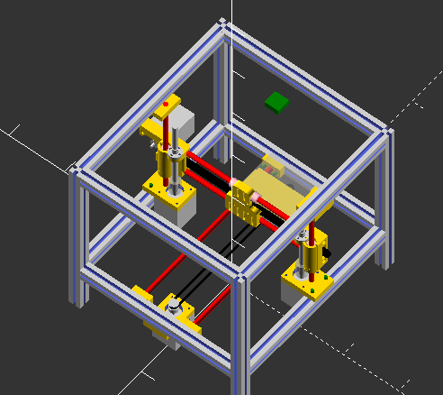

New design

This new frame is necessary for the other steps of the HPTLC pipeline, it could be wise to let this part of the project for later when the other steps are known.

* The visualization should be easy if we go for the raspberry pi camera. If we go for scanner, I have no idea how to do it myself.
* Sample application if we have the inkjet working and only want to print one sample at a time, it will be straighforward to implement.
* I see some problem with the plate eating, in the 3D printer, I used the hotbed which was bellow the plate but there is temperature latency and this is not compatible. So we need the heating part in a fix position and the plate sliding bellow when needed, I looked at infrared heating and there seems to be solutions, it will need investigation.